A

Project Report On

**SPORTS EVENT MANAGEMENT SYSTEM**

Developed by

### IT050-JUI KALARIA– Department of IT, DD University

**IT052-SMIT KALARIYA - Department of IT, DD University**

**IT056-FENI KATHAROTIYA - Department of IT, DD University**

**Guided By**

### Internal Guide:

**Prof. Archana N Vyas**

**Department of Information Technology Faculty of Technology**

**DD University**



# Department of Information Technology Faculty of Technology, Dharmsinh Desai University

**College Road, Nadiad-387001 October-2021**

# DHARMSINH DESAI UNIVERSITY NADIAD-387001, GUJARAT



**CERTIFICATE**

This is to certify that the project entitled “Sports Event Management System” is a bonafied report of the work carried out by

1. JUI KALARIA , Student ID No : 19ITUOS131
2. SMIT KALARIYA , Student ID No : 19ITUES143
3. FENI KATHAROTIYA , Student ID No : 19ITUOS138

of Department of Information Technology, semester V, under the

guidance and supervision for the subject Database Management System. They were involved in Project training during academic year 2021-2022.

**Prof. Archana N Vyas**

(Project Guide)

Department of Information Technology, Faculty of Technology,

Dharmsinh Desai University, Nadiad

#### Prof. Vipul Dabhi

Head , Department of Information Technology, Faculty of Technology,

Dharmsinh Desai University, Nadiad

# ACKNOWLEDGEMENT

We would like to give our sincere acknowledgement to everybody responsible for the successful completion of our project “**SPORTS EVENT MANAGEMENT SYSTEM**”.

The success and final outcome of this project required a lot of guidance and assistance from many people and we are extremely privileged to have got this all along the completion of this project.

We owe our deep gratitude to our project guide Prof.Archana N Vyas , who took been interest on our project work and guided us all along till the completion of our project work by providing all the necessary help for developing a good Database System.

We would also like to thank all our lecturers.

Finally we convoy our acknowledgement to all our friends and family members who directly or indirectly associated with us in the successful completion of the project .We thank one and all.

TABLE OF CONTENTS

1. Certificate II
2. Acknowledgement III

1. SYSTEM OVERVIEW .............................................................................................

* 1. Current system 1
  2. Objectives of the Proposed System 1
  3. Advantages of the Proposed system (over current). 1
  4. Entities 2
  5. User Roles 3
  6. Role Wise Requirement Listing 3

1. E-R DIAGRAM. 4
2. DATA DICTIONARY. 5
3. SCHEMA DIAGRAM 8

5. DATABASE IMPLEMENTION..............................................................................

* 1. Create Schema 9
  2. Insert Data values 14
  3. Queries (Based on functions, group by, having, joins, sub query etc.) 21
  4. PL/SQL Blocks 25
  5. Functions 27
  6. Triggers 28
  7. Cursors 33
  8. Views 35

1. FUTURE ENHANCEMENTS OF THE SYSTEM. 36
2. BIBLIOGRAPHY 37

## SYSTEM OVERVIEW

#### CURRENT SYSTEM

* + - Tasks and responsibilities of Sports Event Management System’s administrator: Event management and planning;

Managing sports event and competitions.

* + - the proposed system involves registration of players through computers. and it restricts
    - some school or college organize sports events then they do the registration of the players are manual using paper forms. Using this kind of system, it is difficult to fetch some players or winner information and it is also difficult to fetch particular sports detail.
    - duplication of player's registration.

#### OBJECTIVE OF THE PURPOSED SYSTEM

* + - automate and facilitate of managing the sports events from.
    - organizer can get whole data of students, coach, team..
    - organizers also can enter details related to them like competition detail, venue and sponsor detail and store this kind of information together in meaning way.
    - It is easy for the admin to store data and it also provides data security.
    - get information like number of players who participating on particular sport, winner detail, age and gender wise players details.

#### ADVANTAGES OF THE PURPOSED SYSTEM

Through this system we try to achieve the below objectives

* + - Overcomes the dependency of a single person handling all the sport activity.
    - Multiple teacher can use the web interface to login and perform desired task.
    - It will become easy for handling the event.
    - It will easy to access the system anywhere and anytime.
    - admin can easily arrange the competition and store the data.

#### ENTITIES

* + - Players
    - Coach
    - Sports
    - Competition
    - Team
    - Winner
    - Sponsor
    - Venue

#### USER ROLES

* + - Player
    - Admin

#### ROLE WISE REQUIREMENT LISTING

##### Player:

* + - * Player has unique username and id for

entering in sports event.

* + - * Player can participate any one sport event.
      * Player can choose any coach for training purpose.

##### Admin:

* + - * Admin is responsible for leading and managing sports event.
      * Admin is responsible for different tasks such as

Deciding winners, keep details of players and sponsors ,..etc.

# ER-DIAGRAM

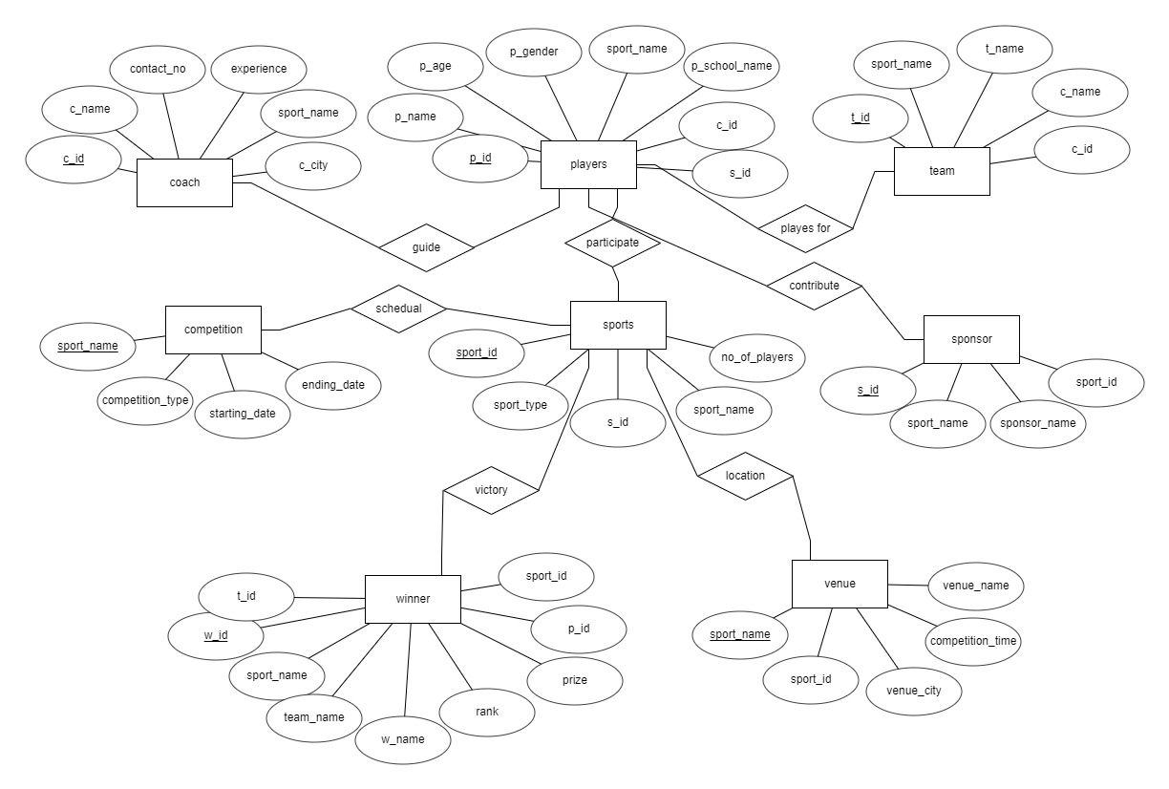

v

## TABLE DESIGN

##### PLAYERS

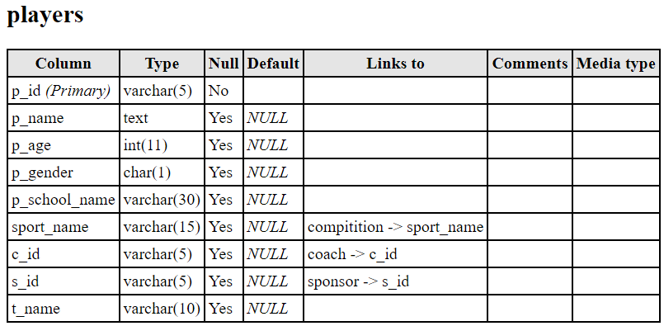

* 1. **COACH**

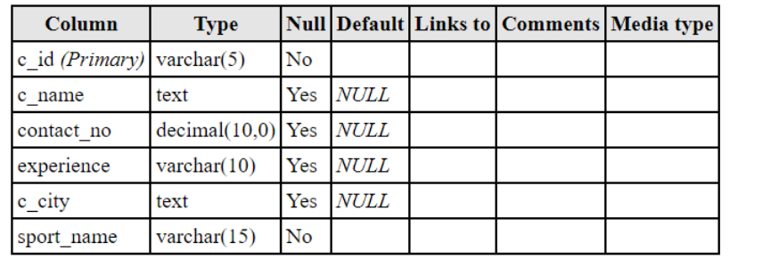

##### SPORTS

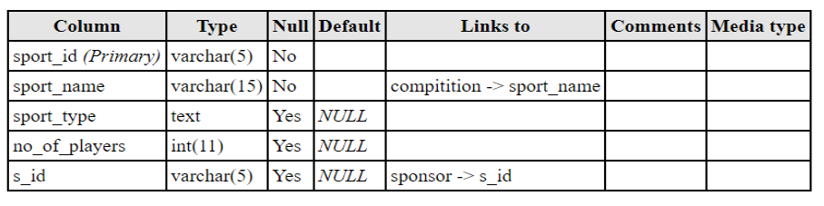

* 1. **COMPETITION**

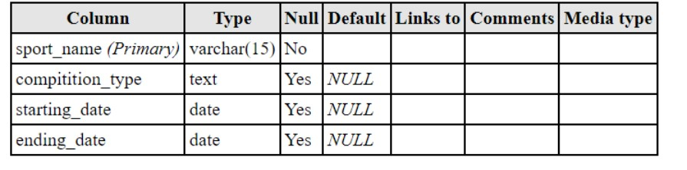

##### TEAM

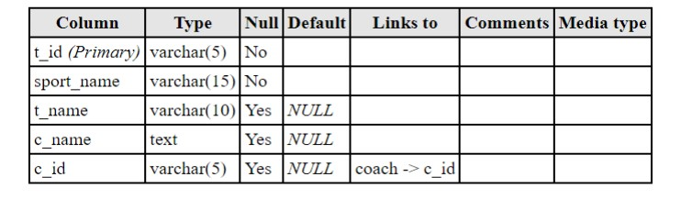

* 1. **WINNER**

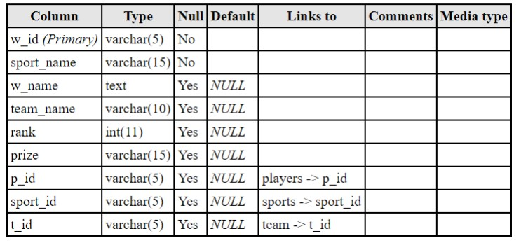

##### SPONSOR

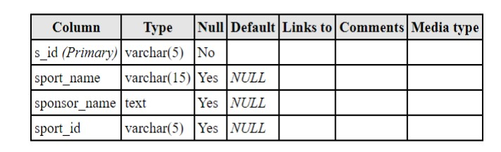

* 1. **VENUE**

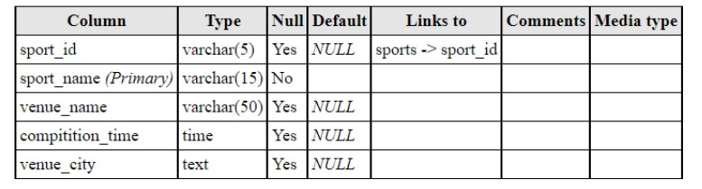

## SCHEMA DIAGRAM

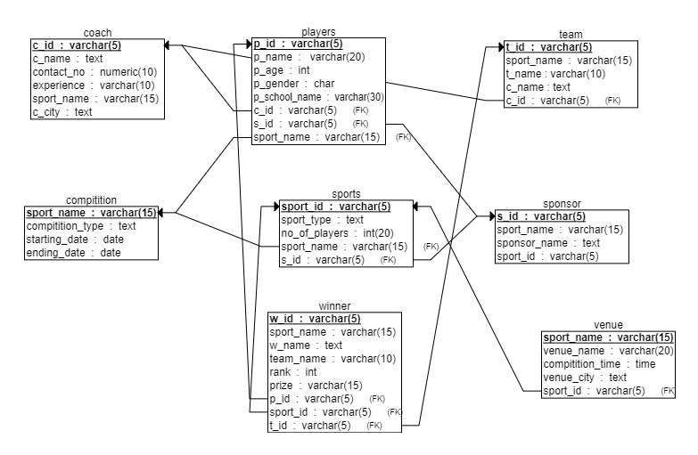

* 1. **DATABASE IMPLEMENTATION**

### CREATE SCHEMA

#### PLAYERS

create table players (

p_id varchar(5) primary key,

p_name text,

p_age int,

p_gender char,

p_school_name varchar(30),

sport_name varchar(15),

c_id varchar(5),

s_id varchar(5),

t_name varchar(10));

#### COACH

create table coach (

c_id varchar(5) primary key,

c_name text,

contact_no numeric(10),

experience varchar(10),

c_city text,

sport_name varchar(15) not null

);

#### SPORTS

create table sports (

sport_id varchar(5) primary key,

sport_name varchar(15) not null,

sport_type text,

no_of_players int,

s_id varchar(5)

);

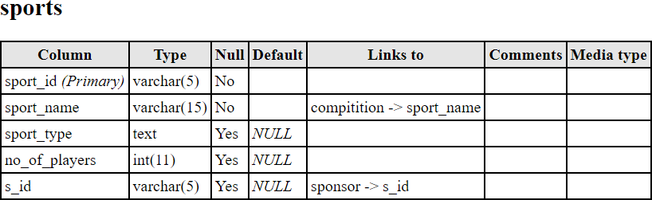

#### COMPETITION

create table compitition (

#### sport_name varchar(15) primary key,

#### compitition_type text,

#### starting_date date,

#### ending_date date);

#### TEAM

create table team (

t_id varchar(5) primary key,

sport_name varchar(15) not null,

t_name varchar(10),

c_name text,

c_id varchar references coach(c_id)

);

#### WINNER

create table winner(

w_id varchar(5) primary key,

sport_name varchar(15) not null,

w_name text,

team_name varchar(10),

rank int,

prize varchar(15),

p_id varchar(5) references players(p_id),

sport_id varchar(5) references sports(sport_id),

t_id varchar(5) references team(t_id));

#### SPONSOR

create table sponsor (

s_id varchar(5) primary key,

sport_name varchar(15),

sponsor_name text,

sport_id varchar(5)

);

#### VENUE

create table venue(

sport_id varchar(5) references sports(sport_id),

sport_name varchar(15) primary key,

venue_name varchar(20),

compitition_time time,

venue city text);

### INSERT DATA VALUE

#### Players

insert into players values(‘p101','Smriti Mishra',18,'F','Panjab University',

‘relay','c12','s1',’R1’) ;

insert into players values(‘p102','Divya Shah,19,'F','Marlboro College', ‘relay','c12','s1',’R1’) ;

insert into players values(‘p103','Payal Dave',18,'F','Izmir Institute of Technology', ‘relay','c12','s1',’R1’) ;

insert into players values(‘p104','Kajal Gandhi',20,'F','Universidad Monteavila', ‘relay','c12','s1',’R1’) ;

insert into players values(‘p105','Diya Mehta',20,'F','William

Mitchell College of Law', ‘relay','c08','s1',’R2’) ;

insert into players values(‘p106','Khushali Dave',21,'F','Grinnell College',

‘relay','c08','s1',’R2’) ;

insert into players values(‘p107','Bhumi Patel',18,'F','St. Thomas University',

‘relay','c08','s1',’R2’);

insert into players values(‘p108','Prachi Patel',19,'F','Neelain University',

‘relay','c08','s1',’R2’);

insert into players values(‘p109','Ajay Patel',18,'M','Upper Iowa University','basket

ball','c02','s2',’B1’);

insert into players values(‘p110','Chintan Shah',19,'M','La Sierra University','basket

ball','c02','s2',’B1’);

insert into players values('p111','Harshal Pandya',20,'M','St. Lawrence University','basket

ball','c02','s2',’B1’);

insert into players values('p112','Saurabh Mehta',20,'M','Millsaps College','basket

ball','c02','s2',’B1’);

insert into players values('p113','Manan Gandhi',20,'M','Vidyasagar University','basket

ball','c02','s2',’B1’);

insert into players values('p114','Jay Pandey',19,'M','Jagannath University','basket ball','c09','s2',’B2’);

insert into players values('p115','Chirag Dabhi',19,'M','Kanazawa Gakuin University','baske t ball','c09','s2',’B2’) ;

insert into players values('p116','Jimit shah',18,'M','Springfield College','basket ball','c09','s2',’B2’) ;

insert into players values('p117','Dev Parmar',21,'M','Samford University','basket ball','c09','s2',’B2’) ;

insert into players values('p118','Hiten Patel',19,'M','Wilson College','basket ball','c09','s2',’B2’) ;

insert into players values ('p119','Khushi Joshi',19,'F','AgroParisTech','badminton','c01','s6') ;

insert into players values ('p120','Reeta Shah',19,'F','Vinoba Bhave

University','badminton','c10','s6'),;

insert into players values('p121','Karan Modi',19,'M','Rosemont

College','tennis','c03','s5') ;

insert into players values('p122','Deep Dhori',18,'M','Vidyasagar

University','tennis','c11','s5') ;

insert into players values('p123','Disha Modi',19,'F','Concord College','long

jump','c04','s3');

insert into players values ('p124','Aman Mishra',20,'M','Panjab University','long

jump','c06','s3') ;

insert into players values('p125','Ritu Pile',22,'F','Grinnell College','hurdling','c07','s4');

insert into players values('p126','Ashim Soni',19,'M','Shimer College','hurdling','c05','s4');

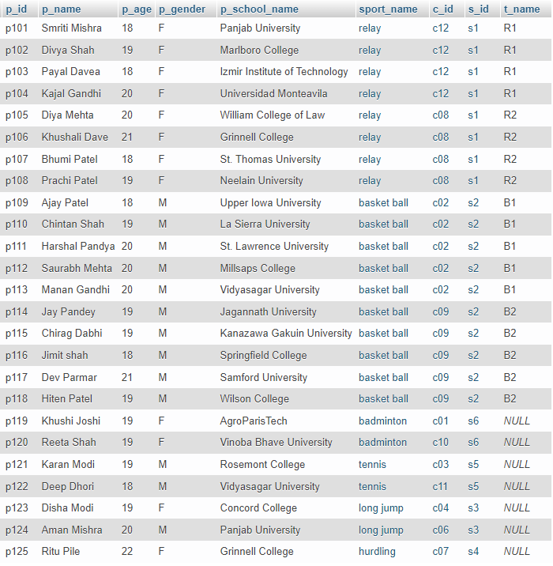

#### COACH

insert into coach values('c01','Rushi Dalal', 8829644591,'2 years','Prroshyan','badminton');

insert into coach values('c02','Manish Verma',6494461140,'1 year','Bochum','basket ball');

insert into coach values('c03','Sachin Joshi',5407233455,'10 months','Goragorskiy','tennis');

insert into coach values('c04','Sonu kumari',3188825906,'4 years','Jishi','long jump');

insert into coach values('c05','Rajesh Shah',5968502488,'9 months','Minle','hurdling');

insert into coach values('c06','Rajesh Verma',1528590023,'3 years','Tres Arroyos','long jump');

insert into coach values('c07','Jenish Goswani', 1455892454,'2 years','Chwaszczyno','hurdling');

insert into coach values('c08','Kirtan Oza',1258954326,'3 years','Prostki','relay');

insert into coach values('c09','Ramesh Bhatt',4526584121,'11 months','Gorodishche','basket ball');

insert into coach values('c10','Arati Bansal',5234891026,'2 years','Sokolac','badminton');

insert into coach values('c11','Denish Bhut',4582361023,'8 months','Yuchi','tennis');

insert into coach values('c12','Hiren Gohil',1485657461,'10 months','Batou','relay');

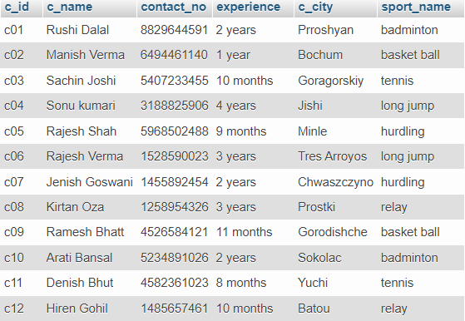

#### SPORTS:

insert into sports values(1,'relay','team',4,'s1');

insert into sports values (2,'basket ball','team',5,'s2');

insert into sports values(3,'badminton','solo',1,'s6');

insert into sports values(4,'tennis','solo',1,'s5');

insert into sports values(5,'long jump','solo',1,'s3');

insert into sports values(6,'hurdling','solo',1,'s4');

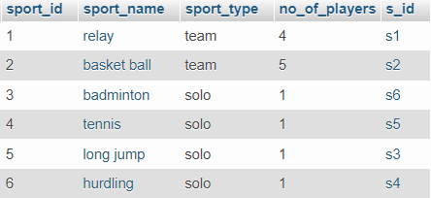

#### Competition

insert into compitition values('relay','team','1/1/2022','1/9/2022');

insert into compitition values('basket ball','team','1/3/2022','1/10/2022');

insert into compitition values('badminton','solo','1/2/2022','1/4/2022');

insert into compitition values('tennis','solo','1/6/2022','1/8/2022');

insert into compitition values('long jump','solo','1/4/2022','1/5/2022') ;

insert into compitition values('hurdling','solo','1/3/2022','1/5/2022');

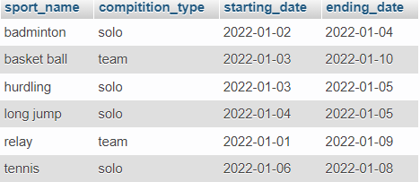

#### Team:

insert into team values('t1','relay','R1','Hiren Gohil','c12') ;

insert into team values('t2','relay','R2','Kirtan Oza','c08');

insert into team values('t3','basket ball','B1','Manish Verma','c02') ;

insert into team values('t4','basket ball','B2','Ramesh Bhatt','c09');

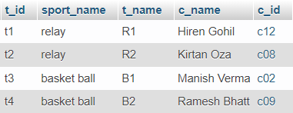

#### Winner

insert into winner(w_id,sport_name,team_name,rank,prize,sport_id,t_id) values('w11','relay','R1',1,'gold medal',1,'t1');

insert into winner(w_id,sport_name,team_name,rank,prize,sport_id,t_id) values('w12','relay','R2',2,'silver medal',1,'t2');

insert into winner(w_id,sport_name,team_name,rank,prize,sport_id,t_id) values('w21','basket ball','B2',1,'gold medal',2,'t3');

insert into winner(w_id,sport_name,team_name,rank,prize,sport_id,t_id) values('w22','basket ball','B1',2,'silver medal',2,'t4');

insert into winner(w_id,sport_name,w_name,rank,prize,p_id,sport_id) values('w31','badminton','Khushi Joshi',1,'gold medal','p119',3);

insert into winner(w_id,sport_name,w_name,rank,prize,p_id,sport_id) values('w32','badminton','Reeta Shah',2,'silver medal','p120',3);

insert into winner(w_id,sport_name,w_name,rank,prize,p_id,sport_id) values('w41','tennis','Deep Dhori',1,'gold medal','p122',4);

insert into winner(w_id,sport_name,w_name,rank,prize,p_id,sport_id)

values('w42','tennis','Karan Modi',2,'silver medal','p121',4);

insert into winner(w_id,sport_name,w_name,rank,prize,p_id,sport_id)

values('w51','long jump','Aman Mishra',1,'gold medal','p124',5);

insert into winner(w_id,sport_name,w_name,rank,prize,p_id,sport_id)

values('w52','long jump','Disha Modi',2,'silver medal','p123',5);

insert into winner(w_id,sport_name,w_name,rank,prize,p_id,sport_id)

values('w61','hurdling','Ritu Pile',1,'gold medal','p125',6);

insert into winner(w_id,sport_name,w_name,rank,prize,p_id,sport_id)

values('w62','hurdling','Ashim Soni',2,'silver medal','p126',6);

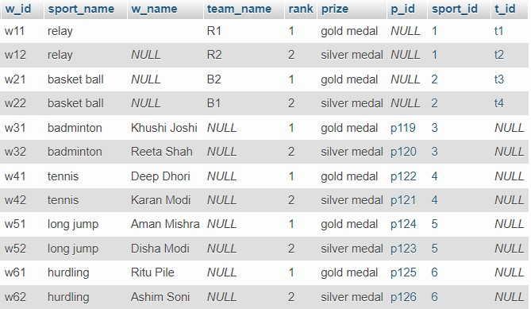

#### Sponsor

insert into sponsor values('S1','relay','Bharat Shah',1);

insert into sponsor values('S2','basket ball','Neeta Desai',2);

insert into sponsor values('S3','long jump','Himansu Pandey',5);

insert into sponsor values('S4','hurdling','Raj Patel',6);

insert into sponsor values('S5','tennis','Arjun Joshi',4);

insert into sponsor values('S6','badminton','Anjali Mehta',3);

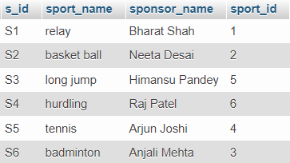

#### Venue

insert into venue values(1,'relay','ground no.G2,surat','10:00:00',’ Surat’) ;

insert into venue values(2,'basket ball','shastri ground,nadiad','09:30:00',’ Nadiad’);

insert into venue values(3,'badminton','LD college,ahmedabad','14:00:00',’ Ahmedabad’);

insert into venue values(4,'tennis','st. teresa college,nadiad','16:00:00',’ Nadiad’);

insert into venue values(5,'long jump','vivekanand ,ground,baroda','11:00:00',’Baroda’) ;

insert into venue values(6,'hurdling','C.V.ground,baroda','08:50:00',’ Baroda’);

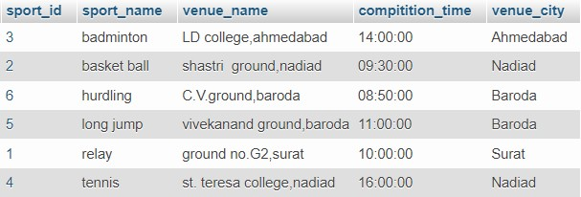

## QUERIES

5.3.1 Display the players details whose sport name starts with ‘b’ and ends with ‘n’:

→SELECT * FROM players WHERE sport_name LIKE 'b ________n';

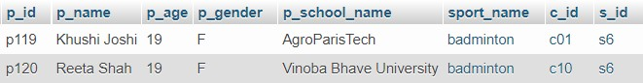

5.3.2 Display the players details whose coach is starts with ‘c1’:

→SELECT * FROM players WHERE c_id LIKE 'c1%';

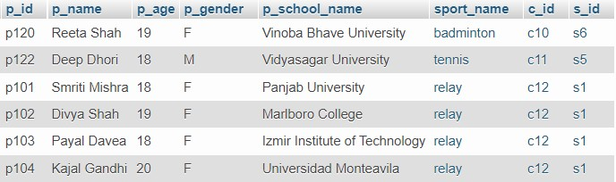

5.3.2 Display the players details whose age is in between 19 to 20.

→SELECT * FROM players WHERE p_age BETWEEN 19 AND 20;

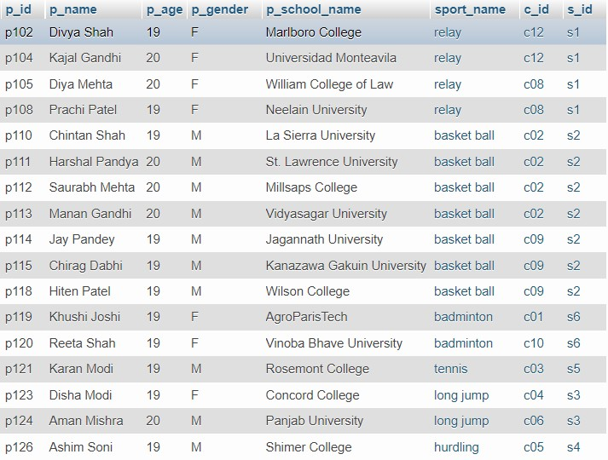

5.3.4 Display the competition detail for the competition which is held in between date 2022-01-01 to 2022-01-05 .

--->SELECT * FROM compitition WHERE starting_date BETWEEN '2022-01-01' AND

'2022-01-05';

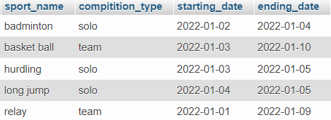

5.3.5 display the competition detail according to descending order of ending date

→SELECT * FROM compitition ORDER BY ending_date DESC;

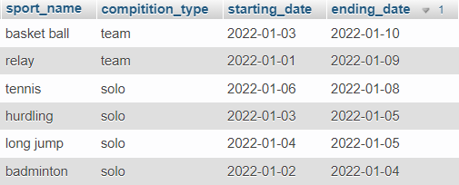

5.3.6 display the competition detail according to descending order of ending date

→SELECT * FROM compitition ORDER BY ending_date DESC;



5.3.7 Display the details of players who are participating in tennis and hurdling.

--->SELECT p_id,p_name,p_age,p_gender,sport_name FROM players WHERE sport_name IN('tennis','hurdling');

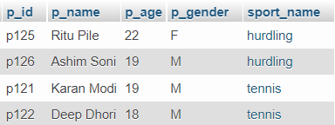

5.3.8 Display the sponsor details for all sports excepting relay and basket ball.

→SELECT * FROM sponsor where sport_name NOT IN('relay','basket ball');

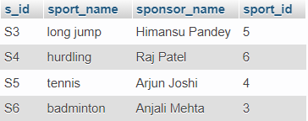

5.3.9 Display the total number of male and female players.

→SELECT COUNT(p_gender) as total_players, p_gender FROM players GROUP BY p_gender;

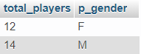

* 1. JOIN AND SUB QUIRIES

**5.4.1 Display the details of coach of the player which is participating in relay.**

---->SELECT p_id, p_name, players.sport_name, players.c_id, c_name FROM players INNER JOIN coach ON players.c_id = coach.c_id WHERE players.sport_name = 'relay';

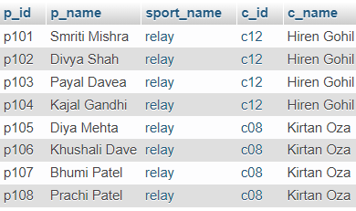

5.4.2 Display the details of player and sponsor of the long jump and tennis

--->SELECT p_id,p_name,players.sport_name, sponsor_name FROM players RIGHT JOIN sponsor ON players.s_id = sponsor.s_id WHERE players.sport_name IN ('long jump', 'tennis');

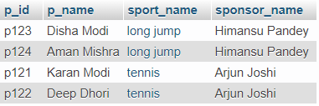

5.4.3 Display the details of the winner of the hurdling and long jump.

--->SELECT players.p_id, players.p_name, players.p_school_name, players.sport_name, winner.rank, winner.prize FROM players INNER JOIN winner ON players.p_id = winner.p_id WHERE players.sport_name IN ('long jump', 'hurdling');

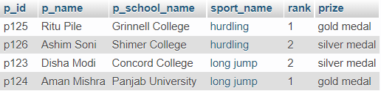

5.4.4 This query is example of sub query that shows a coach name and sport name of male player

--->SELECT p_id, p_name, p_gender, sport_name, c_name FROM (SELECT players.p_id, players.p_name, players.p_gender, players.sport_name,coach.c_name FROM players CROSS JOIN coach ON players.c_id = coach.c_id WHERE p_gender = 'M')p;

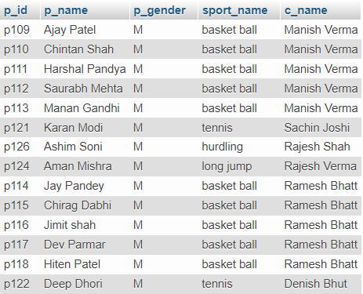

5.4.5 This query is also example of sub query that shows a details of the venue of the sport name which competition time is having between 10 to 14.

--->SELECT * FROM venue WHERE compitition_time IN (SELECT compitition_time FROM venue WHERE compitition_time BETWEEN '10:00:00' AND '14:00:00');

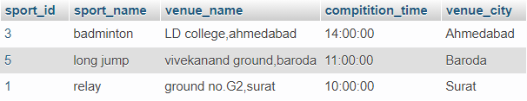

5.4.6 Display the winners and runner up of all sports event.

--->SELECT w_id,sport_name,w_name,team_name,rank FROM winner ORDER BY rank;

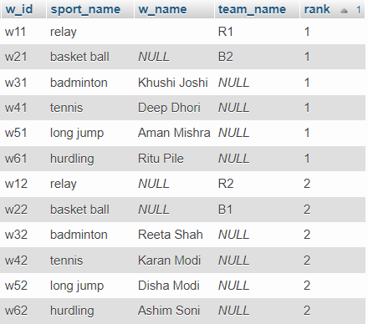

* 1. **FUNCTIONS**

5.5.1 Display the total number of players for provided age.

create function get_total_players(age_from integer, age_to integer)

returns integer

language plpgsql

as

$$

declare

total_count int;

begin

select count(*)

into total_count

from players

where p_age between age_from and age_to;

return total_count;

end

$$;

#### OUTPUT:

select get_total_players(20,22);

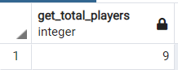

## TRIGGERS

#### This trigger is called before data is inserted or updated into the backup table .This trigger also insert data from player table.

* Backup table is created

Create table backup(

backup_id int primary key AUTO_INCREMENT,

p_id varchar(5),

p_name text,

sport_name varchar(15),

action1 text

);

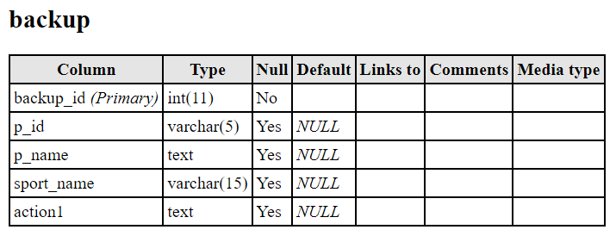

5.6.1.1 Insert some data into backup table with the help of trigger.

1. Insert Trigger:

CREATE TRIGGER insertBackup

AFTER INSERT

ON players

FOR EACH ROW INSERT INTO backup

VALUES(null,NEW.p_id, NEW.p_name, NEW.sport_name,'Inserted');

--->testing

insert INTO players VALUES('p127','Aasha Kher',20,'F','SGC Collage','hurdling','c05','s4',null);



5.6.1.2 Update some data into backup table with the help of trigger

1. update trigger:

CREATE TRIGGER updateBackup

AFTER UPDATE

ON players

FOR EACH ROW INSERT INTO backup

VALUES(null,NEW.p_id, NEW.p_name, NEW.sport_name,'Updated');

--->testing

UPDATE players set sport_name='long jump' WHERE p_id = 'p127';

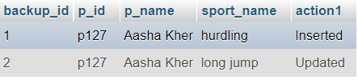

## CURSOR

**5.7.1 Display the players whose age is less than 19.**

BEGIN

DECLARE mycur CURSOR FOR SELECT p_name, sport_name FROM players;

OPEN mycur;

SELECT p_name, sport_name,p_age FROM players WHERE p_age = 18;

CLOSE mycur;

END

##### OUTPUT:

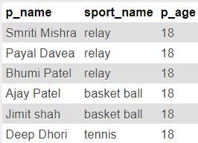

## VIEWS

5.8.1 Create view for the female winner player.

CREATE VIEW female_winner AS

SELECT players.p_name, players.sport_name, winner.rank

FROM players INNER JOIN winner ON players.p_id = winner.p_id

WHERE players.p_gender = 'F';

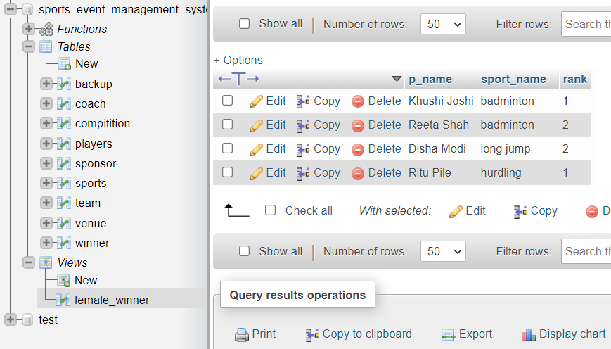

## FUTURE ENHANCEMENS OF THE SYSTEM

* + - * We will design Front-end in HTML, CSS and JavaScript.
      * We will implement Back-end using Django.
      * We will make database more consistent, efficient and easy to implement with huge data capacity.
      * We will also add some extra features so that it will become more user friendly.

## BIBLIOGRAPHY

* + - * For implementation of this project we referred to many website and books.
      * Mostly we referred the online material for syntax of procedure, triggers, exception and cursors.
      * We created schema using mysql workbench.

**Reference Book:**

**Data Base System Concepts**

### -Henry F. Korth &A. Silberschatz

**Reference Websites:**

* + - * + **<https://www.w3schools.com/>**
        + **<https://www.tutorialspoint.com/index.htm>**
        + **<https://stackoverflow.com/>**