**CHAPTER 4**

**RESULTS AND DISCUSSION**

**4.1 Results**

These results were based on the methods carried out from the previous chapter on the vibration analysis of a gas turbine failure. These results which are in three cases where the first case deals with analysis of the high vibration in the generator side during the first run up at full speed with no load. The second case deals with the analysis of the high vibration in the gas turbine during the full speed with no load. The third case deals with the analysis of the gas turbine tripping during start-up.

**4.1.1 Case 1**

This study was carried out to analyze the reason for high vibration in the generator side during the first run up at Full Speed with No Load (FSNL). The vibration pick up instrument with accelerometers are used to measure the vibration. The accelerometers were mounted at four locations of the gas turbine assembly and these locations are tabulated in Table 1 and corresponding vibration readings required for investigation were collected at these locations. The amplitude of vibration recorded at rotor rotational speed of 3000 rpm is shown in Fig 4.1. It is observed that high vibration at front and rear bearing locations in horizontal direction. To identify the cause for this high vibration, the unit put in crank mode to check if any damage in the compressor, generator or in the turbine. Initially it is noticed that the damage in the coil, even after cleaning and replacing the coil it is observed the high vibration as shown in Fig. 4.2.

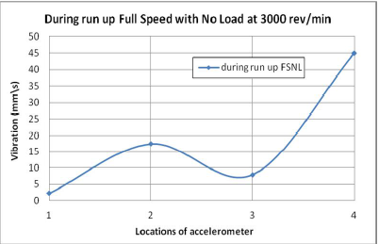

**Fig. 4.1: Graph of Vibration against Locations of accelerometer during run up full speed with no load at 3000 rev/min**

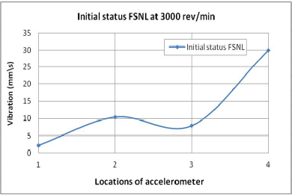

**Fig. 4.2: Graph of Vibration against Locations of accelerometer at initial status FSNL at 3000 rev/min**

Further analysis shows that this is due to unbalance in the rotor of the generator. This is due to accumulation of dust and additional weights added to balance the rotor year after year. As a corrective measure, it was decided to remove weights added at exciter (rear bearing) of 4 weights at 348° and 3 weights at 0° of weighing 25 gram each as shown in Fig. 4.3. The vibration reading were recorded and represented in Fig. 4.4.

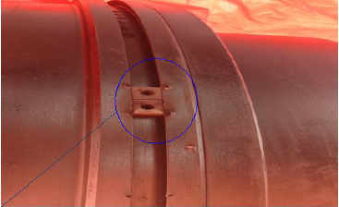

**Fig. 4.3: Removal weight from rotor**

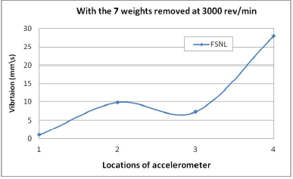

**Fig. 4.4: Graph of Vibration against Locations of accelerometer with 7 weights removed at 3000 rev/min**

However it is observed only small reduction in vibration level, hence it is suggested to do balancing of rotor. To achieve proper balance, further five weights with a total of 125 grams were added at angle 330° on the generator rotor as shown in Fig. 4.5. It is observed that the vibration level is reduced to acceptable level as shown in Fig. 4.6. After balancing the vibration reading were collected with different operating conditions. The results of tests performed before and after the balancing of the generator rotor in the gas turbine to see the effectiveness and success of the process of balancing. To make sure the last balancing step was successful, we do the other test by the run-up gas turbine and put at load 10 MW and take a reading of vibration. If we compare the results of vibration between the after balancing on FSNL and after base load 10 MW we can see how the result observed is very close to the results obtained which is shown in Fig. 4.6. This means that the balancing process is completed perfectly and the gas turbine now operating in good condition.



**Fig. 4.5: Rotor with an addition of five weight**

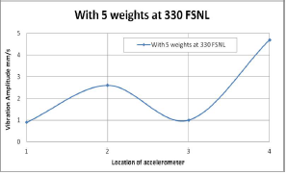

**Fig. 4.6: Graph of Vibration against Locations of accelerometer with 5 weights at 330FSNL**

**4.1.2 Case 2**

This study was carried out to analyze the reason for high vibration in the gas turbine during the first run up at Full Speed with No Load (FSNL). Seven locations were identified to acquire vibration readings using accelerometer on the gas turbine and gearbox. The accelerometers were mounted at these seven locations of the gas turbine assembly and these locations. Vibration readings were acquired in all three directions for three different load conditions such as Full Speed with No Load (FSNL), at 10 MW, at 15MW and at 20 MW load to investigate the problem. The amplitude of vibration recorded at rotor rotational speed of 3000 rpm which are shown in fig. 4.7. It was noted that the high vibration amplitude at reduction low speed compound thrust journal bearing (in gearbox) which is coupled to generator rotor in all the three directions. As the load increases the amplitude of vibration is also proportionally increased.

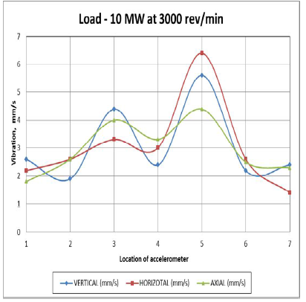

**Fig. 4.6: Graph of Vibration against Location of accelerometer with a load of 10 MW at 3000 rev/min**

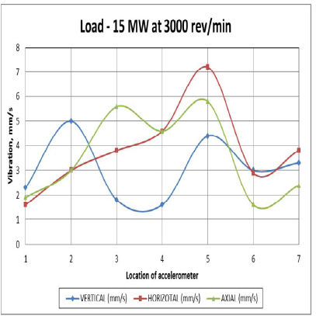

**Fig. 4.7: Graph of Vibration against Location of accelerometer with a load of 15 MW at 3000 rev/min**

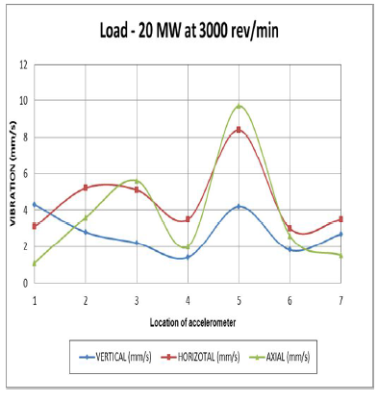

**Fig 4.9: Graph of Vibration against Location of accelerometer with a load of 20 MW at 3000 rev/min**

**4.1.3 Case 3**

This study was carried out to analyze the reason for Gas turbine tripping during start-up due to servo valve problem that was created a very loud sound in the technical building and observed heavy dust came-out from the chimney. Immediate action was initiated to put the unit into crank mode to check if any damage in compressor or in the gas turbine. The investigation was started with a thorough visual inspection of the turbine and the blades surfaces; the observation showed that a serious damage in the diffuser. However, there was no clear evidence that it was caused due to this incident and it is not unusual to find this kind of damages during planned annual maintenance. A little shift of silencer was observed and also a buckling and a minor crack were observed on the exhaust stack wall outer surface. No evidence of a possible oil leak was found in the exhaust stack. This study was carried out to analyze the reason for Gas turbine tripping during start-up due to servo valve problem that was created a very loud sound in the technical building and observed heavy dust came-out from the chimney. Immediate action was initiated to put the unit into crank mode to check if any damage in compressor or in the gas turbine. The investigation was started with a thorough visual inspection of the turbine and the blades surfaces; the observation showed that a serious damage in the diffuser.