Frontend Assignment
Tech: Any modern frontend stack. Next with TypeScript is common, but all are fine. You may use any supporting libraries, including Three.js.

Goal
You’re building a custom video player where a background image and a video are composited together on a canvas — with a synced transcript sidebar. This mirrors how modern creative and media tools render video as part of a larger visual scene instead of treating it as a standalone media element.

Reference Design
Below is a sample layout. Your implementation should follow the overall structure and feel of the design, with minor stylistic differences allowed.
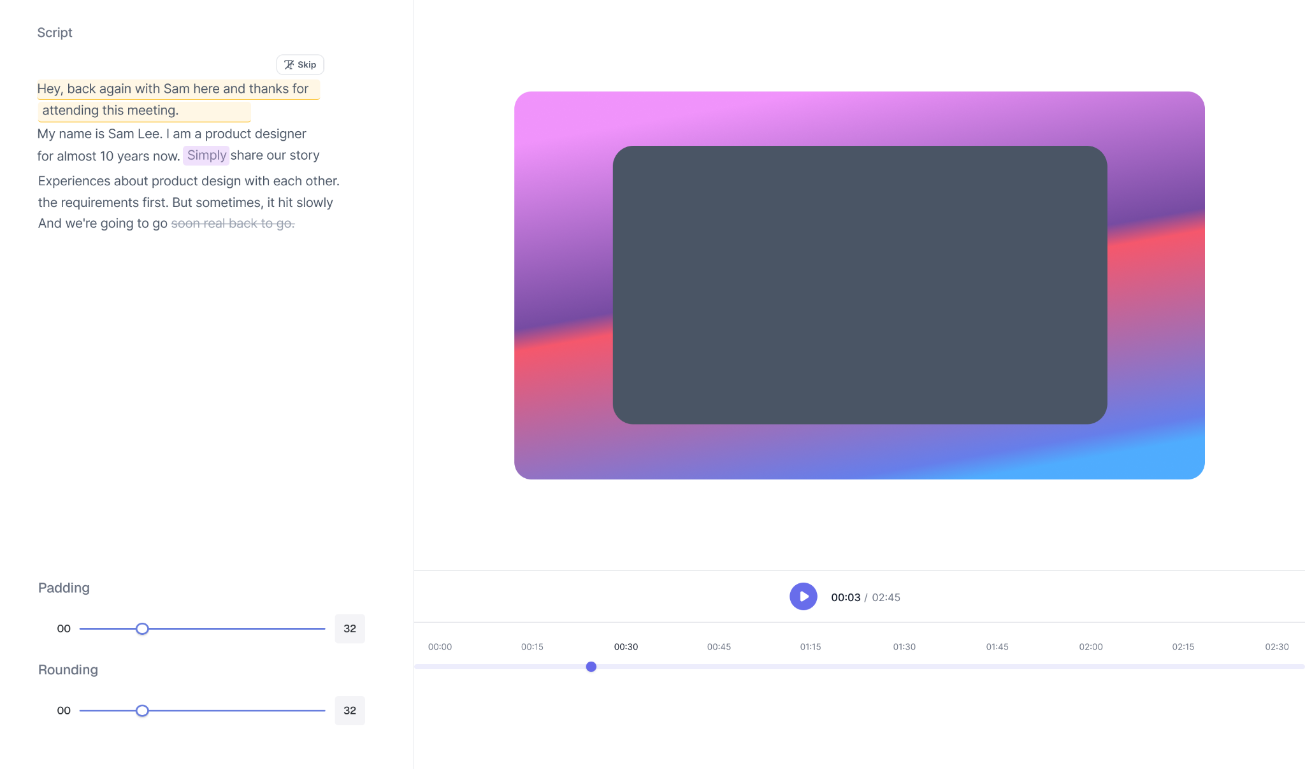

Inputs Provided
You will be given the following assets to work with:
- A video file
- A background image
- A word-level timestamp JSON script (each word mapped to a start/end time)

What to Build
It should be a single-page app split into two sections: a Left Sidebar and a Right Player Panel.

1. Right Panel — Player Canvas
You must explicitly use Three.js (https://threejs.org/) to build the player. The player must be built as a self-contained, reusable component that can be dropped into any part of an application.
- Render the background image as the scene
- Render the video centered on top of the background

2. Left Sidebar

Transcript
- Display the full transcript using the provided word-level timestamps
- Highlight the individual word that corresponds to the video’s current playback position
- Support selecting portions of the transcript text for further actions

Video Controls
- A padding control slider adjusts the padding of the video element
- A rounding control slider adjusts the border radius of the video element

3. Playback Controls
- A Play / Pause button
- A seekable timeline slider that reflects current video progress and allows scrubbing

Example of Schema
Below is an example of the word-level timestamp JSON. You’re free to adjust the structure based on your implementation.

interface Word {
"text": string,
"start": number,
"end": number,
"type": string,
}

interface Transcript {
text: string;
words: Word[];
}

Validations

Basic
- The word highlight in the transcript must stay in sync with the video
- Allow selecting transcript text and skipping the selected portion. Skipped text appears struck-through, is not played during playback, and can be unskipped. (Refer to image).
- Padding and rounding sliders must produce real-time visible updates on the video element
- Playback controls must correctly reflect and update currentTime

Bonus
- Click a word in the sidebar to seek the video to that timestamp
- Since real-world videos are very long, implement optimizations to improve page load and playback performance
- Use a mock API to fetch transcript or video metadata instead of hardcoding the data

UI Expectations
- Clean and modern interface
- Modular Player Design
- Playback should not trigger unnecessary React re-renders.
- Clear and thoughtful state management

Deliverables
- A hosted working version (Vercel, Netlify, CodeSandbox, Replit, or similar)
- A clean and readable codebase
- Think through how you would export the final composed video as an MP4 file. No implementation is required, but be prepared to discuss your approach, tooling choices, architecture, and performance considerations during the interview.
- Optional screenshots or a short demo video

