GitHub Repo Link: https://github.com/fenilfinava/StudentHub/tree/main/Practical-7

1. Form UI
The "Submit Student Inquiry" form (Contact Us page) contains Student Name, Enrollment Number, Student Email and Message fields with Send Inquiry and Clear buttons. The form is submitted to a PHP script using the POST method.
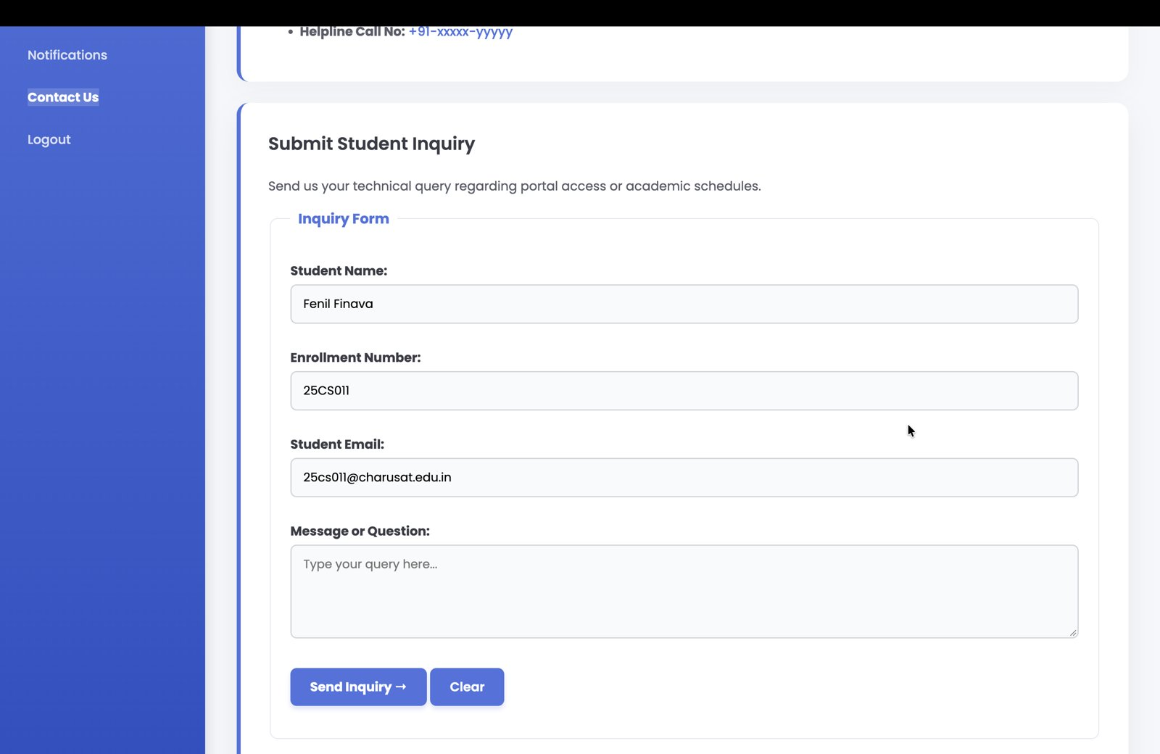
Figure 1: Student Inquiry form

2. Successful Submission
When all inputs are valid, the PHP script sanitizes the data, saves it to a CSV file and the page shows a green success message.
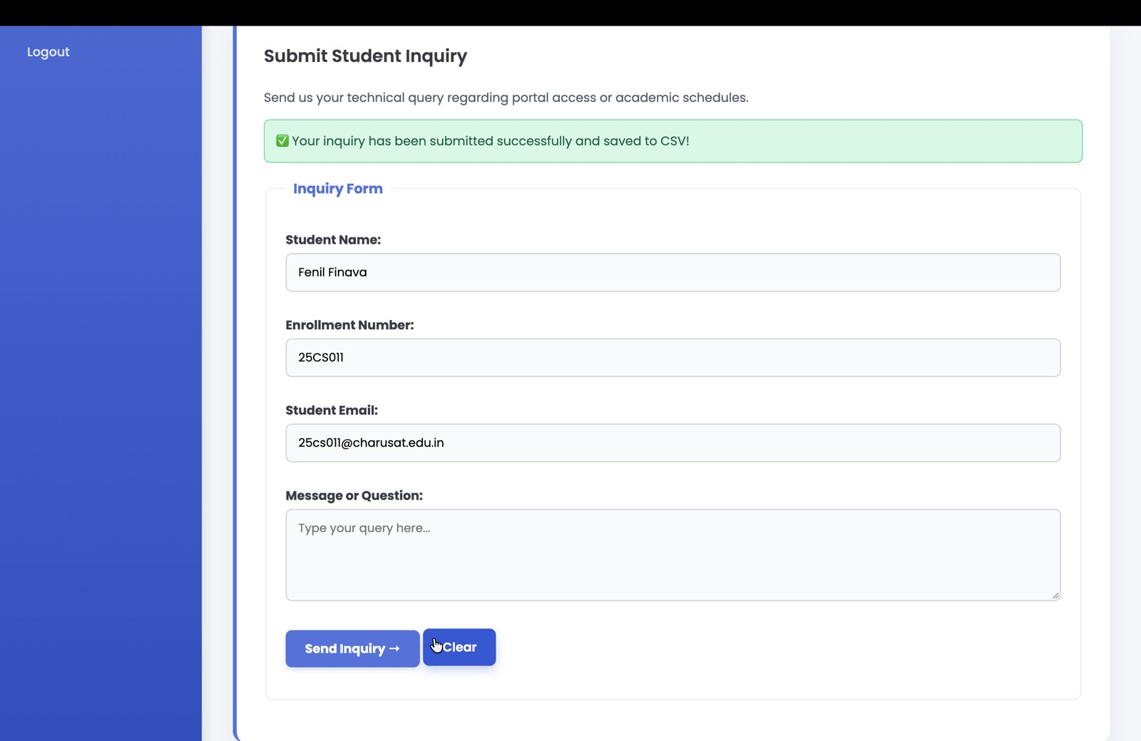
Figure 2: Success message after submitting the form
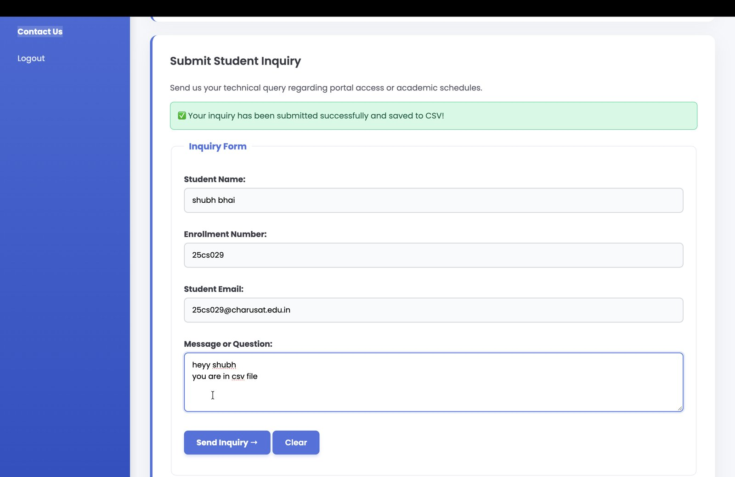
Figure 3: Another submission with a multi-line message

3. Validation / Error Message
If an input is invalid (for example, a name containing numbers or special characters), the script rejects the data and shows a red error message at the top of the form.
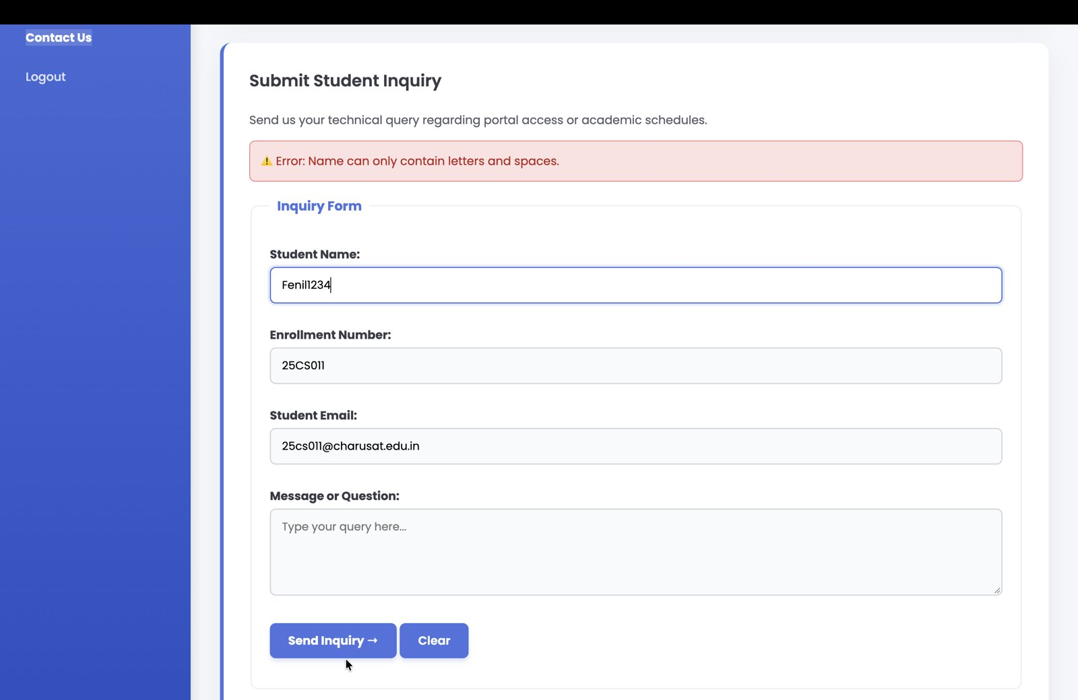
Figure 4: Error message – "Name can only contain letters and spaces."

4. CSV Stored Data
Each valid submission is appended to contacts.csv with Timestamp, Name, Enrollment, Email and Message columns. The first screenshot shows the file after the first submission and the second shows it after more submissions.
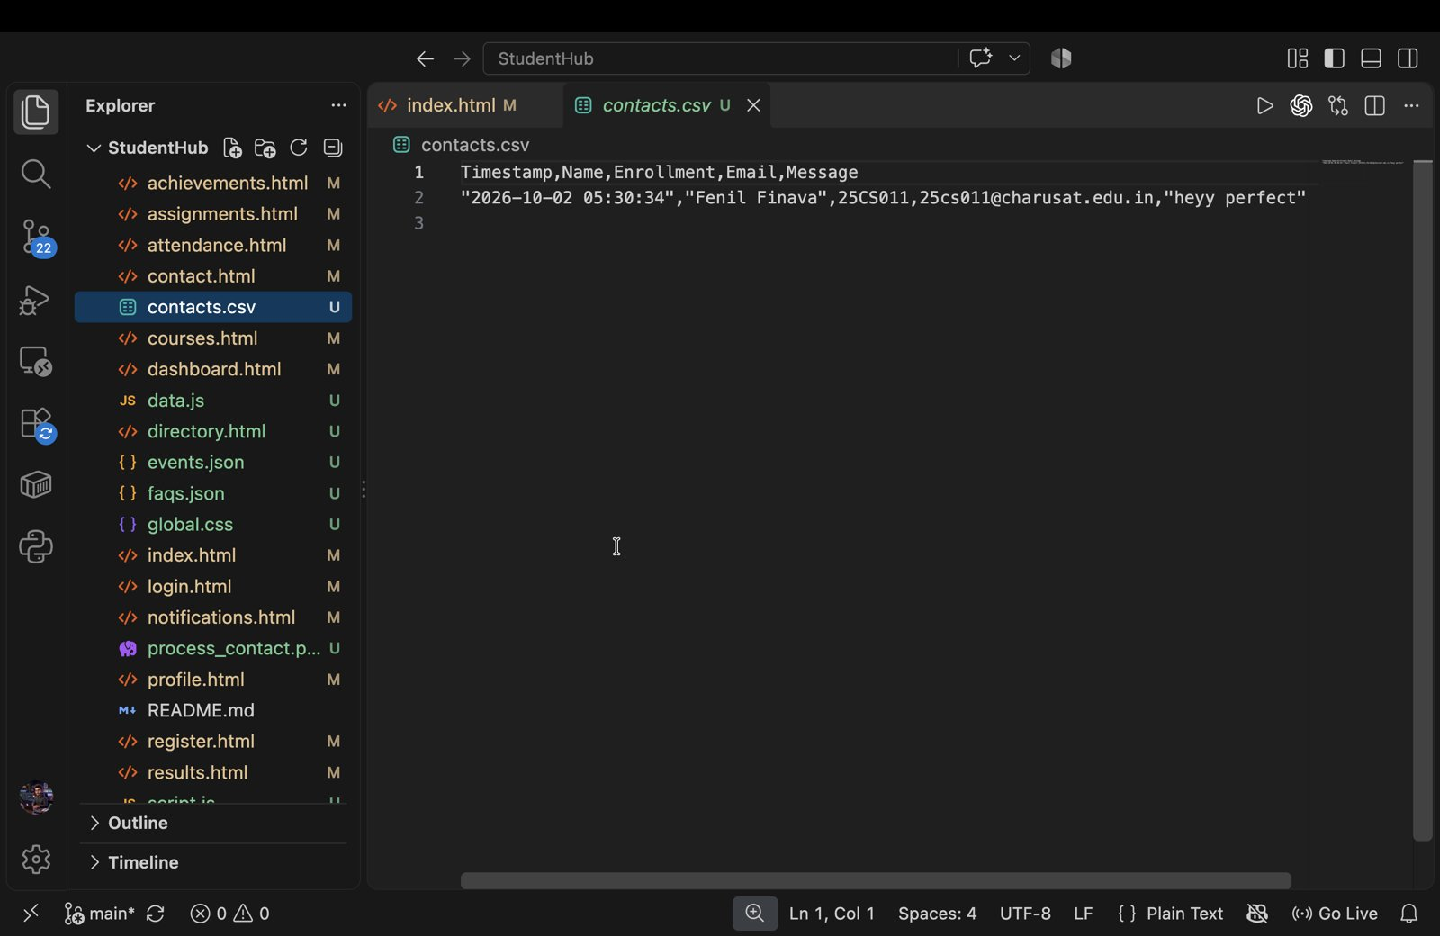
Figure 5: contacts.csv after the first submission
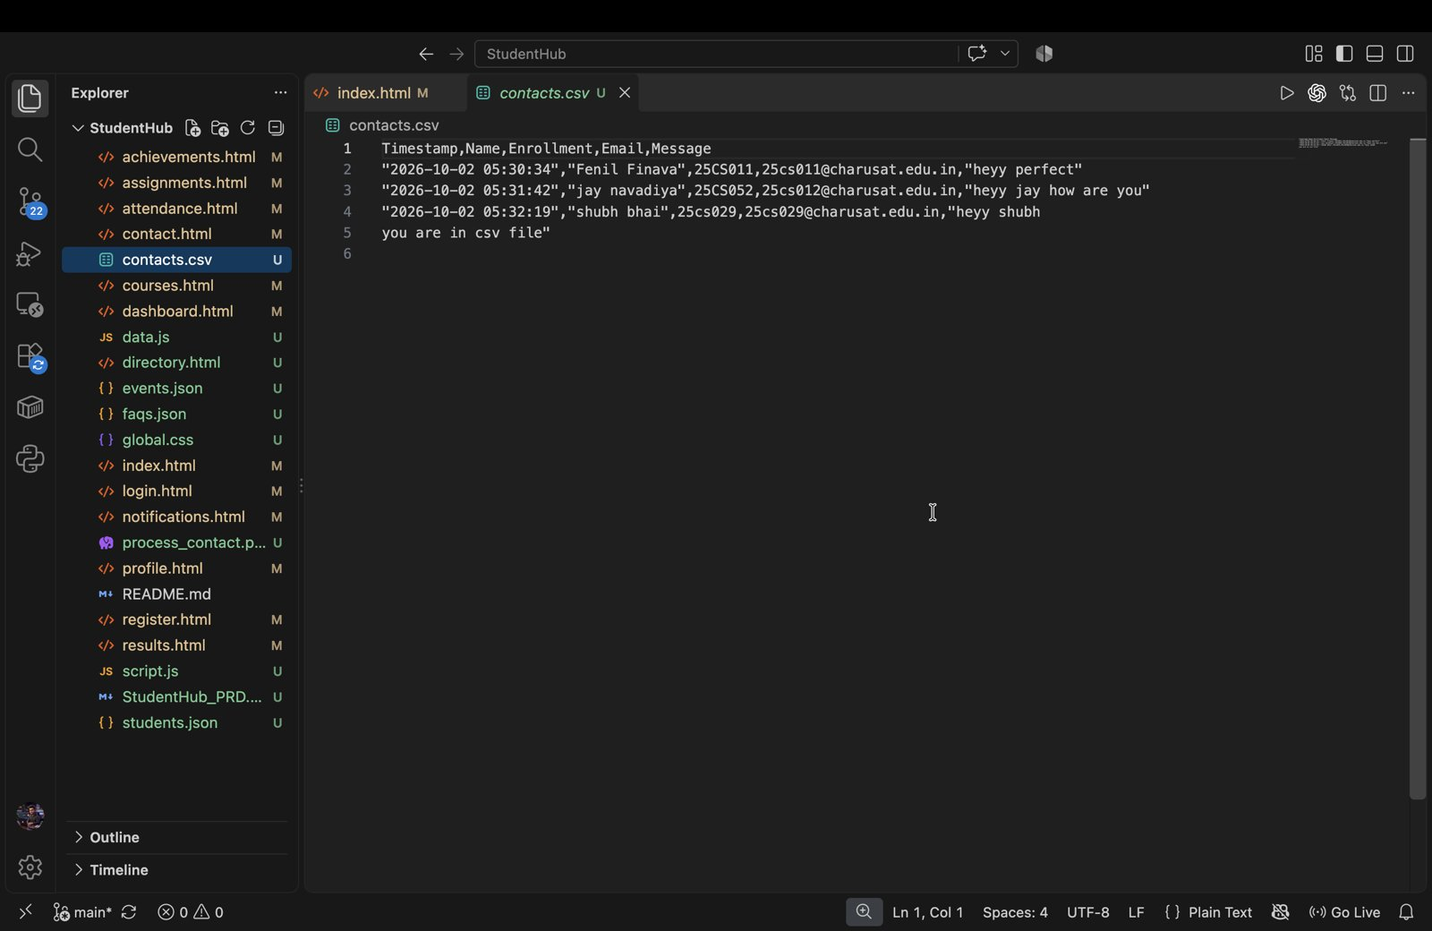
Figure 6: contacts.csv with multiple stored records

