GitHub Repo Link: https://github.com/fenilfinava/StudentHub/tree/main/Practical-3

- CSS Grid
  - Screenshot of the output
  - 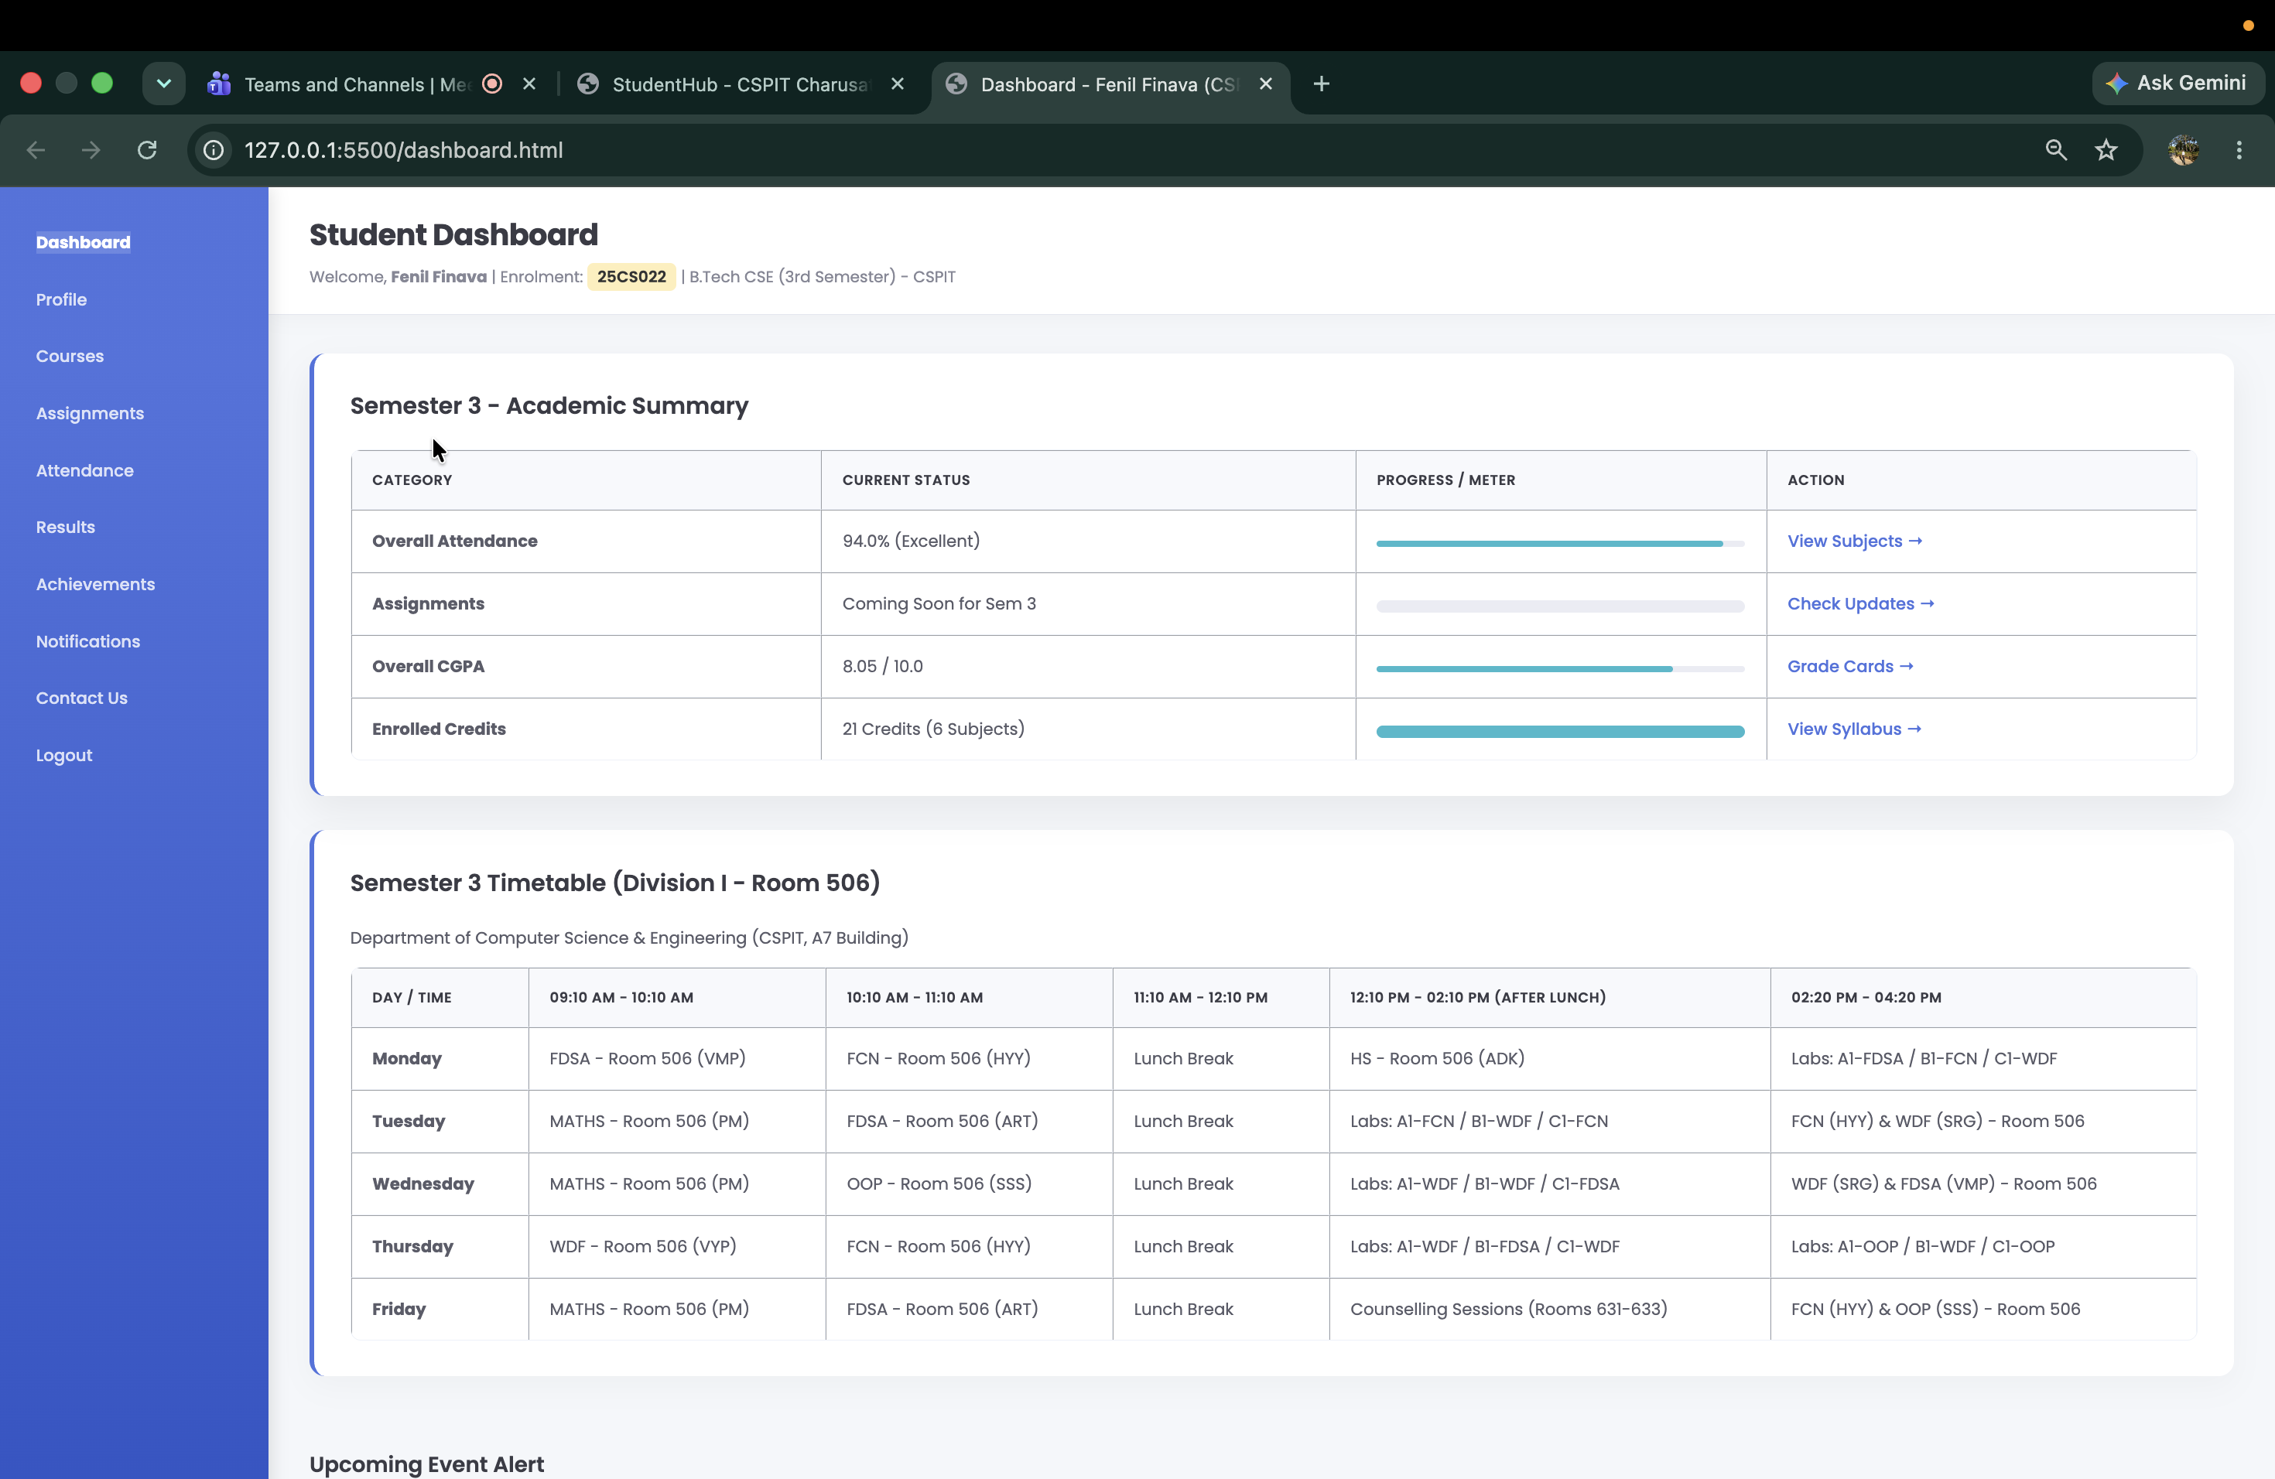

HTML & CSS code
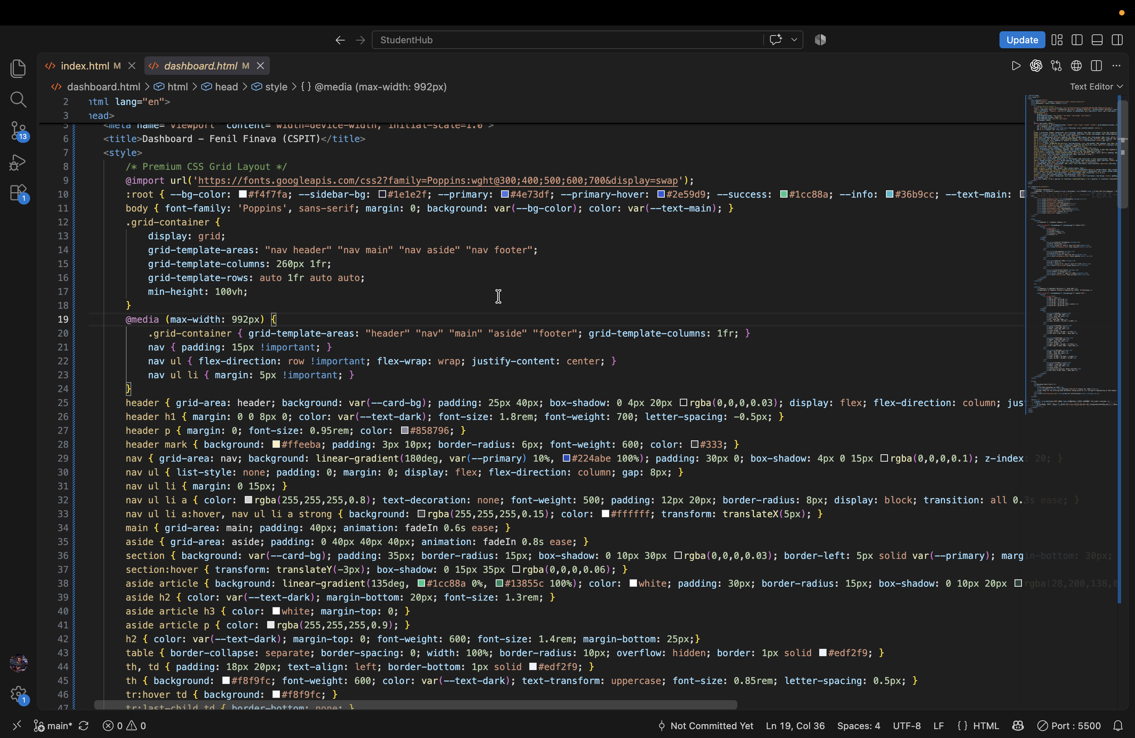

- Flexbox
  - Screenshot of the output
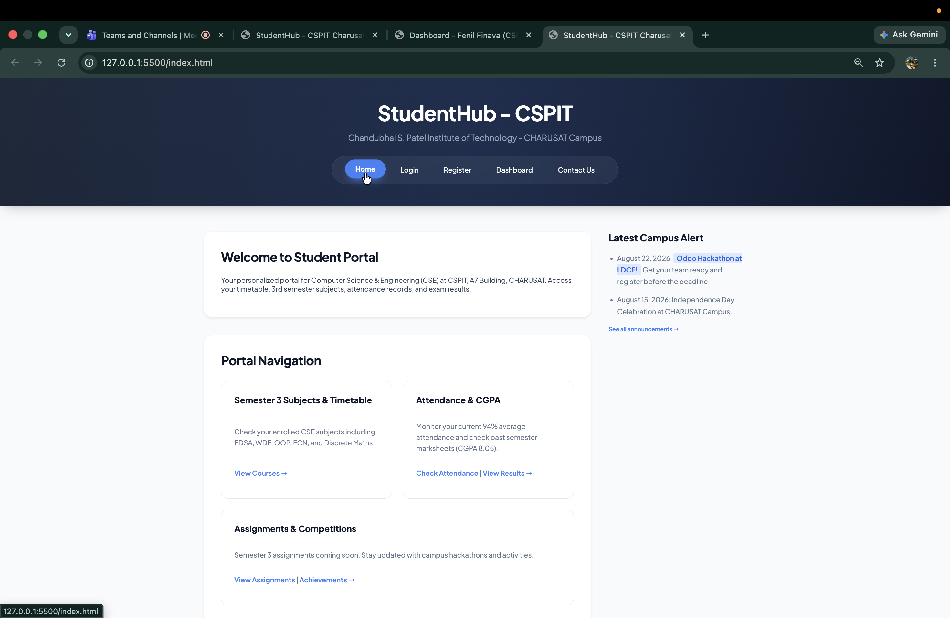

  - HTML & CSS code
  - 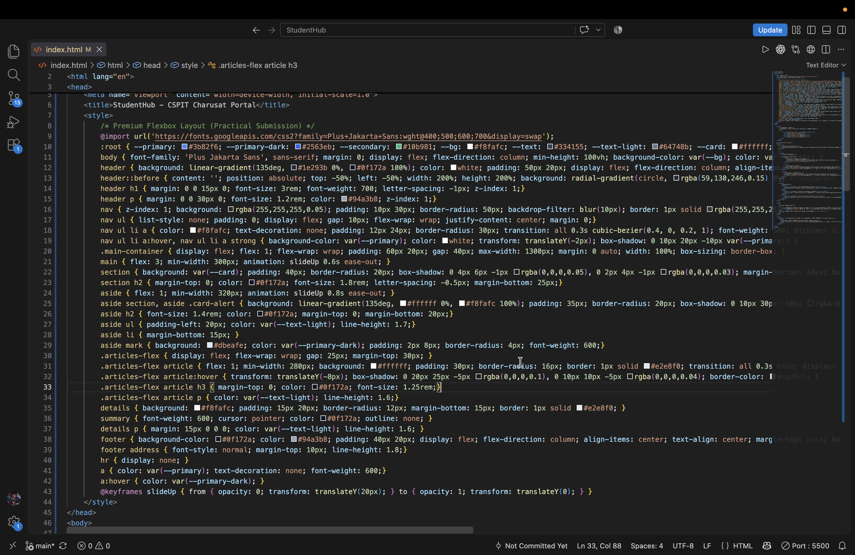
- Bootstrap/Tailwind
  - Screenshot of the responsive web page created using Bootstrap or Tailwind CSS

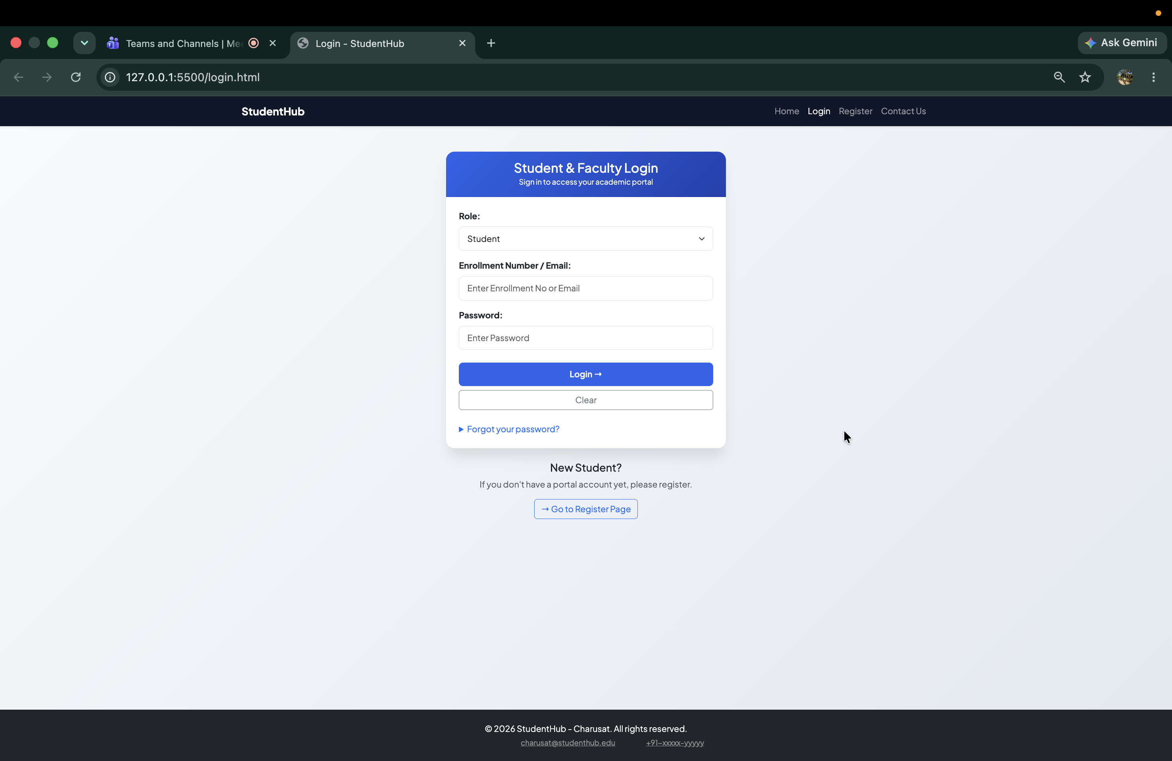
  - HTML code (and any supporting files if applicable)
  - 