 | 

Faculty of Technology and Engineering
Chandubhai S. Patel Institute of Technology (CSPIT) Department of Computer Science & Engineering
Date: 08/07/2026
Laboratory Manul

Academic Year | : | 2026-27 | Semester | : | 3rd
Course code | : | ITUE203 | Course name | : | WEB DEVELOPMENT FRAMEWORKS

Practical – 1
Project Initiation, Requirement Analysis, Sitemap,
Wireframe, and GitHub Setup
Problem Statement :
Initiate the semester-long StudentHub portal by identifying the problem
scope, user roles, key modules, navigation flow, and minimum 10 pages.
Create a sitemap, low-fidelity wireframe, project folder structure,
README file, and GitHub repository.

Objective :
To initiate the development of the StudentHub Portal by analyzing project requirements, identifying user roles and modules, designing the sitemap and low-fidelity wireframes, organizing the project folder structure, and setting up a GitHub repository for future development.

GitHub Repo Link :
https://github.com/fenilfinava/StudentHub.git

Screenshot :

- Project Folder – Complete StudentHub project folder created in VS Code.
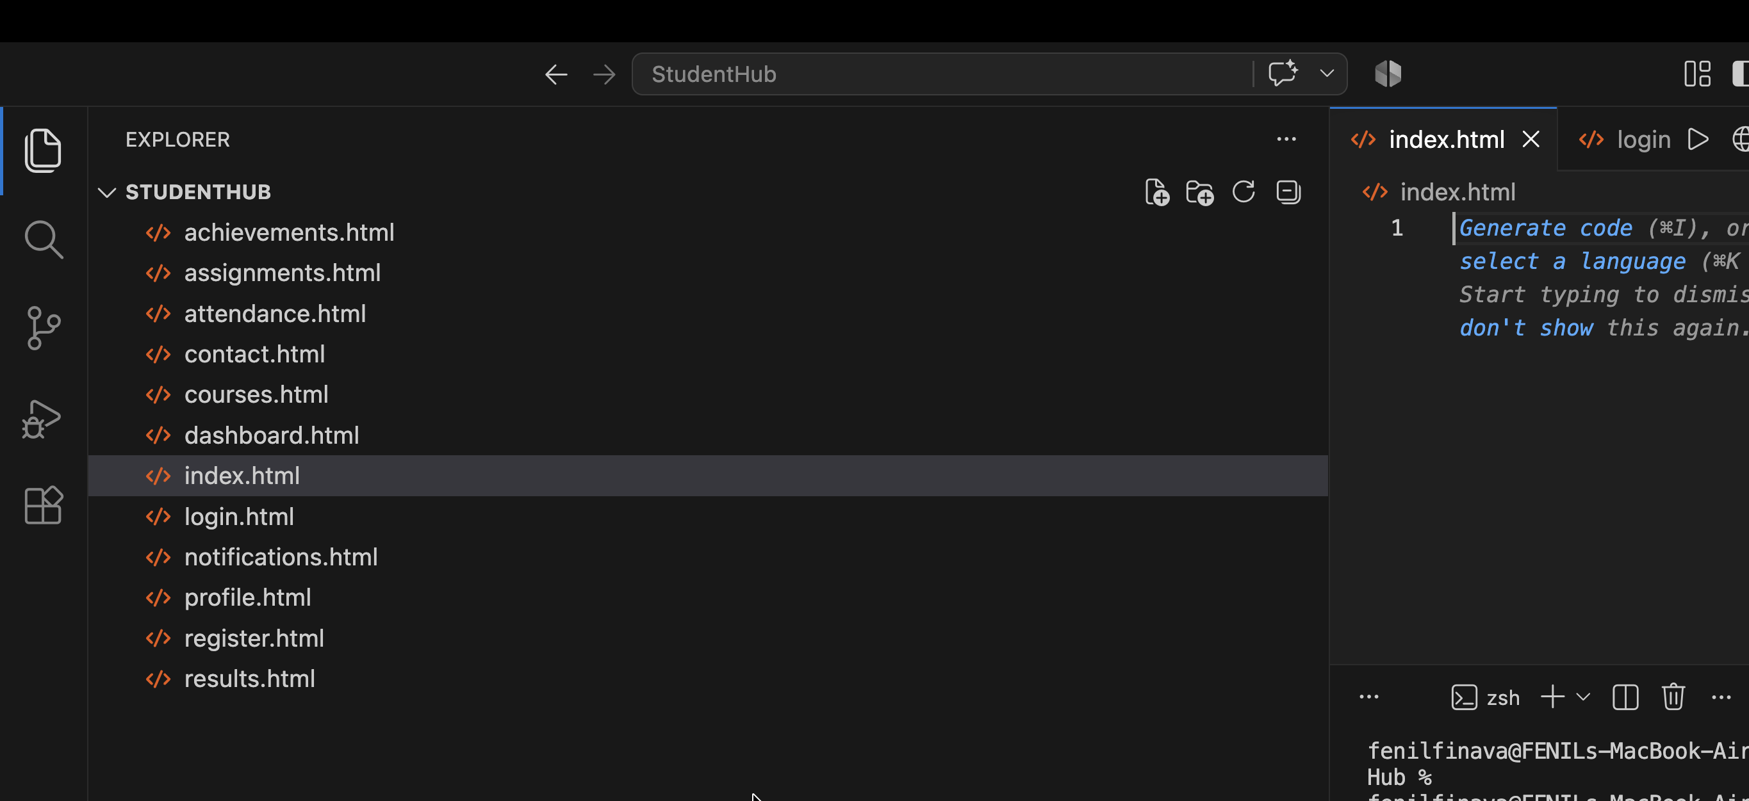

- GitHub Repository Screenshot – Screenshot showing the created GitHub repository and uploaded project.
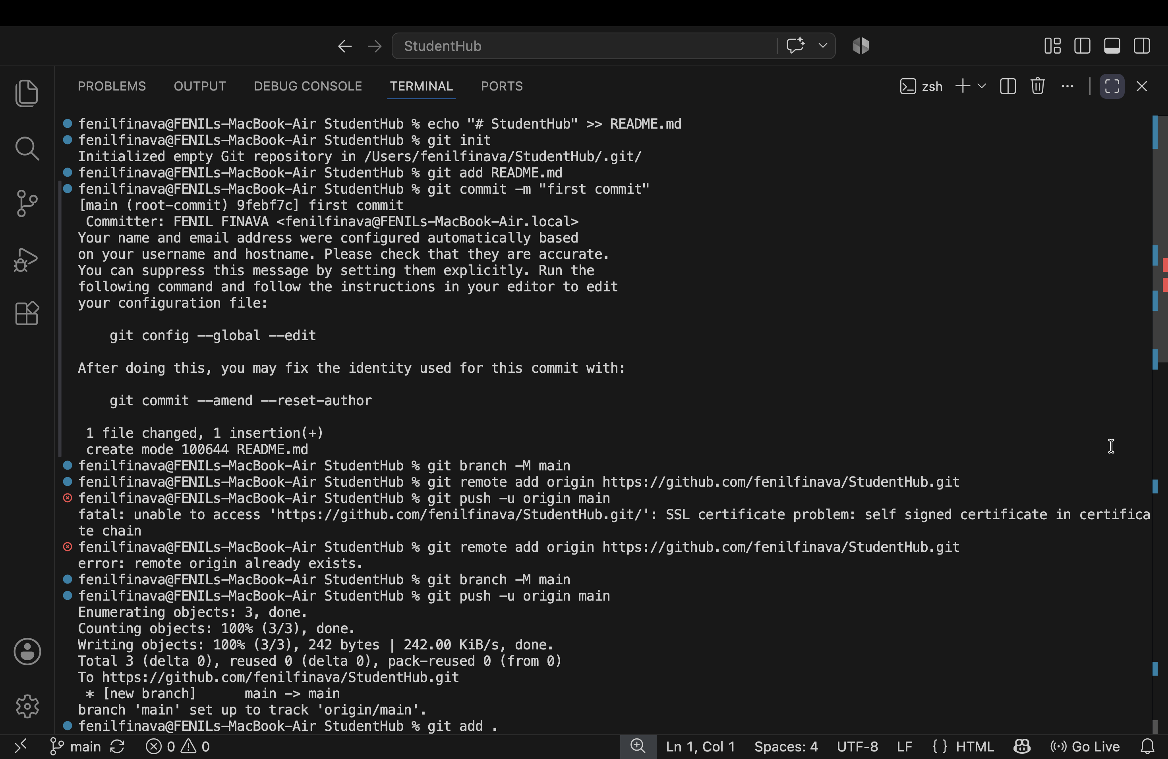

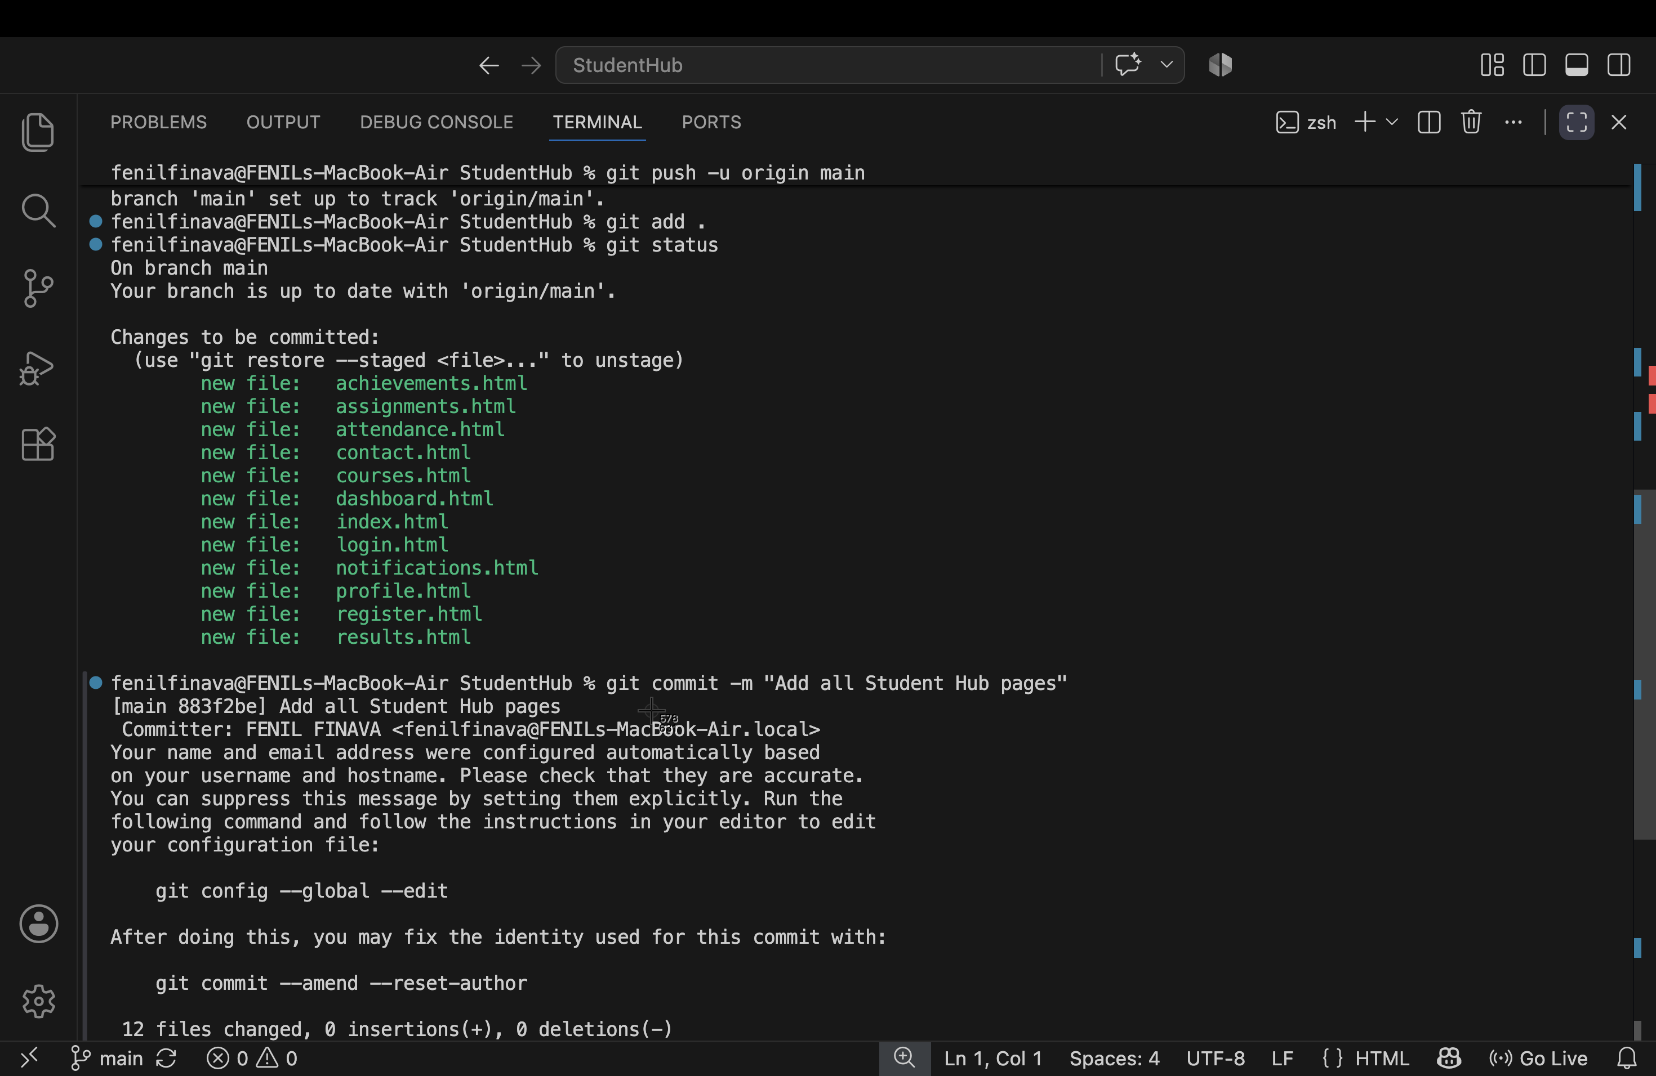

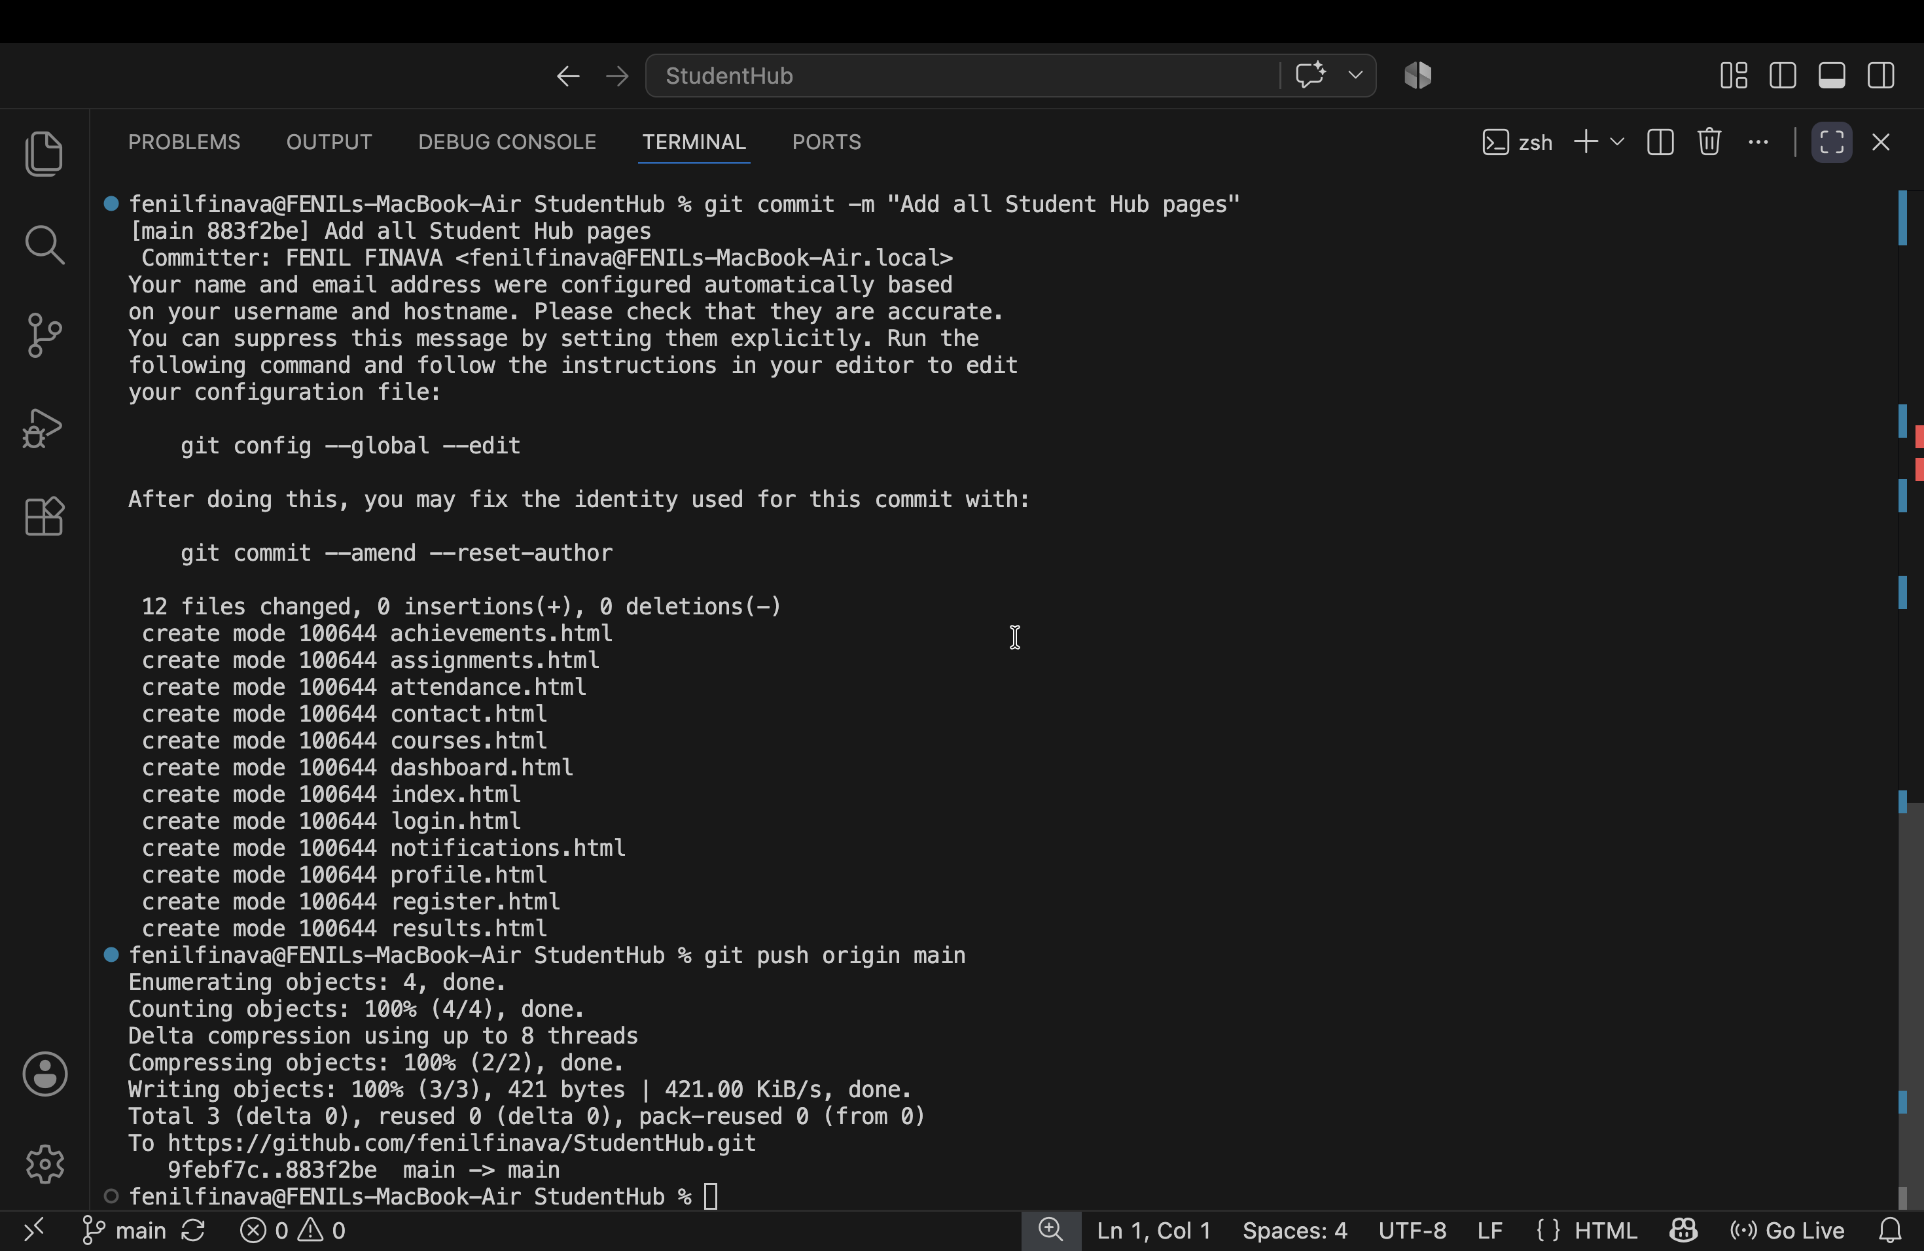

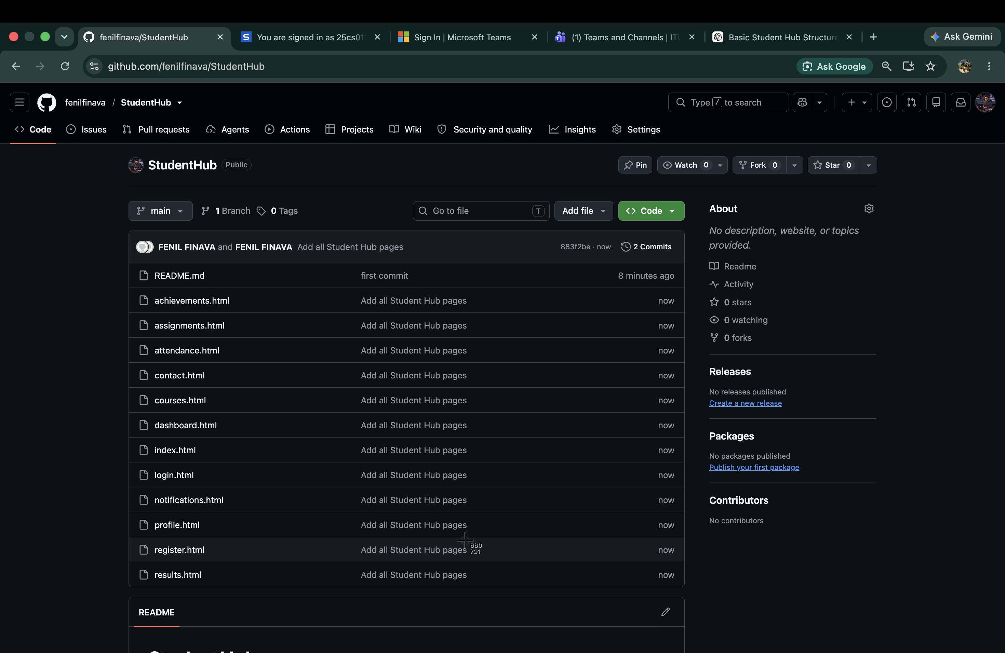

- GitHub Repository Link – Submit the link to your GitHub repository.
https://github.com/fenilfinava/StudentHub.git

- Sitemap PDF – Submit the sitemap created in Figma as a PDF file.
