 | 

Faculty of Technology and Engineering
Chandubhai S. Patel Institute of Technology (CSPIT) Department of Computer Science & Engineering
Date: 08/07/2026
Laboratory Manul

Academic Year | : | 2026-27 | Semester | : | 3rd
Course code | : | ITUE203 | Course name | : | WEB DEVELOPMENT FRAMEWORKS

Practical – 3
GitHub Repo Link : https://github.com/fenilfinava/StudentHub.git

- CSS Grid
  - Screenshot of the output
  - 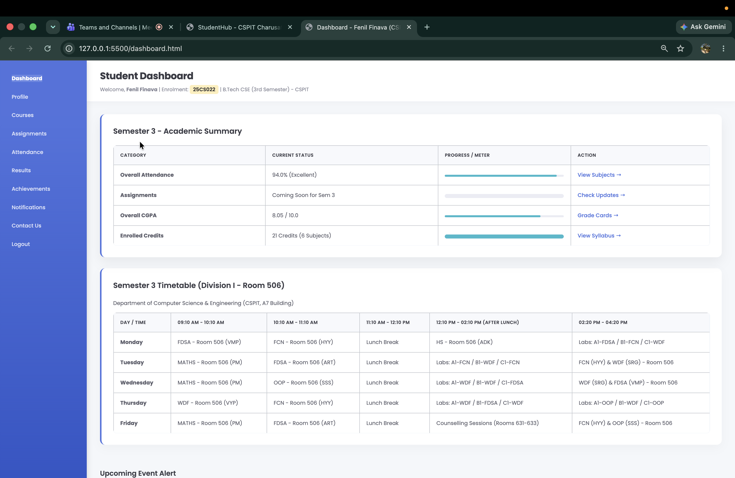

HTML & CSS code
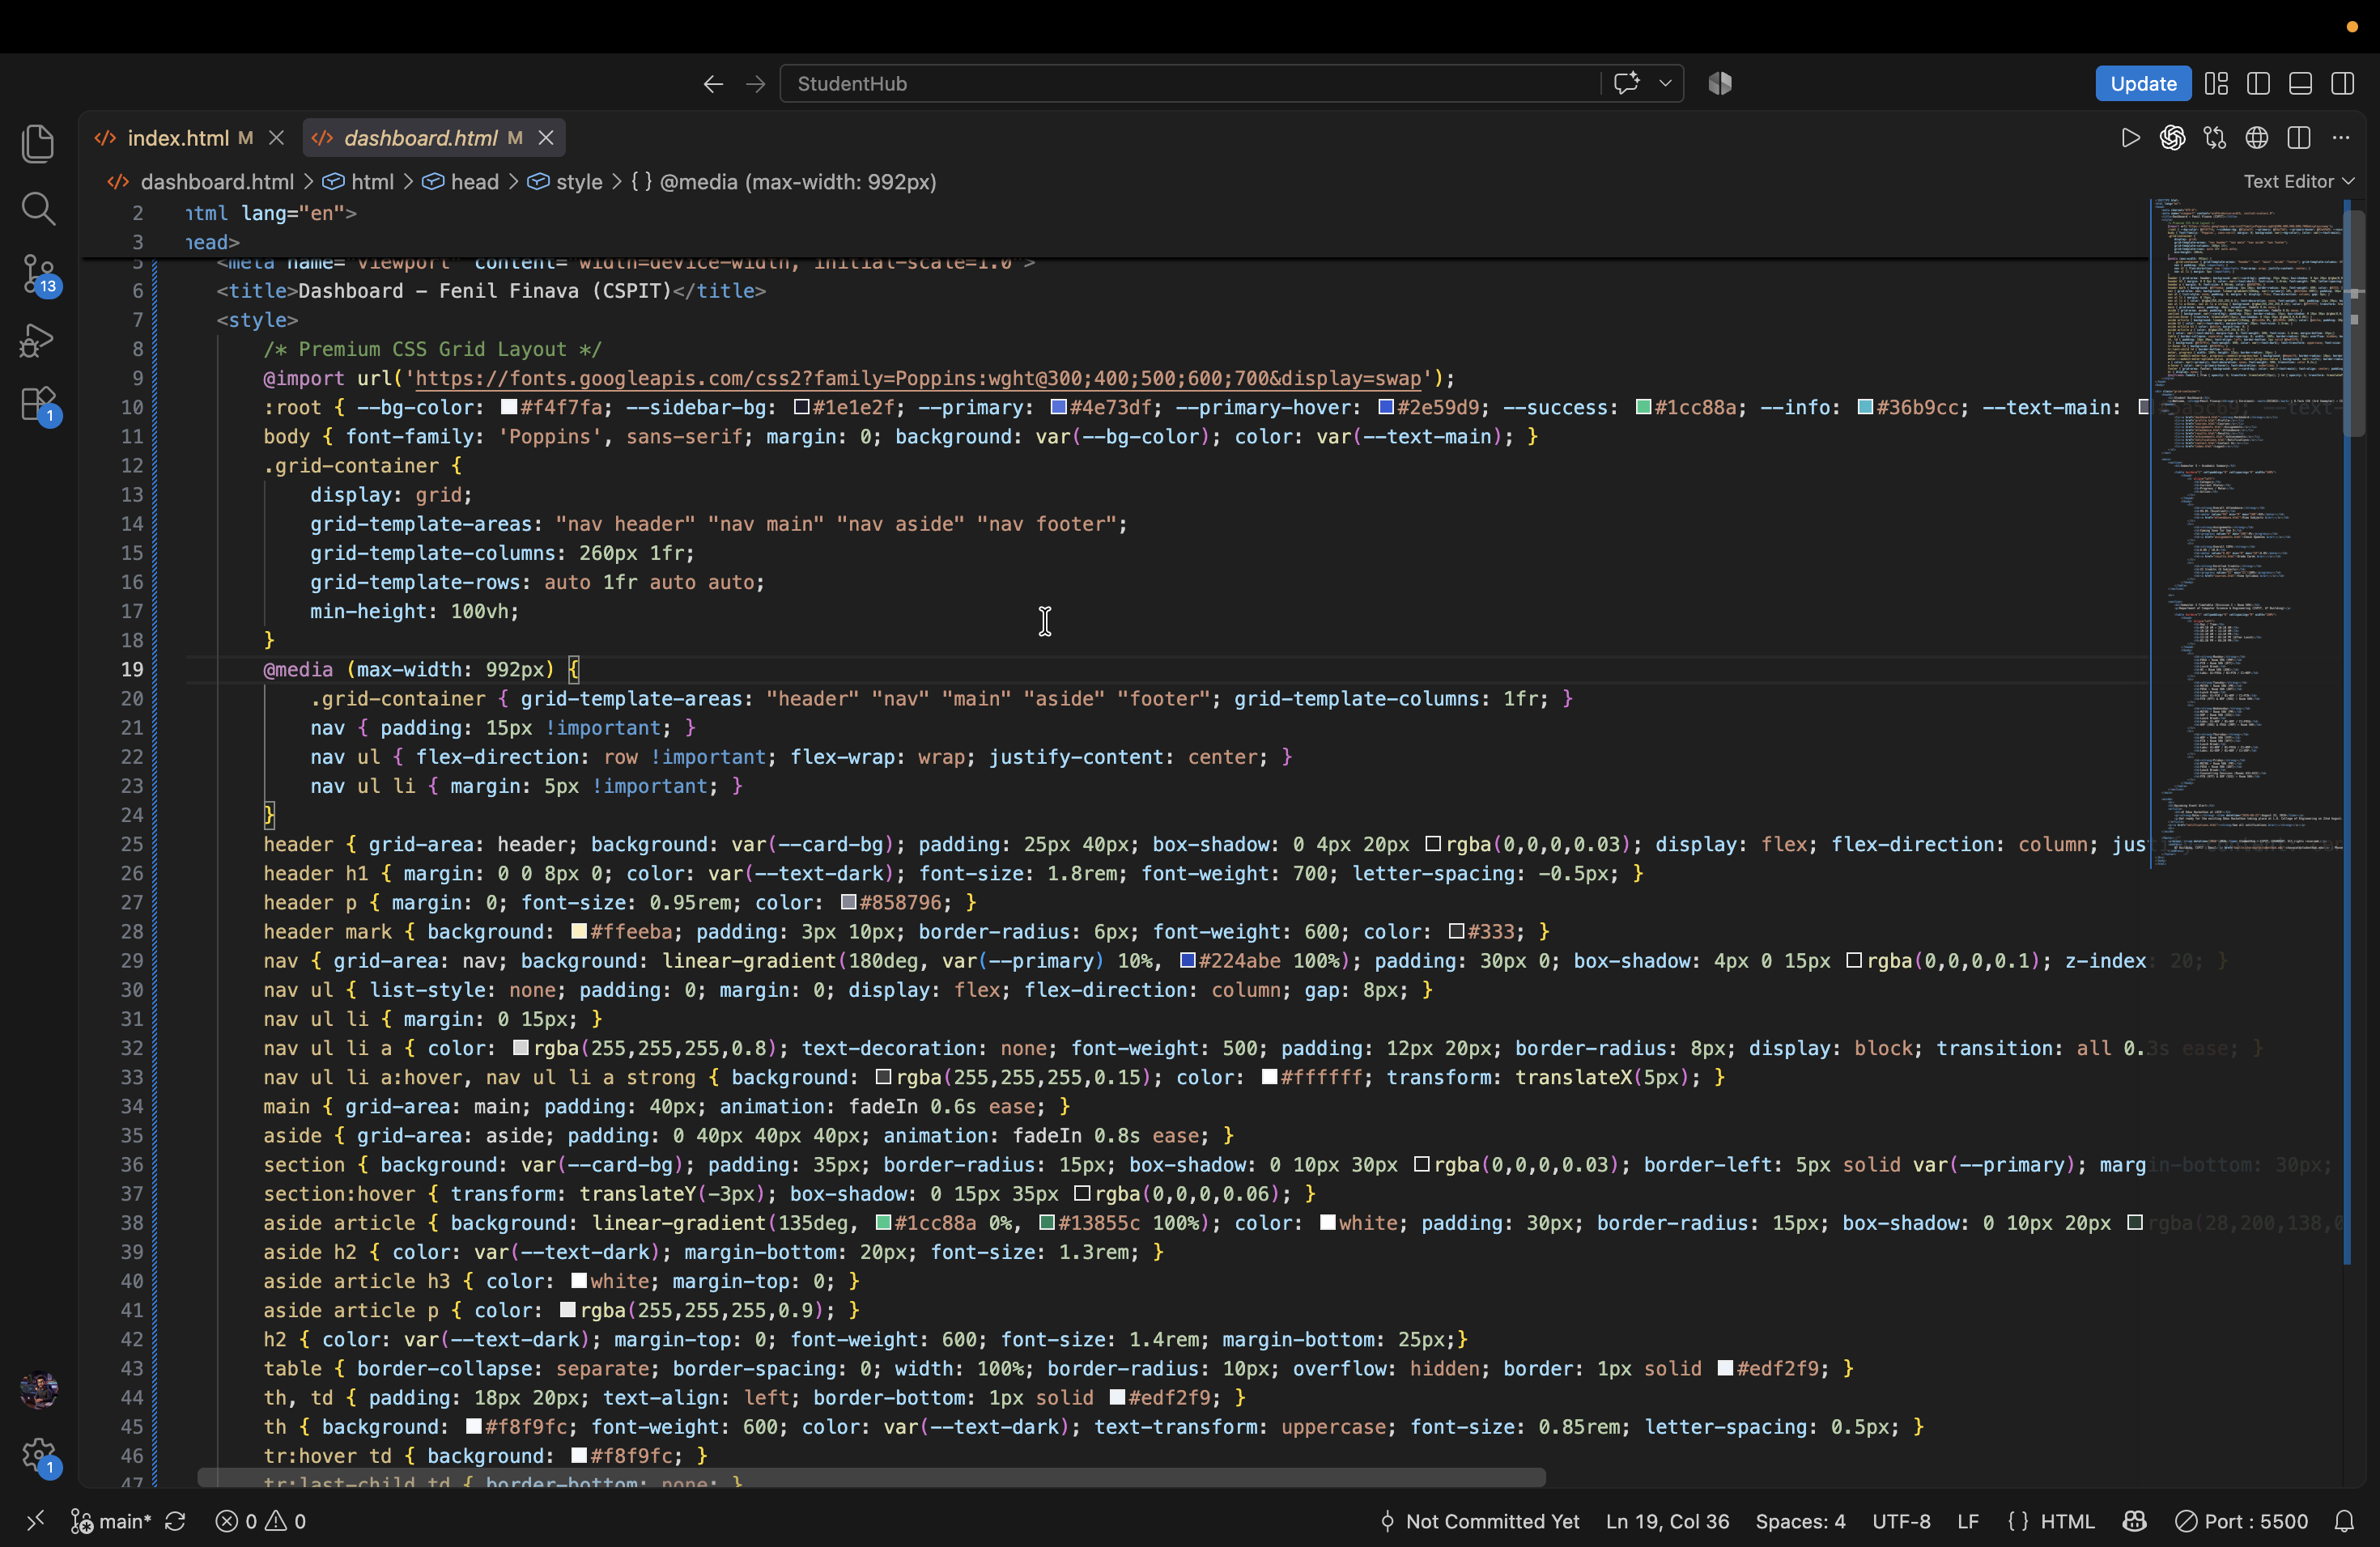

- Flexbox
  - Screenshot of the output
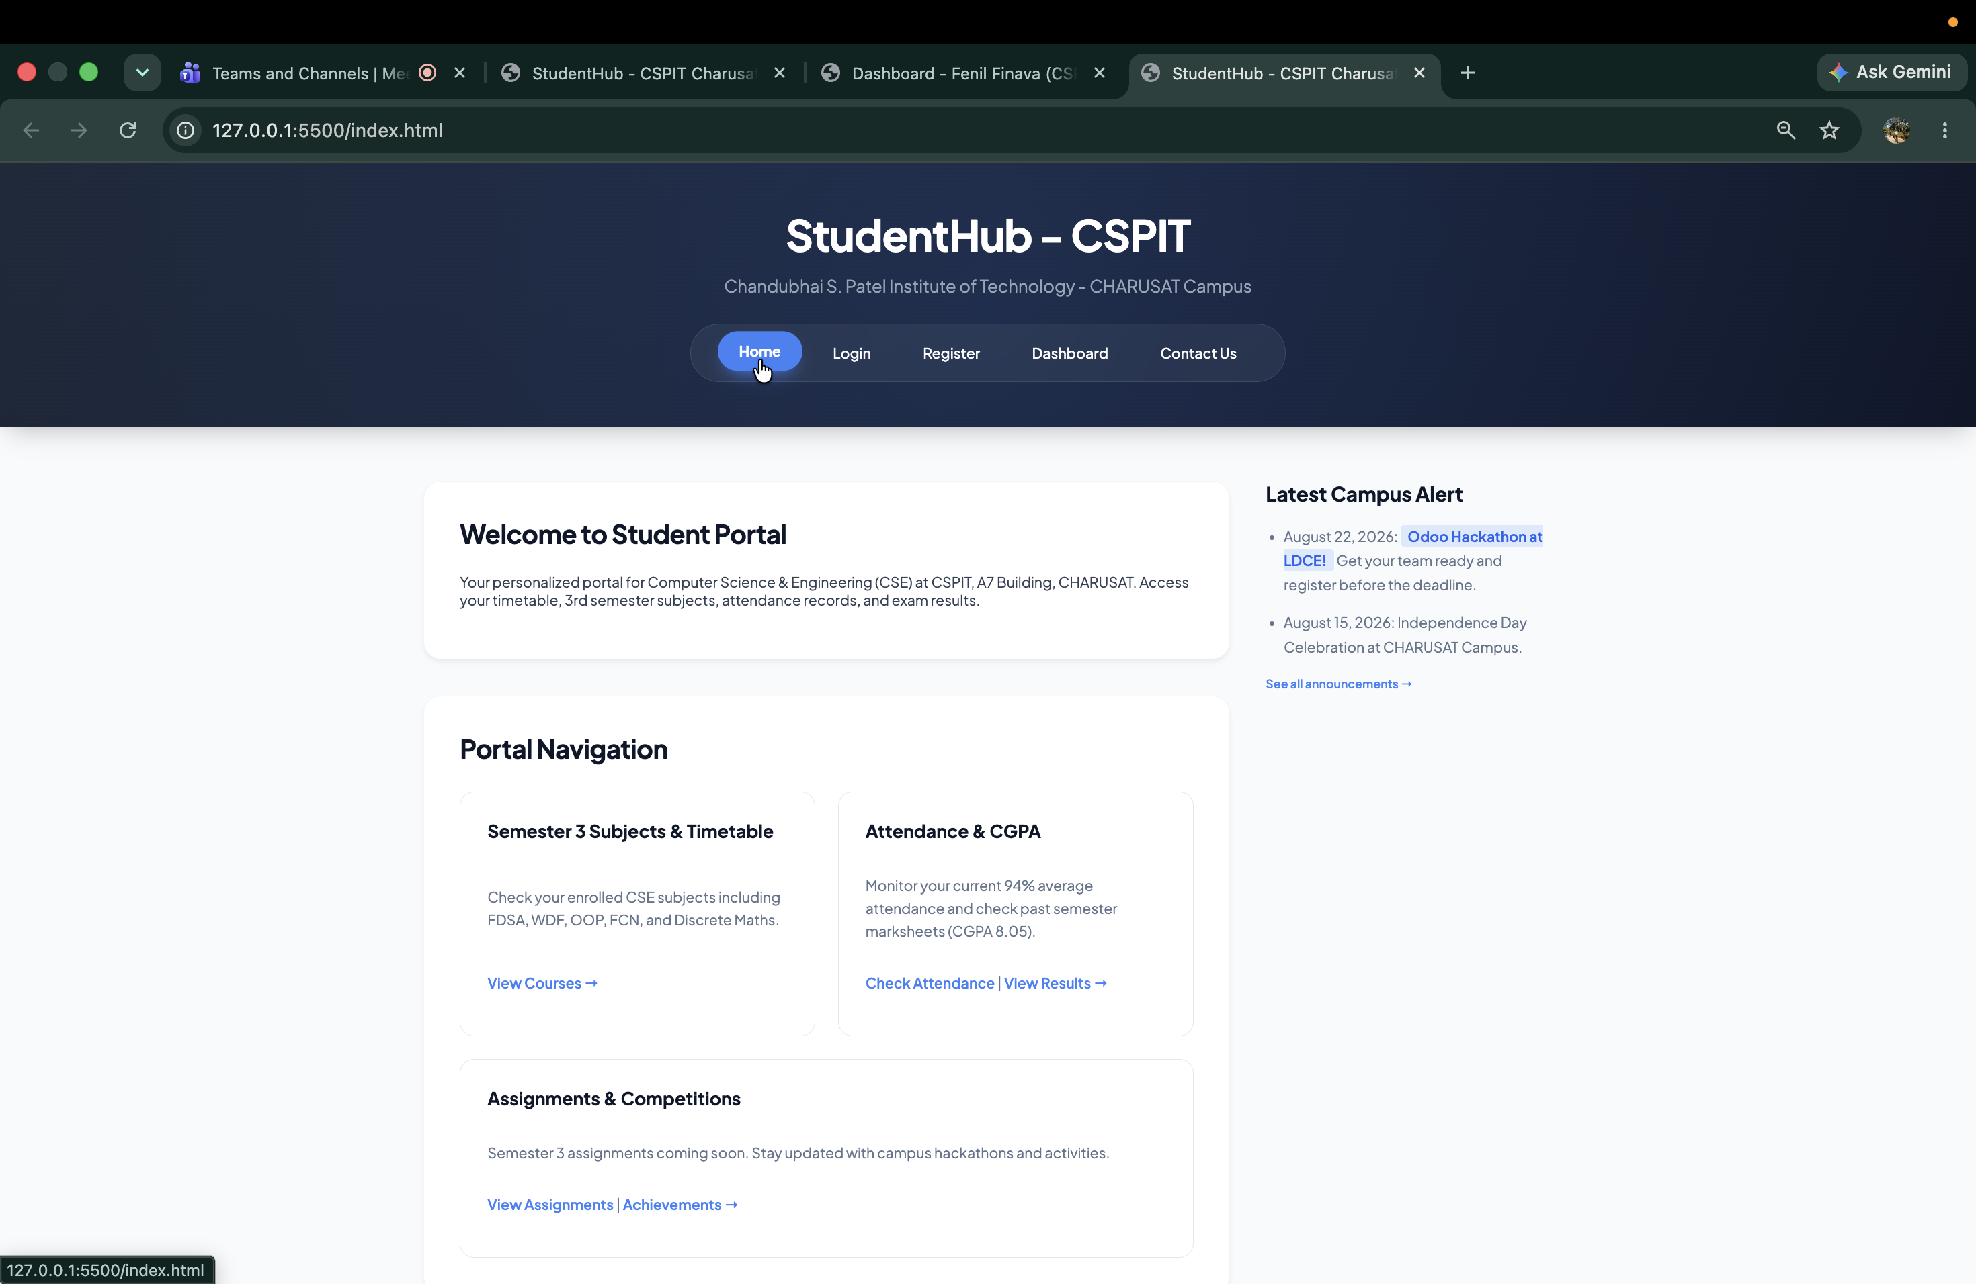

  - HTML & CSS code
  - 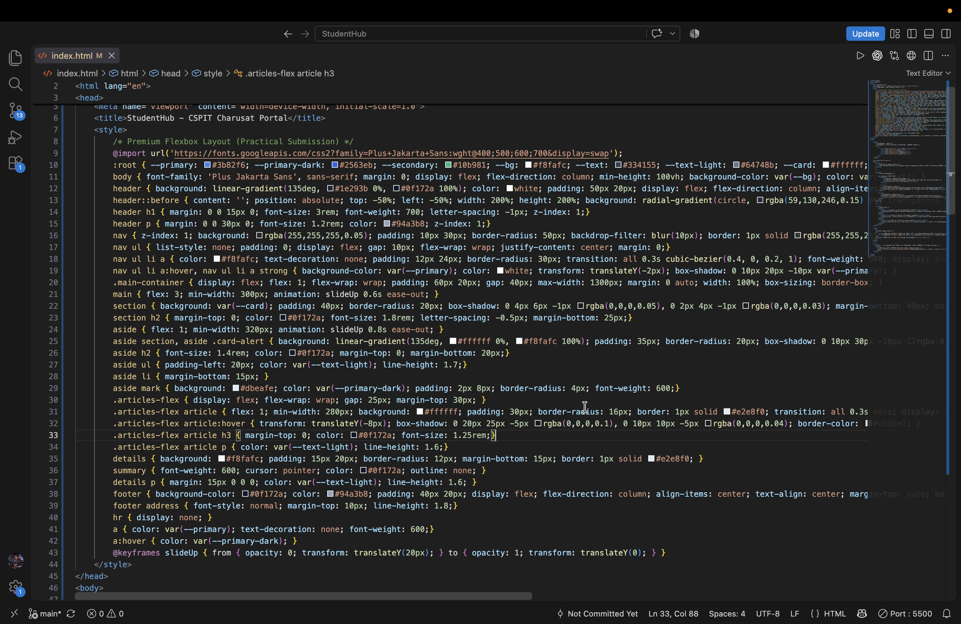
- Bootstrap/Tailwind
  - Screenshot of the responsive web page created using Bootstrap or Tailwind CSS

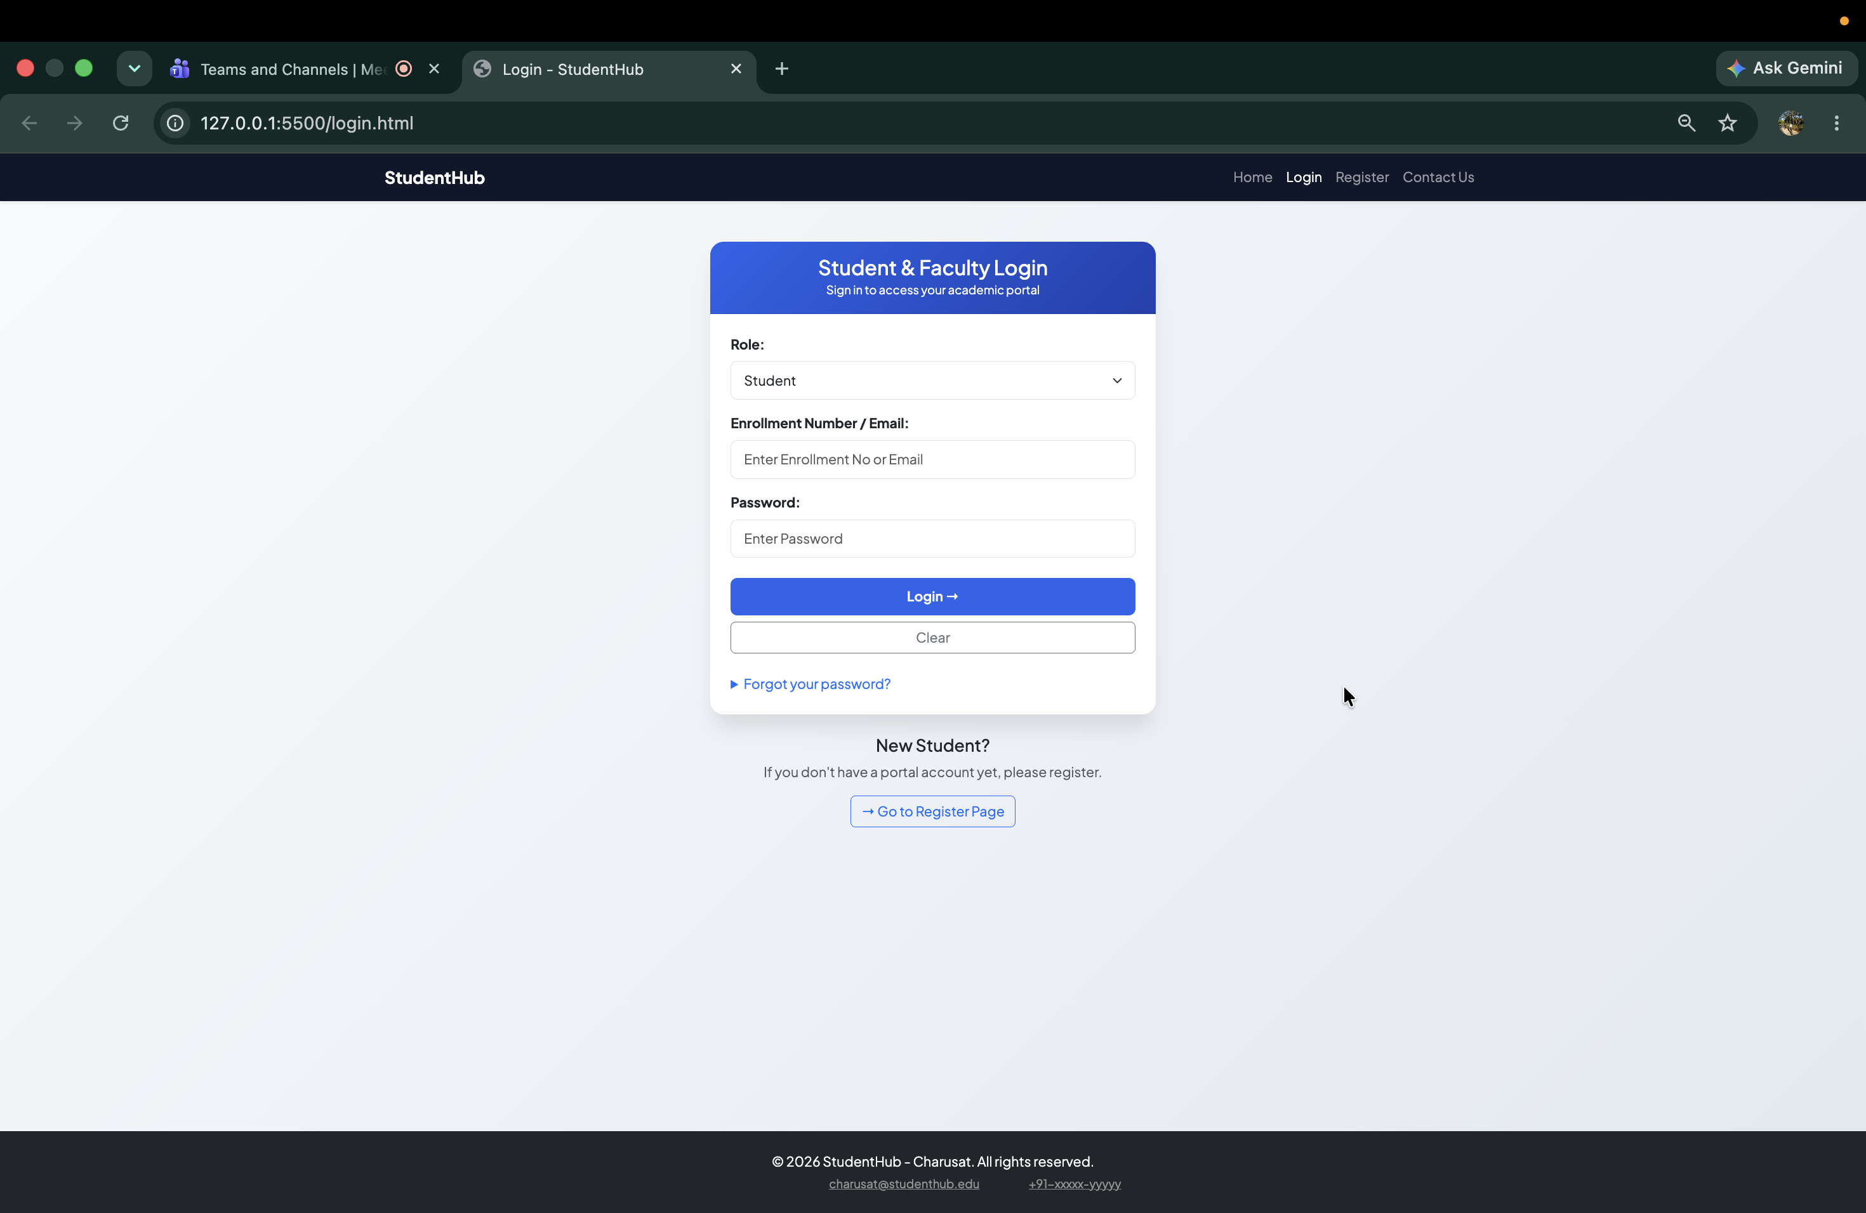
  - HTML code (and any supporting files if applicable)
  - 