 | 

Faculty of Technology and Engineering
Chandubhai S. Patel Institute of Technology (CSPIT) Department of Computer Science & Engineering
Date: 08/07/2026
Laboratory Manul

Academic Year | : | 2026-27 | Semester | : | 3rd
Course code | : | ITUE203 | Course name | : | WEB DEVELOPMENT FRAMEWORKS

Practical – 4
GitHub Repo Link : https://github.com/fenilfinava/StudentHub.git

1. Notification Banner
A green notification banner is shown at the top of the page. It is created and controlled with JavaScript DOM, and the user can dismiss it using the close (✖) button.
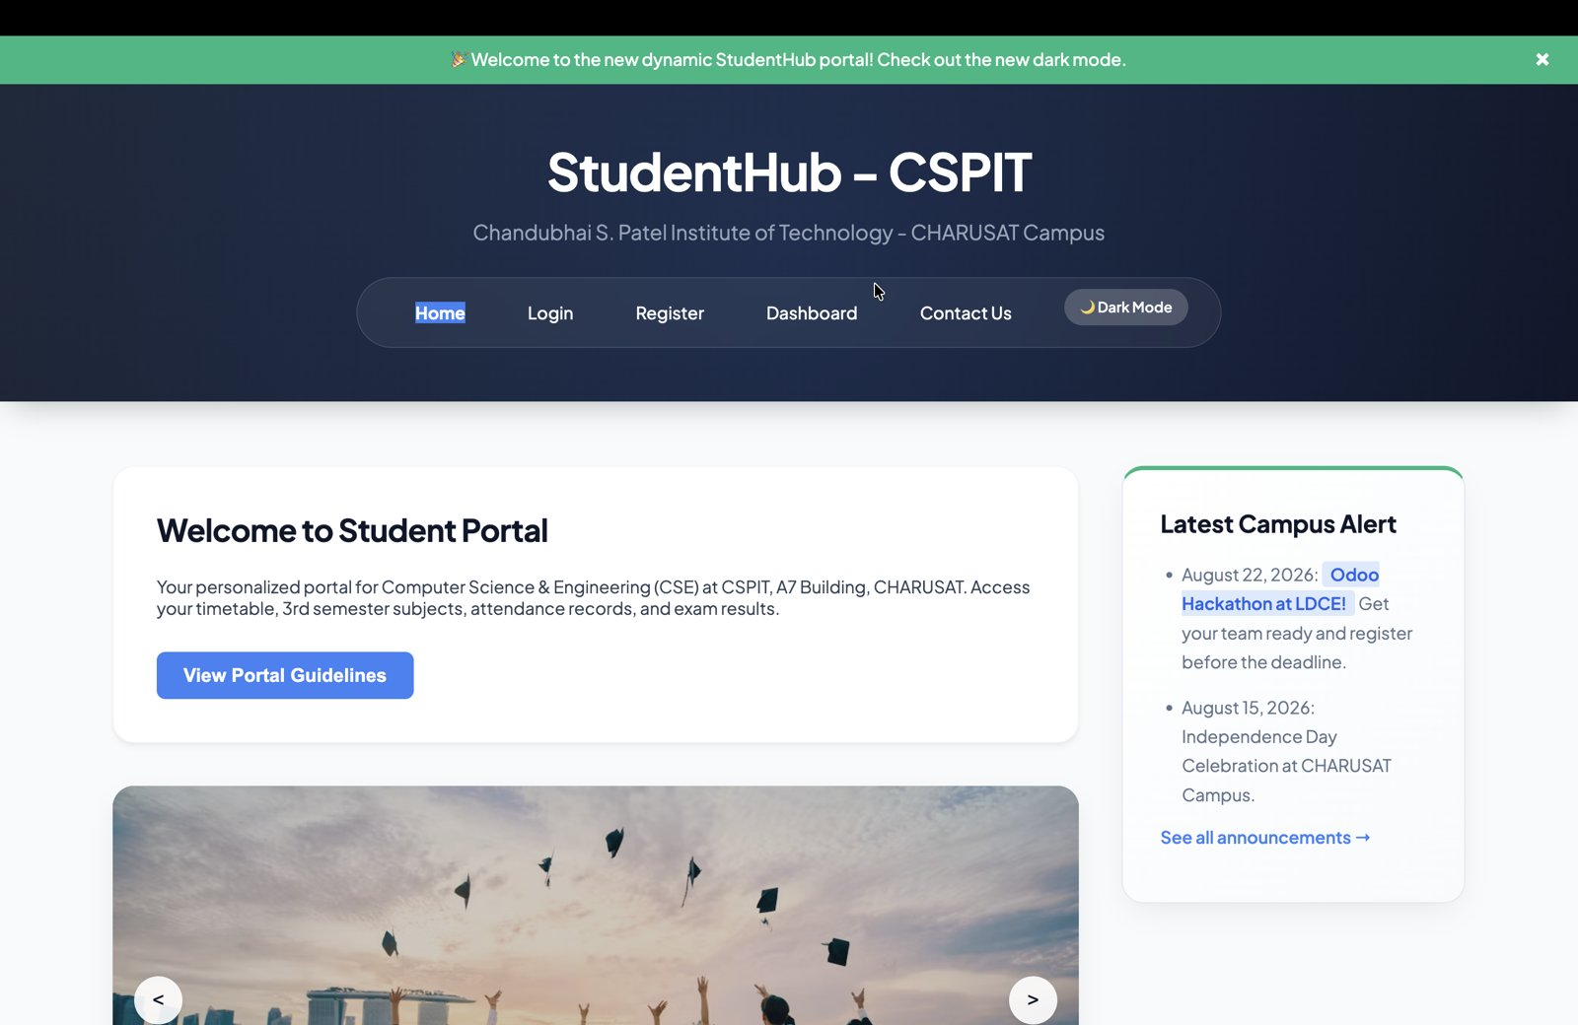
Figure 1: Notification banner with close button

2. Light / Dark Theme (localStorage)
The Dark Mode button toggles the theme by changing a class on the page. The selected theme is saved in localStorage, so it is remembered after refreshing the page.
Figure 2: Light mode (button shows "Dark Mode")
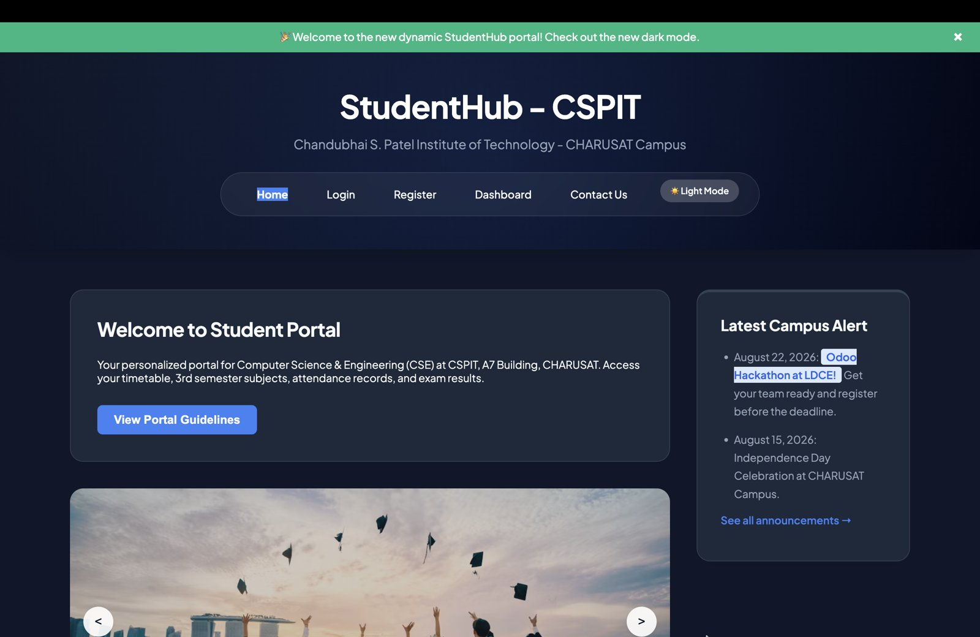
Figure 3: Dark mode (button changes to "Light Mode")

3. Modal Popup
Clicking "View Portal Guidelines" opens a modal popup with a blurred background. It can be closed with the ✖ button or the "I Understand" button.
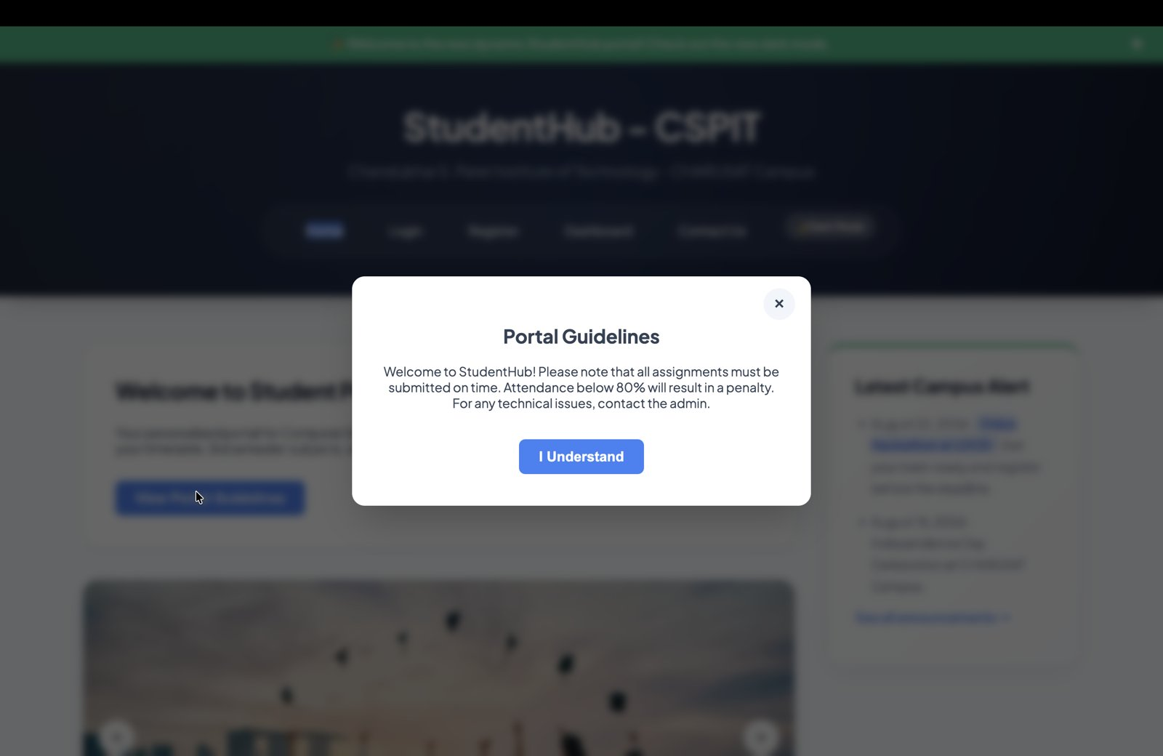
Figure 4: Portal Guidelines modal popup

4. Image / Content Slider
The slider shows images with captions. The user can move between slides using the previous (<) and next (>) buttons.
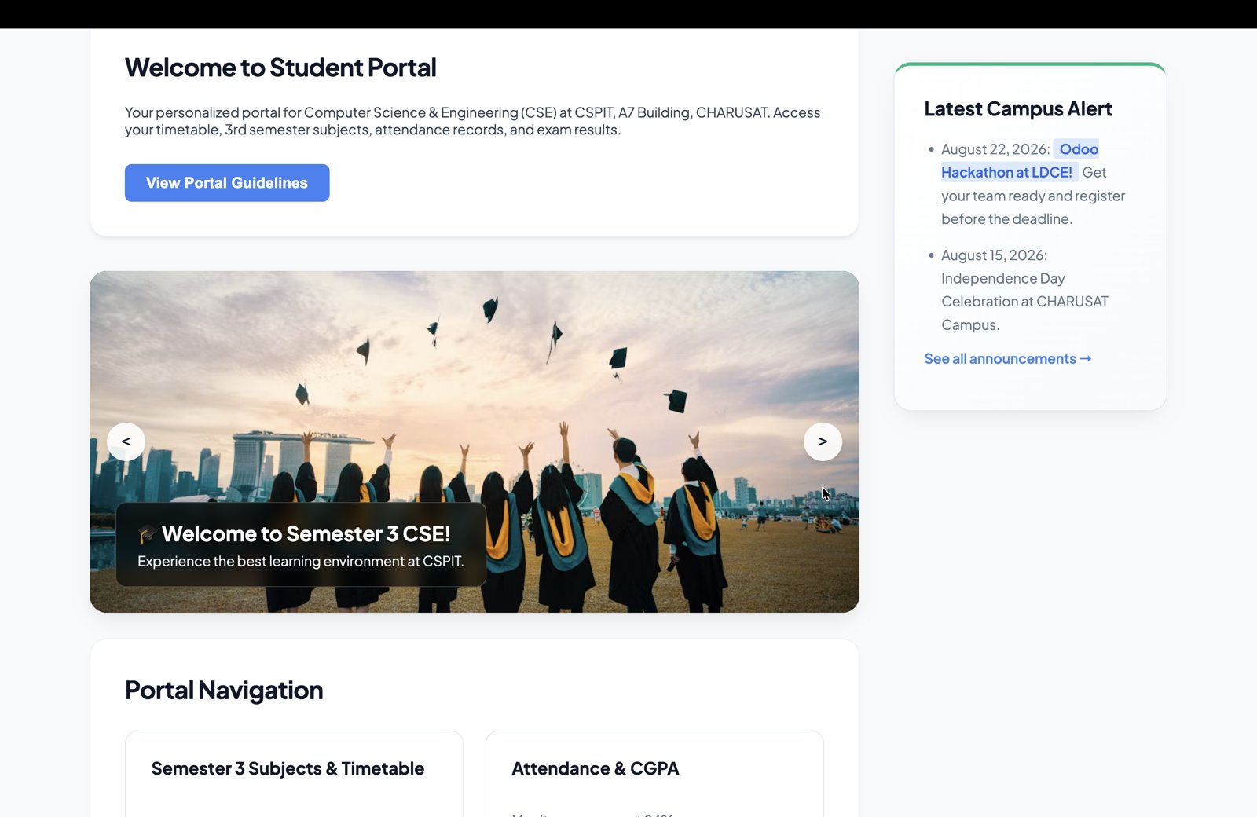
Figure 5: Slide 1 – Welcome to Semester 3 CSE!
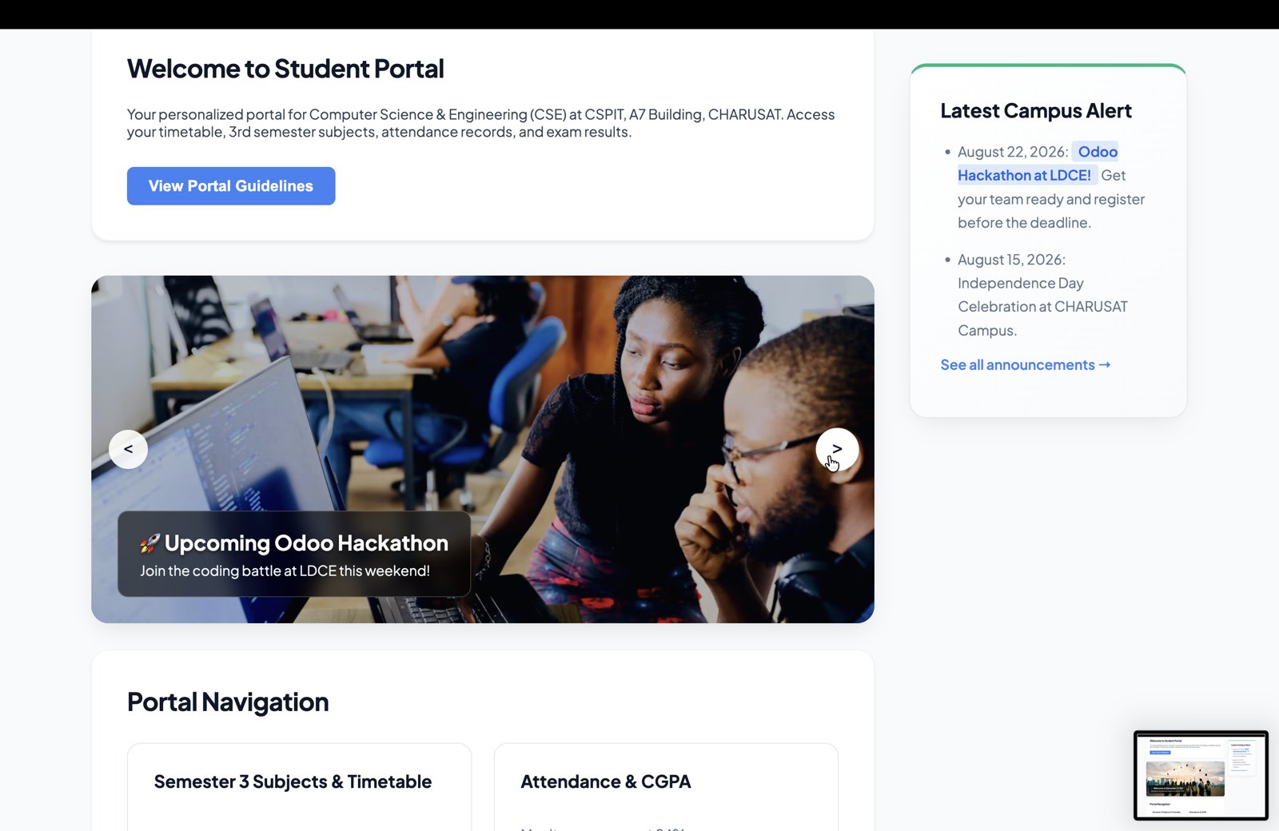
Figure 6: Slide 2 – Upcoming Odoo Hackathon
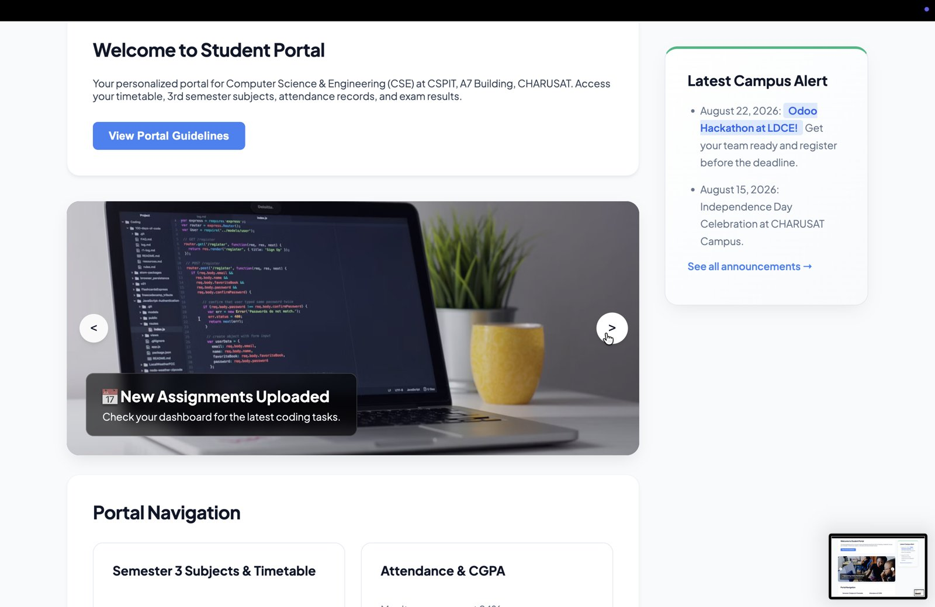
Figure 7: Slide 3 – New Assignments Uploaded

5. FAQ Open / Close (Accordion)
Each FAQ question toggles its answer on click. The icon changes between + (closed) and × (open), and only one answer is open at a time.
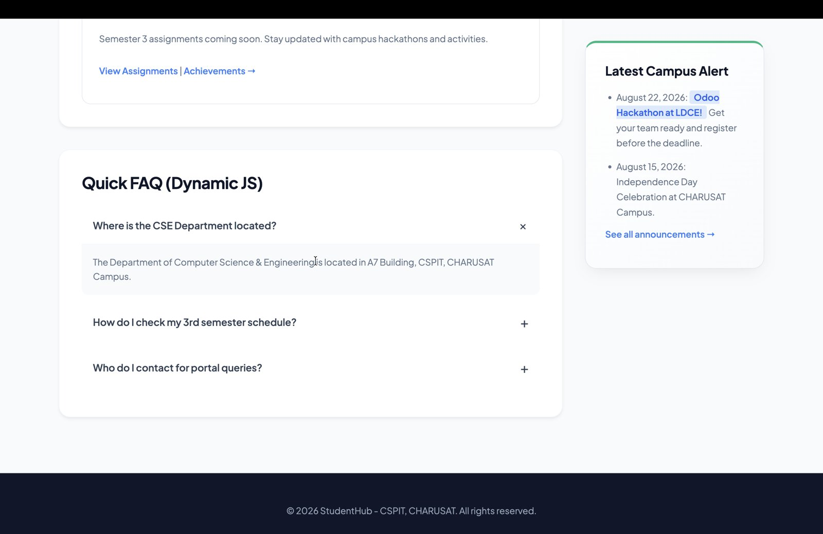
Figure 8: FAQ 1 opened
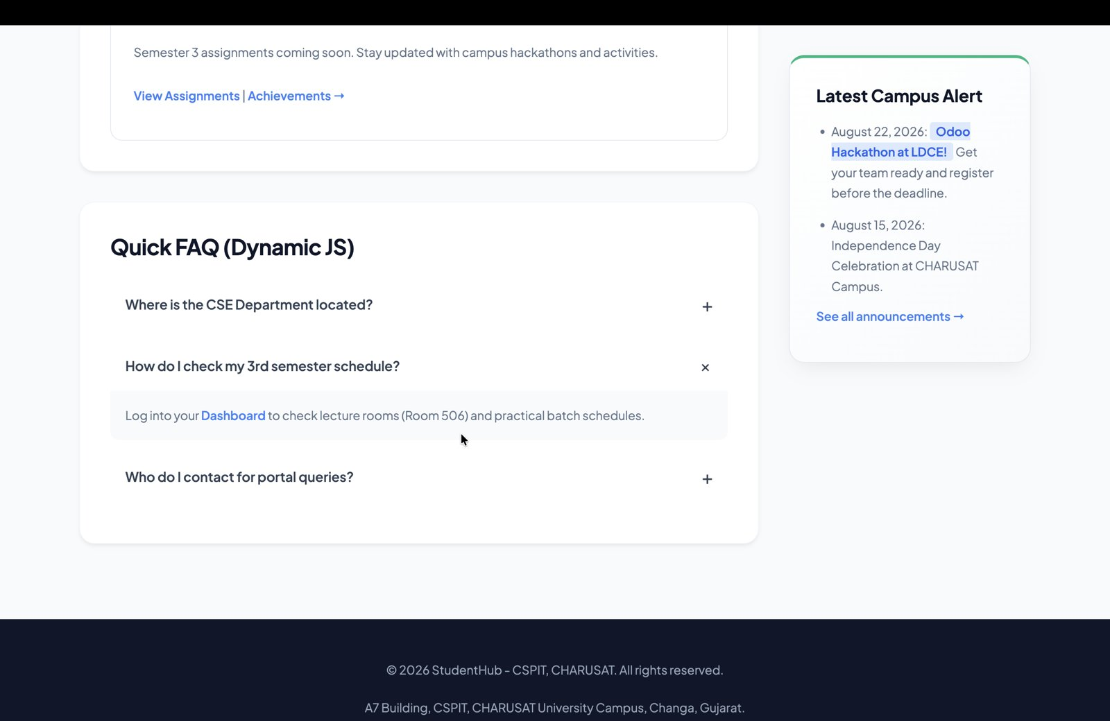
Figure 9: FAQ 2 opened (FAQ 1 closed)
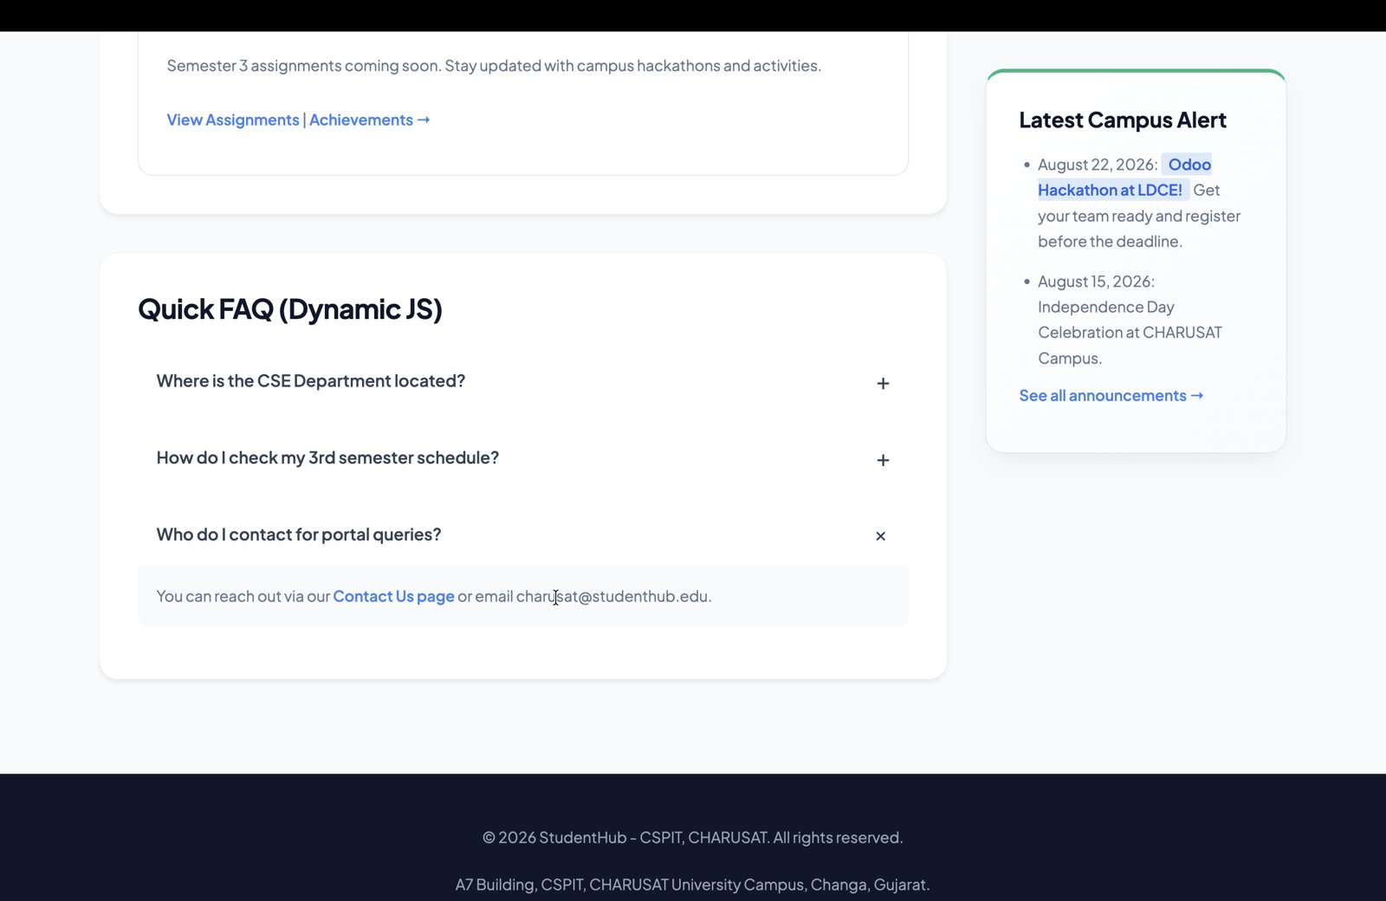
Figure 10: FAQ 3 opened (FAQ 2 closed)

6. Hamburger Menu
On small screens, the navigation links collapse into a hamburger (☰) menu that opens and closes on click.
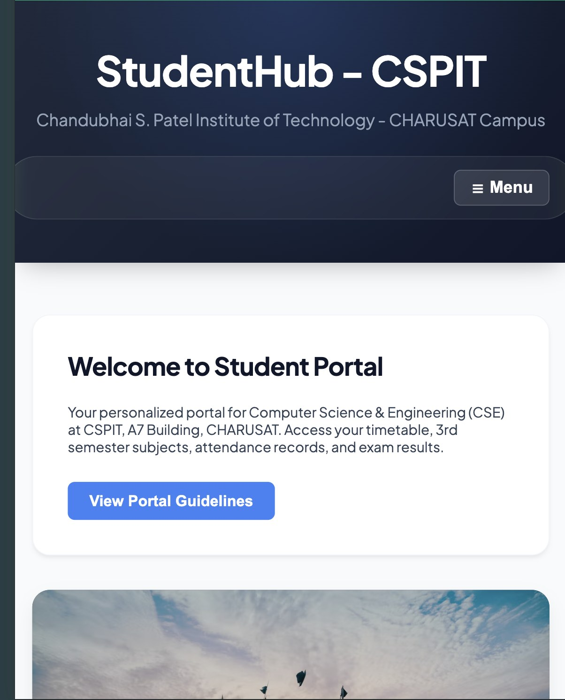
Figure 11: Hamburger menu button (☰ Menu) on small screen

