 | 

Faculty of Technology and Engineering
Chandubhai S. Patel Institute of Technology (CSPIT) Department of Computer Science & Engineering
Date: 08/07/2026
Laboratory Manul

Academic Year | : | 2026-27 | Semester | : | 3rd
Course code | : | ITUE203 | Course name | : | WEB DEVELOPMENT FRAMEWORKS

Practical – 6
GitHub Repo Link: https://github.com/fenilfinava/StudentHub.git

1. JSON Data Displayed
Data is fetched from JSON files (students.json, events.json, faqs.json) using the Fetch API and rendered dynamically as a table. The tabs (Students Data, Events Data, FAQs Data) switch between the different JSON files.
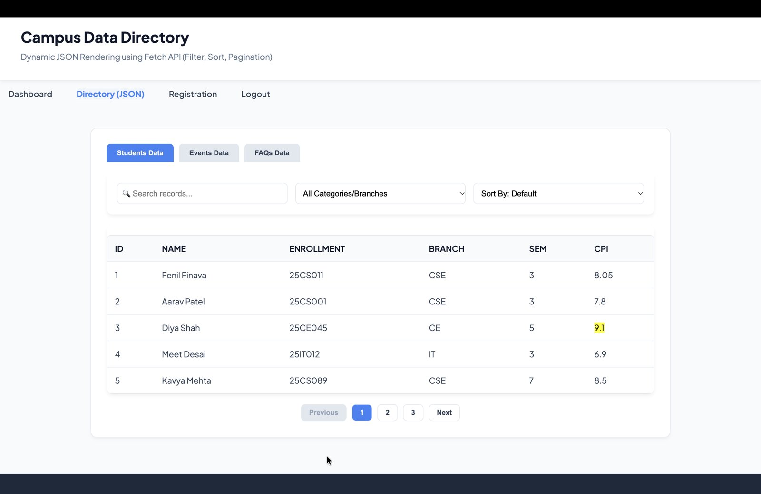
Figure 1: Students data rendered from JSON

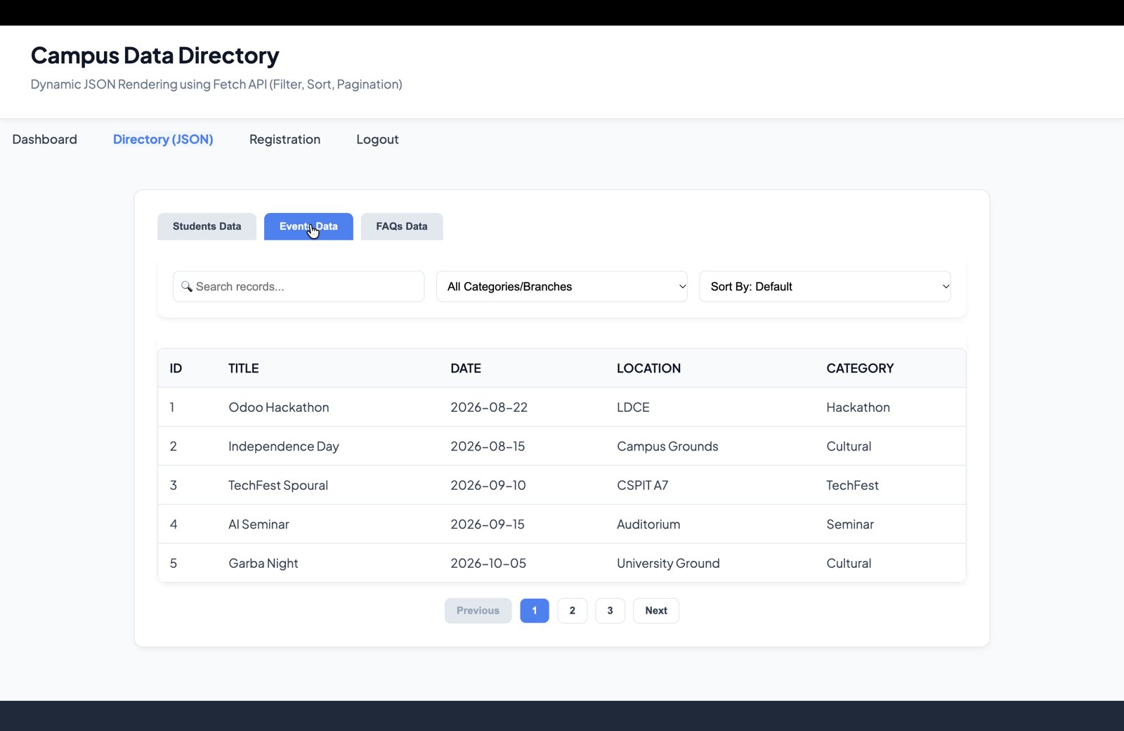
Figure 2: Events data rendered from JSON

2. Search Result
Typing in the search box filters the records instantly. Searching for "fenil" shows only the matching student record.
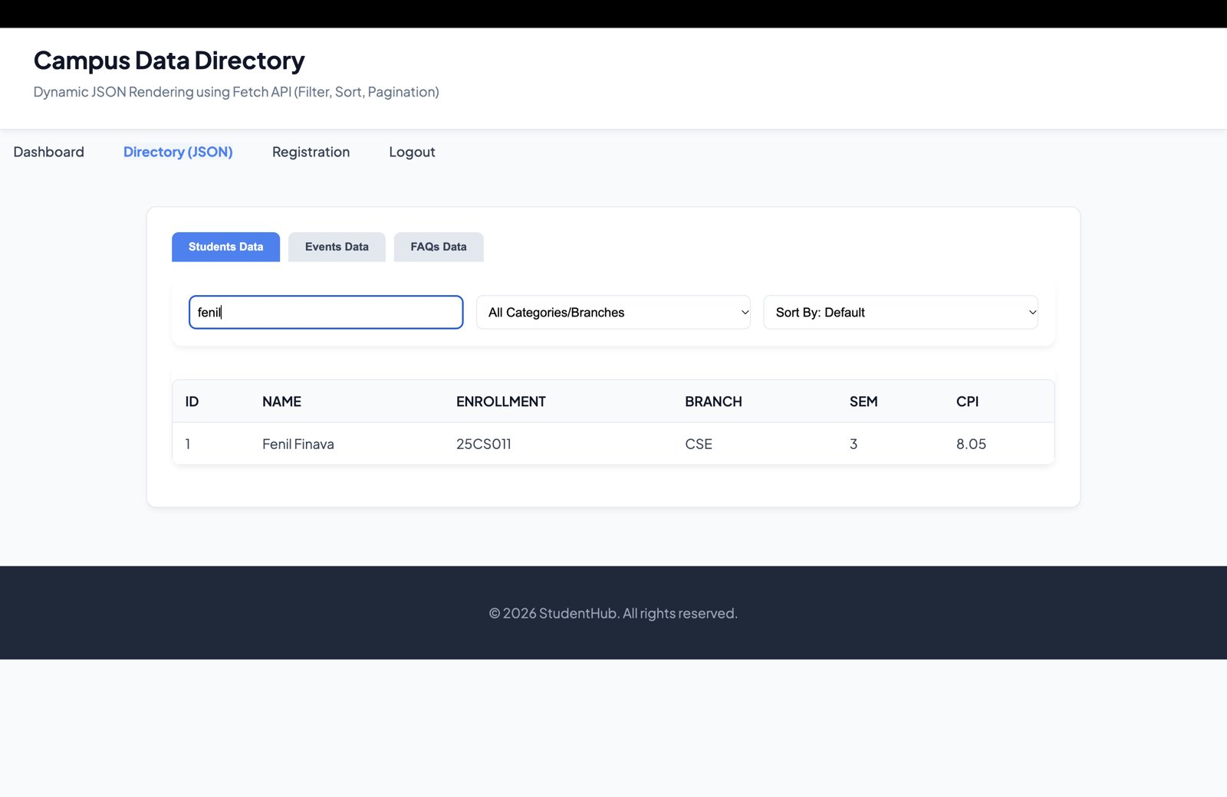
Figure 3: Search result for "fenil"

3. Filter Result
The category/branch dropdown filters the records. Selecting "CE" shows only students of the CE branch.
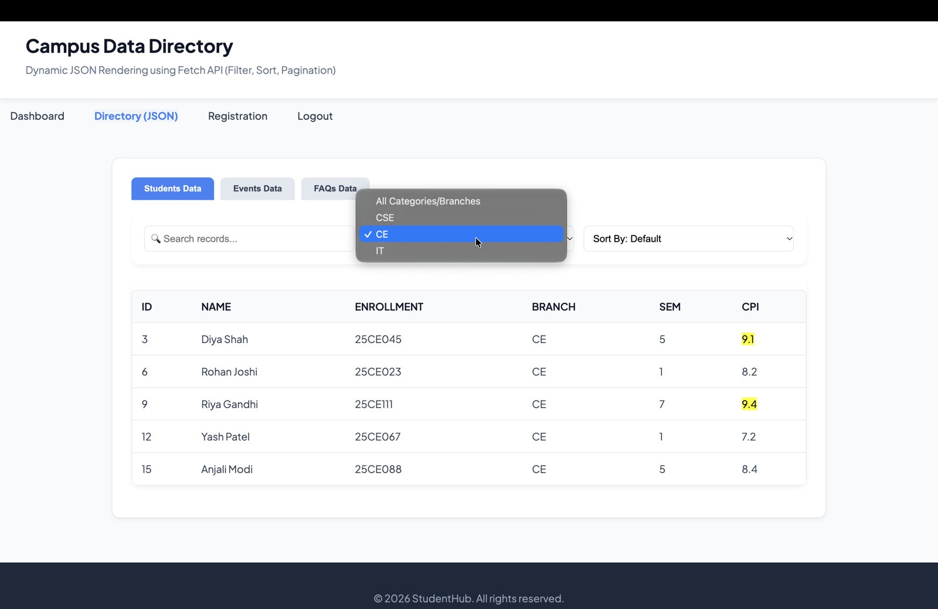
Figure 4: Records filtered by branch = CE

4. Sorting Result
The "Sort By" dropdown sorts the records by Name/Title in ascending (A-Z) or descending (Z-A) order using JavaScript. The screenshot shows Z-A sorting.
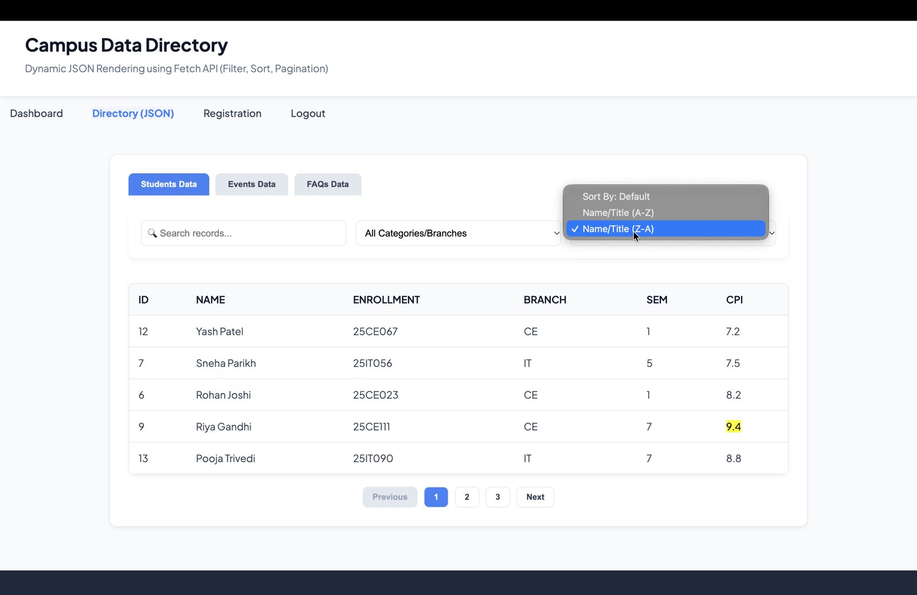
Figure 5: Records sorted by Name (Z-A)

5. Pagination
Records are displayed page by page (5 records per page) using the Previous, Next and page number buttons. The active page is highlighted.
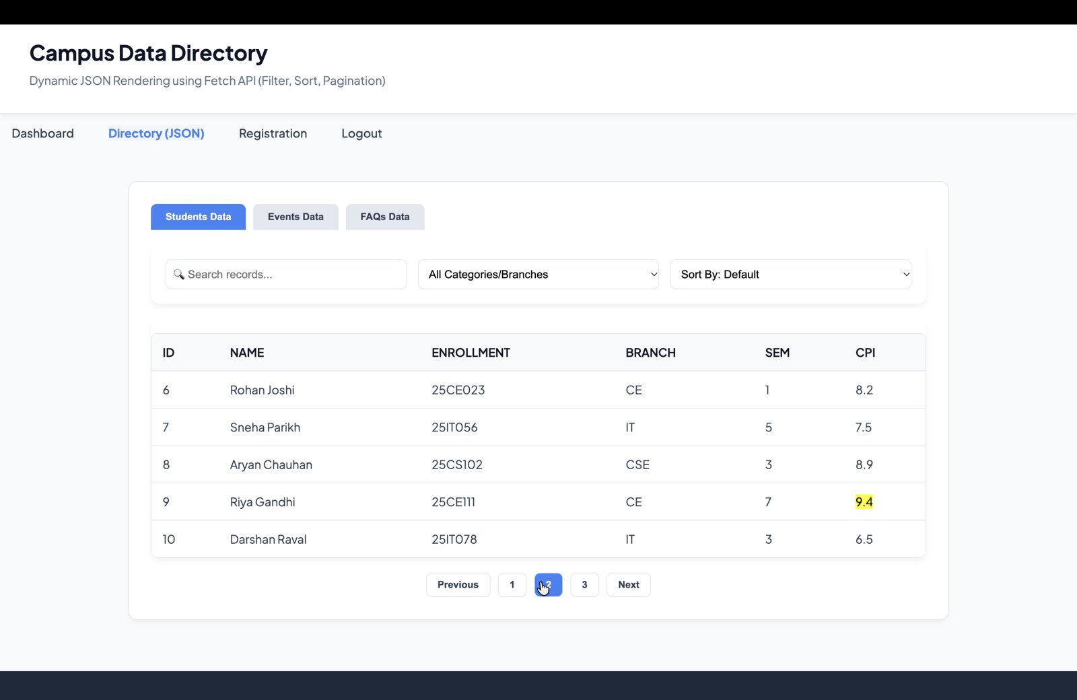
Figure 6: Pagination – page 2 of students data

6. Loading / Error Message
While the JSON data is being fetched, a loading message is displayed. If the fetch fails, an error message is shown to the user.
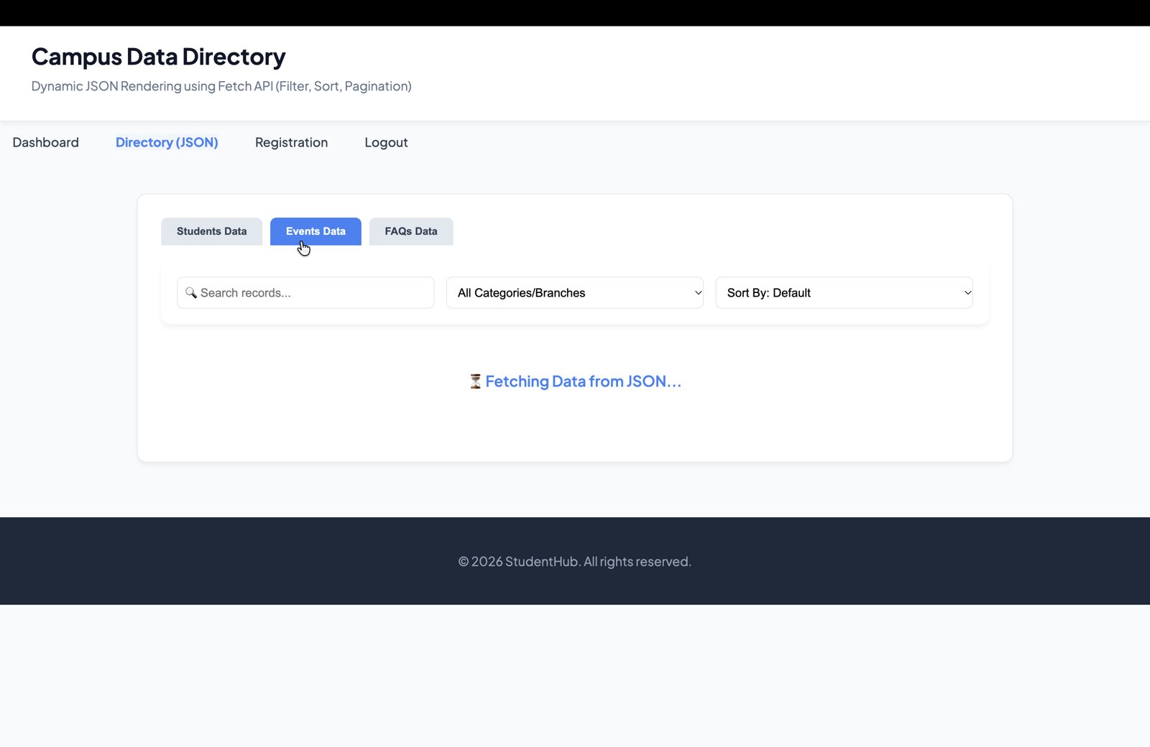
Figure 7: Loading message while fetching JSON data
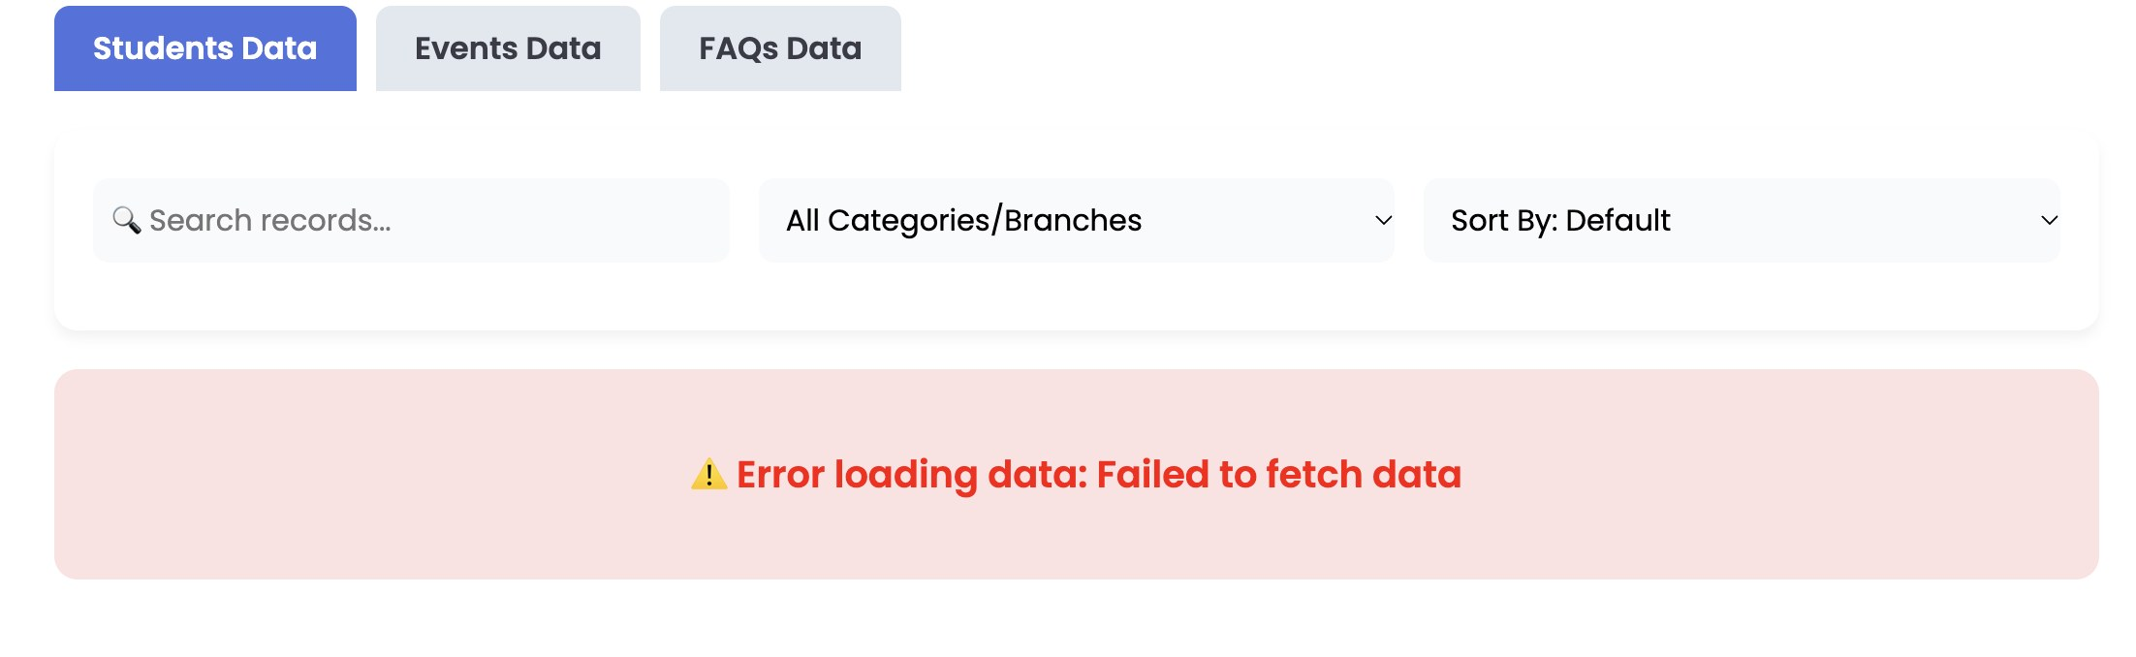
Figure 8: Error message when JSON data fails to load

