Que1
Write a date command to display date in following format:
1. dd/mm/yy hh:mm:ss
2. Today's date is: 01/04/14. Current time is: 14:50:03 04th January 2015
3. 2015-02-04
4. Sat Jan 4 2015 5 PM
5. Wish you happy Monday
6. What will be the output of following commands?
a. $date “+This is Date”
b. $date “+This is date: %B

Ans
1. date "+%d/%m/%y %H:%M:%S"
2. date "+Today's date is: %d/%m/%y. Current time is: %H:%M:%S %dth %B %Y"
3. date +%Y-%m-%d
4. date "+%a %b %d %Y %I %p"
5. date "+Wish you Happy %A"
6. a. This is Date
b. This is date: January

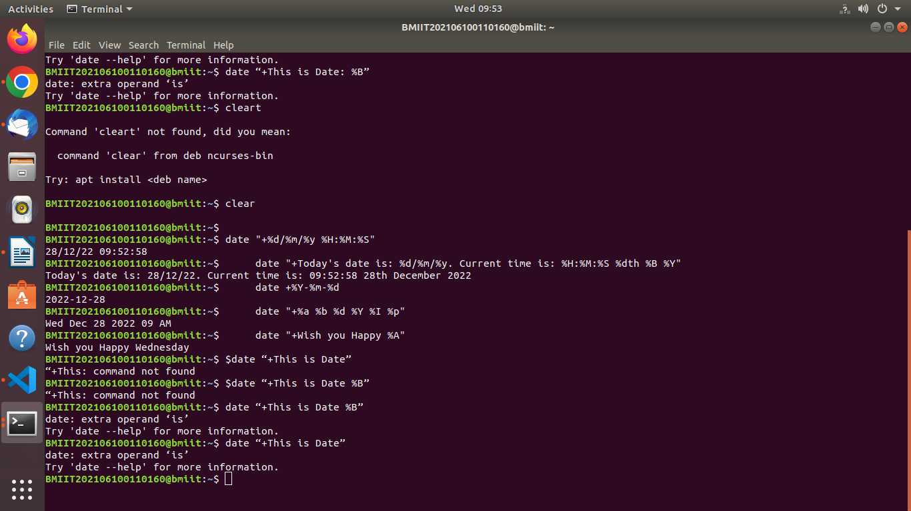

Que2

Write a cal command to do following:
1. To display calendar of current month. (don’t give argument as 2017)
2. Display calendar for single month and Monday as the first day of week.
3. Display calendar of January month of 2050 year.

Ans2
1. cal
2. ncal -M -b 1 2022
2. cal 1 2050

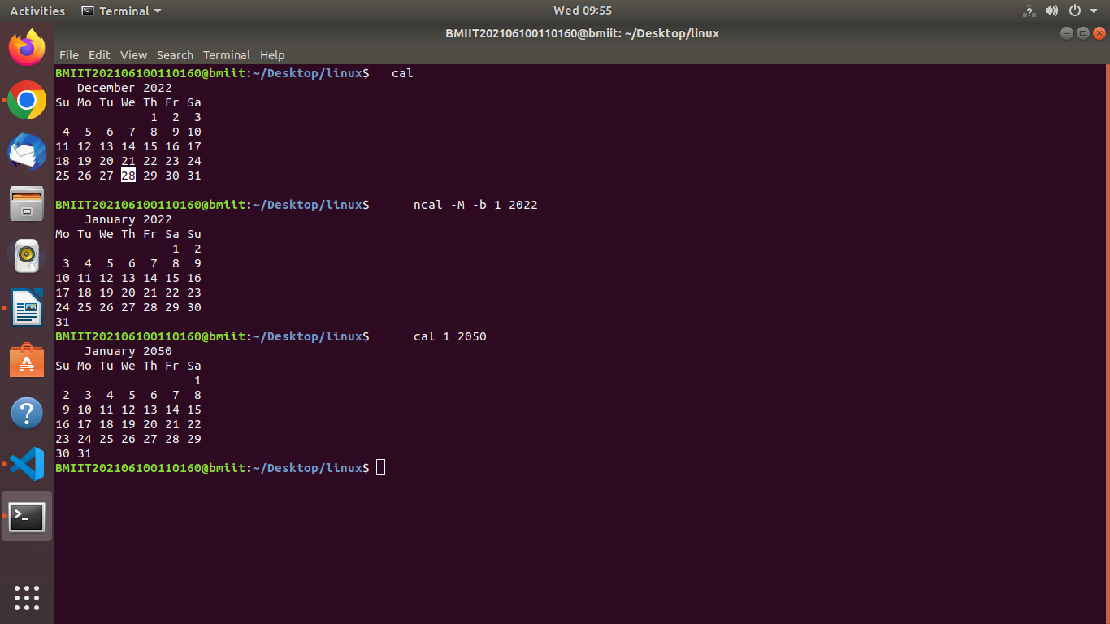

Que3

Write ls command for following:
1. Display all files names including hidden files.
2. Display current working directory name.
3. Display all file names in one column.
4. List all current directory recursively.
5. List all file names having only one character length.
6. List filenames with their inode numbers

Ans3

1. ls -a
2. ls -d
3. ls -1
4. ls -R
5. ls | grep -E "^.{1}$"
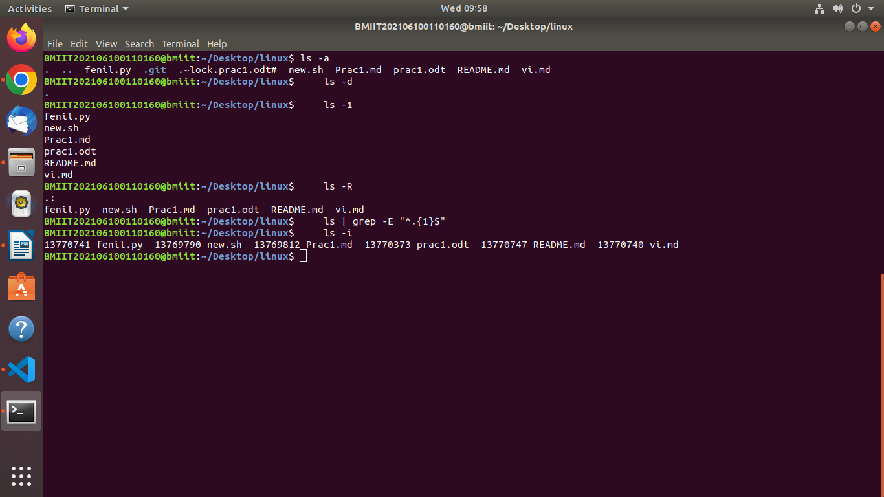
6. ls -i

Que4

Do as directed.
1. Create three directories named UNIX, Assembly and C++ under your
Home directory.
2. Write command to move into UNIX from current directory by writing
single command.
3. Write command to move directly to Assembly by writing single
command. (Your current directory is UNIX).
4. Create a directory named LINUX in Desktop directory by writing single
command. (Your current directory is UNIX and do not use cd command.)
5. Write command to create text file named “Linux.txt”; Rename the file
“Linux.txt” to “Unix.txt”.
6. Recursively list all of the directories you created in Home directory by
writing single command. (Your current directory is UNIX and do not use
cd command).

Ans4

1. mkdir UNIX Assembly C++
2. cd UNIX
3. cd ../Assembly
4. mkdir ~/Desktop/LINUX
5. touch Linux.txt
mv Linux.txt Unix.txt
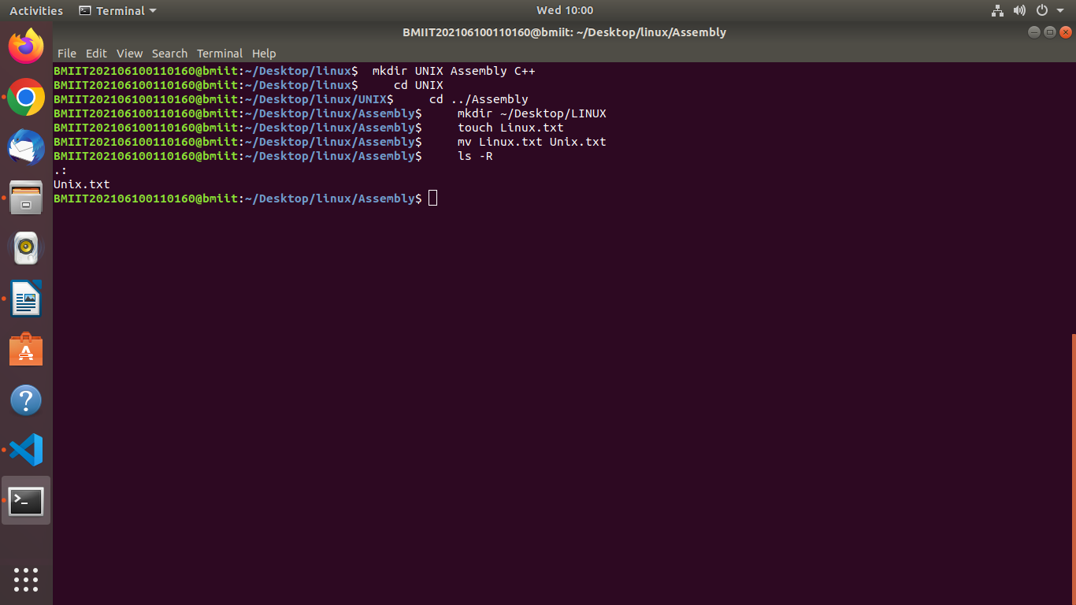
6. ls -R

Que5

Write a bc command for following:
1. To evaluate "21/2". Answer should contain 5 decimal places.
2. To convert 42 from decimal to hexadecimal.
3. To print digits from 1 to 10 using for loop.
4. To convert 1100 from binary to decimal.
5. To print digits from 11 to 20 using while loop.

Ans5

1. echo "scale=5; 21/2" | bc
2. echo "obase=16; 42" | bc
3. for number in {1..10}
do echo $number
done
4. echo "ibase=2; 1100" | bc
5. for number in {11..20}
do echo $number
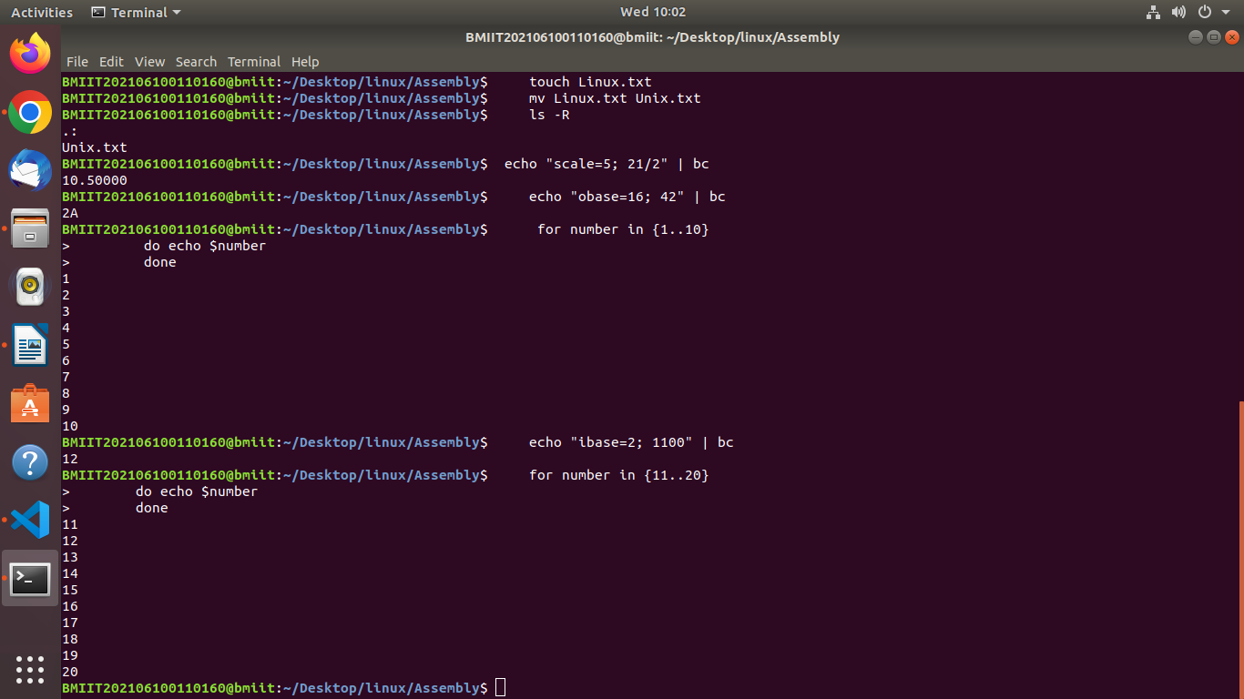
done

Que6
Solve following using echo command:
1. Write the output of a command:
$ echo "Current directory file list is `ls`" ( ` is back quote)
2. Write an interpretation of a command:
$ echo Welcome to the LINUX's world.
3. Write the output of a command:
echo {first, second, black, white}fish
4. Write an interpretation of a command:
echo -e "Welcome to the LINUX \c world."
echo "Welcome to the LINUX \c world."
5. Write the output of a command: echo *.txt
6. Write output and interpretation of:
echo "0 || 0" | bc
echo "0 || 0"
7. Write output and interpretation of:
echo "3*4+2"|bc
echo "3*4+2"|bc
8. Write output and interpretation of:
echo "length(123456)" | bc
echo "length(123456)"
9. Write output of and interpretation:
echo "(2+3)*4"|bc
echo "(2+3)*4"
10. Write output and interpretation of following commands:
a. echo "1 == 2" | bc
b. echo "10 == 10" | bc
c. echo "10 == 1 || 1 == 2" | bc
d. echo "10 == 10 || 1 == 2" | bc

Ans6

1. Current directory file list is java linux
2. echo "Welcome to the LINUX's world."
3. {first, second, black, white}fish\
4.a. Welcome to the LINUX
b. Welcome to the LINUX \c world
5. test.txt
6. a. 0
b. 0 || 0
7. a. Command 'bc*' not found, did you mean:
command 'bc' from deb bc
command 'bcp' from deb libboost1.65-tools-dev
command 'bcp' from deb libboost1.62-tools-dev
command 'bcc' from deb bcc
command 'bch' from deb bikeshed
command 'bcd' from deb bsdgames
b. 14
8. a. 6
b. length(123456)
9. a. 20
b. (2+3)*4
10. a.0
b.1
c.0
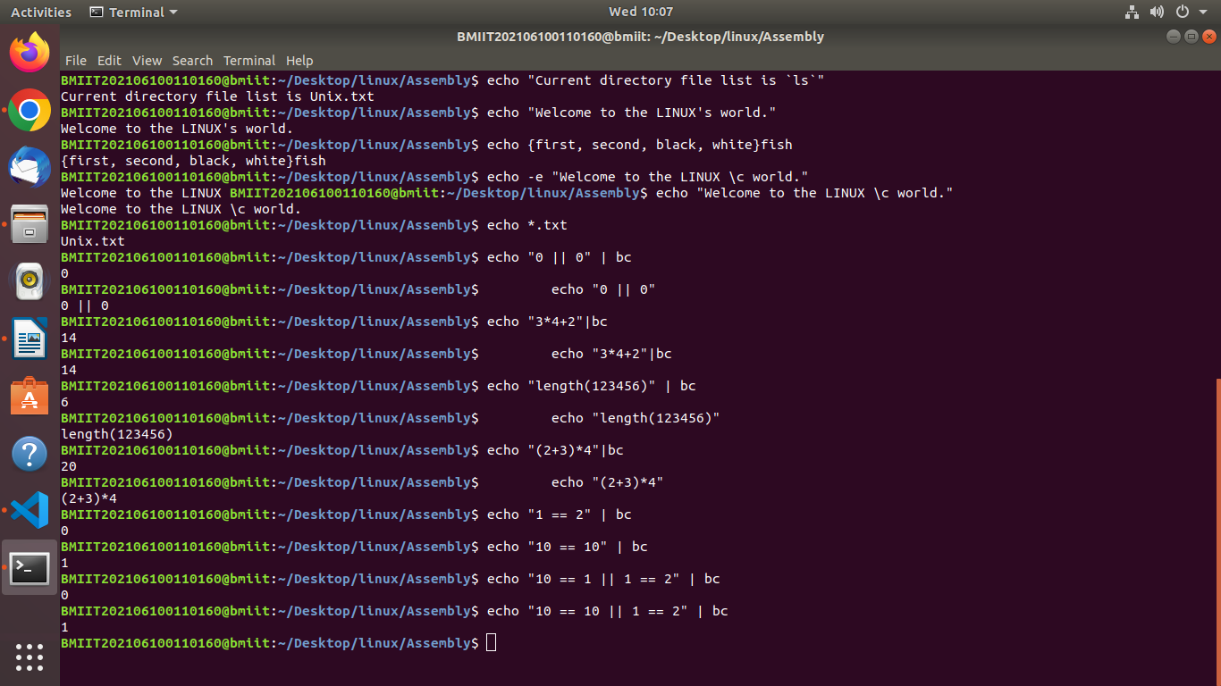
d.1

Que7
Write ls & echo command to display following list of files:
File names:
1. Having digit at the end of filename.
2. First characters should be capital rest of could be anything.
3. Having three consecutive alphabets.
4. Having "?" and "*" characters in filename.
5. Minimum length is 5 characters.
6. First character may be in uppercase or lowercase & second character must
in uppercase.
7. Having first and last character must be capital letter.

Ans7

1. ls | grep -E "[0-9]$"
2. ls | grep -E "^[A-Z]"
3. ls | grep -E "[a-zA-Z]{3}"
4. ls | grep -E "[?*]"
5. ls | grep -E "^.{5}$"
6. ls | grep -E "^[a-zA-Z][A-Z]"
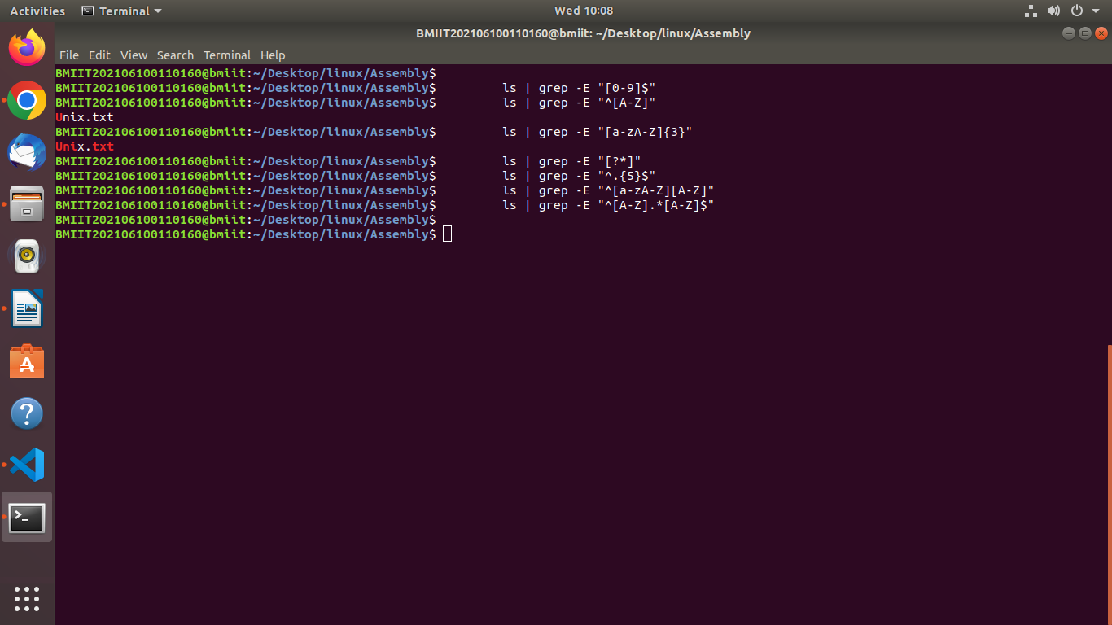
7. ls | grep -E "^[A-Z].*[A-Z]$"

