Rapport des resulats de l'apprentissage automatique pour la prédiction du degré de sévérité de la maladie de Tuberculose pulmonaire

Benkedadra Mohamed
Youcefi Mohemmed Yassine
Benkorreche Mohamed El Amine

Groupe 1 - ISI

A - J48 (MÉTHODE 1) :
- Y_features_opt2_300:
- Y_features_opt2_300 - OPTIONS:
-P 57 -O -S 54 -I 15
-store-out-of-bag-predictions -output-out-of-bag-complexity-statistics
-represent-copies-using-weights -W weka.classifiers.trees.J48 -- -U -Q 90

- Y_features_opt2_300 - VAL MESURE:
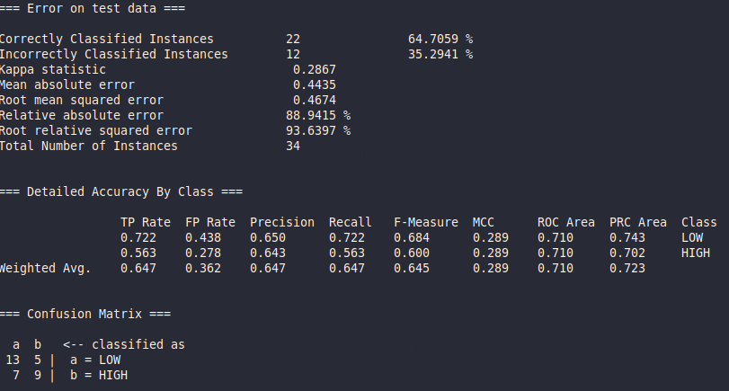
- Y_features_opt2_300 - TRAINVAL MESURE:
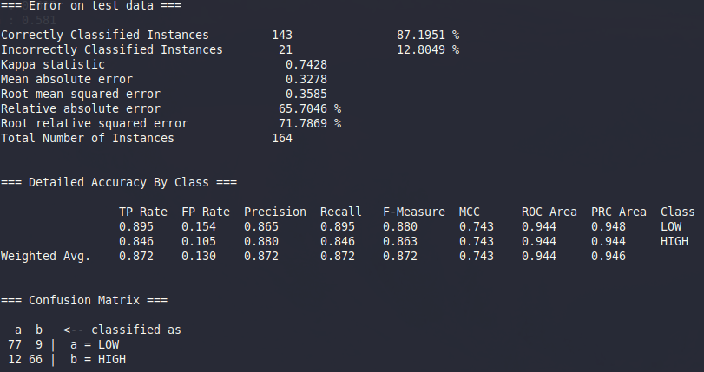

- Z_features_opt2_300 :
- Z_features_opt2_300 - OPTIONS:
-O -S 89 -I 18
-W weka.classifiers.trees.J48 -- -C 0.1355511376705627 -Q 64 -J

- Z_features_opt2_300 - VAL MESURE:
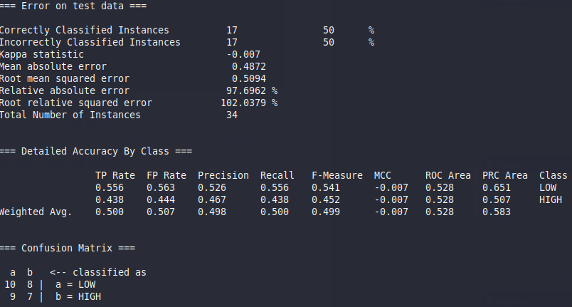

- Z_features_opt2_300 - TRAINVAL MESURE:
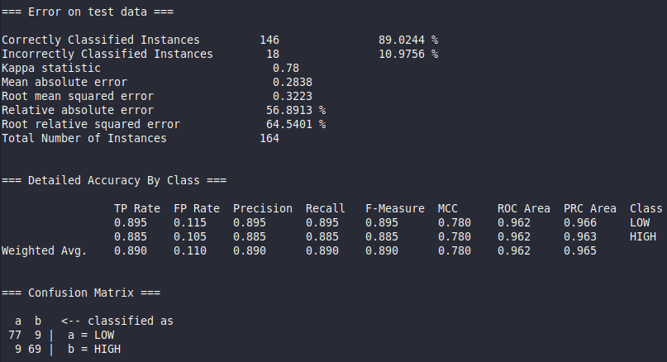

- YZ_features_opt2_600:
-YZ_features_opt2_600 – OPTIONS:
-O -S 70 -W weka.classifiers.trees.J48 -- -N 104 -R -Q 105

- YZ_features_opt2_600 - VAL MESURE:

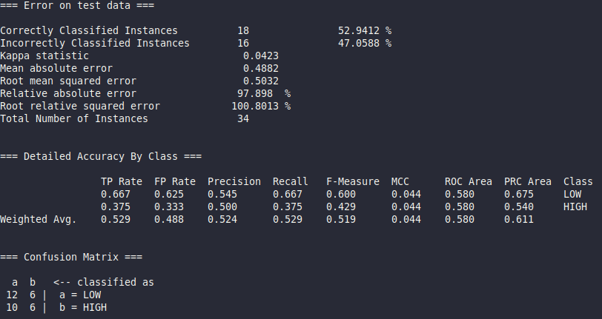

- YZ_features_opt2_600 - TRAINVAL MESURE:

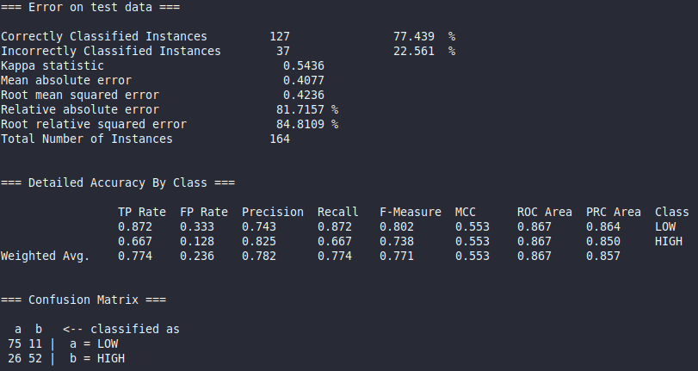

A - HoeffdingTree (MÉTHODE 2) :
- Y_features_opt2_300:
- Y_features_opt2_300 - OPTIONS:
-P 29 -O -S 55 -num-slots 17 -output-out-of-bag-complexity-statistics
-W weka.classifiers.trees.HoeffdingTree --
-H 0.41623 -L 1 -E 0.41813 -M 0.21027 -P

- Y_features_opt2_300 - VAL MESURE:

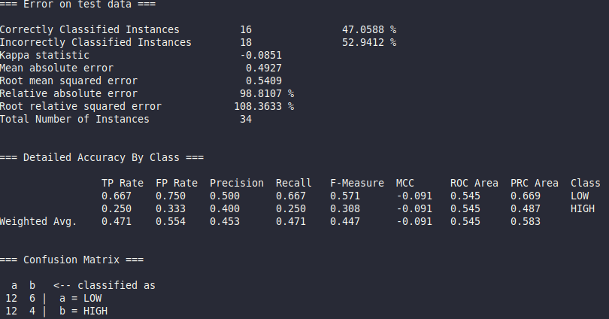
- Y_features_opt2_300 - TRAINVAL MESURE:

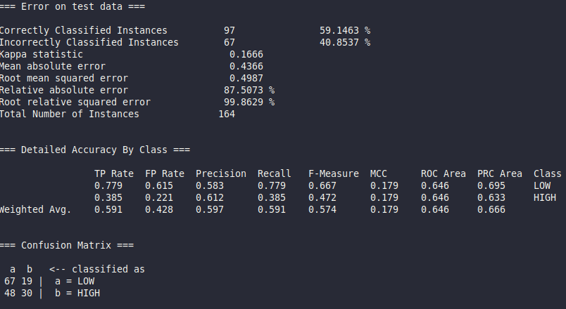
- Z_features_opt2_300 :
- Z_features_opt2_300 - OPTIONS:
-P 53 -S 77 -W weka.classifiers.trees.HoeffdingTree -- -H 0.65928 -L 1 -S 1 -G 0 -N 57

- Z_features_opt2_300 - VAL MESURE:

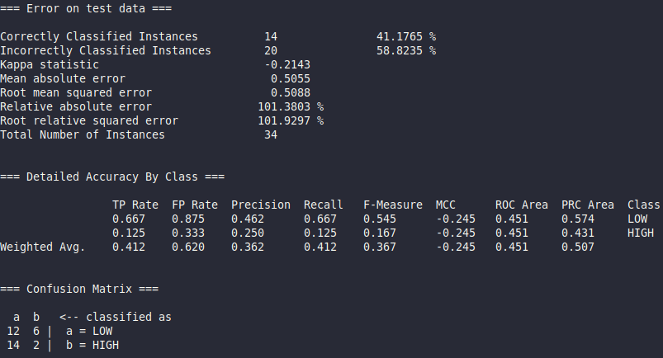

- Z_features_opt2_300 - TRAINVAL MESURE:

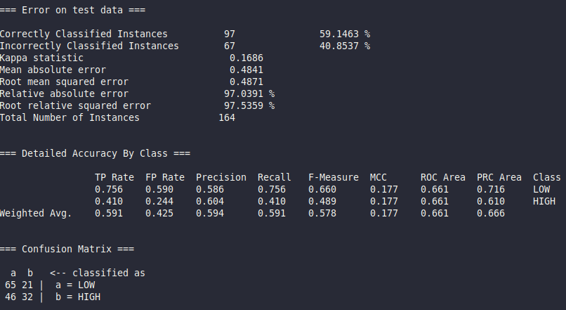
- YZ_features_opt2_600:
-YZ_features_opt2_600 – OPTIONS:
-I 8 -output-out-of-bag-complexity-statistics -represent-copies-using-weights
-W weka.classifiers.trees.HoeffdingTree -- -H 0.77991 -S 0 -M 0.85064 -G 50 -N 41 -P

- YZ_features_opt2_600 - VAL MESURE:

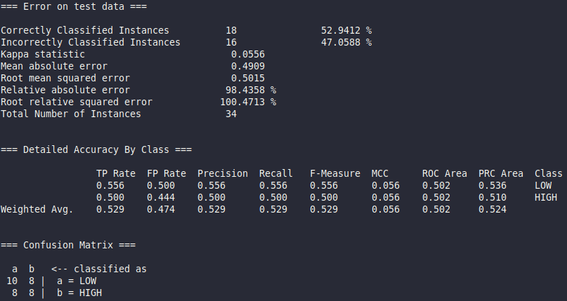

- YZ_features_opt2_600 - TRAINVAL MESURE:

