ASSESMENT

Database Management – SQL & PL/SQL
Theme: Personal Expense Tracker DB Section A:
Concept Application
1. Explain how relational databases help maintain accuracy in expense records.
Relational databases store data in related tables using primary keys and foreign keys. This reduces duplicate data, maintains consistency, and ensures that expense records are linked to valid users and categories, improving accuracy.
2. Why are constraints important in personal finance data?
Constraints enforce rules on data entry. They prevent invalid or duplicate information, ensure unique IDs, and maintain data integrity, making financial records reliable and accurate.
3. How does GROUP BY help analyze spending patterns?
The GROUP BY clause groups similar records together and allows aggregate functions like SUM() and AVG() to calculate totals. It helps users analyze expenses by category, month, or user to identify spending patterns.
4. Explain a scenario where rollback is required during expense entry.
Suppose a user accidentally enters an expense amount of ₹50,000 instead of ₹500. If the mistake is detected before committing the transaction, the ROLLBACK command can undo the incorrect entry and restore the previous state of the database.
5. How do views help users track monthly expenses efficiently?
Views provide a simplified representation of data by storing frequently used queries. A monthly expense view can display only relevant expense information, making it easier and faster for users to track their spending.
6. Why use triggers for automatic category or balance updates?
Triggers automatically execute predefined actions when data is inserted, updated, or deleted. They can automatically update account balances or categorize expenses, reducing manual work and ensuring data consistency.

SECTION-B (SQL HAND_ON)
1. DDL Understanding
● Explain why foreign keys are used: Specifically, why must user_id in the expenses table correspond to a real ID in the users table?
Foreign keys maintain referential integrity between tables. The user_id in the expenses table must match an existing user_id in the users table, ensuring that every expense belongs to a valid user. Similarly, category_id must exist in the categories table.
● Mention one issue that would occur if foreign keys were removed: Describe the risk of "Orphaned Records" (e.g., an expense existing for a user who has been deleted).
Without foreign keys, an expense record could reference a user or category that does not exist. For example, if User ID 3 is deleted but their expense records remain, those expenses become orphaned records, causing inaccurate and inconsistent data.
2. DML Operations Write SQL queries to:
● Insert 5 users into the users table with unique names and emails.
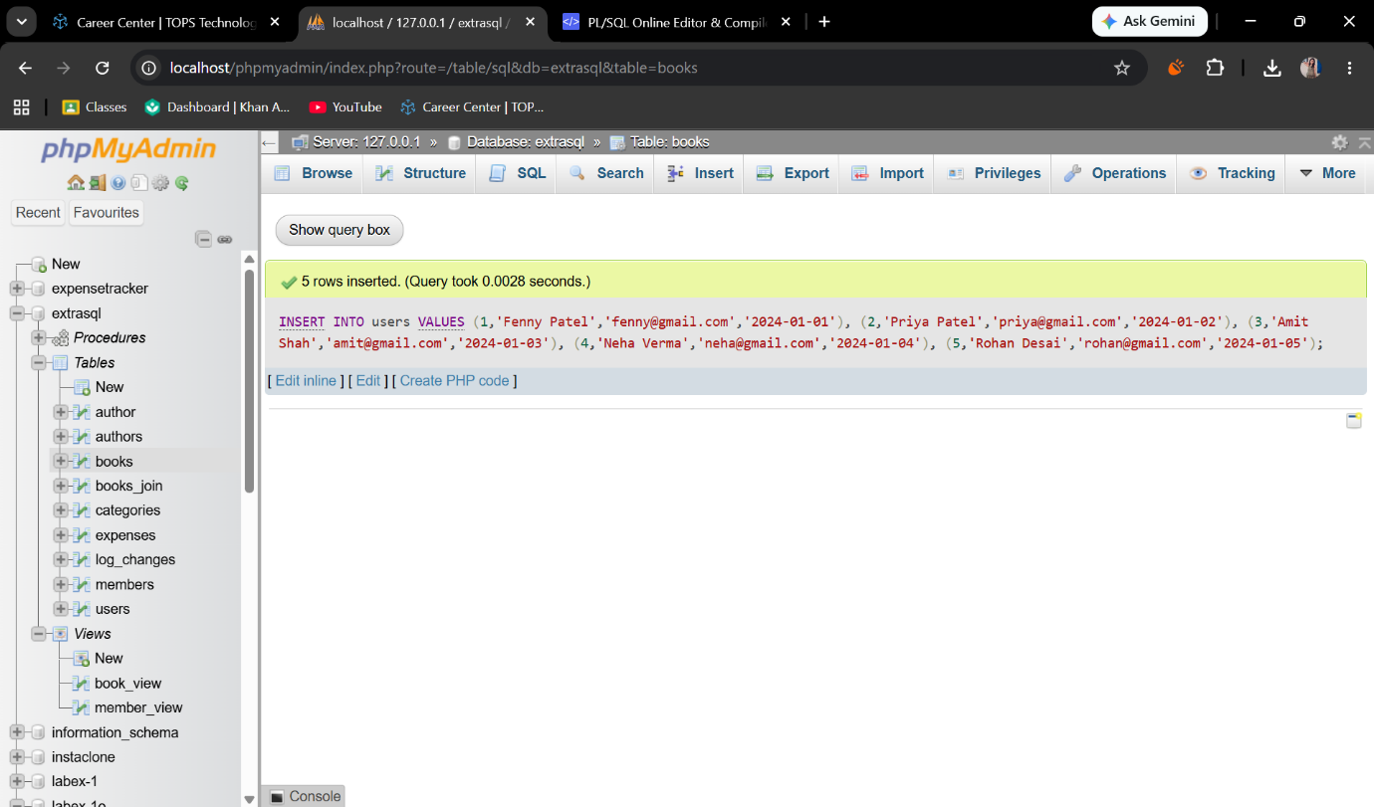
● Insert 3 categories (e.g., 'Food', 'Rent', 'Entertainment').
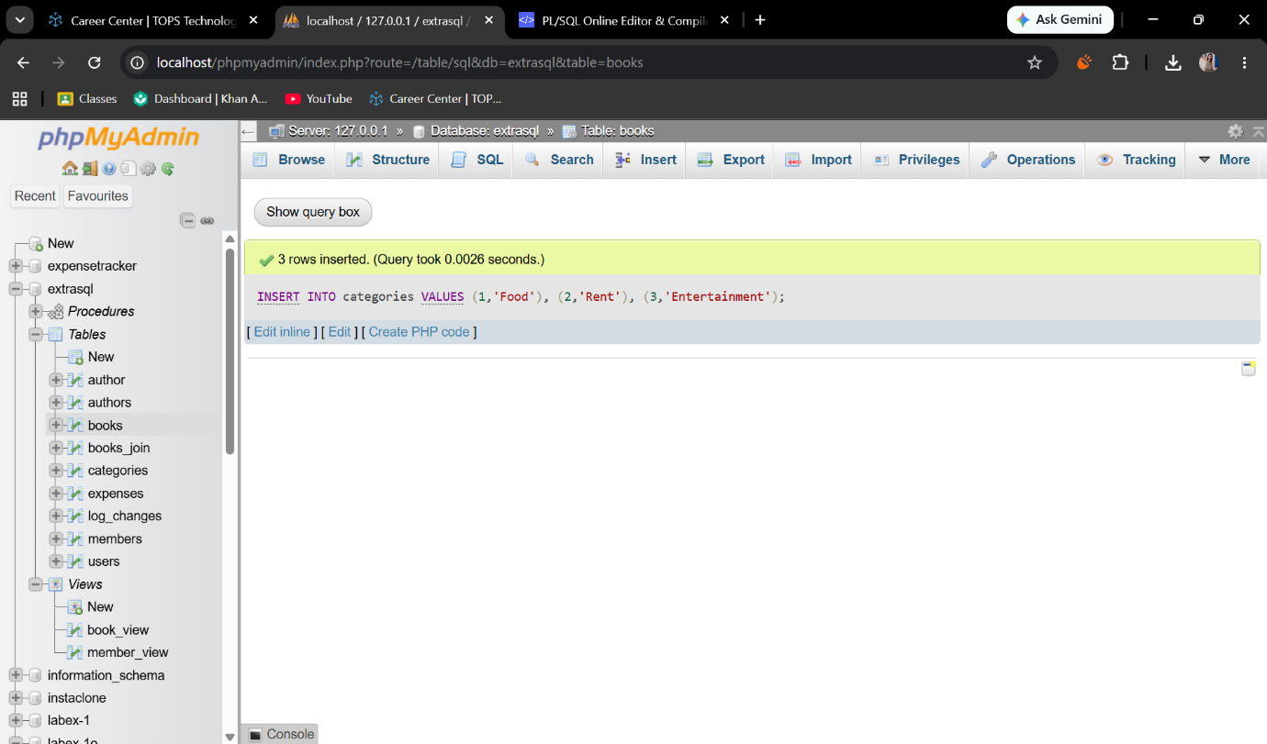
● Insert 10 expense records distributed across different users and categories.
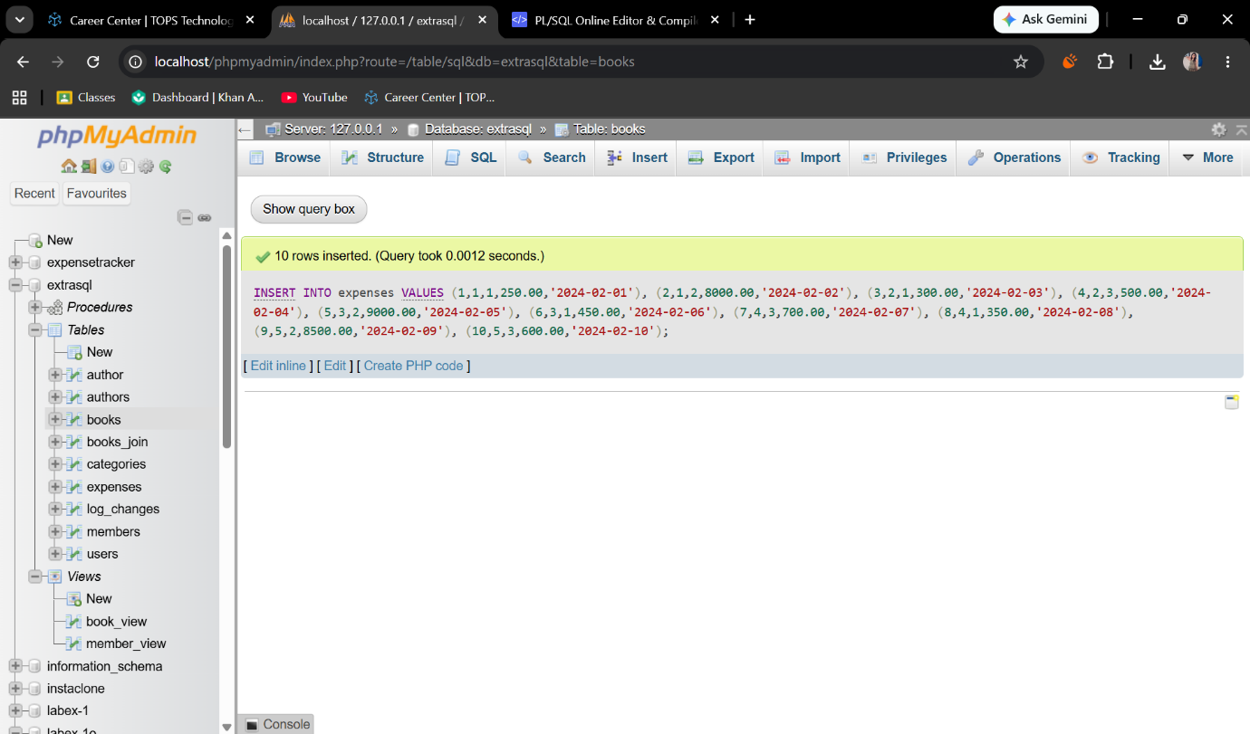

● Update one incorrect expense: Use the UPDATE command to change the amount of a specific expense_id.
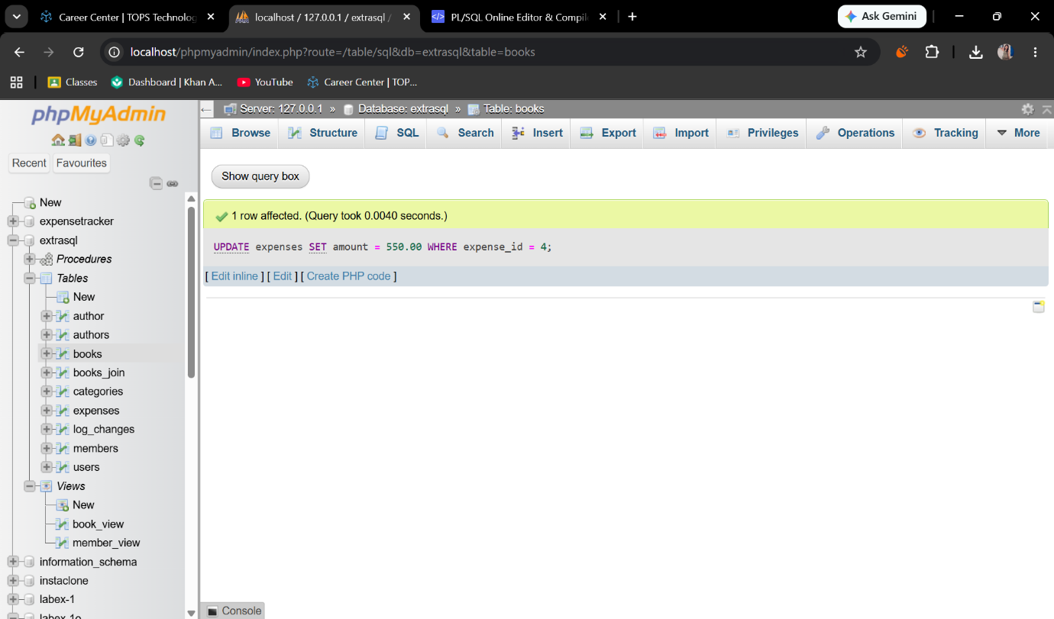
● Delete one expense: Remove a record where the amount is less than a specific value.
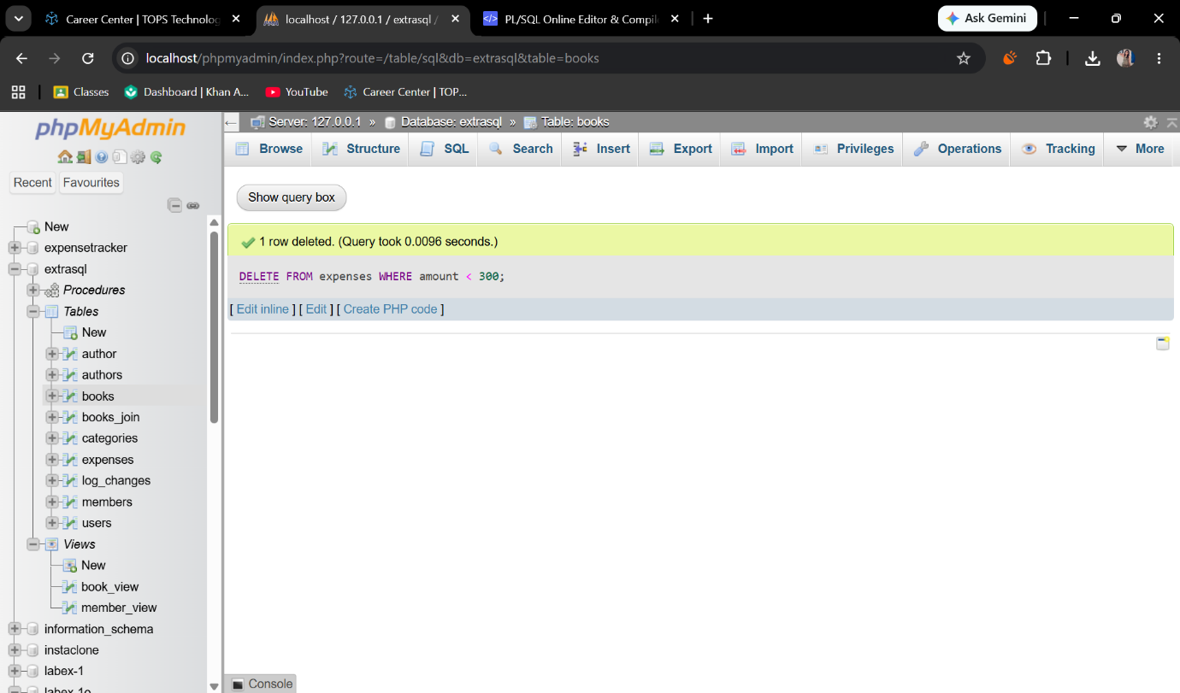

3. Data Retrieval
Write queries to:
● Display all expenses with details: Show the expense_date, amount, name (from users), and category_name (from categories) using INNER JOIN.
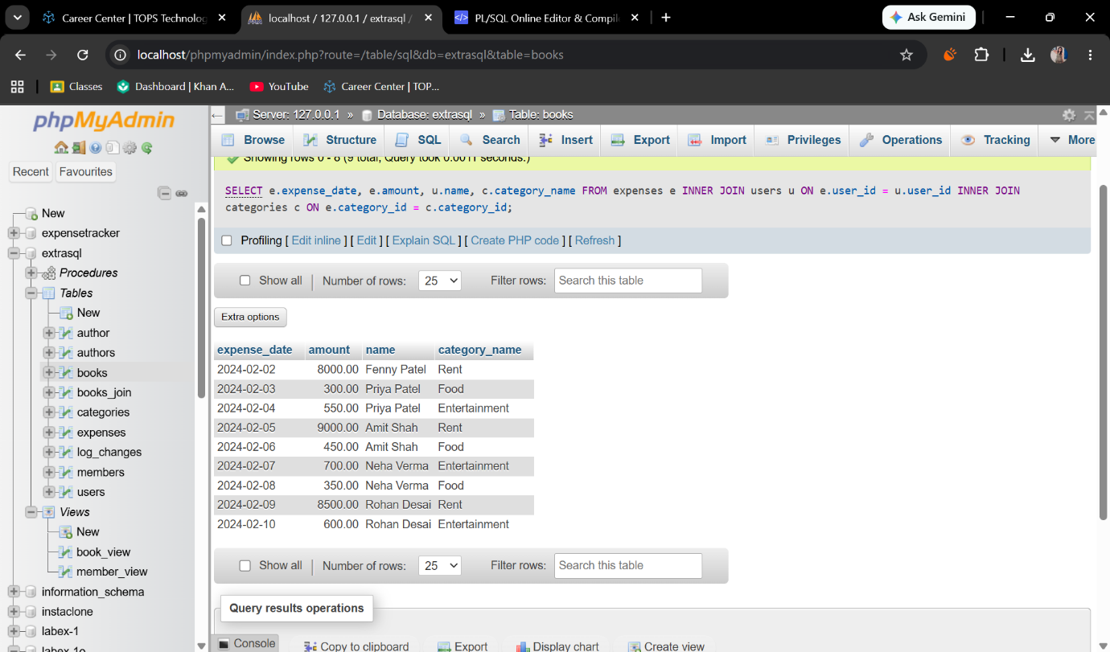
● Show total expense amount per category: Use SUM(amount) and GROUP BY category_name.
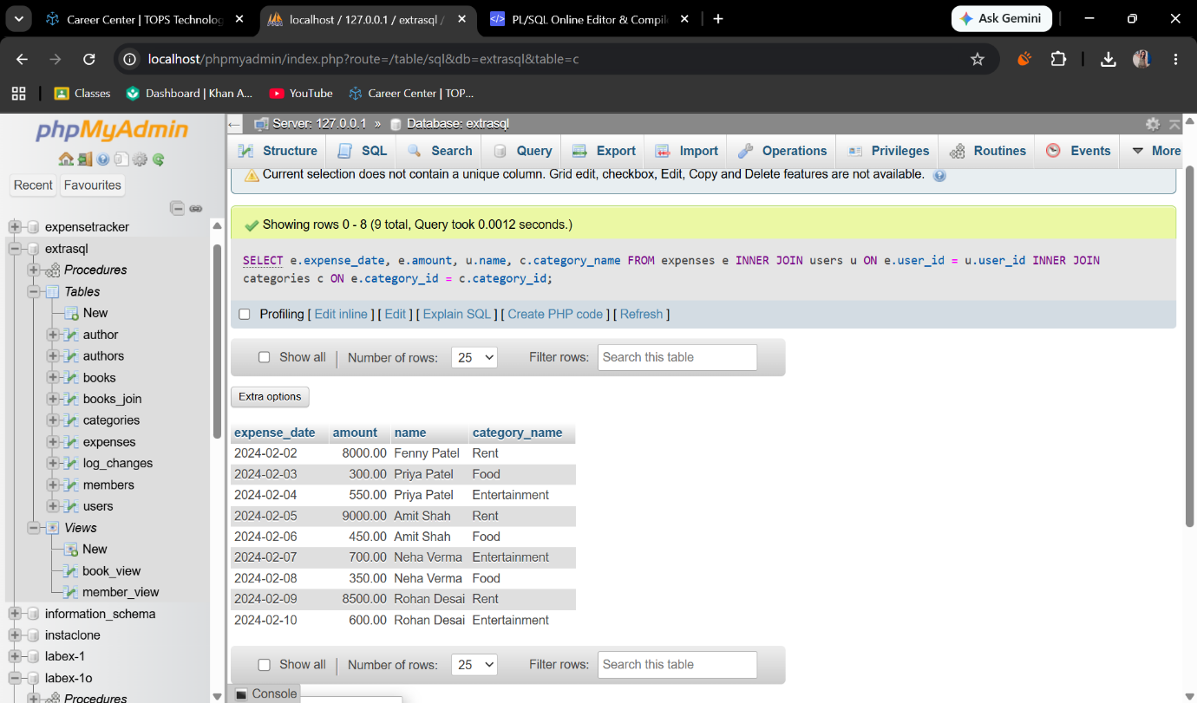
● Display users sorted by total spending: List user names and their total sum of expenses, ordered from highest to lowest.
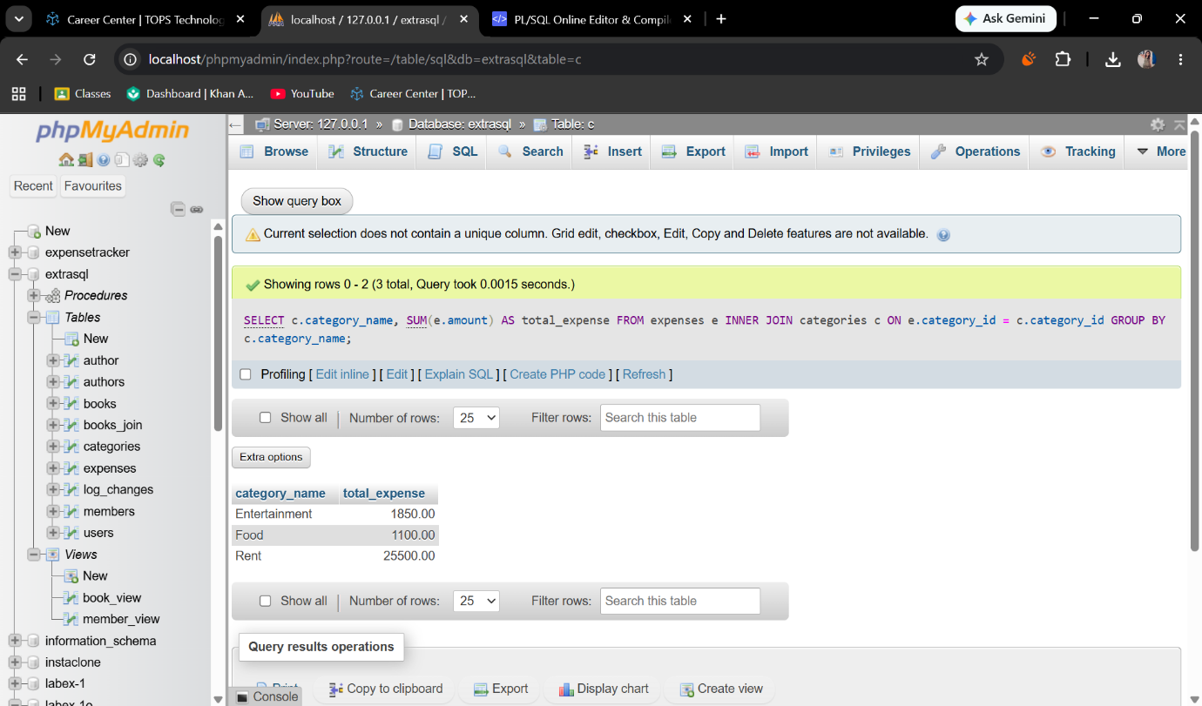

4. Views
● Create a view named ActiveUsersView: This view should list the name and email of any user who has logged more than 5 individual expense records.
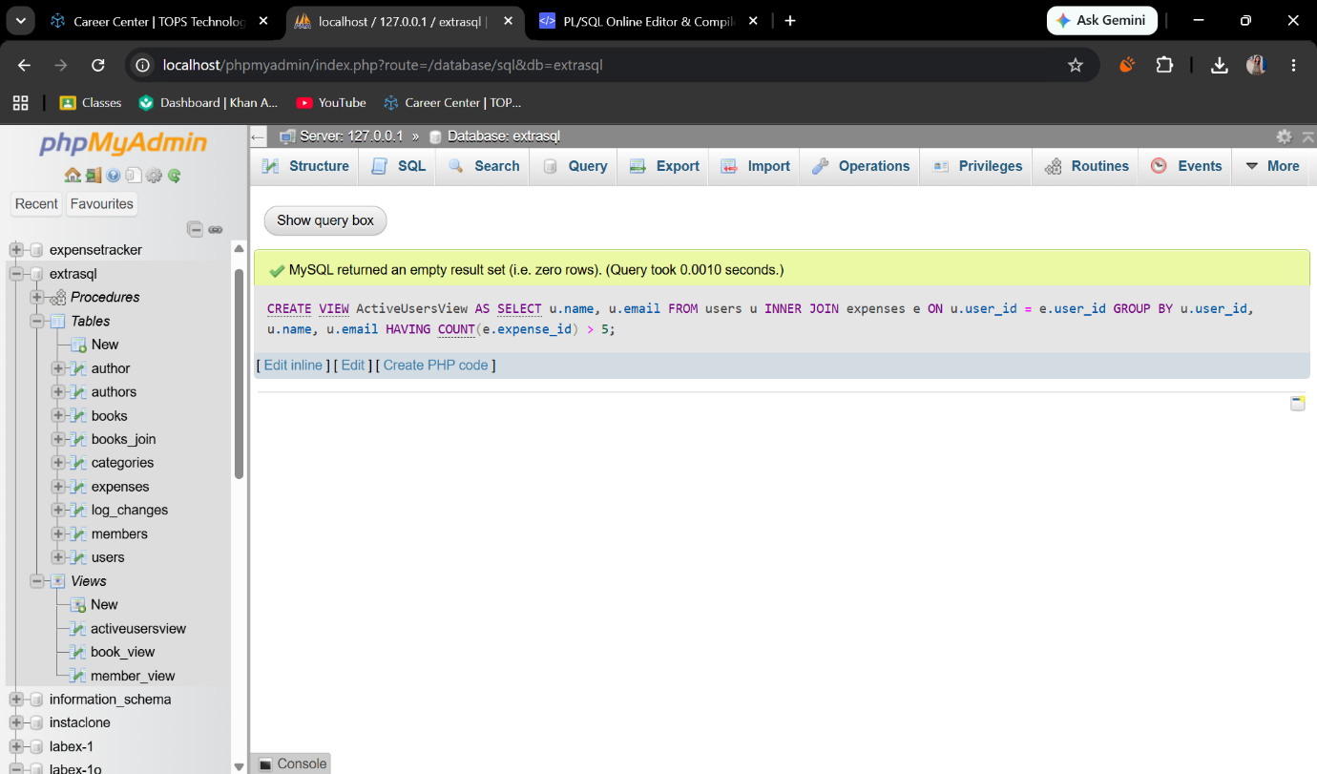
● Query the view: Write a simple SELECT statement to show all data from ActiveUsersView.
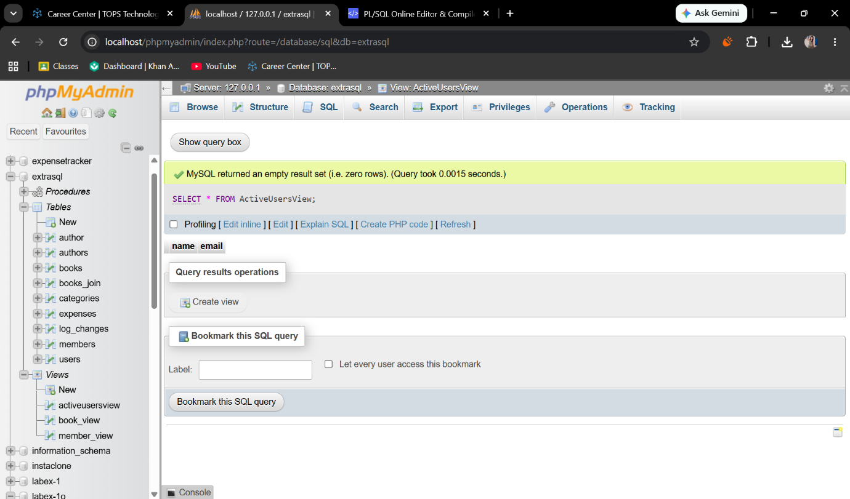

Section C: Mini Project
Mini Project: Expense Tracker DB
Using the same schema:
● Write CRUD queries
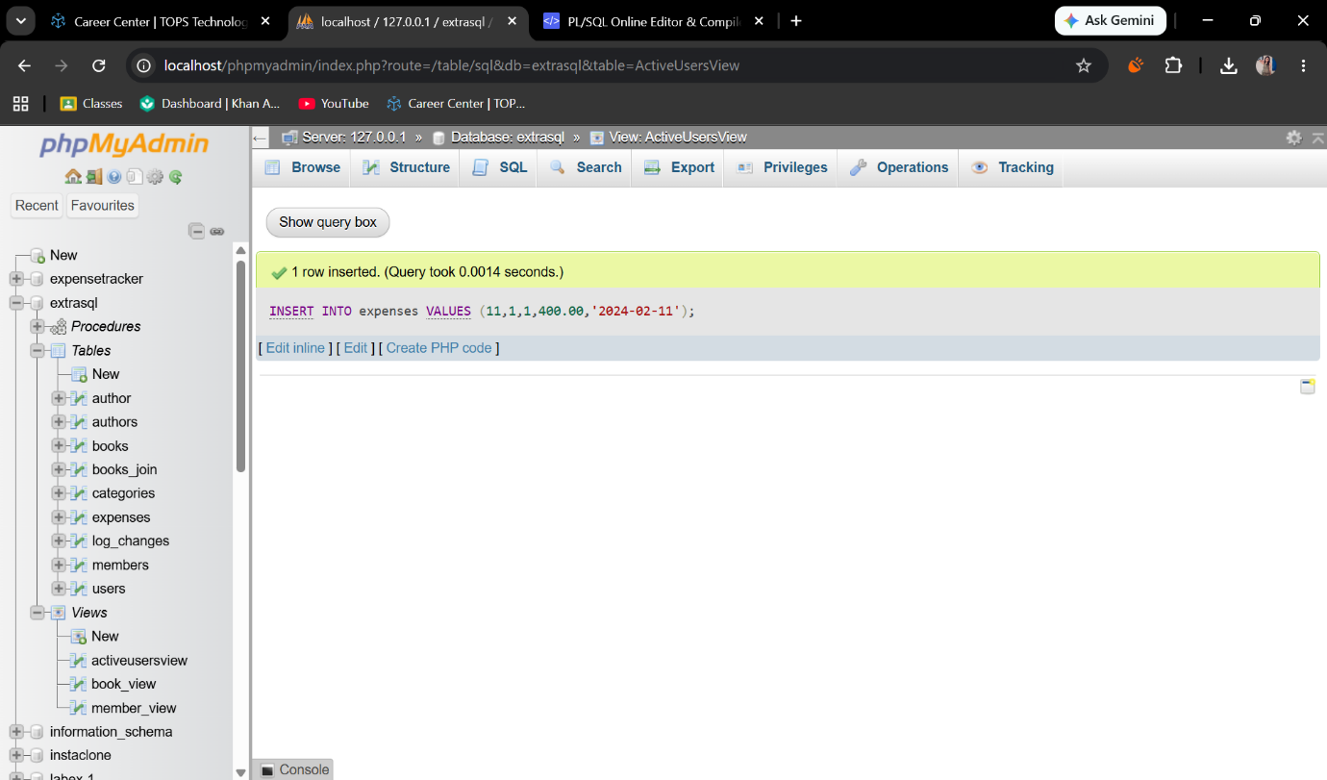
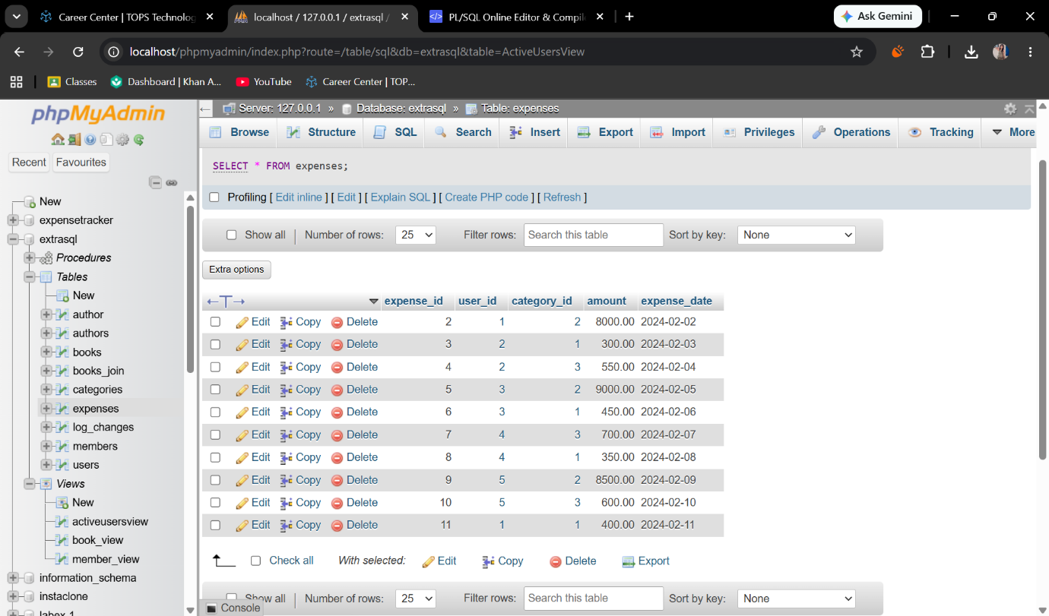
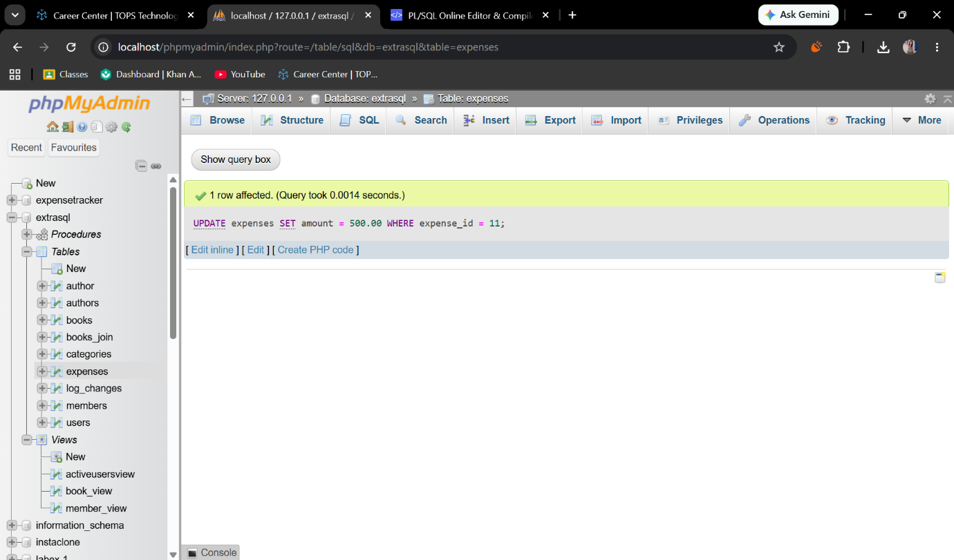
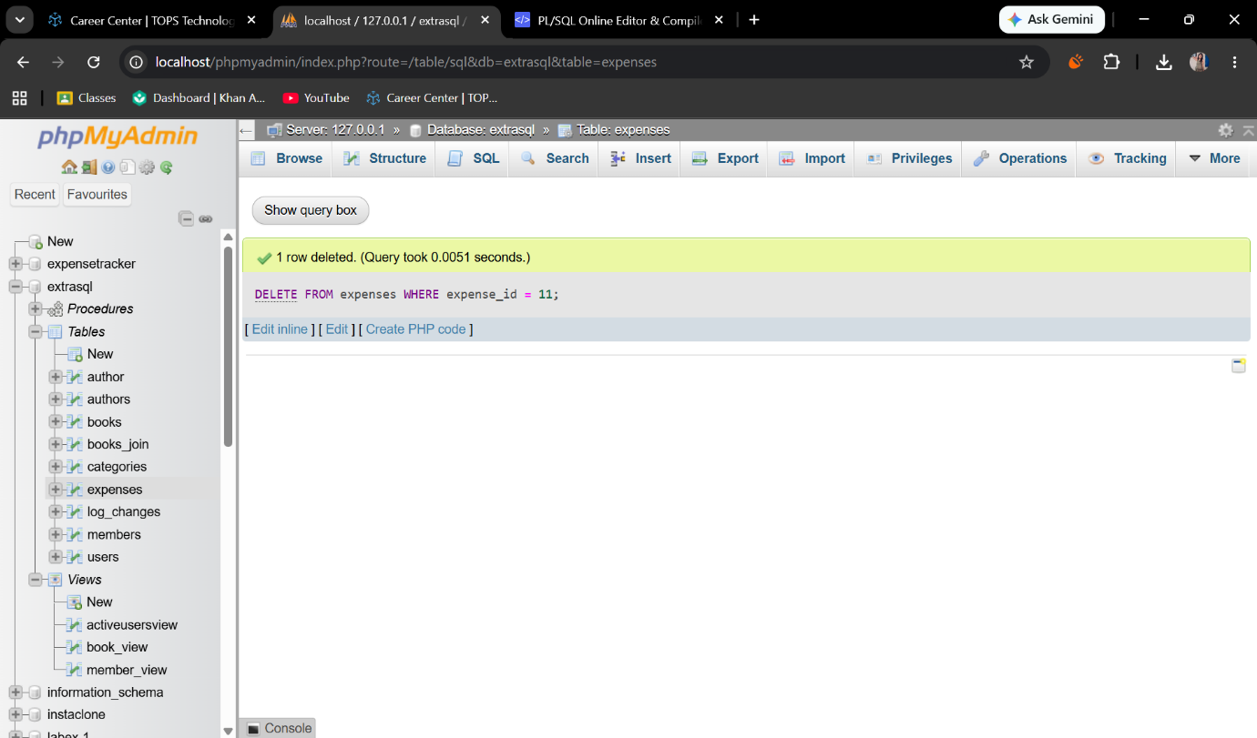
● Write a stored procedure to calculate monthly user expense.
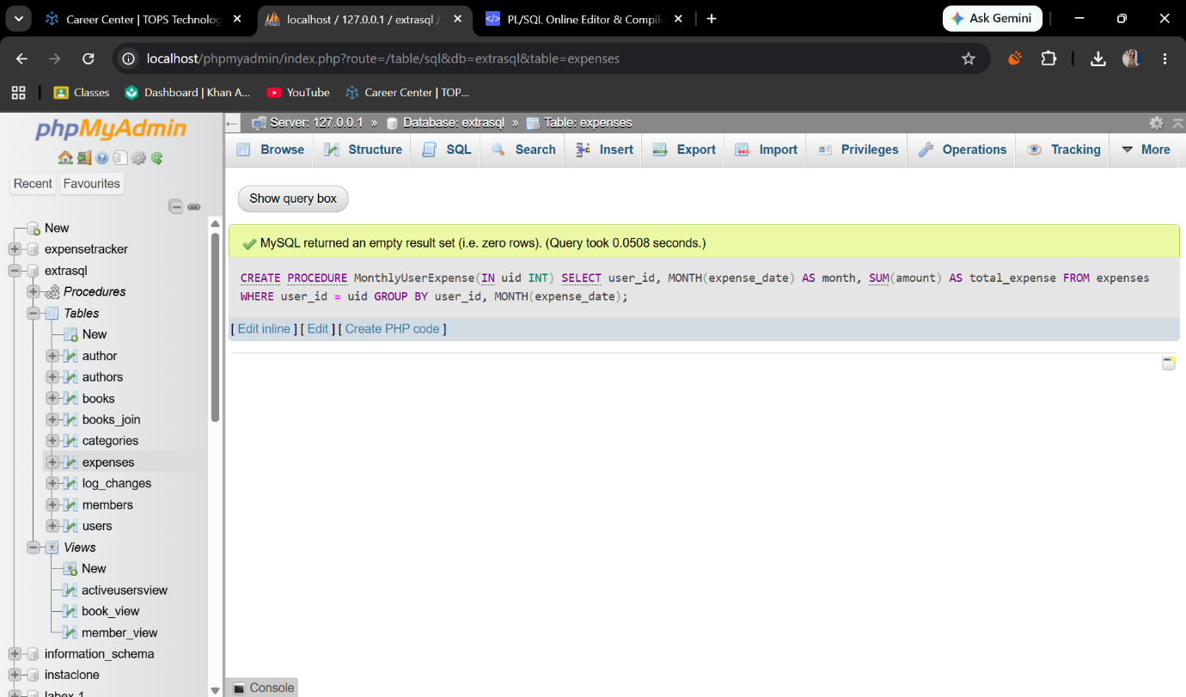
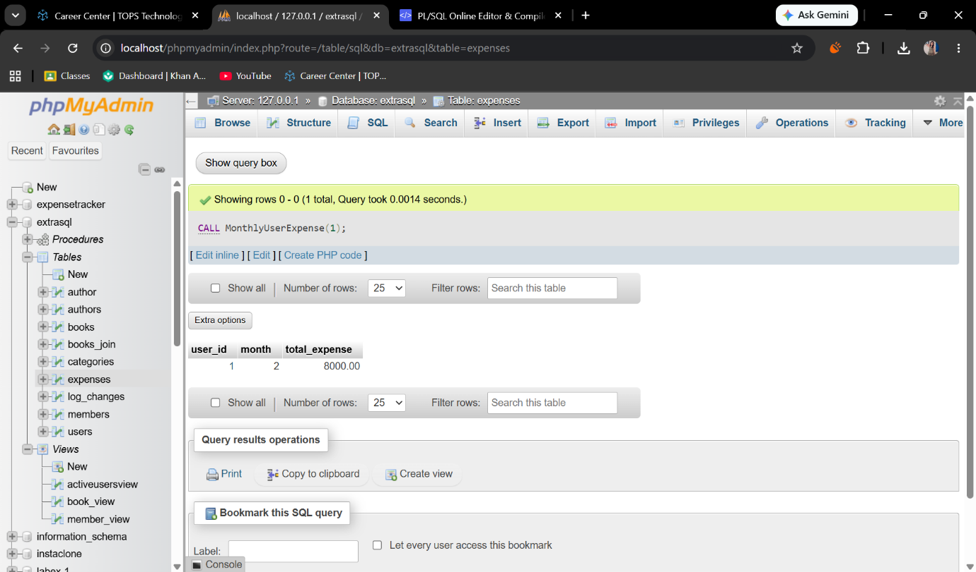
● Demonstrate COMMIT and ROLLBACK with example queries.
