MINI-PROJECT-3
1. Create a MySQL table called playlists to store Spotify-style music playlists, with columns: playlist_id (primary key), user_id (foreign key), name (varchar), and created_at (datetime). Write the CREATE TABLE statement.
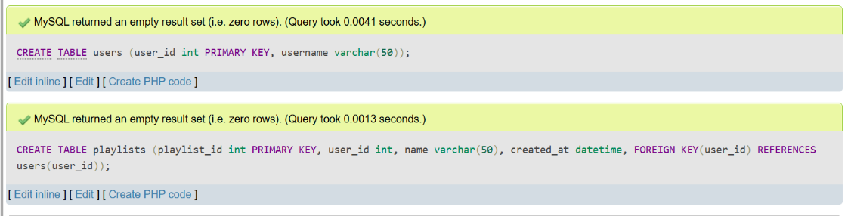
2. Insert three sample records into the playlists table: one for a user with a 'Workout Mix', one with a 'Chill Vibes', and one with a 'Top Hits' playlist. Use realistic data for each field.
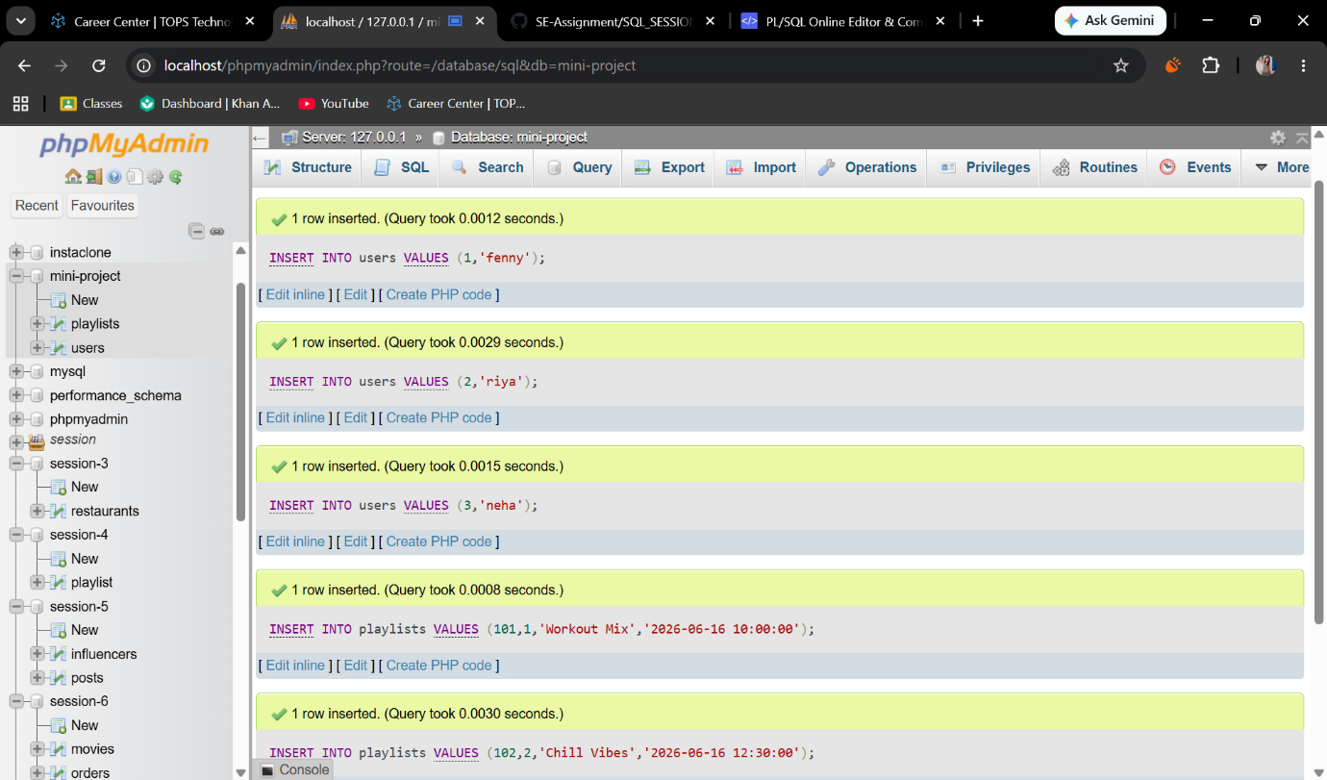
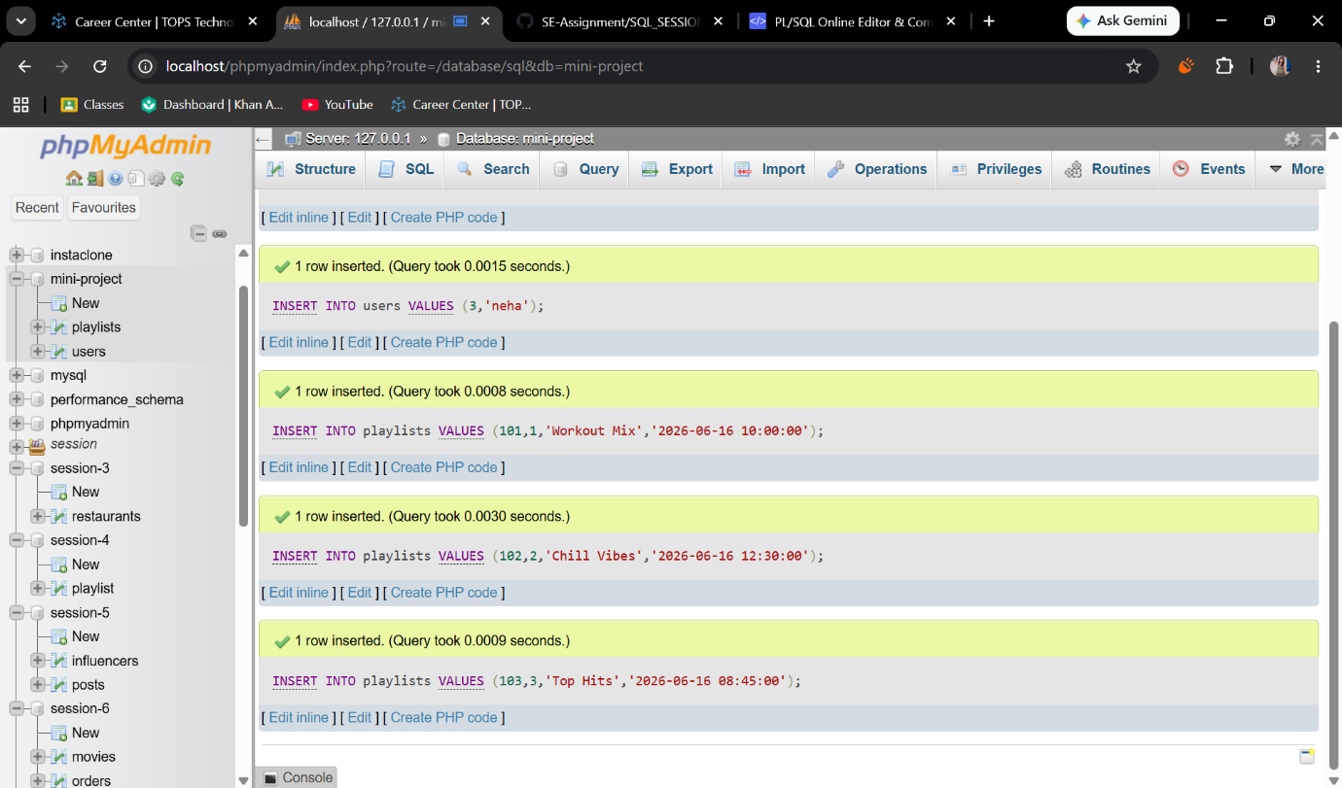

3. Write an SQL UPDATE statement to rename the 'Chill Vibes' playlist to 'Evening Chill' for a specific user_id.
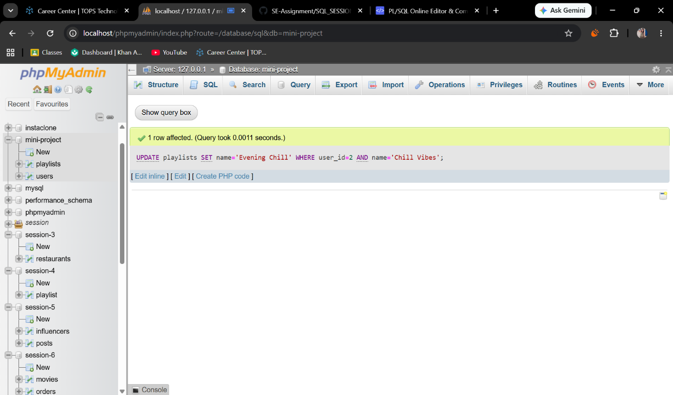

4. Write a DELETE statement to remove a playlist named 'Workout Mix' for a given user_id from the playlists table.<br><br><em><strong>Hint:</strong> Make sure your WHERE clause targets only the intended row.</em>
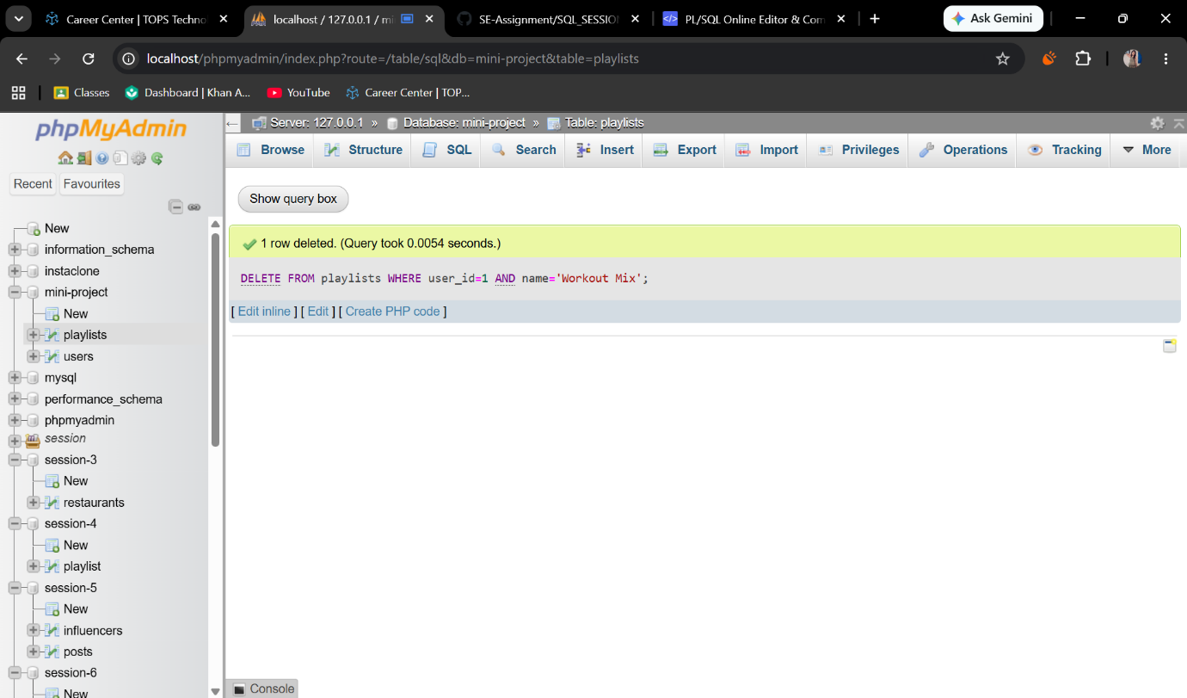
5.Create a stored procedure named GetMonthlyPlaylistCount that takes a user_id and a month (as an integer) as input, and returns the total number of playlists the user created in that month.<br><br><em><strong>Hint:</strong> Use the MONTH() function in your WHERE clause.</em>
