**Bitter**

**Bitter** is a social media developed in Indonesia. Originally a mobile-based application, the owner wants a website version to increase accessibility.

As a web developer, you are asked to create a website using JSP for this social media. There are two types of user’s role in this website: **Member**, and **Guest** (**non-logged-in user**).

Minimum pages you need to create are:

* + - **Member**
* Home
* Profile
* Edit Profile
* Search
* Logout
  + - **Guest**
* Login/Register

Each pages except login page shows **greeting to user**, **current** **date** **time**. **For logged in user**, the pages will also **total online user**. The descriptions for each page are:

* + - 1. **Login/Register**

This page provides login and register. Validate this page is accessible only to **guest**. For login, display an **error message** on this page if user enters wrong combination of **username** and **password**. The following table shows the existing fields in this page and validations for each field:

|  |  |
| --- | --- |
| **Field** | **Information** |
| **Username** | * + - Must be filled and appropriate to the data in the database |
| **Password** | * + - Must be filled and appropriate to the data in the database |

If user has entered correct U**sername** and **Password**, the page will be redirected to the **Home Page** and if user checks the “**Remember Me**” checkbox, the website will save the **username** using cookies for **1 day**.

For register, display an **error message** if user input incorrect personal data. The following table shows the existing fields on this page and the validation for each field.

|  |  |
| --- | --- |
| **Field** | **Information** |
| **Username** | * + - Username must be filled     - Username may not be already exists in database |
| **Password** | * + - Must be filled with **alphanumeric**. |
| **Full Name** | * + - Must be filled and only can contain **alphabet** and **whitespace**     - Minimal length is **8 characters** |
| **Birth Date** | * + - Must be filled in “**mm/dd/yyyy**“format     - Minimal current age is **17 years old** |

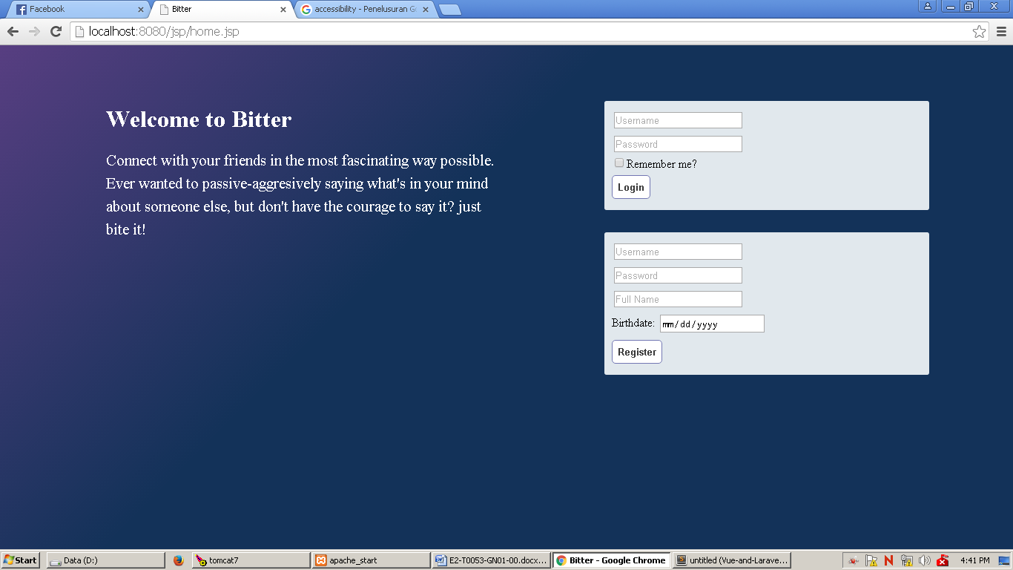

***Login/Register Page (for Guest)***

1. **Home**

This page allows users to see all **tweets from users whom he/she follows and the user’s own tweet** and **search** **tweets** and **users**, this page is accessible for all users **except** **guest.**  For every tweet:

* **Validate** if the tweet is owned by **current user**, display a link to **delete** and **update** that tweet.
* Display a link to **favorite** the tweet, if a tweet has been already **Favorited** by **current user**, display a link to **unfavorite** the tweet.
* If a word in any tweet starts with a **hashtag** (# sign), that word will appear as a link to **search** for any tweet that contains that word that including the **hashtag**.

Tweets are displayed using **paging** with **5** tweets for each page. Display **current date**, **number of online users**, and **user**’**s profile** containing full name, birthdate, and number of users he/she is following, and link to **edit profile** page. There’s also a **textbox** in which user can make a new **tweet**. Users who want to make a new tweet have to fill in the textbox, and click on the Tweet button. This will save the information about the new tweet like tweet date, tweet content, and tweet owner to database. If the tweet contains words that begins with a **hashtag** (# sign), check if those words exist in database. If there is not, save the new word to database, otherwise, you can skip this step. In either case, save a new entry for the relation between the hashtagand tweet, containing hashtag’s ID and tweet’s ID.

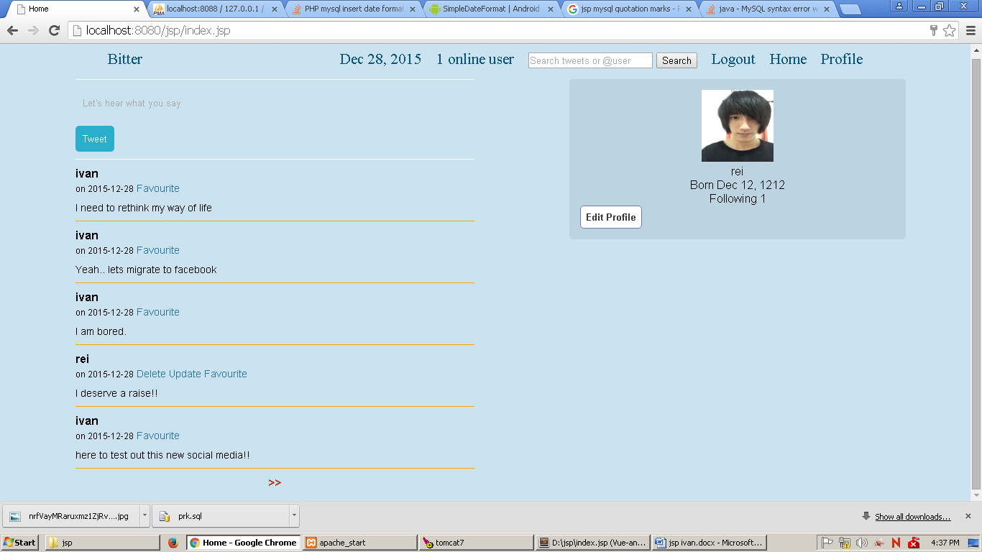

***Home Page***

1. **Profile**

This page displays a **user’s profile** and **his**/**her tweets**. **Validate** if the page is displaying profile of **current** **user**, display a link to **edit profile** and provide **textbox** to make new tweet, otherwise, display a link to **follow** or **unfollow** that user.

If the page is displaying current user’s profile, user can choose to display between **all** or **favorited tweets**.

For every tweet:

* **Validate** if the tweet is owned by **current user**, display a link to **delete** and **update** that tweet.
* Display a link to **favorite** the tweet, if a tweet has already been **favorited** by **current user**, display a link to **unfavorite** the tweet.
* If a word in any tweet starts with a **hashtag** (# sign), that word appears as a link to **search** for any tweet that contains that word, including the **hashtag**.

Whether the page is displaying current user or other user, display **current date**, **number of online users**, **search** **textbox**, and **user**’**s profile** containing full name, birthdate and number of users he/she is following. For creating new tweet, same rules apply as in Home page. Users who want to make a new tweet have to fill in the textbox, and click on the Tweet button. This will save the information about the new tweet like tweet date, tweet content, and tweet owner to database. If the tweet contains words that begins with a **hashtag** (# sign), check if those words exist in database. If there is not, save the new word to database, otherwise, you can skip this step. In either case, save a new entry for the relation between the hashtagand tweet, containing hashtag’s ID and tweet’s ID

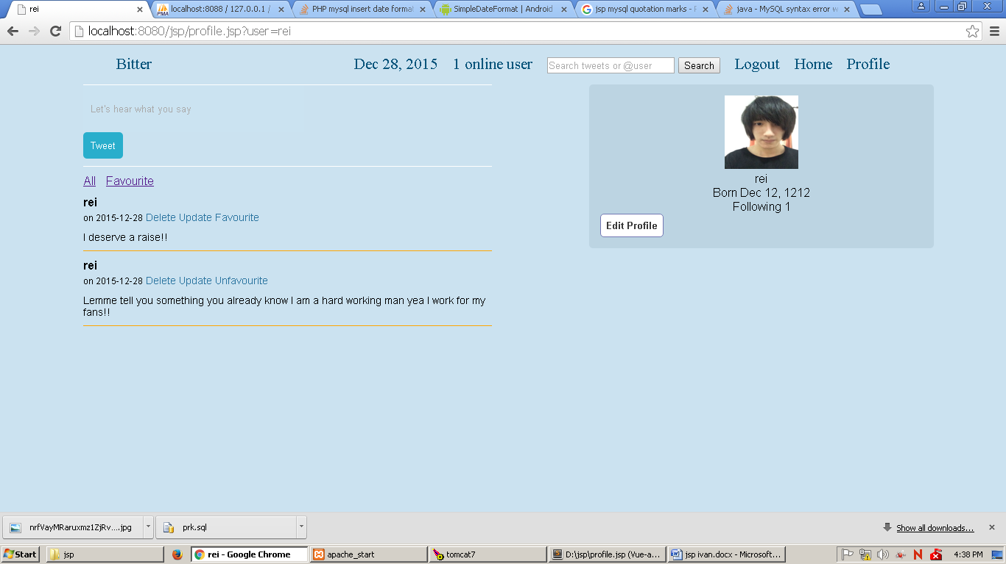

***Profile page (Current user)***

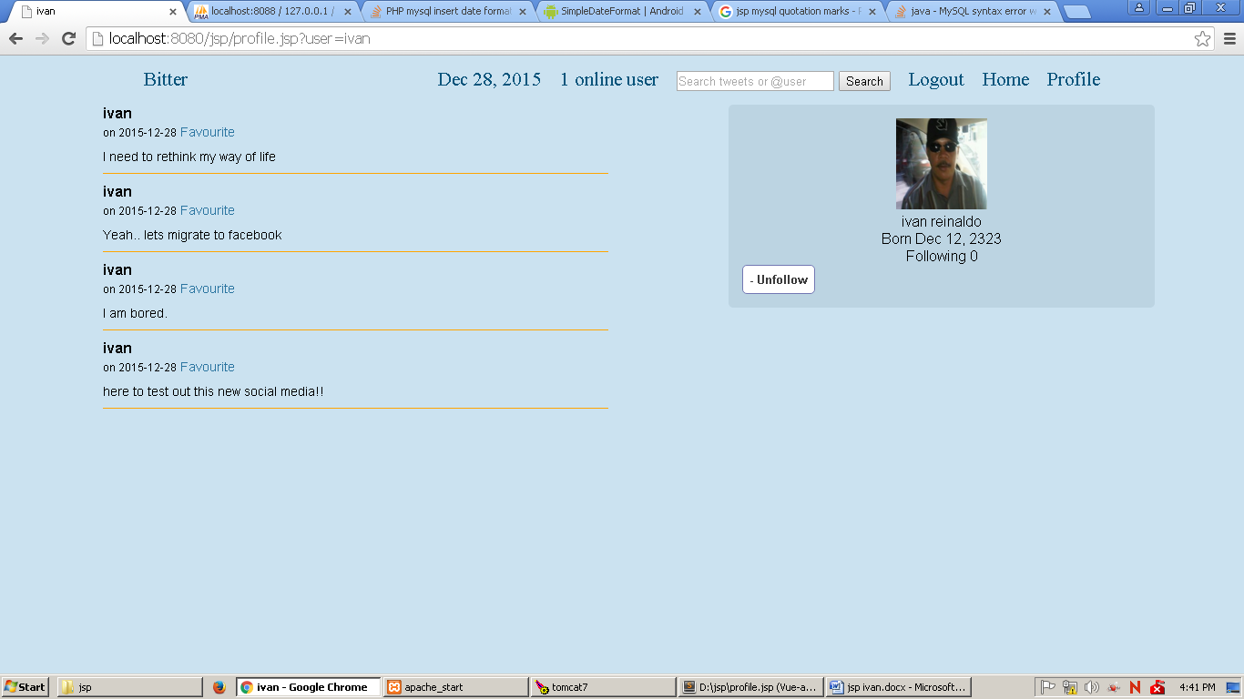

***Profile page (another user, following)***

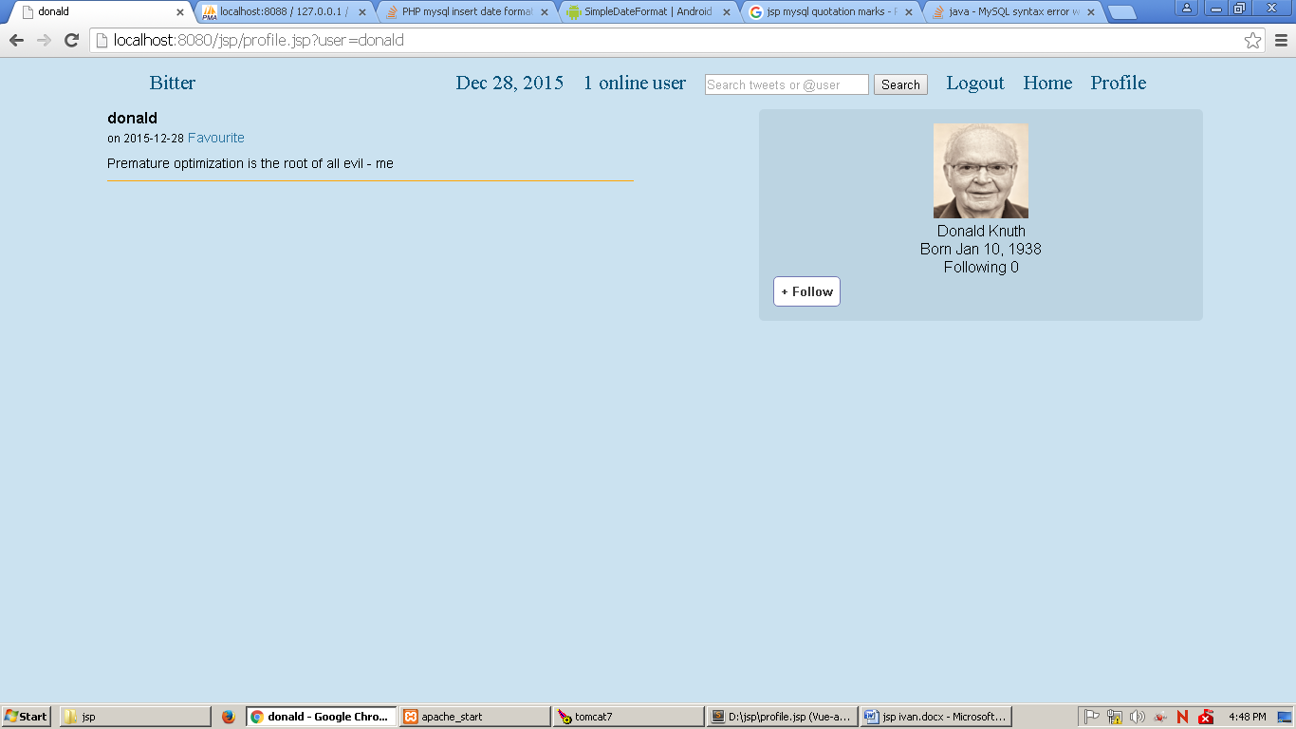

***Profile page (another user, not following)***

1. **Edit Profile**

This page allows **user** to update his profile and **deactivate his**/**her account**. This page will be shown if **user** clicks **Edit Profile** button in **Home** or **Profile** page. Display **error message** if **user** updates with incorrect data. The following table shows existing fields in this page and the validation for each field:

|  |  |
| --- | --- |
| **Field** | **Information** |
| **Full Name** | * + - Must be filled and only can contain **alphabet** and **whitespace**     - Minimal length is **8 characters** |
| **Password** | * + - Must be filled with **alphanumeric**. |
| **Birth Date** | * + - Must be filled in “**mm/dd/yyyy “**format     - Minimal current age is **17 years old** |
| **Profile Picture** | * + - Image extension must be **jpg** |

Deactivating account will get the user to **log out** and **delete the user**, **user’s tweet** and relations like **follow** and **favorite activities** will also be deleted.

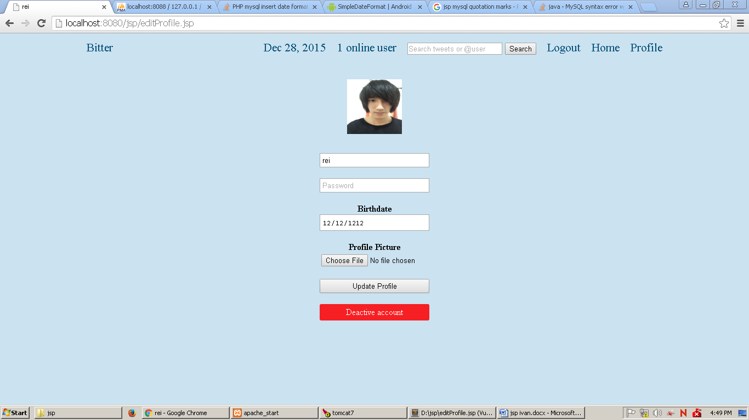

***Edit Profile page***

1. **Search**

This page displays **a search result** which the user may have entered from **any page** except login. There are two kinds of search: **user search** and **tweets search**. **User search** always starts with ‘**@**’ (at sign). If the user searches for tweets, display **all tweets** that contain word the user had entered, along with link to profile of the tweet’s owner. Otherwise, if user **searches for user**, display all users whose username contains the user had entered, without the ‘**@**’ sign, along with each user’s birthdate and link to user’s profile.

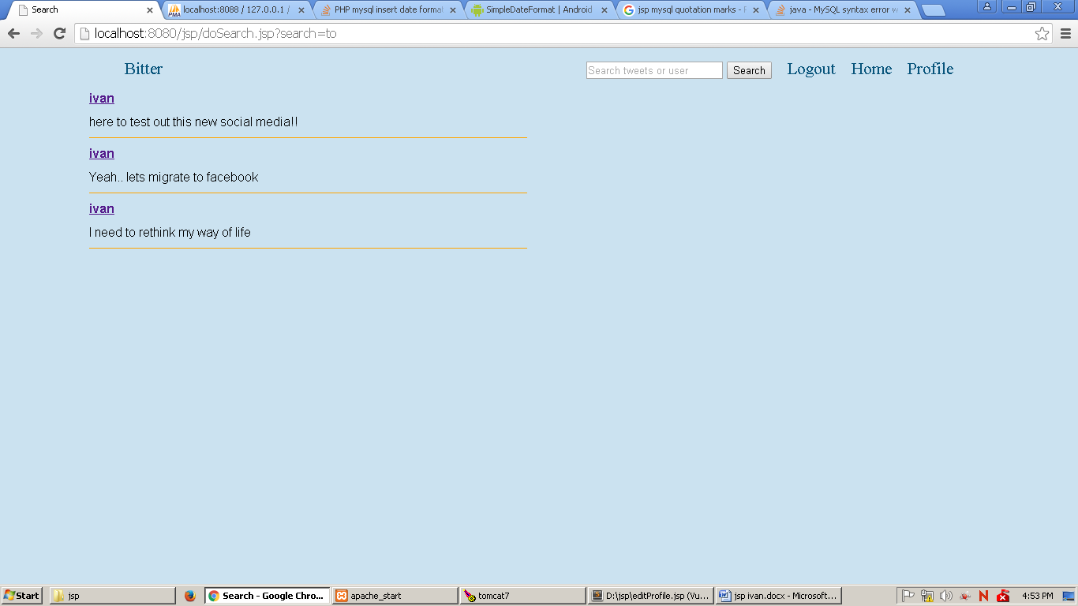

***Search result (tweet search)***

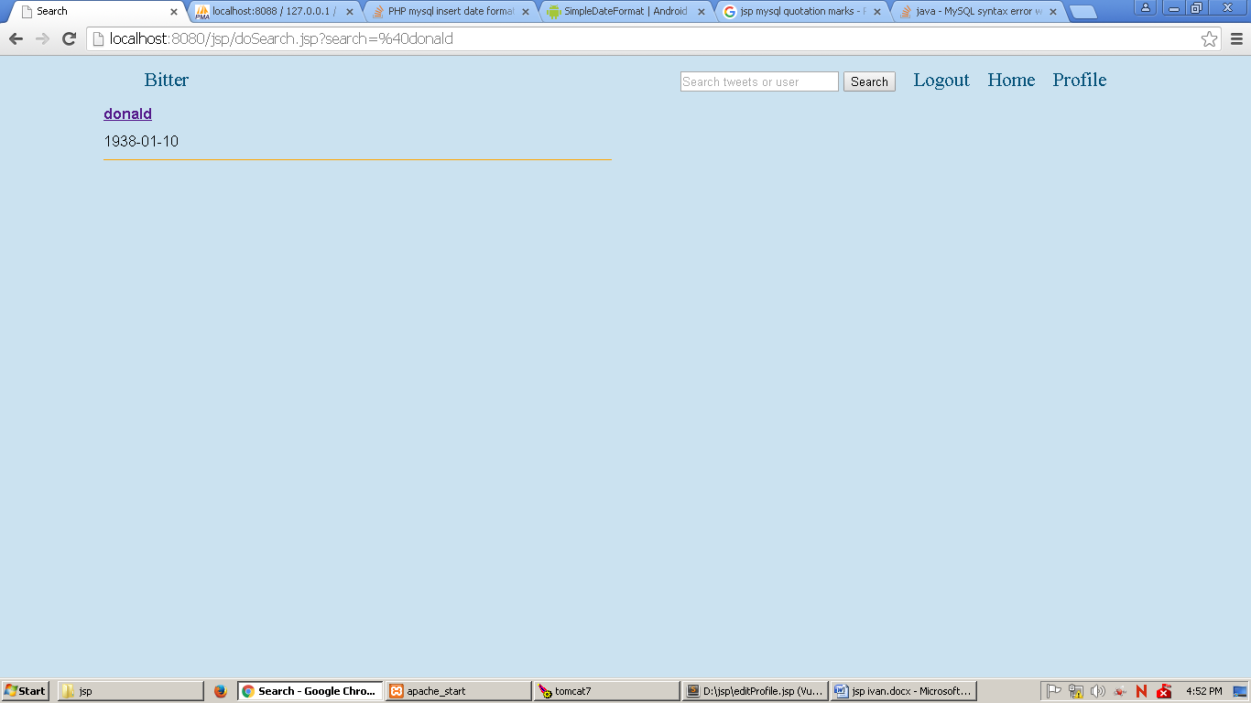

***Search result (user search)***