**D’warneTS**

“**D’warneTS**”is an internet café that provides many online games. To simplify data management, the manager wants to use desktop application to record every transaction that has been done, and to help manage the computers. They decided to hire your service as a programmer to create the application. Here are the requirements that need to be done:

**Database:**

* + - 1. **MsUser**

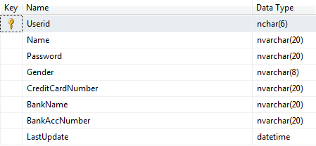

* **MsComputer**

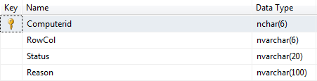

* **MsPayment**

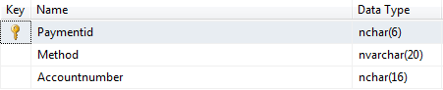

* **DetailTransaction**

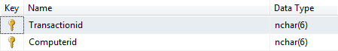

* **HeaderTransaction**

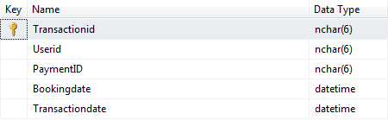

**Application:**

* + - 1. **Loading Screen**



**Components:**

* **Label** for status loading
* **ProgressBar** for loading progress
* **PictureBox** for Image

**Description:**

* If progress bar full, close loading screen and show login form.

1. **Login Form**

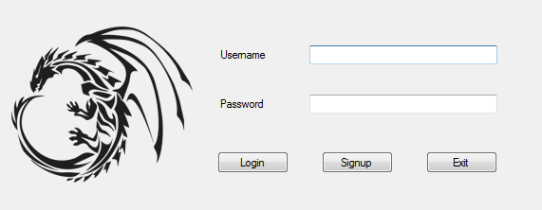

This Form is used to login and will appear when user open the application or logout.

**Components:**

* **Label** for Username and Password
* **Textbox** for Username and Password
* **Button** for Login, Signup and Cancel

**Description:**

* If **Login Button** is clicked, then validate :
* If Username or Password textbox is empty, then show error message “**Username and password cannot be null**”.
* If Username or Password length is not between 6 and 16, then show error message “**Username and password length must be between 6 and 16**”.
* If Username is **not** **alphanumeric**, then show error message “**Username must be alphanumeric**”.
* If Password is **not** **alphanumeric and not contain upper-case and lower-case letter**, then show error message “**Password must be alphanumeric and combine capital and non-capital letter**”.
* If Username and Password don’t match with data in **MsUser** table then show error message “**Id and password not valid**”.
* If Employee ID, Password, and Role match with data in **MsUser** table, then Login Form will close and Main Form will be active.
* If **Exit Button** is clicked, then the program will be closed.
* If **Signup Button** is clicked, then signup form will be opened and login form will be closed.

1. **Register Form**

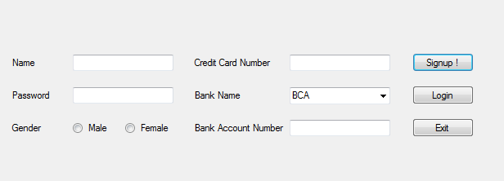

**Components:**

* **Button** for Signup, Login and Exit
* **Label** for Register Name, Password, Gender, Credit Card Number, Bank Name, and Bank Account Number
* **Textbox** for Name, Password, Credit Card Number, and Bank Account Number
* **Combo Box** for Bank Name (contains BCA, Mandiri, and Permata)
* **RadioButton** for Gender (Male and Female)

**Description:**

* Userid is automatically generated from **MsUser** with format **[USxxxx] plus by 1**. For example if the last User ID is **“US0002”**, then the program will generate it into **“US0003”**.
* If Signup Button is clicked, then validate :
* If Name length is not between 6 and 16, then show error message “**Username length must be between 6 and 16**”.
* If Password length is not between 6 and 16, then show error message “**Password length must be between 6 and 16**”.
* If Name is not alphanumeric, then show error message “**Username must be alphanumeric**”.
* If Password is not alphanumeric and not contain capital and non-capital letter, then show error message “**Password must be alphanumeric and combine capital and non-capital letter**”.
* If gender is not selected, then show error message “**Select Gender**”.
* Credit Card Number must be 16 digits, otherwise show error message “**Credit Card Number must be 16 digits**”.
* Credit Card Number must be numeric, otherwise show error message “**Credit Card Number must be numeric**”.
* Bank Name Contains BCA, Mandiri, and Permata.
* Bank Account Number must be between 10 and 16 digits, otherwise show error message “**Bank Account Number must be between 10 and 16 digits**”.
* Bank Account Number must be numeric, otherwise show error message “**Bank Account Number must be numeric**”.
* If Login Button is clicked, login form will be opened.
* If Exit Button is clicked, the program will be closed.

1. **Main Form**

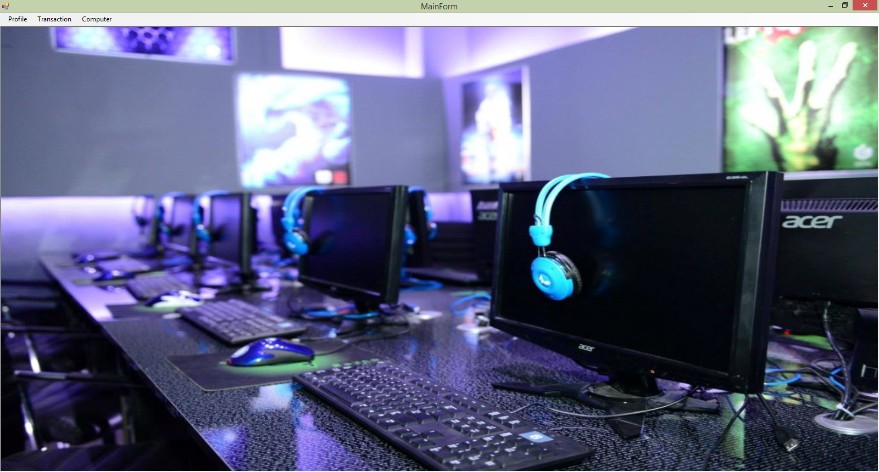

Main Form is MDI Form that contains submenu to open other forms.

**Components:**

* **Menu Strip** for the main menu
* **Tool Strip** for **Profile**, **Transaction**, and **Computer**

**Main menu:**

* **Profile**
* **My Profile =>** Show **Profile Form**
* **Logout =>** Log out and go back to **Login Form**
* **Transaction**
* **New Booking =>** Show **Booking Form**
* **Booking History =>** Show **History Form**
* **Computer**
* **Control Computer =>** Show **Control Form**

**Description:**

* For **admin**, can access all form except Profile form (Hide the profile tool strip).
* For **user**, can access all form except Control form (Hide the control tool strip).

1. **Profile Form**

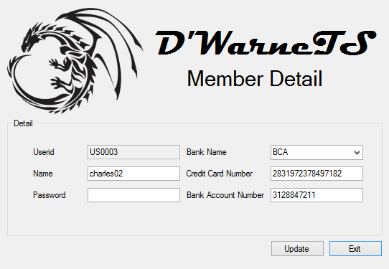

**Components:**

* **GroupBox** for Detail.
* **Button** for Update and Exit.
* **Label** for Title, Userid, Name, Password, Credit Card Number, Bank Name, and Bank Account Number.
* **Textbox** for Userid, Name, Password, Credit Card Number, and Bank Account Number.
* **ComboBox** for Bank name.
* **PictureBox** for Image.

**Description:**

* Show all data about the user into correct textbox except the password.
* If Update Button is clicked, then validate :
* If Name length is not between 6 and 16, then show error message “**Username length must be between 6 and 16**”.
* If Password length is not between 6 and 16, then show error message “**Password length must be between 6 and 16**”.
* If Name is not alphanumeric, then show error message “**Username must be alphanumeric**”.
* If Password is not alphanumeric and not contain capital and non-capital letter , then show error message “**Password must be alphanumeric and combine capital and non-capital letter**”.
* If gender is not selected, then show error message “**Select Gender**”.
* Credit Card Number must be 16 digits, otherwise show error message “**Credit Card Number must be 16 digits**”.
* Credit Card Number must be numeric, otherwise show error message “**Credit Card Number must be numeric**”.
* Bank Name Contains BCA, Mandiri, and Permata.
* Bank Account Number must be between 10 and 16 digits, otherwise show error message “**Bank Account Number must be between 10 and 16 digits**”.
* Bank Account Number must be numeric, otherwise show error message “**Bank Account Number must be numeric**”.
* Users can only **update** **Bank Account Number** or **Credit Card Number once in 30 days**.

1. **Booking Form**

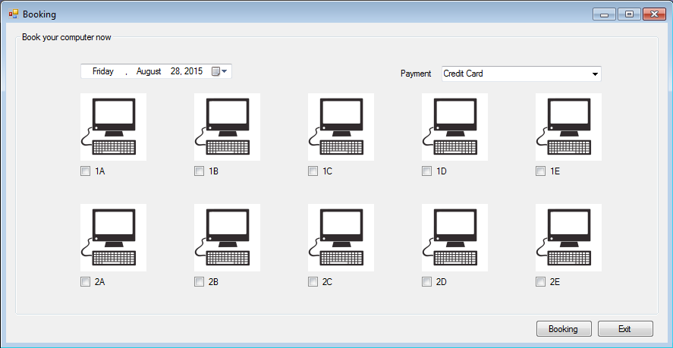

**Components:**

* **DateTimePicker** tochoose booking date
* **CheckBox** to pick computer to book.
* **Button** for Booking and Exit
* **Label** for Computer Number and reason if computer is not online
* **ComboBox** for Payment (Credit Card, Transfer - BCA, Transfer - Mandiri, Transfer - Permata)
* **PictureBox** for Photo

**Description:**

* **Adjust** the **mininum date** of datetimepicker to the system time.
* **Payment** have 4 static content (Credit Card, Transfer - BCA, Transfer - Mandiri, Transfer - Permata)
* If there is any **computer booked on the date** on datetimepicker, the checkbox on these computers will be **read only and checked**.
* If there is any **computer** on offline status, the checkbox on these computers will be **read only** and **the reason is listed** below the checkbox.
* The status of every computer will be refreshed every datetimepicker value changed.
* If Bookingbutton is clicked, the program will save the transaction to database.

1. **Booking History Form**

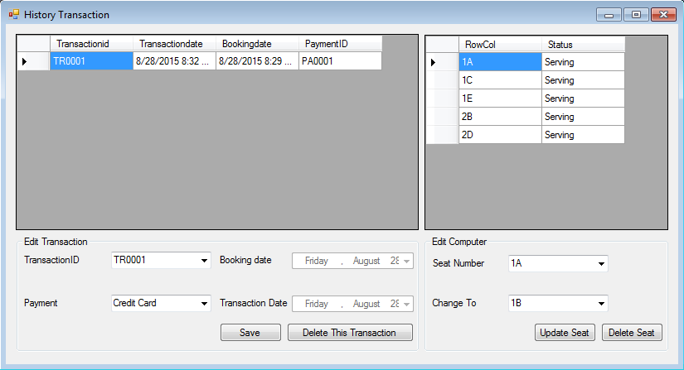

**Components**:

* **DataGridView** to show all transaction from online user**,** and seat detail from selected transaction.
* **DateTimePicker** to show booking date and transaction date.
* **Button** for Save, Delete Transaction, Update Seat, and Delete Seat.
* **Label** for TransactionID, Payment, Booking Date, Transaction Date, Seat Number, and New Seat Number.
* **ComboBox** for TransactionID, Payment, Seat Number, and New Seat Number.

**Description**:

* **TransactionID** contain **all ID of transactions that user did** in the past.
* Booking date and Transaction date are **read only.**
* **Payment** have **4 static content** (Credit Card, Transfer BCA, Transfer Mandiri, Transfer Permata).
* If **DataGridView of Transaction** is clicked, then show all information to the existing fields based on clicked TransactionID, and update DataGridView of seat detail.
* If Save button clicked, **update** the **payment** of chosen TransactionID.
* If Delete button clicked, **delete** the **payment** of chosen TransactionID.
* The "**Seat** **Number**" combo box **only contain** the row and column of **computers thats user booked on the selected TransactionID.**
* The "**Change** **to**" combo box **only contain** the row and column of **computers thats no one booked on the booking date of the selected TransactionID**.
* If Update Seat button clicked, **update** the seat in the database based on "**Seat Number**" and "**Change To**" the combobox.
* If Delete Seat button clicked, **delete** the selected seat number of the **TransactionID** in the database.

1. **Control Form**

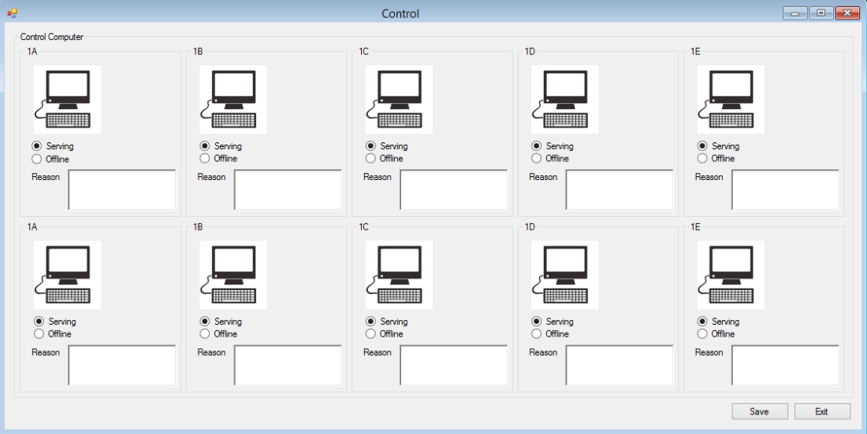

**Components:**

* **Button** for Save and Exit.
* **GroupBox** for each computer.
* **RichTextbox** for reason to make computer offline.
* **RadioButton** status for each computer.
* **PictureBox** for images.

**Description:**

* All computers have 2 status. Serving and offline.
* **Serving** means computers are working **properly** and registered users **can book** that computers.
* **Offline** means computer is **on defect** status that cause user **can't book** that computer.
* Everytime this form **called or opened**, each computer status and reason will be **set to current status**.
* If button save clicked, Validate that offline computer must have reason:
  + If **all** **offline** computers **have reason**, program will show messages "Computer Update Success".
  + If there is **an** **offline computer without reason**, the program will update all computer status **except** the one that **offline computer without reason**. And the system will inform the user "**There is an offline computer without reason**".

**NOTE :**

1. The numbers of computer is static. There are 10 computers.
2. There is 1 pre-registered user with id **US0001** that act as admin which can control computer with name "admin1" and password "Admin1"