**Bluejack Music**

**Bluejack Music** is an application to recognize album’s information according to the image. First, the program will ask the user to input several albums information, including its album cover. The program will use ANN (*Artificial Neural Network*) to process the provided data. There are conditions that must be fulfilled before processing the photo:

* Input: **resize** the photo size (JPG, PNG, BMP) to **7x7 pixels**, then **preprocessing** the image into **gray scale**. Total input in neural network must be **49 nodes**
* Output: there are **10 digits output** representing the album cover

**First Picture : 1000000000**

**Second Picture : 0100000000**

**Third Picture : 0010000000**

**Fourth Picture : 0001000000**

**Fifth Picture : 0000100000**

**Sixth Picture : 0000010000**

**Seventh Picture : 0000001000**

**Eighth Picture : 0000000100**

**Ninth Picture : 0000000010**

**Tenth Picture : 0000000001**

* Method: **Back propagation**
* Activation Function: **Sigmoid**
* Goals: **0.0000001**
* Max Epochs: **10000**

Example:

Initial Image Preprocessing Output

1000000000

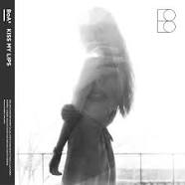 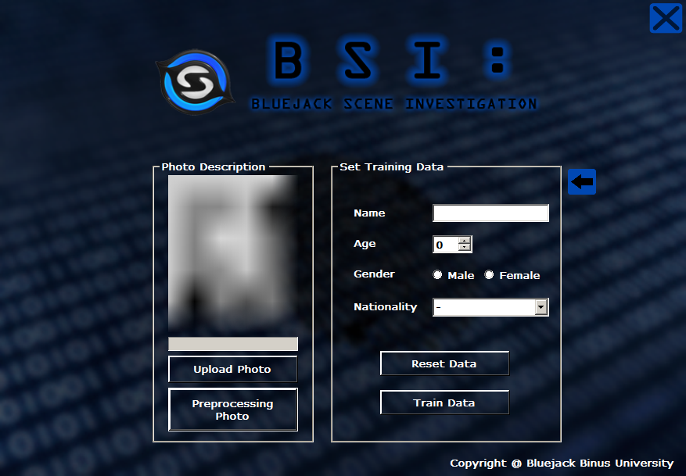

1. **Main Menu**

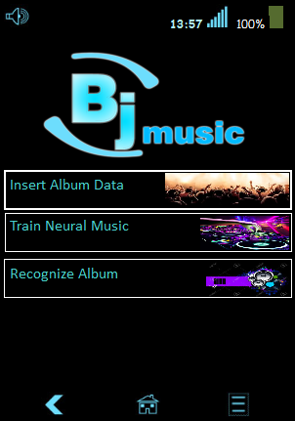

**Main Menu of Bluejack Music**

**Components:**

* **Picture Box**: Bluejack Music Logo, Icon
* **Label**: Time, Battery power text, Button text
* **Button**: Menu Button,Back Button, Home Button, Option Button
* **Panel** : Battery, Main Screen

**Description:**

* The program will start with this interface
* If the user presses back button, the application will exit.
* If the user click Insert Album Data, then the screen will change to insert album data screen.
* If the user click Train Neural Music, then the screen will change to train neural data screen.

1. **Insert Album**

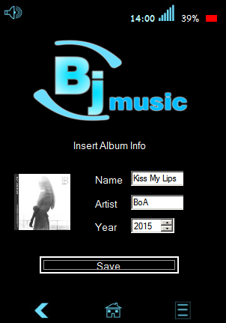

**Insert Album Interface**

**Components:**

* **Picture Box**: Bluejack Music Logo, Album Photo, Icon
* **Label**: Name, Artist, Year, Title
* **Button**: Save Button, Menu Button,Back Button, Home Button, Option Button
* **Text Box :** Name, Artist
* **Numeric Up Down** : Year
* **Open File Dialog**: Browse the Image
* **Panel** : Battery, Main Screen

**Description:**

* Initial State:
  1. The picture box’s default image will show “no image” image.
  2. All fields are empty and numeric year start in 1900
* If the **Upload Photo** button is clicked, then:
  1. Show file dialog to choose the picture.
  2. Validate the **image extension** must be “**.jpg**”**,** “**.png**”, or “**.bmp**”.
  3. After successfully load the image, **show** the **image** in the **picture box**.
* If the **Save Photo** button is clicked then:
  1. Validate the album cover must be uploaded and show message to upload album cover if the user choose to save before upload it.

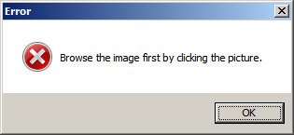

**Error dialog to upload album cover**

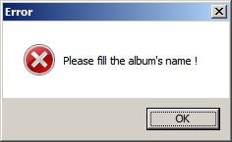

**Error dialog to fill the album’s name**

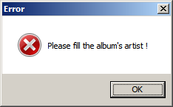

**Error dialog to fill the album’s artist**

1. **Train Data**

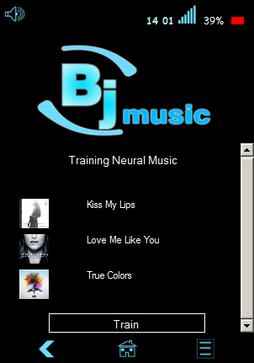

**Show all data before train them**

**Components:**

* + **Picture Box** : Album Cover, Bluejack Music Logo
  + **Label** : Album name, Title
  + **Button**: Save Button, Menu Button,Back Button, Home Button, Option Button
  + **Panel** : Battery, Main Screen

**Description:**

* Initial State
  1. If there are no data to be trained, then show label with “**No data to be trained**” text.
  2. Otherwise, show all album cover and their title.
  3. If the user click the train button, then the application will train the neural from the first data inserted to the last data.

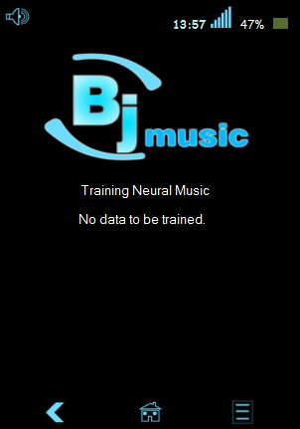

**No data to be trained screen**

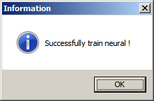

**Successfully train the data**

1. **Recognize Data**

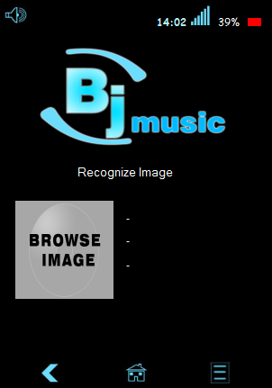

**Recognize Data of Album**

**Components:**

* **Label**: Name, Artist, Year
* **Picture Box**: Bluejack Music Logo, Icon, Browse Image
* **Panel** : Main screen, Battery Level
* **Open File Dialog**: Upload Photo

**Descriptions:**

* Initial State:
  1. Value of name, artist, and year are empty.
  2. If there are no data to be trained, then show no data to be recognized
* If the **Browse Image** button is clicked, then:
  1. Open the dialog so the user can choose the album cover.
  2. Validate the **image extension** must be “**.jpg**”,“**.png**”, or “**.bmp**”.
  3. Image is **gray scaled** and resized to **7x7 pixels**.
  4. After the image loaded successfully, **show** the **image** in the **picture box** and its information.

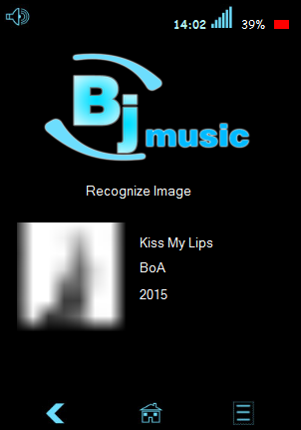

**Recognize Data of Album**

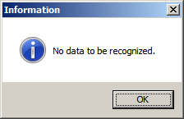

**Information Message Recognize Album**

* If the user clicks **Back Arrow,** then the application will back to main menu.

References:

http://1.bp.blogspot.com/-g0C6j8-LM1s/VVKlpIkXHbI/AAAAAAAAm1k/3O8ehYMGePM/s0/boa_kiss_my_lips_cover.jpg

http://www.lavozdaily.com/wp-content/uploads/2015/01/10257392_10152443833401642_5065608720609159165_o.jpg

http://img.ccrd.clearchannel.com/media/mlib/1794/2015/05/default/zedd_0_1431358567.jpg