**PhotoRush**

**PhotoRush** is a simple application where user can add effect to their image or video. You as a programmer are asked to create this program:

* + - * 1. **Login Form**
    - When the **application is started**, user is asked to **login**
    - Components of login form are :
* **Label** : Title, Username, Password
* **Text Box** : Username, Password
* **Link Label** : Sign Up
* **Button** : Login
  + - Validation and Action :
* If user click **Login Button** then the application will:
  + Validate **username** and **password** field must be **filled**
  + Validate **username** must be a **registered username**
  + Validate **password** must be **same** with the **registered username’s password**
  + If user **input data correctly**, the application will redirect to **home page**
* If user click **Sign Up Link Label**, then the application will redirect to **Register Form**

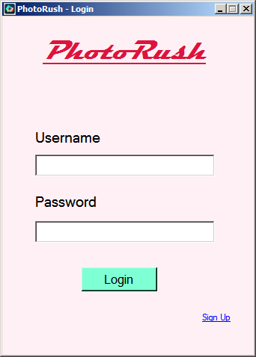

**Login Form**

1. **Register Form**
   * + Components of register form are :

* **Label** : Title, Name, Username, Password, Email
* **Text Box** : Name, Username, Password, Email
* **Button** : Register
* **Link Label** : Login
  + - Validation and Action :
* If user click **Register Button** then the application will:
  + Validate **name**, **username**, **password**, and **email** field must be **filled**
  + Validate **name** must be in following format :
    - Name character **length** must be **between 3 - 20**
  + Validate **username** mustbe in following conditions:
    - Username character **length** must be **between 3 – 15**
  + Validate **password** mustbe in following conditions:
    - Password character **length** must be **between 6 - 20**
    - Must be **Alphanumeric**
  + Validate **email** must be in following format :
    - Email must contain At (@) character
  + If user **input data correctly**, the new user data will be registered and **back to login form**
* If user click **Login Link Label**, the application will redirect back to **login form**

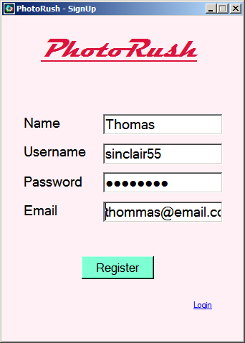

**Register Form**

1. **Home Page**
   * + When the home page is opened, user will be asked **to browse image or video**.
     + Components of home page are:

* **Picture Box** : Show image or video chosen
* **Label** : Show image or video file name when chosen
* **Button** : Browse Image, browse video, grayscale, threshold, smoothing, shape detection, object detection, edge detection
  + - Validation and Action :
* If user **haven’t choose image or video**, **effect** **button** will be **disable**
* If user **choose browse image button**, then it will **only filter image file extension** (**.jpg**, **.jpeg**, **.png**).
* If user **choose browse video button**, then it will **only filter video file extension** (**.mp4**).
* If user **haven’t choose any picture or video**, then there is a **label** “**Browse Image or Video**”
* Only **grayscale button and object detection button enable** when **video file** **is** **chosen**, and **enable all effect buttons** when **image file is chosen**.
* If user choose effect button, the effect form will show up based on the effect button chosen.

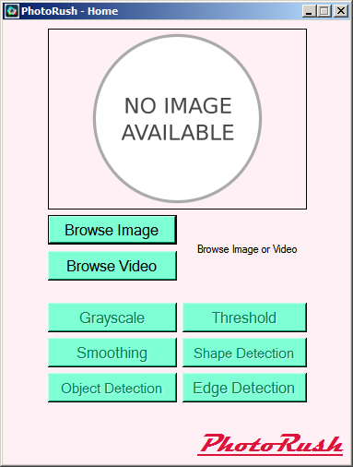

**Home Page when no image or video chosen**

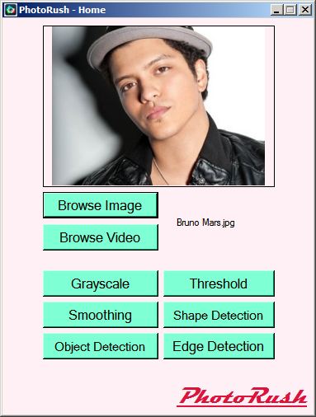

**Home Page when image is chosen**

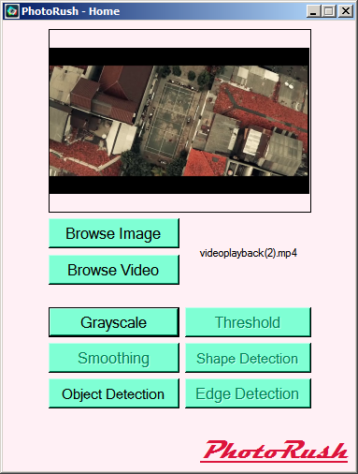

**Home Page when video is chosen**

1. **Grayscale Form**

* Components of post form are :
* **Picture Box** : Chosen image or video
* **Button** : Save image
* When the grayscale form is opened, it will **show gray scaled image or video**
* **Save Image** **button** only shown when image file is chosen
* A gray scaled video **will play automatically**
* Validation and Action **:**
* If user click **Save Button**, then grayscaled image will be saved with file name **Graycaled.jpeg** and show message “**Image Saved to [Save Place]**”.

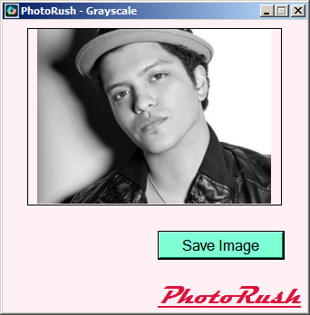

**Grayscale Form with gray scaled image**

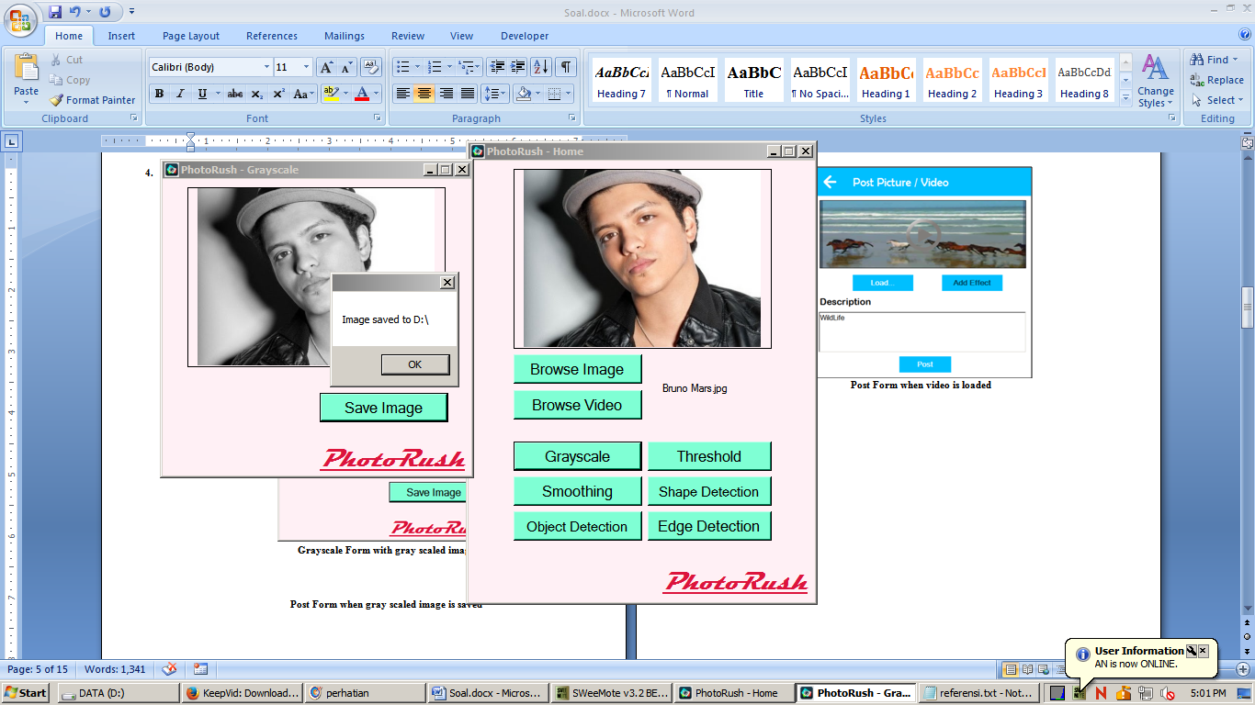

**Grayscale Form when gray scaled image is saved**

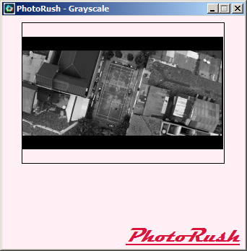

**Post Form when gray scaled video play**

1. **Threshold Form**

* Components of post form are :
* **Picture Box** : Chosen image
* **Combo Box** : Binary, Binary Inverse, Zero, Zero Inverse
* **Numeric Up Down** : High value, low value
* **Button** : Save image
* **Label** : High, low
* When the threshold form is opened, it will **show image with selected threshold effect**
* Numeric up down high and low values determine threshold effect and make effect will whenever value changed
* Threshold effect also change when combo box item is changed
* Validation and Action **:**
* If user click **Save Button**, then image with threshold effect will be saved with file name **[Threshold type] .jpeg** and show “**Image saved to [Save Place]**” message box.
* **Maximum** value of numeric up down is **1000**, **minimum** value of numeric up down is **0** with 11 for each step’s increment or decrement.

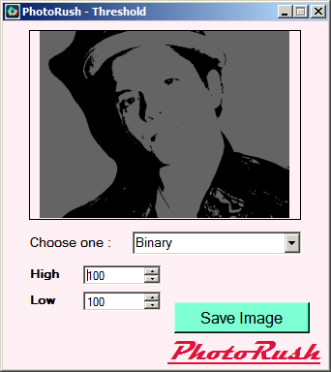

**Threshold form (Binary)**

1. **Smoothing Form**

* Components of post form are :
* **Picture Box** : Chosen image
* **Combo Box** : Gaussian, Median, Bilateral
* **Numeric Up Down** : Level
* **Button** : Save image
* **Label** : Level
* When the smoothing form is opened, it will **show image with selected smoothing effect**
* Numeric up down level values determine smoothing effect and make effect will whenever value changed
* Smoothing effect also change when combo box item is changed
* Validation and Action **:**
* If user click **Save Button**, then smoothing image will be saved with file name **[Smoothing type].jpeg** and show “**Image saved to [Save Place]**” message box.
* **Maximum** value of numeric up down is **1000**, **minimum** value of numeric up down is **0** with 11 for each step’s increment or decrement.

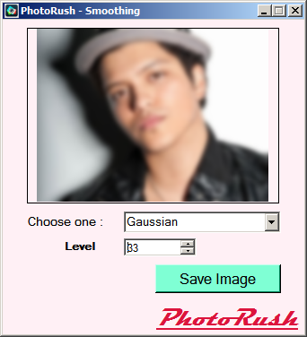

**Smoothing form (Gaussian)**

1. **Shape Detection Form**

* Components of post form are :
* **Picture Box** : Chosen image
* **Radio Button** : Lines, Rects, Circles, Triangle
* **Button** : Save image
* When the shape detection form is opened, it will **show image with selected shape detection radio button**
* Shape detection change when selected combo box is changed
* Validation and Action **:**
* If user click **Save Button**, then shape detection image will be saved with file name **Shape detection.jpeg** and show “**Image saved to [Save Place]**” message box.

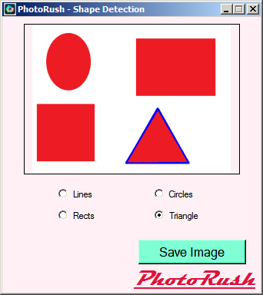

**Shape Detection form (Triangle)**

1. **Edge Detection Form**

* Components of post form are :
* **Picture Box** : Chosen image
* **Combo Box** : Sobel, Canny, Laplace
* **Button** : Save image
* **Numeric Up Down** : High, Low
* **Group Box** : Value
* When the edge detection form is opened, it will **show image with selected object detection radio button**
* Numeric up down high and low values determine edge detection effect and make effect will whenever value changed
* Edge detection effect also change when combo box item is changed
* Validation and Action **:**
* If user click **Save Button**, then edge detection image will be saved with file name **[Edge Detection type].jpeg** and show “**Image saved to [Save Place]**” message box.
* **Maximum** value of numeric up down is **255**, **minimum** value of numeric up down is **0** with 5 for each step’s increment or decrement.

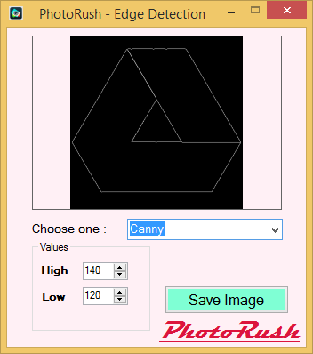

**Edge Detection form(Canny)**

1. **Object Detection Form**

* Components of post form are :
* **Picture Box** : Chosen image or video
* **Radio Button** : Camera, Video, Eyes, Face and Eyes
* **Button** : Save image
* When the object detection form is opened, it will **show image with selected object detection radio button**
* Object detection change when selected radio button is changed
* Validation and Action **:**
* If image file is chosen, video radio button will not visible
* If video file is chosen, video will be played automatically with selected object detection radio button
* If camera radio button is chosen, it will open web camera to detect object.
* If camera is not found, the application will show “**No camera found!**” message box.

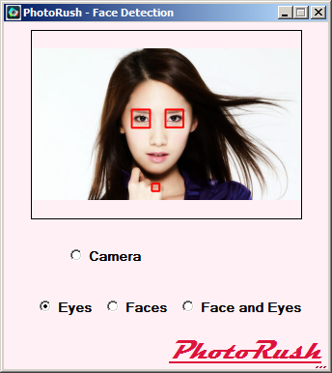

**Object Detection form (Image Eye detection)**

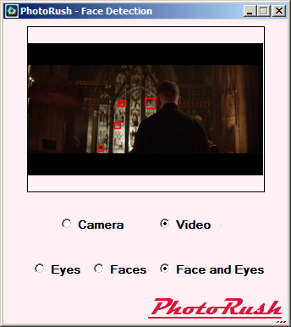

**Object Detection form (Video Face and Eyes detection)**



**Object Detection form (Camera Face and Eyes detection)**

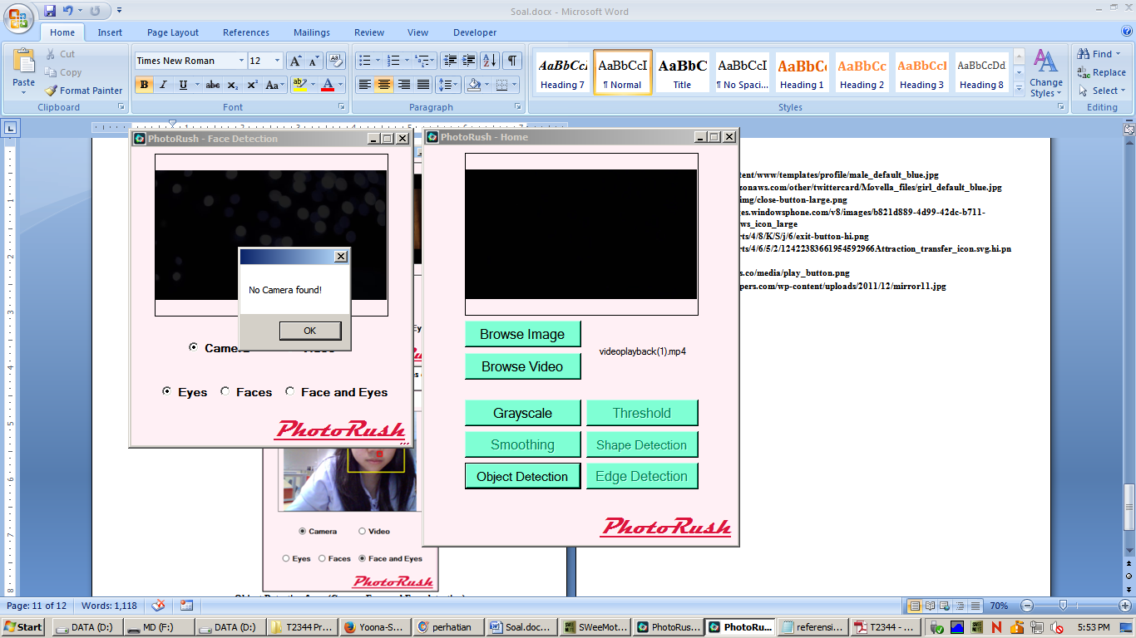

**Object Detection form (Camera not found)**

**References:**

* + - * **http://i.ytimg.com/vi/rM_b40QeUtk/hqdefault.jpg**
      * **http://www.youtube.com/watch?v=Yy0a6i8BnYM**
      * **http://www.tugupost.com/wp-content/uploads/2015/03/Yoona-SNSD.jpg**