UnoFA League
You are a pokemon trainer from UnoFA region aiming to be pokemon champion. You have travelled all across the region and battled all the gym leaders. Now you have obtained all the badges and have the opportunity to challenge the pokemon champion, but you must beat the elite four first.
- At first, the program will show a splash screen
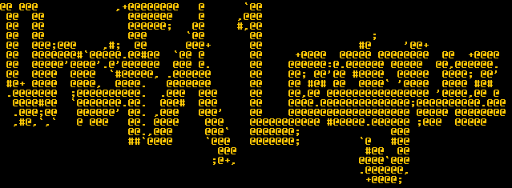
Figure 1. Splash Screen
- After that, the program will show the menus:
  - Play
  - About
  - Exit
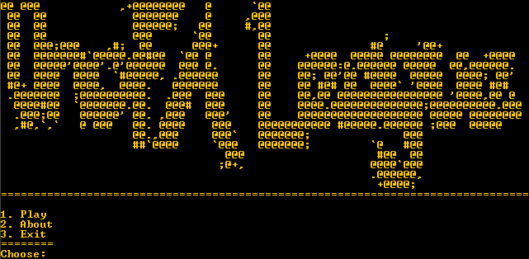
Figure 2. Main Menu
- Play
  - If there is no save file, the play menus are:
    - New Game, and
    - Back.
  - Otherwise, the play menus are:
    - New Game,
    - Continue, and
    - Back.
  - The program will show play menus.
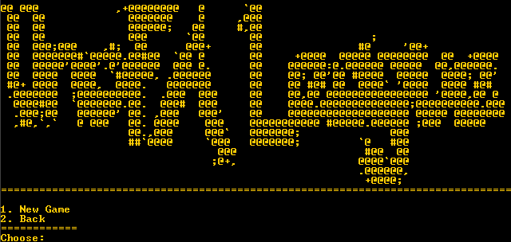
Figure 3. Menu without save file
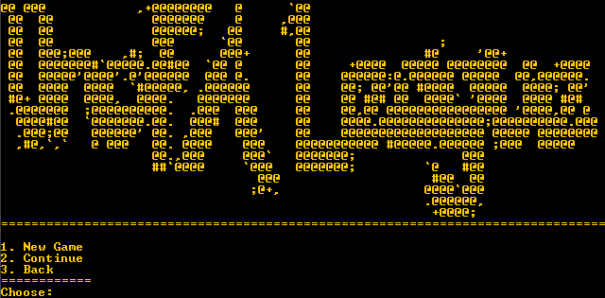
Figure 4. Menu with save file
      - New Game
        - Asks user to choose a between ‘Fire’,’Water’, and ’Grass’.
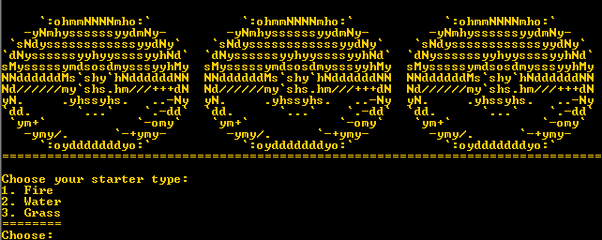
Figure 5. Choose starter
        - Add starter pokemon to player’s pokemons with the specification:
Type | Pokemons
Fire | Emboar level 50
Water | Samurott level 50
Grass | Serperior level 50

Figure 6. If choose fire
Figure 7. If choose water
Figure 8. If choose grass
      - Continue
        - Validate this menu only available if there’s a save file.
        - Load all the pokemons from the file
      - Back
        - Return to the main menu.
    - The program will show adventure menus:
      - Catch Pokemon
      - Fight Elite Four
      - Restore Pokemon’s Health
      - Manage Pokemons
      - Save
      - Back To Main Menu
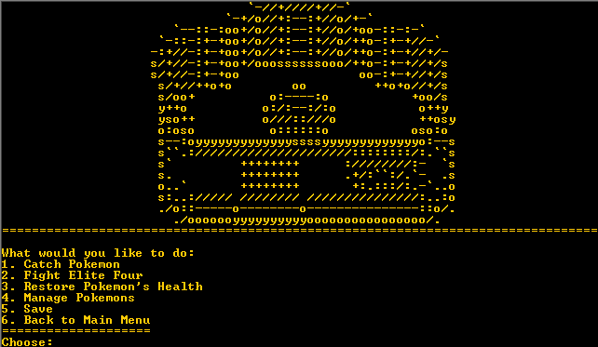
Figure 9. Adventure Main Menu
    - A pokemon battle consist of these specification:
      - The battle is turn based.
      - Every turn, the pokemon will use their ability.
      - Battle will be the first concious player’s pokemon against the random pokemon.
      - Pokemon with the biggest speed will attack first.
      - Battle is over when one of the side has no more concious pokemon.
      - If player has no more concious pokemon, end the battle and go back to pokemon center.
      - If the foe current active pokemon loses, add exp to the current active player’s pokemon, with the following formula:
Exp = Exp + foe’s.baseExp * foe’s level / pokemon’s level
      - After that choose the next concious pokemon to fight.
      - Pokemon will level up if:
Exp > pokemon’s level * pokemon’s base level
      - If pokemon reached the level to evolve, it will evolve
      - Count the attack with the following formula:
        - For critical hit:
Damage = ((attacker’s attack / attacked’s defense * attacker’s base attack) + 2) * power * random between 0.5 to 0.75 * 1.5
        - For normal hit:
Damage = ((attacker’s attack / attacked’s defense * attacker’s base attack) + 2) * power * random between 0.5 to 0.75
      - Where power is obtained from both of the types compability with the specification:
        - If one of the type has power 0 on the foe, then the power is 0.
        - Otherwise, multiply the power with the rules:
Power | Ghost | Dark | Dragon | Fighting | Normal | Water | Fire | Grass | Psychic | Flying
Ghost | 2 | 0.5 | 1 | 1 | 1 | 1 | 1 | 1 | 2 | 1
Dark | 2 | 0.5 | 1 | 0.5 | 1 | 1 | 1 | 1 | 2 | 1
Dragon | 1 | 1 | 2 | 1 | 1 | 1 | 1 | 1 | 1 | 1
Fighting | 0 | 2 | 1 | 1 | 2 | 1 | 1 | 1 | 0.5 | 1
Normal | 0 | 1 | 1 | 1 | 1 | 1 | 1 | 1 | 1 | 1
Water | 1 | 1 | 0.5 | 1 | 1 | 0.5 | 2 | 0.5 | 1 | 1
Fire | 1 | 1 | 0.5 | 1 | 1 | 0.5 | 0.5 | 2 | 1 | 1
Grass | 1 | 1 | 0.5 | 1 | 1 | 2 | 0.5 | 0.5 | 1 | 1
Psychic | 1 | 0 | 1 | 2 | 1 | 1 | 1 | 1 | 0.5 | 1
Flying | 1 | 1 | 1 | 2 | 1 | 1 | 1 | 2 | 1 | 1

- Catch Pokemon
  - Asks user to choose between ‘White Forest’, ‘Challenger’s Cave’, or ‘Fishing’. Add menu ‘Back’ to go back.
  - If user chooses ‘Back’, return to main menu.
  - Otherwise, Battle with a random pokemon with the following specification:
    - Random pokemon based by place with the rule:
Place | Pokemons
White Forest | - Masquerain level 45  - Rufflet level 45
Challenger’s Cave | - Mienfoo level 45  - Fraxure level 45
Fishing | - Sharpedo level 45  - Jellicent level 45

    - Create pokemon with the status rule:
Stat = base stat + (random from 0 to pokemon’s level) + pokemon’s level
    - For every turn, show the battle menus:
      - Attack
        - Attack pokemon with the formula.
      - Switch
        - Asks user to choose from player’s pokemons.
        - Set the chosen player’s pokemon to battle.
      - Catch
        - Catch the pokemon with the catch rate of 30%.
      - Escape
        - Return to pokemon center.
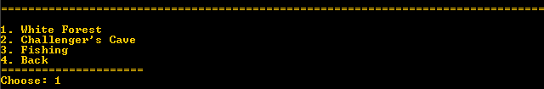
Figure 10. Choose place to catch pokemon
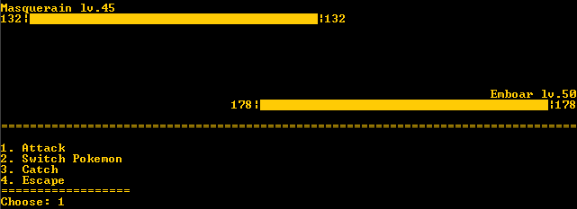
Figure 11. Battle Scene when catching pokemon
- Fight Elite Four
  - Battle with the Elite Four with the following order:
    - For every turn, show the battle menus:
      - Attack
        - Attack pokemon with the formula.
      - Switch
        - Asks user to choose from player’s pokemons.
        - Set the chosen player’s pokemon to battle.
Trainer | Pokemons
Shauntal | - Golurk level 48  - Chandelure level 50
Grimsley | - Krookodile level 48  - Bisharp level 50
Caitlin | - Sigilyph level 48  - Gothitelle level 50
Marshall | - Conkeldurr level 48  - Mienshao level 50
  - Then battle the champion with the following specification:
    - For every turn, show the battle menus:
      - Attack
        - Attack pokemon with the formula.
      - Switch
        - Asks user to choose from player’s pokemons.
        - Set the chosen player’s pokemon to battle.
Trainer | Pokemons
Alder | - Bouffalant level 75  - Druddigon level 75  - Volcarona level 77
  - After that, Program will ask a confirmation message to overwrite data. Validate the confirmation can only be ‘Y’ and ‘N’(Case Insensitive).
  - If the confirmation is ‘Y’, all the player pokemon will be saved in an external save file.
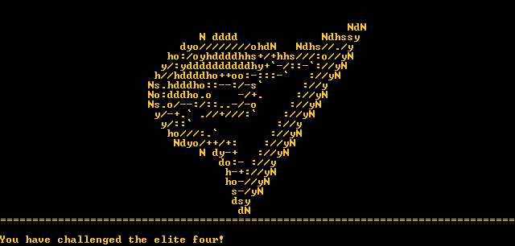
Figure 12. Challenging elite four
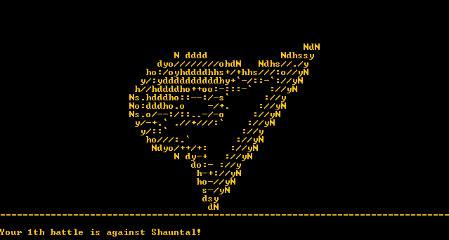
Figure 13. First time battle
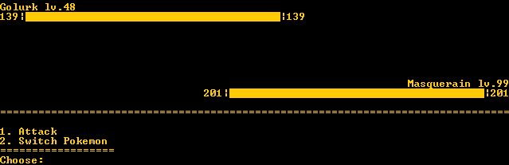
Figure 14. Battle with elite four
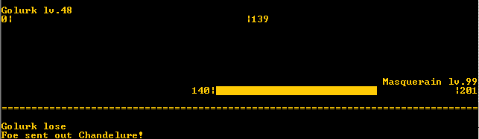
Figure 15. If active pokemon loses
Figure 16. Winning the battle
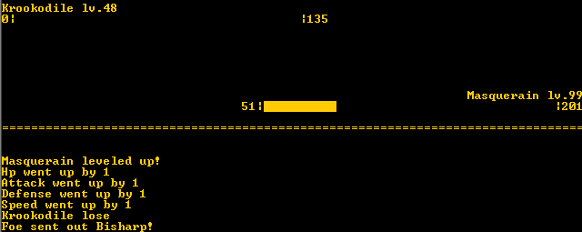
Figure 17. Leveling Up
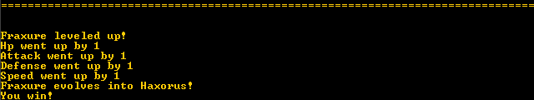
Figure 18. Evolving
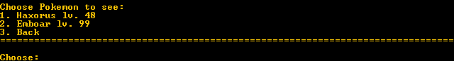
Figure 19. Pokemon after evolving

Figure 20. Switching pokemon
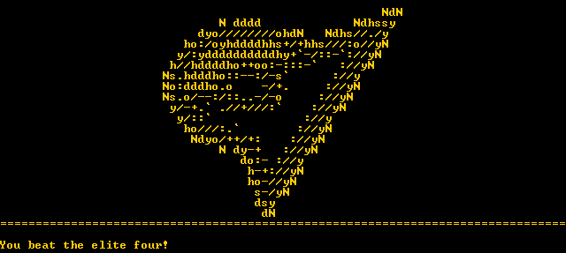
Figure 21. Beating the elite four
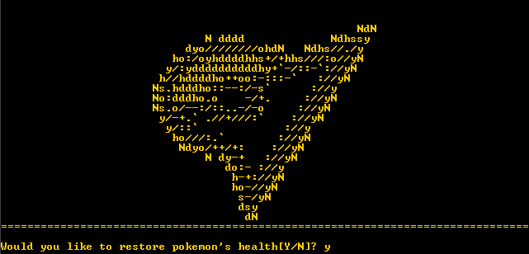
Figure 22. Confirmation message
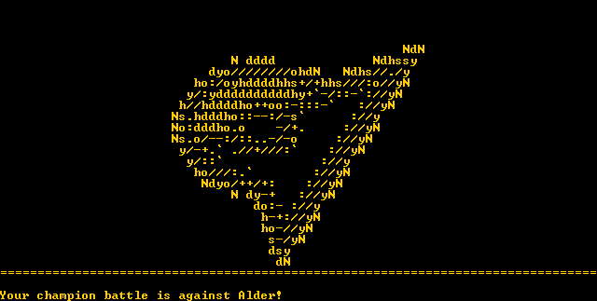
Figure 23. Before battle
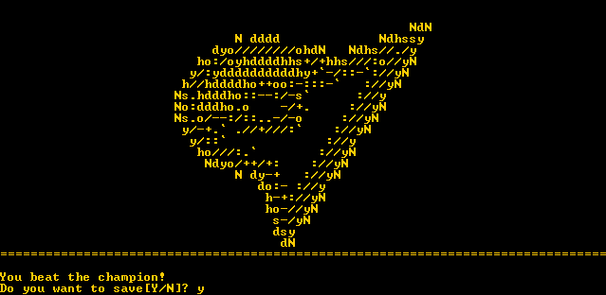
Figure 24. Beating the champion
- Restore Pokemon’s Health
  - Fill health points of every player’s pokemons
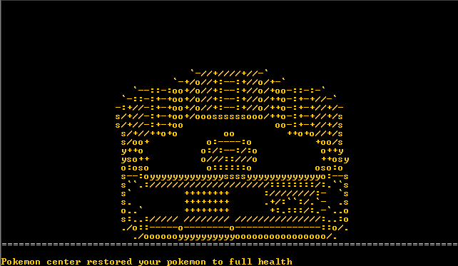
Figure 25. Restoring health
- Manage Pokemons
  - The program will show menus:
    - See Pokemon
    - Switch Pokemon
    - Free Pokemon
    - Back
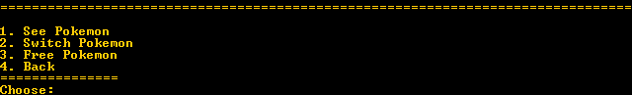
Figure 26. Managing pokemon
- See Pokemon
  - Asks user to choose from player’s pokemons. Add Back menu to go back.
  - If user chooses ‘Back’, return to main menu.
  - Otherwise, show the chosen pokemon’s status.
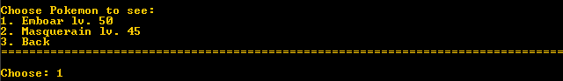
Figure 27. See pokemon
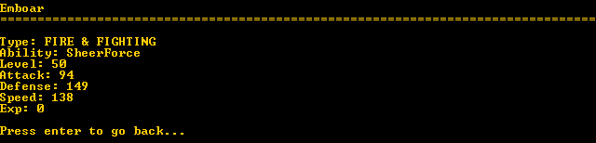
Figure 28. Pokemon status

- Switch Pokemon
  - Asks user to choose from player’s pokemons to switch from. Add Back menu to go back.
  - If user chooses ‘Back’, return to main menu.
  - Otherwise, asks user to choose from player’s pokemons to switch to. Add Back menu to go back.
  - If user chooses ‘Back’, return to main menu.
  - Else, switch the two pokemon’s positions.
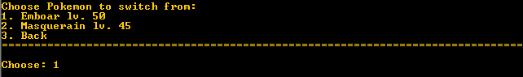
Figure 29. Switching pokemon
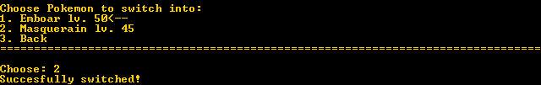
Figure 30. Switch pokemon into
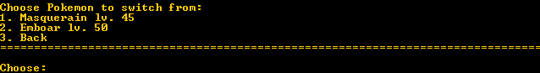
Figure 31. Pokemon order after switched
- Free Pokemon
  - Validate player’s pokemons must be more than one.
  - Asks user to choose from player’s pokemons. Add Back menu to go back.
  - If user chooses ‘Back’, return to main menu.
  - Otherwise, asks user for confirmation message. Validate the confirmation can only be ‘Y’ and ‘N’(Case Insensitive).
  - If the confirmation is ‘Y’, remove the chosen pokemon from player’s pokemons.
Figure 32. Validate more than one pokemon
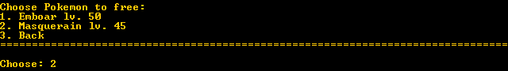
Figure 33. Choose pokemon to free
Figure 34. Release Pokemon
- Back
  - Return to the menu

- Save
  - Program will ask a confirmation message to overwrite data. Validate the confirmation can only be ‘Y’ and ‘N’(Case Insensitive).
  - If the confirmation is ‘Y’, all the player pokemon will be saved in an external save file.
Figure 35. Confirmation message
- Back To Main Menu
  - Return to the main menu.

- About
  - The program will the description of the program.
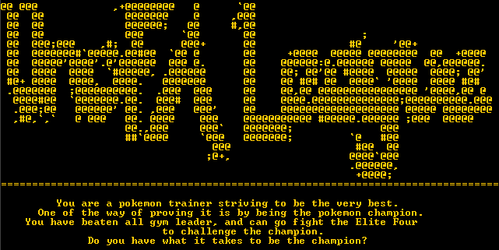
Figure 36. About
- Exit
  - The program will exit.

References:
- List of abilities in the game:
Name | Description
Analytic | Powers up the attack 30% before turn if speed is lower than foe’s.
Intimidate | Powers down foe’s attack 30%, gradually restored to original every turn.
Moody | At every turn, powers down 10% one of the status while powers up two of other status 20%.
SheerForce | Powers up attack 30% gradually restored to original every turn.

- List of Pokemons in the game:
Pokemon | Type | Ability | Base Hp | Base Attack | Base Defense | Base Speed | Base Exp
Bisharp | Dark | Moody | 65 | 125 | 100 | 70 | 172
Bouffalant | Normal | SheerForce | 95 | 110 | 95 | 55 | 172
Braviary | Normal & Flying | SheerForce | 100 | 123 | 75 | 80 | 179
Chandelure | Ghost & Fire | Analytic | 60 | 55 | 90 | 80 | 234
Conkeldurr | Fighting | SheerForce | 105 | 140 | 95 | 45 | 227
Druddigon | Dragon | Intimidate | 77 | 120 | 90 | 48 | 173
Emboar | Fire & Fighting | SheerForce | 110 | 123 | 65 | 65 | 238
Fraxure(48) | Dragon | SheerForce | 66 | 117 | 70 | 67 | 144
Golurk | Ghost | SheerForce | 58 | 50 | 145 | 30 | 169
Gothitelle | Psychic | Moody | 70 | 55 | 50 | 65 | 221
Haxorus | Dragon | SheerForce | 76 | 147 | 90 | 97 | 243
Jellicent | Water & Ghost | Analytic | 100 | 60 | 70 | 60 | 168
Krookodile | Dark | Intimidate | 58 | 50 | 145 | 30 | 229
Masquerain | Flying | Intimidate | 70 | 60 | 62 | 60 | 145
Mienfoo(50) | Fighting | Moody | 45 | 85 | 50 | 65 | 70
Mienshao | Fighting | SheerForce | 65 | 125 | 60 | 105 | 179
Rufflet(54) | Normal & Flying | Moody | 70 | 83 | 50 | 60 | 70
Samurott | Water | Analytic | 95 | 100 | 85 | 70 | 238
Serperior | Grass | Moody | 75 | 75 | 95 | 113 | 238
Sharpedo | Water & Dark | Intimidate | 70 | 120 | 40 | 95 | 161
Sigilyph | Psychic & Flying | Analytic | 72 | 58 | 80 | 97 | 172
Volcarona | Fire | Moody | 85 | 60 | 65 | 100 | 248

