Create environments and connect them to a compas version

INSTALL FROM SOURCE > latest version > update source tree beforehand

conda create -n ita19-dev python=3.6 python.app COMPAS=0.8.1 --yes

cd path/to/your/clone/of/compas/compas

conda activate ita19-dev

pip install -e .

python

import compas

or

INSTALL the released version

conda create -n ita19 python=3.6 python.app COMPAS=0.8 --yes

conda activate ita19

python

import compas

for rhino visualization

python -m compas_rhino.install -v 6.0 -p compas compas_rhino compas_ghpython

Create repository

1. <https://github.com/fentons?tab=repositories>

repositories > new > copy the link

2. sourcetree

New > clone from url > paste the link > path to where you want to place your repo

Ex :/Users/fentons/Code/Repositories/tna

Folders structure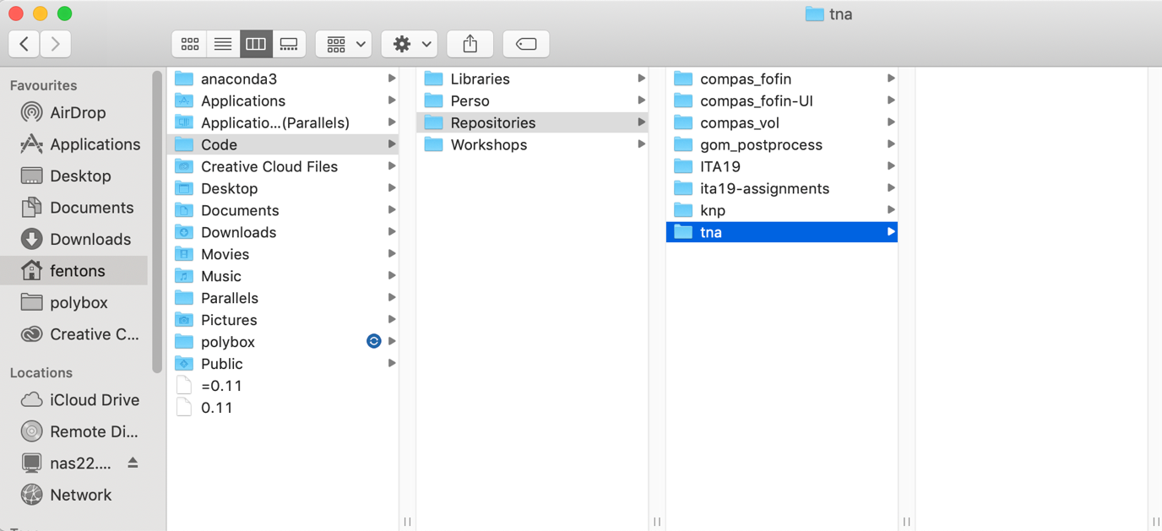

VS code

Start

* open folder
* bottom left > choose the env you want
* choose the branch you want
* when finished : 1 add 2 commit 3 push 4 pull

to move from minor branch to master branch :   
> on minor branch send a pull request

> on major branch merge pull request