

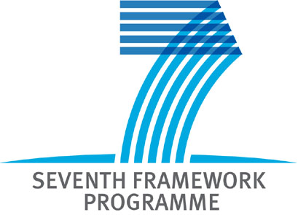

Structure of Annex I to the Grant Agreement (Description of Work)

FP7 Collaborative Projects, Networks of Excellence, Coordination and Support Actions, Research for the Benefit of Specific Groups (in particular SMEs)

Version 17/05/2010

Disclaimer
These guidance notes are aimed at assisting participants who are invited for project negotiation following the evaluation of their proposal. It outlines the structure of Annex I – Description of Work. It is provided for information purposes only and its contents are not intended to replace consultation of any applicable legal sources or the necessary advice of a legal expert, where appropriate. Neither the Commission nor any person acting on its behalf can be held responsible for the use made of these guidance notes.

Introduction 3
Structure of Annex I for Collaborative Projects (Description of Work) 3
1. PART A 3
1.1. Cover Page 3
1.2. Table of contents 3
1.3. A1. The project summary 3
1.4. A2. The list of beneficiaries 3
1.5. A3. The budget breakdown 3
1.6. A4. RTD Performers (applicable for the BSG-SME funding schemes) 3
1.7. A5. Project Results (applicable for the BSG-SME funding schemes) 3
Project results (including knowledge) to be acquired by the participants 3
1.8. Workplan Tables – Detailed implementation 3
1.8.1. WT1 List of work packages 3
1.8.2. WT2 list of deliverables 3
1.8.3. WT3 Work package descriptions 3
1.8.4. WT4 List of milestones 3
1.8.5. WT5 Tentative schedule of project reviews 3
1.8.6. WT6 Project effort (in person-months) by beneficiary per work package 3
1.8.7. WT7 Project effort by activity type per beneficiary 3
1.8.8. WT8 Project efforts and costs 3
2. PART B 3
B1. Concept and objectives, progress beyond state-of-the-art, S/T methodology and work plan 3
B2. Implementation 3
B3. Impact 3
B4. Ethical issues (if applicable) 3
B5. Gender aspects (optional) 3
Annotated Structure of Annex I – Networks of Excellence 3
Annotated Structure of Annex I – Coordination Actions 3
Annotated Structure of Annex I – Support Actions 3
Annotated Structure of Annex I – Research for the benefit of specific groups (in particular SMEs) 3

Introduction
Structure of the Description of Work
The Description of Work, which is Annex I to the Grant Agreement, contains the details of the implementation of the project with regard to the work packages, deliverables, milestones, resources and costs of the beneficiaries – organised in a table format - as well as a detailed narrative description of the work.
It consists of two parts:
1. Part A of Annex I contains the cover page, the project summary, the list of participants and the budget breakdown as well as 8 Workplan Tables, which provide details on the implementation of the project.
2. Part B of Annex I is based on information from Part B of the proposal. However, during the negotiation stage several sections of the original proposal need to be updated and the Consortium may be requested to shorten certain sections of the proposal and elaborate on others. Part B of Annex I is the narrative part of Annex I. All pages must be numbered and each page should be headed with the project acronym and proposal number.

Online support for the preparation of the Description of Work
The DoW of the projects can be prepared with the help of the online tool NEF (NEgotiation Facility). For the calls published after October 2009, the use of this tool for the preparation of the DoW is highly recommended.
- The cover page and Part A are generated by NEF based on the information given already in the GPFs.
- With the help of NEF, the necessary work tables can be edited in an intelligent way, taking into account the links between the different tables and pre-filling some of the information after you have filled in the information under the titles 'work packages' and 'project review'.
- The Part B of the Description of Work is uploaded into NEF by the coordinator as a pdf document.

In case you are using NEF for the preparation of the Description of Work (Annex I.), the system will create the Description of Work out of two files:
- one file generated by NEF containing PART A
- a second file "PART B - narrative part" uploaded in NEF.
NEF will create out of the two files the Description of Work (Annex I).
Accessing NEF
Please note that the access to the NEF system has changed. The previous session key mechanism is replaced by the use of the services accessible via the Participant Portal: http://ec.europa.eu/research/participants/portal.
Each contact person of a given project, who would like to access NEF, has to register for an ECAS account (or use the existing one) – with the same e-mail address that was given during the proposal submission and later on during the negotiation phase.
After obtaining an ECAS account, each participant and the coordinator will be able to access and edit information in NEF in case a session is open or view the previous data in case no session is open under the 'My Projects' tab. The services of the Participant Portal will be able to recognise the roles of a certain 'client' entering the Portal.

Structure of Annex I for Collaborative Projects (Description of Work)
PART A – Structured information

Cover page
Table of contents
A1. Project summary
A.2 List of beneficiaries
A.3 Overall budget breakdown for the project

Workplan Tables
WT1 List of work packages
WT2 List of deliverables
WT3 Work package descriptions
WT4 List of milestones
WT5 Tentative schedule of project reviews
WT6 Project effort by beneficiaries and work package
WT7 Project effort by activity type per beneficiary
WT8 Project efforts and costs

PART B – Narrative information

Table of contents
B1. Concept and objectives, progress beyond state-of-the-art,
S/T methodology and work plan
B.1.1 Concept and project objective(s)
B.1.2 Progress beyond the state of the art
B.1.3 S/T methodology and associated work plan
B.1.3.1 Overall strategy and general description
B.1.3.2 Timing of work packages and their components
B2. Implementation
B.2.1 Management structure and procedures
B.2.2 Beneficiaries
B.2.3 Consortium as a whole
If applicable [Sub-contracting]
If applicable [Funding for beneficiaries from third countries]
If applicable [Additional beneficiaries / Competitive calls]
If applicable [Third parties]
B.2.4 Resources to be committed
B3. Potential impact
B.3.1 Strategic impact
B.3.2 Plan for the use and dissemination of foreground
If applicable [Contributions to standards]
[Contribution to policy developments]
[Risk assessment and related communication strategy]
[B4. Ethical issues] if applicable
[B5. Consideration of gender aspects] optional

PART A

Cover Page
In case you use NEF for the preparation of Annex I, this page is prepared automatically on the basis of the information given previously in the GPFs.

SEVENTH FRAMEWORK PROGRAMME
THEME [#]
[Theme Title]

Grant agreement for: <Funding Scheme>

Annex I. - “Description of Work”

Project acronym: (same as proposal acronym)
Project full title:
Grant agreement no.: (same as proposal no)
Date of preparation of Annex I (latest version):
Date of approval of Annex I by Commission: (to be completed by Commission)

Table of contents
In case you use NEF for the preparation of the Description of Work (Annex I), a table of contents page is created automatically by NEF. Please note this table of contents covers Part A as described in this section.
In case you are not using NEF for the preparation of the Description of Work (Annex I), please include a Table of contents page following the structure of Part A as described in this Section.
The narrative part (which has to be edited by you) and uploaded in NEF should contain its own table of contents.

A1. The project summary
In case you use NEF for the preparation of the Description of Work (Annex I), you do not have to fill in this form again, as the system takes the information from GPF A1. (Part A in NEF).
In case you are not using NEF for the preparation of the Description of Work (Annex I), please insert the information from GPF A1.

A2. The list of beneficiaries
List of Beneficiaries

Beneficiary Number | Beneficiary name | Beneficiary short name | Beneficiary type | Country | Date enter project | Date exit project
1(coordinator)
2
3

A3. The budget breakdown
Participant number in this project | Organisation  short name | Type | Funding % | Indirect  Costs | Estimated eligible costs (whole duration of the project) |  |  |  |  | Total receipts | Requested  EU  contribution
 |  |  |  |  | RTD / Innovation  (A) | Demonstration  (B) | Management  (C) | Other  (D) | TOTAL  A+B+C+D | Total receipts | Requested  EU  contribution
Total

In case you use NEF for the preparation of Annex I, the system takes the information from GPF A 3.2. automatically (Part A in NEF).

A4. RTD Performers (applicable for the BSG-SME funding schemes)
Offer from the RTD performers to the SME / SME-Associations participants

Name of RTD Performer | Number of person months | Personnel costs | Durable equipment | Consumables | Computing | Overhead costs | Other costs | Total by RTD | Project results  N° | Work package  N°
Total (*)

(*) This total must be equal to the figure estimated in form GPF A3.2 (Total amount of subcontracting to RTD performers, excl. VAT)

A5. Project Results (applicable for the BSG-SME funding schemes)

Project results (including knowledge) to be acquired by the participants

 |  | Participant Num.: |  | Participant Num.: |  | Participant Num.:
Project Result (No) | Description (of project result) | Type of Exploitation (*) | Remuneration (€) | Type of Exploitation (*) | Remuneration (€) | Type of Exploitation (*) | Remuneration (€)
Subtotal remuneration
Total remunerations(**)
(*) Ownership, Patenting, Licensing, other IPR protection, etc
(**) This Total must be equal to the figure estimated in GPF form A3.2 (Total amount of subcontracting to RTD performers, excl. VAT)

Workplan Tables – Detailed implementation
Introduction
The Workplan Tables are based on Part B of the proposal.
As mentioned earlier, NEF supports the preparation of the Workplan Tables. For an interim period the use of the online forms will be optional but highly recommended. If you are preparing your proposal on paper, you can still use the following tables for providing the necessary information.
All beneficiaries can provide input to the following tables if the consortium decides to use the online NEF possibility, but only the coordinator will be able to submit the final information to the negotiating officer.
In case you are using NEF for the preparation of the Description of work, you will be guided by the system during the preparation of the tables starting from the 'Work packages' or 'Project reviews' section.
In case you are not using NEF for the preparation of the Description of Work (Annex I), then Workplan Tables 1-7 will have to be prepared by you on the basis of the following tables. Please note that in this case WT8 is an optional table.
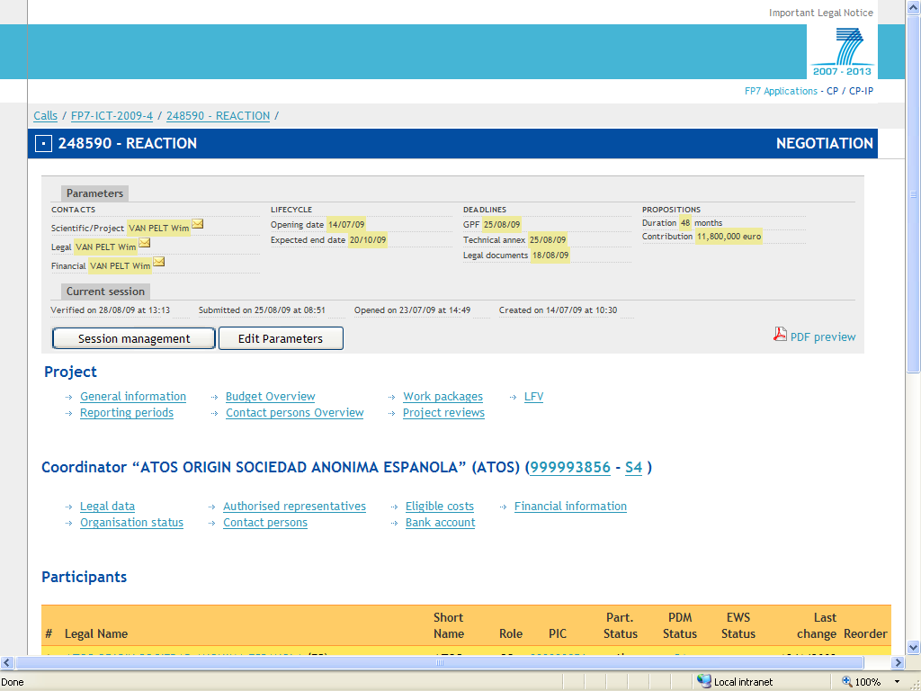
After filling in the information about the work packages, deliverables and milestones, the rest of the tables will be generated automatically on the basis of the information set in the first tables.
Please start the process with entering information on the work packages.
Information on the deliverables and milestones will be read-only on the starting page. These sections can be modified only within a certain work package.

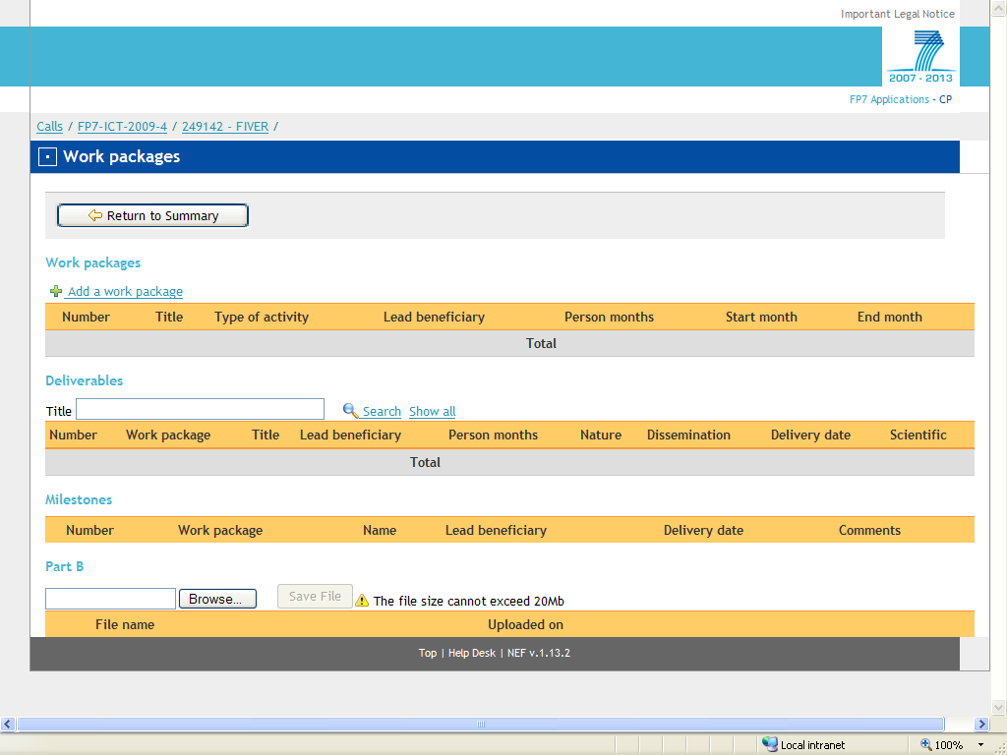

WT1 List of work packages
Each work package must relate to one and only one specific activity type, allowed by the chosen funding scheme: e.g. research, technological development and innovation related activities, demonstration management of the Consortium activities, training activities, etc. Large, long-duration work packages make the job of monitoring technical progress difficult and should be avoided.
If you are using NEF for the preparation of the Description of work, under 'Work Packages' first you will have to create the list of work packages for the project, which will initiate the creation of the forms for WT3 Work package descriptions.
The following form shows you the printed format of the form which will then be pre-filled with the information given earlier by you.
The information given here e.g. on person months will later serve as a reference point for the calculations.
If you are preparing the tables without the help of NEF, please fill in the following table.

List of work packages
WP Number | WP Title | Type of activity | Lead beneficiary number | Person-months | Start month | End month
 |  |  | Total:

WT2 list of deliverables
If you are using NEF for the preparation of the Description of work, you will have to edit the information on deliverables under the work package to which the deliverables are related – as seen in WT3 Work package descriptions.
WT2 will be prepared automatically on the basis of the complete deliverables' list based on the delivery number. Deliverables are always linked to one work package, therefore they are editable under one work package's information.
The deliverable number can be either a plain number of the form "n" or two numbers separated by a dot "n.m", either form can be used. The deliverables will be ordered by "n" increasing with "m" as a subdivision of "n" (1; 1.1; 1.2; 1.3; 2.1; 2.2 etc…). All the sub-tasks (marked with 'm') related to one major task will be under the same 'n' number.
If you are preparing the tables without the help of NEF, please prepare the list of deliverables for the whole project cycle according to the delivery number.

WT2 gives a tabular listing of deliverables indicating deliverable number and title, work package reference number, participant leading production of deliverable, estimated number of person-months attributed to the production of the deliverable, dissemination level of deliverable, security rating of deliverable, date to be delivered to Commission.
Each significant element of the project should conclude with a deliverable which is the concrete output and evidence of the work. A small work package may produce just one deliverable whereas larger work packages may produce several deliverables.
Deliverables should be limited in number, and be specific and verifiable. All listed deliverables must be sent to the Commission for review on behalf of the Consortium by the project coordinator. Please note that this list of deliverables will serve as a basis of reporting.
Deliverables should be described in clear words explaining what can be expected in terms of content and detail. A deliverable may be a report or be of a different nature such as the construction of a prototype, the production of a demonstrator the organisation of a conference, the publication of a book, the completion of a specification, etc. In the latter cases, a short written description of the deliverable should be submitted as an indicator for the deliverable itself.
Delivery dates may also be closely linked to the timing of project reviews.
As the Seventh Framework Programme is funded with public funds, a reasonable number of non-confidential deliverables, suitable for publication, should be foreseen.

List of deliverables – to be submitted for review to EC
Deliverable Number | Deliverable Title | WP number | Lead beneficiary number | Estimated indicative person-months | Nature | Dissemination level | Delivery date
 |  |  | Total

WT3 Work package descriptions
Each work package should represent a major sub-division of the project and have a verifiable end-point (normally a deliverable or an important milestone in the overall project). Each work package should have an associated precise, clear and quantified description.
A. Preparing the tables without NEF
Please give information on the objectives of the work package. Prepare the 'Description of Work' section possibly broken down into tasks and give a brief description on each deliverable. Prepare the list of deliverables and milestones and set the person-months per participant for a given work package. Please use the format given as the printed version of Workplan Table 3 below.
B. Preparing the tables with the help of NEF
If you are using NEF for the preparation of the Description of work, you will have to edit all information linked to a certain work package under this section. All calculations will be based on the information given under the 'Work package descriptions' sections.
Information on the main data linked to the work package, the Objectives and the Description of work – possibly broken down into tasks - can be edited here. You are advised to use no more than 4000 characters for each sub-section.
The person-months, deliverables and milestones sections are editable under this section.

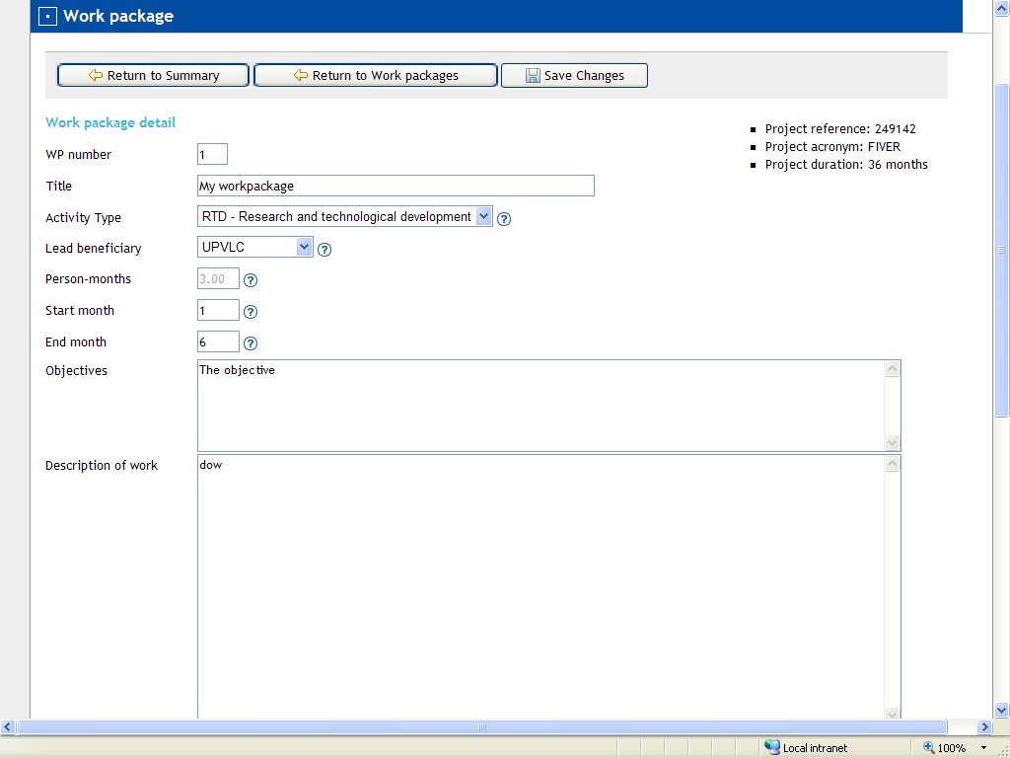

The data on person-months per participant of a given work package has to be set here. This data will be used for the calculation of Workplan Table 6.
Deliverables: Please read section on Workplan Table 2 regarding the contents.
Set the title, the lead beneficiary and the estimated indicative person-months – the value cannot be higher than the person-months set for the entire work package. Nature of deliverables is either report/prototype/demonstrator or other. Set the dissemination level and the delivery date. Give a short description of the deliverables. By filling in this table, Workplan Table 2 will be prepared automatically for the whole project cycle.
Milestones: Please read section on Workplan Table 4 regarding the contents.
Please set the information on milestones. Milestones can be linked to more work packages; therefore you can either create a new milestone or select and add existing one(s) to a certain work package. Set the lead beneficiary and the delivery date. You can also add comments here. This information will be compiled under Workplan Table 4 covering the whole project cycle.

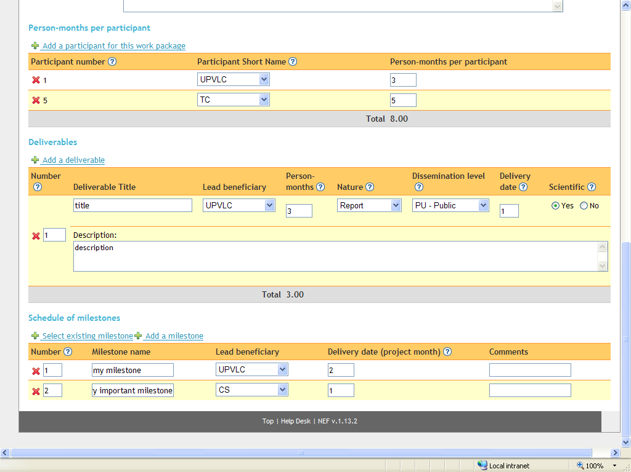
Printed format of WT 3
One form per work package
Work package number |  | Type of activity
Work package title
Start month
End month
Lead beneficiary number

Objectives

Description of work and role of partners

Person months per participant
Participant number | Participant short name | Person-months per participant
 | Total

List of WP Deliverables
Deliverable Number | Deliverable Title | Lead beneficiary number | Estimated indicative person-months | Nature | Dissemination level | Delivery date
 |  | Total

Description of WP Deliverables

Schedule of relevant milestones
Milestone number | Milestone name | Lead beneficiary number | Delivery date from Annex I | Comments

WT4 List of milestones
Each milestone needs to be described in terms of expected results and achievements. Milestones are points where major results have been achieved as the basis for the next phase of work, or are control points at which decisions are needed; for example a milestone may occur when a major result has been achieved, if its successful attainment is a pre-requisite for the next phase of work. Another example would be a point when a choice between several technologies will be adopted as the basis for the next phase of the project.
If you are using NEF for the preparation of the Description of work, this table will be filled in automatically for the whole project cycle on the basis of the information set under the work packages.

List of milestones

Milestone number | Milestone name | WP numbers | Lead beneficiary number | Delivery date from Annex I | Comments

WT5 Tentative schedule of project reviews
Reviews should ideally be synchronised with ends of project reporting periods – which may coincide with the major milestones of the project. The planning must include the timing and the venue of the review. You can add comments to each section. This is a new table which was not included in the proposal.
If you are using NEF for the preparation of the Description of work, select the "Project reviews" section to perform this task.

Tentative schedule of project reviews

Review number | Tentative timing | Planned venue of review | Comments, if any

WT6 Project effort (in person-months) by beneficiary per work package
If you are using NEF for the preparation of the Description of work, this table will be filled in automatically after finalising the work packages section.

Project effort by beneficiary per work package

Beneficiary short-name | WP1 | WP2 | WP3 | … | … | WPn | Total per Beneficiary
Total

WT7 Project effort by activity type per beneficiary
If you are using NEF for the preparation of the Description of work, this table will be filled in automatically after finalising the work packages section.
Project effort by activity type per beneficiary
Activity type | Part. 1 | Part. 2 | Part. 3 | Part. 4 | Part. 5 | Part. 6 | Total

RTD/Innovation activities
WP2
Total Research

Demonstration activities
WP1
Total Demo

Consortium Management activities
Total Management

Other activities
Total other

Total

WT8 Project efforts and costs
If you are using NEF for the preparation of the Description of work, this table will be filled in automatically after finalising the work packages section. This table is optional in case you are not using NEF for the preparation of the Description of work.
Project efforts and costs

Beneficiary number | Beneficiary short name | Estimated eligible costs (whole duration of the project) |  |  |  |  |  | Total receipts (€) | Requested EU contribution (€)
Beneficiary number | Beneficiary short name | Effort (PM) | Personnel costs (€) | Subcontracting (€) | Other Direct Costs (€) | Indirect costs OR lump sum, flat-rate or scale-of-unit (€) | TOTAL costs | Total receipts (€) | Requested EU contribution (€)
 | Total

PART B
Introduction
Part B of Annex I to ECGA, which is the narrative part of the Description of Work, is based on Part B of the proposal.

The Part B, which is the narrative part of Annex I (Description of Work) can be uploaded to NEF by the coordinator as a pdf document (or as a Word document before finalising Annex I in order to be able to track the changes). The page numbering of this narrative section should be done separately together with the relevant table of contents for the narrative section.
All pages must be numbered and each page should be headed with the project acronym and proposal number.
When printing the forms, the system will automatically compile one document including Part A – the structured part generated by NEF, as well as Part B – the narrative part uploaded to NEF.

Table of Contents
Insert the table of contents covering Part B of the Description of Work, following the structure described in this section.

B1. Concept and objectives, progress beyond state-of-the-art, S/T methodology and work plan
B 1.1 Concept and project objective(s)
This section should be based on Part B section 1.1 of the original proposal. Explain the concepts of your project, and the main ideas that lead you to propose this work.
- Describe the objectives of the project in detail, in particular in a measurable and verifiable form.
- Objectives should be achievable within the project (not through subsequent developments) and be specific and timed (e.g. by which date/milestone the objectives will be achieved), well in line with the milestones that will be indicated under section 1.3 below.
B 1.2 Progress beyond the state of the art
This section should be based on Part B section 1.2 of the original proposal, but the description of the state-of the-art should be shorter while the 'baseline' descriptions and a description of the performance / research indicators have to be added.
- Describe briefly the state-of-the art in the area concerned, and the advance that the project will bring about.
- Include also a description of the "baseline" of the project in terms of "where does the project work start", and ‘the baseline data’ against which the project will measure its progress and the results the project aims to achieve (e.g. advances over the state of the art, increase of innovation /exploitation potential, etc.).
- The Consortium should in particular include the definition of criteria and "performance/ research indicators" for the project along which results, progress and impact of the project will be measured in later reviews and assessments.
B 1.3 S/T Methodology and associated work plan
This section is based on Part B section 1.3 of the proposal. It describes the scientific and technical (S&T) approach and provides in detail the work planned, over the full duration of the project, to achieve the objectives.
- A detailed work plan should be presented broken down into work packages (WPs) which should follow the logical phases of the project implementation.
- It must include consortium management and assessment of progress and results (Please note that your overall approach to management will be described later, in section 2 of Annex I).
- Usually the work plan should also include a separate work package for dissemination and use/exploitation planning.
- Overall, the work plan should be sufficiently detailed to justify the proposed effort and allow progress monitoring by the Commission.
Essential elements of this section are:
B 1.3.1 Overall strategy and general description: This section should outline the strategy for the work plan, provide a general description of the structure of the work plan and explain how it will lead the participants to achieve the objectives of the project. It should also identify any significant risks and describe contingency plans.
B 1.3.2 Timing of work packages and their components: Include a graphic representation, e.g. GANTT chart or similar, of the planned timing of the different work packages and their components. Timing should be relative, expressed in months (e.g. project month 3, project month 18 etc.). Month 1 is the month that starts at the start date of your grant agreement.

The Workplan tables of Part A form an essential part of the Description of work and are closely linked to this section. You do not have to repeat the workplan tables in the narrative part. Make sure you are using references to the work packages, deliverables and milestones, etc. in a consistent manner.
WT1 List of work packages
WT2 List of deliverables
WT3 Work package descriptions
WT4 List of milestones
WT5 Tentative schedule of project reviews
WT6 Project effort by beneficiaries and work package
WT7 Project effort by activity type per beneficiary
WT8 Project efforts and costs

B2. Implementation
B 2.1 Management structure and procedures
This section describes the project’s organisational structure and high-level decision-making mechanisms:
- how the project management will enable the project to achieve its goals;
- how the management structure will adapt to the addition of beneficiaries during the lifetime of the project.
B 2.2 Beneficiaries
This section should be based on section 2.2 of part B of the proposal but possibly in a reduced format, if requested by the project officer. Upon request of the Commission you may be asked to include a full description in an Appendix to your Annex I.
For each beneficiary provide:
- a brief description of the organisation (including names of key persons to be involved);
- the main tasks attributed to them in the project, and the previous experience relevant to those tasks;
- a short profile of the personnel who will be undertaking the work.
NOTE: if the named key persons do not in fact take part in the work, or are substituted by other persons without the knowledge of the Commission, this could be seen as beneficiaries not fulfilling their obligations towards the technical quality of the work. This could lead to a more in-depth review of the project.
B 2.3 Consortium as a whole
This section is based on Part B section 2.3 of the proposal.
Describe:
- how the beneficiaries collectively constitute a consortium capable of achieving the project objectives and how they are suited and committed to the tasks assigned to them and what are the complementarities between beneficiaries.
- Explain how the composition of the consortium is well balanced in relation to the objectives of the project.
- If appropriate, describe the industrial/commercial involvement foreseen to ensure exploitation of the results.
- If appropriate, show how the opportunity of involving SMEs has been addressed.
Further, if relevant; explain the following items:
Sub-contracting: If any part of the work is foreseen to be sub-contracted by a participant, describe the work involved and an estimation of the costs, explain why a sub-contract is needed and how the selection will be performed. Please note that there are special conditions for subcontracting for the funding scheme 'Research for the benefit of specific groups (in particular SMEs).
Third parties (other than subcontractors): If any part of the work is foreseen to be carried out using financial resources or resources in kind provided by third parties, identify and describe these third parties and the amount involved and their relation to the respective beneficiaries.
More explanation regarding sub-contracting and third parties can be found in the Negotiation Guidance Notes (Appendix 6) and in the Guide to Financial Issues.
Funding for beneficiaries from "third" countries: If one or more of the beneficiaries requesting EU funding are based outside of the EU Member and Associated states and is not in the list of 'International Cooperation Partner Countries', explain in terms of the project’s objectives why such funding would be essential.
Additional beneficiaries / Competitive calls: If there are as-yet-unidentified beneficiaries in the project, the expected competences, the role of the potential beneficiaries and their integration into the running project should be described. If any 'competitive calls' for new beneficiaries are planned, describe the timing, expected budget, purpose, scope and procedure for publication and evaluation of the call.
B 2.4 Resources to be committed
This section is based on section 2.4 of the original proposal part B, but may require more details than provided in the proposal.
In addition to the budget breakdown form (part A) and the overviews of staff effort broken down to work package level in the relevant Workplan Tables, please provide:
- a management level description of resources and budget identifying personnel and any other major costs, and
- a description of the resources which are needed to carry out the project (personnel, indirect costs, equipment, etc. for each of the beneficiaries).
Show that the project will mobilise the resources necessary to carry out the work for the overall duration, including those resources that will complement the EU contribution. Describe how the resources will be integrated and used to form a coherent project within the overall financial plan.

B3. Impact
B 3.1 Strategic impact
This section is based on Part B section 3.1 of the proposal. Describe:
- how your project will contribute to the expected impacts listed in the work programme in relation to the topic(s) in question;
- the steps that will be needed to bring about these impacts, for example in reinforcing competitiveness or in solving societal problems or addressing specific problems.
- If relevant, mention the specific areas in which the project results can have a genuine influence.
- Why this contribution requires a European (rather than a national) approach. Indicate how account is taken of other national or international research activities. Mention any assumptions and external factors that may determine whether the impacts will be achieved.
B 3.2 Plan for the use and dissemination of foreground
This section is based on section 3.2 of the original proposal. If appropriate, a separate work package should be designed with the relevant activities to accomplish this task.
Appropriate measures should be planned and implemented to ensure the optimal dissemination and use / exploitation of project results. The description should cover the Consortium's strategy and measures regarding:
- The management of knowledge and intellectual property
- The plan for the use of results (e.g. further research or commercial exploitation) and for the dissemination of the foreground (knowledge generated during the project) beyond the Consortium; both during the lifetime of the project and afterwards.
A plan for the use and dissemination of foreground is mandatory for all projects for the final report and form part of the compulsory deliverables, even if not listed in the WT2, list of deliverables. A basic version of the dissemination and use plan can be prepared in the first phase of the project (or at mid-term), and foreseen in Annex 1. A project website is strongly recommended.
If applicable this section should also include:
Contributions to standards: Contributions to national or international standards, which may be made by the project, if any should be described.
Contribution to policy developments: Any significant impacts the project may have on research or research-based policy development at regional, national or European level should be described together with a description, if relevant, of the policy process in which the project is embedded.
Risk assessment and related communication strategy: Any potential risks (real or perceived) for society/citizens associated with the project and the communication strategy adopted in this regard should be fully described.

B4. Ethics issues (if applicable)
If in the proposal you have answered some of the questions in the ethics issues table with 'YES' or if your evaluation summary report mentions that ethics issues need to be addressed, then repeat your section 4 of the proposal here and address any issues which may be requested in the Evaluation Summary Report or the separate ethics issues review report (http://cordis.europa.eu/fp7/ethics_en.html#ethics_cl). Please see Appendix 2 of the Negotiation Guidance Notes for the negotiation of ethics issues.

B5. Gender aspects (optional)
The Consortium or individual beneficiaries have the option to give an indication of the type of actions that will be undertaken during the course of the project to promote gender equality in the project, or in the specific research field.
Relevant activities might include actions related to the project consortium (e.g. improving the gender balance in the project consortium, measures to help reconcile work and private life, awareness raising within the Consortium) or, where appropriate, actions aimed at a wider public (e.g. events organised in schools or universities)
The gender dimension of the research content should also be considered.
Gender Aspects should be addressed in a work package or task within a work package. See Appendix 8 of the Negotiation Guidance Notes.

Annotated Structure of Annex I – Networks of Excellence

The structure of Annex I to GA for Networks of Excellence is similar to the one for Collaborative projects, except for the sections described below.

B1. Concept and objectives, long term integration, Joint Programme of Activities

B 1.2 Long term integration
This section should be based on section 1.2 of part B of the proposal.
Indicate in this section how:
- the research domain addressed by the network will benefit from the long term integration of the beneficiaries activities and capacities,
- the implementation of the Joint Programme of Activities (JPA) will contribute to the creation of a 'virtual centre of excellence'
- the JPA entails for its implementation the combination and complementary use of a significant volume of resources from the beneficiaries.

B 1.3 Joint Programme of Activities
This section should be based on section 1.3 of part B of the proposal.
Describe, in detail, the work planned to achieve the objectives of the project - for the full duration of the project.
The Joint Programme of Activities (JPA) comprises all activities carried out jointly by the beneficiaries. It should entail, for example, mutual access to infrastructure, equipment, material, data and knowledge; exchanges of researchers, managers, technicians; redesign of the research portfolios and the research priorities, and reallocation of resources. The JPA should be designed in a way that increases the number and the quality of the results produced, while optimising the use of the beneficiaries.
A detailed work plan should be presented, broken down into work packages which include consortium management and assessment and progress of results. (Please note that the overall approach to management will be described later in section 2).
You are able to use NEF for the preparation of the Description of Work (Annex I) and for the creation of the Workplan Tables, but please insert the scheme-specific information as seen above in the narrative part.

B 1.3.1 Overall strategy and general description: This section should outline the strategy for the JPA, provide a general description of the structure of the JPA and explain how it will lead the participants to achieve the objectives of the project. It should also identify any significant risks and describe contingency plans.

B 3.2 Spreading excellence, exploiting results, disseminating knowledge
This section outlines how the project intends to achieve the envisaged benefits through engagement with stakeholders outside the network and public at large. It is based on section 3.2 of part B of the proposal

Annotated Structure of Annex I – Coordination Actions
The structure of Annex I to GA for Coordination Actions is similar to the one for collaborative projects, except for the sections described below.
B1. Concept and objectives, contribution to the coordination of high quality research, quality and effectiveness of the coordination mechanism and associated work plan

B 1.2 Contribution to the coordination of high quality research
This section is based on section 1.2 of part B of the proposal.
Indicate how the area addressed by the project will benefit from the coordination (including networking) that you propose.

B 1.3 Quality and effectiveness of the coordination mechanisms and associated work plan

All the comments for collaborative projects in the section above apply also here, only the wording of the heading is slightly different. This section is based on section 1.3 of part B of the proposal.
You are able to use NEF for the preparation of the Description of Work (Annex I) and for the creation of the Workplan Tables, but please insert the scheme-specific information as seen above in the narrative part.

B 3.2 Spreading excellence, exploiting results, disseminating knowledge

This section is based on section 3.2 of part B of the proposal. It outlines how the project intends to achieve the envisaged benefits through engagement with stakeholders outside the coordination action, and the public at large.

Annotated Structure of Annex I – Support Actions

The structure of Annex I to ECGA for Support Actions is similar to the one for collaborative projects, except for the sections described below.
You are able to use NEF for the preparation of the Description of Work (Annex I) and for the creation of the Workplan Tables, but please insert the scheme-specific information in the narrative part.

B1. Concept and objectives, quality and effectiveness of the support mechanisms and associated work plan

B 1.2 Quality and effectiveness of the support mechanisms and associated work Plan
This section is based on section 1.2 of part B of the proposal.
All the comments under heading 1.3 of collaborative projects apply also here.

B 3.2 Spreading excellence, exploiting results, disseminating knowledge
This section is based on section 3.2 of part B of the proposal. It outlines how the project intends to achieve the envisaged benefits through engagement with stakeholders outside the support action, and the public at large.

Annotated Structure of Annex I – Research for the benefit of specific groups (in particular SMEs)

The structure of Annex I to GA (Description of Work) is slightly different from that of the Collaborative Projects. The structure below should be adapted accordingly to the two types of activities within this funding scheme: Research for SMEs and Research for SME Associations.

Part B of Annex I to EC GA is based on information from Part B of the proposal. Certain sections described below differ from that of the Collaborative Projects'.

B2. Implementation
B 2.3 Consortium as a whole
Further, if relevant; explain the following items
Sub-contracting: Other than those covered by the "Transaction" in Part A Section 2. If any part of the work is foreseen to be sub-contracted by a participant, describe the work involved and an estimation of the costs, explain why a sub-contract is needed and how the selection will be performed.

B3. Potential impact
B 3.1.1 Impact for the participating SMEs / SME Associations and their members
This section is based on Part B section 3.1 of the proposal. Describe:
- how your project will contribute to the expected impacts listed in the work programme in relation to the topic(s) in question.
- Mention the steps that will be needed to bring about these impacts, for example in reinforcing competitiveness or addressing specific problems.
- If possible, identify the specific areas in which the project results can have a genuine influence.
- Explain why this contribution requires a European (rather than a national) approach. Indicate how account is taken of other national or international research activities. Mention any assumptions and external factors that may determine whether the impacts will be achieved.

B 3.1.2 Project Results and IPR
This section is based on Part B section 3.2.1 of the proposal
Provide a clear and adequate description of how the participants will organise IPR ownership and user rights (e.g. licences, royalties) among themselves.
By default, the participating SMEs / SME Associations retain the full ownership of all project results ("foreground") and the RTD-performers are remunerated accordingly. The consortium may however reach a different agreement in their own best interests, as long as the SMEs / SME Associations are provided with all the rights that are required for their intended use and dissemination of the project results. In the case of SME Associations it should be ensured that a large group of SMEs benefit from the results post project completion.
If the consortium decides to follow the default approach it has to ensure that the RTD performers provide the participating SMEs/ SME Associations with the full ownership and exploitation rights of all the results generated by the project. Describe adequately and clearly the intended process and measures for the exploitation and/or protection of project results by the participating SMEs. The proposal should clearly outline how the consortium intends to protect, share, manage and exploit IPR (both background and foreground).
If the consortium agrees that the RTD performers keep part ownership or the entire foreground, the consortium has to describe clearly:
1) How it is ensured that the participating SMEs / SME Associations are provided with all the rights that are required for their intended use and dissemination of the project results?
2) How this is reflected in the value of the transaction (remuneration of the RTD performers)?
3) How the RTD performers are going to exploit the project results and IPR?
Furthermore the consortium may foresee that members of the SME Associations and/or Other enterprises and end-users involve resources in the project and receive in return access rights for the dissemination and use of results generated by the project. This has to be described clearly.
In all cases the participants should present a breakdown on how to share different elements of IPR proportional to their work in the project and in line with their business strategy or position in the supply chain. Describe clearly, if applicable, any allocation of rights for the dissemination and use to Other Enterprises and end-users, or RTD performers
Access rights to background and foreground to carry out the project and after its conclusion should be clearly defined. A table listing all items by partner and type of access right granted should be included in this chapter.

The following funding schemes are distinguished: Collaborative Project (if a distinction is made in the call it states which type of Collaborative project is referred to: (i) Small of medium-scale focused research project, (ii) Large-scale integrating project, , (iii) Project targeted to special groups such as SMEs and other smaller actors), Network of Excellence, Coordination Action, Support Action.
For the funding scheme: Research for the benefit of Specific Groups: SMEP, RTD Performer, SME Association, Other
At the start of the project the values for all beneficiaries are “month 1 (start of project)” and “month n (end of project)”. This list is to be kept updated as the project is implemented and participants join or leave the consortium
Funding % for RTD/Innovation – either 50% or 75%
As in GPF A3.2.
And, if applicable, to Other Enterprises and end-users
For projects involving the use of classified information, please use security sensitive tabular list (Appendix 4) of the Negotiation Guidance Notes.
RTD/Innovation = Research and technological development including scientific coordination – applicable for Collaborative projects, NoEs and Research for the Benefit of Specific Groups DEM = Demonstration – applicable for collaborative projects, Research for the Benefit of Specific Groups OTHER = Other activities (including management) – applicable for all funding schemes MGT = Management of the consortium – applicable for all funding schemes COORD = Coordination activities – applicable only for CAs SUPP = Support activities – applicable only for SAs
Number of the beneficiary leading the work in this work package.
The total number of person-months allocated to each work package.
Relative start date for the work in the specific work packages, month 1 marking the start date of the project, and all other start dates being relative to this start date.
Relative end date, month 1 marking the start date of the project, and all end dates being relative to this start date.
For projects involving the use of classified information, please use security sensitive tabular list (Appendix 4) of the Negotiation Guidance Notes.
Periodic and final reports are not linked to one work package and they should not be included in the list of deliverables.
R = Report, P = Prototype, D = Demonstrator, O = Other
PU = Public PP = Restricted to other programme participants (including the Commission Services) RE = Restricted to a group specified by the consortium (including the Commission Services) CO = Confidential, only for members of the consortium (including the Commission Services)
Month in which the deliverables will be available. Month 1 marking the start date of the project, and all delivery dates being relative to this start date.
Periodic and final reports are not linked to one work package therefore they should not be included in the list of deliverables.
Please indicate the dissemination level using one of the following codes PU = Public PP = Restricted to other programme participants (including the Commission Services) RE = Restricted to a group specified by the consortium (including the Commission Services) CO = Confidential, only for members of the consortium (including the Commission Services
Possible values :RTD, DEM, OTHER, MGT, COORD, SUPP
Month in which the milestone will be achieved. Month 1 marking the start date of the project, and all delivery dates being relative to this start date.
Month after which the review will take place. Month 1 marking the start date of the project, and all dates being relative to this start date.
Other than subcontracting to RTD performers (Research for the Benefit of SMEs)
Other than subcontracting to RTD performers (Research for the Benefit of SMEs)

