- 新建web工程，
写好服务端代码
package service;
import vo.Student;
public class StudentService {

public String sayHello(Student stu){
System.out.println( "hello , "+stu.getName() );
return "hello , "+stu.getName();
}

public Student createStudent(int age,String name ){
return new Student(name,age);
}
package vo;

public class Student {
private String name;
private int age;

public Student(){

}

public Student(String name, int age) {
super();
this.name = name;
this.age = age;
}

public String getName() {
return name;
}

public void setName(String name) {
this.name = name;
}

public int getAge() {
return age;
}

public void setAge(int age) {
this.age = age;
}
}
}

2. 添加My-Eclipse中JAX-WS自带的library ,操作如下图

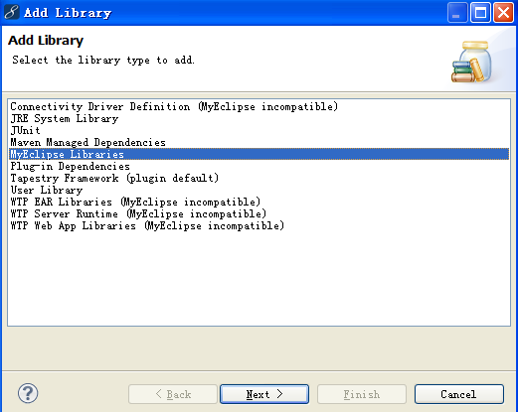

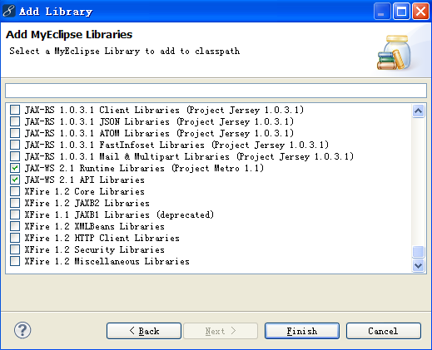

- 使用MyEclipse生成service的代理类和配置文件:

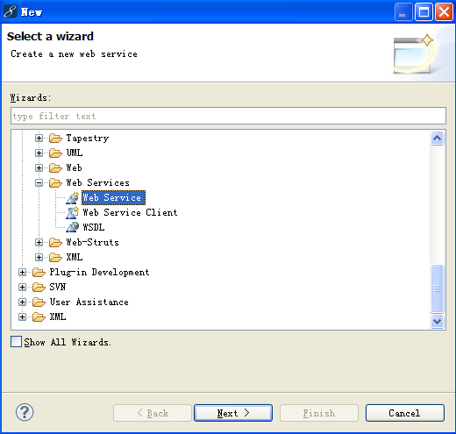

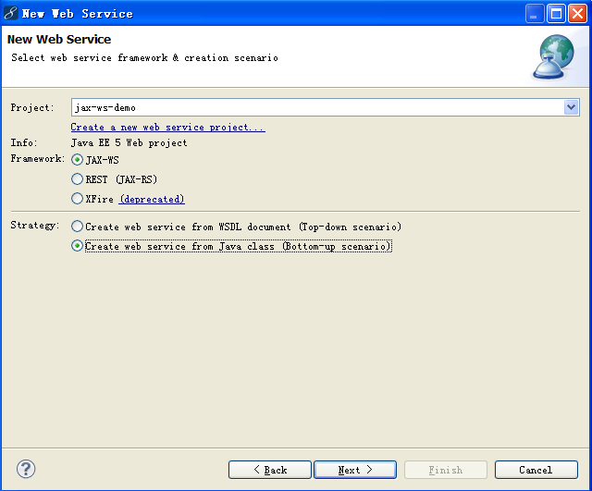

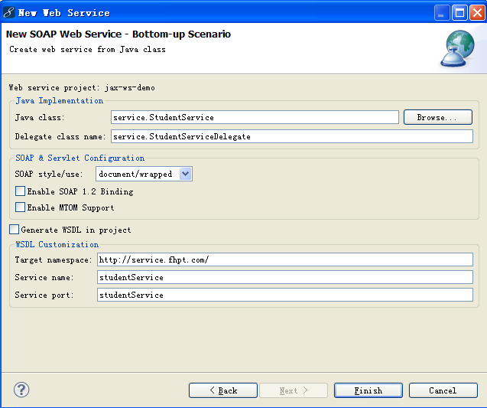

生成的代理类如下：
package service;
import vo.Student;
@javax.jws.WebService(targetNamespace = "http://service.fhpt.com", serviceName = "studentService", portName = "studentService")
public class StudentServiceDelegate {

service.StudentService studentService = new service.StudentService();

public String sayHello(Student stu) {
return studentService.sayHello(stu);
}

public Student createStudent(int age, String name) {
return studentService.createStudent(age, name);
}

}
生成的配如下：
Web.xml中生成配置
<listener>
<listener-class>
com.sun.xml.ws.transport.http.servlet.WSServletContextListener
</listener-class>
</listener>

<servlet>
<description>JAX-WS endpoint - studentService</description>
<display-name>studentService</display-name>
<servlet-name>studentService</servlet-name>
<servlet-class>
com.sun.xml.ws.transport.http.servlet.WSServlet
</servlet-class>
<load-on-startup>1</load-on-startup>
</servlet>

<servlet-mapping>
<servlet-name>studentService</servlet-name>
<url-pattern>/studentService</url-pattern>
</servlet-mapping>
生成新的配置文件sun-jaxws.xml，内容
<?xml version = "1.0"?>
<endpoints version="2.0"
xmlns="http://java.sun.com/xml/ns/jax-ws/ri/runtime">
<endpoint name="studentService"
implementation="service.StudentServiceDelegate"
url-pattern="/studentService">
</endpoint>
</endpoints>

- 发布服务端代码到tomcat/webapps下，启动服务， 在IE地址栏输入：
http://localhost:8888/jax-ws-demo/studentService，结果如下：

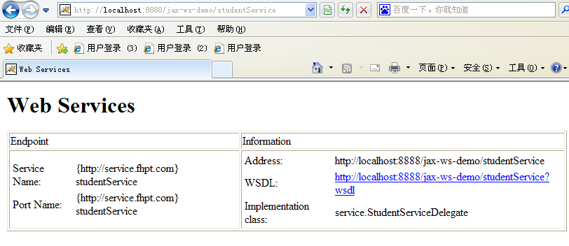
输入http://localhost:8888/jax-ws-demo/studentService?wsdl ， 结果如下：
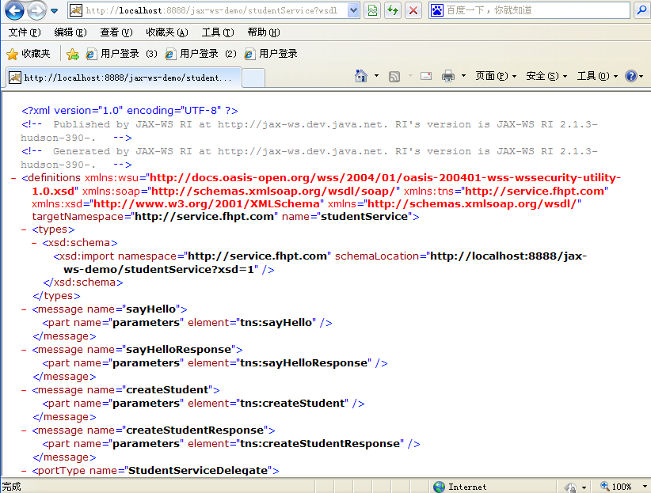
5. 使用MyEclipse生成客户端代码：

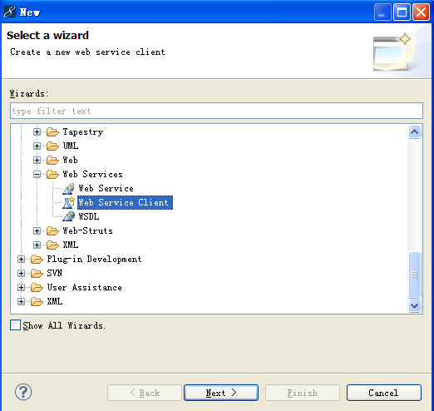

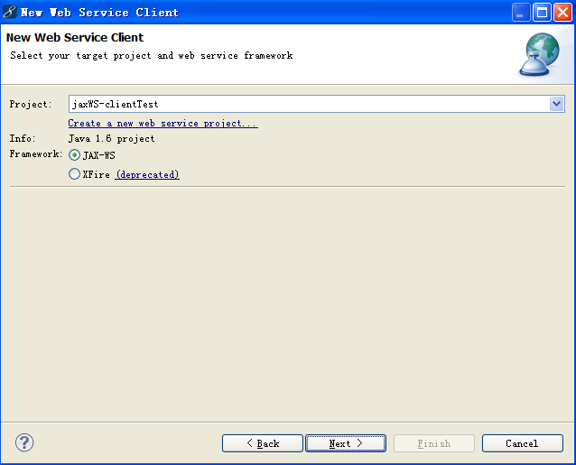

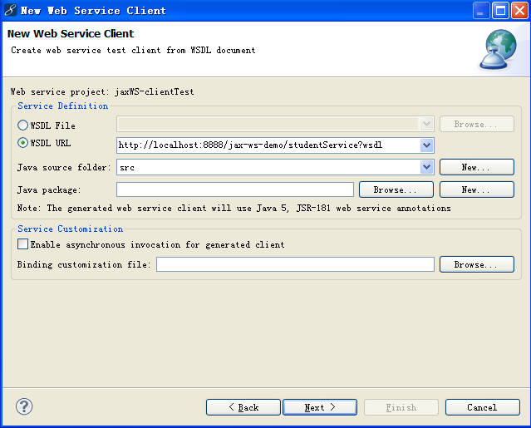
生成客户端代码结构如下图：
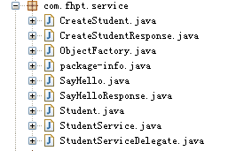

6. 写测试代码：
package test;

import com.fhpt.service.Student;
import com.fhpt.service.StudentService;
import com.fhpt.service.StudentServiceDelegate;

public class ClientTest {

/**
* @param args
*/
public static void main(String[] args) {

StudentServiceDelegate stuService =new StudentService().getStudentService();
Student stu=new Student();
stu.setAge(27);
stu.setName("pengcc");
String returnValue=stuService.sayHello(stu);
System.out.println(returnValue);

Student stu2=stuService.createStudent(26, "pengcc1985");
System.out.println(stu2);
System.out.println(stu2.getAge());
System.out.println(stu2.getName());
}

}

运行结果：
hello , pengcc
com.fhpt.service.Student@467991
26
pengcc1985

