这是我在2015年发现这个用途的，专门为[手脏](https://www.zhihu.com/search?q=%E6%89%8B%E8%84%8F&search_source=Entity&hybrid_search_source=Entity&hybrid_search_extra=%7B%22sourceType%22%3A%22answer%22%2C%22sourceId%22%3A3103713059%7D)工作者准备的

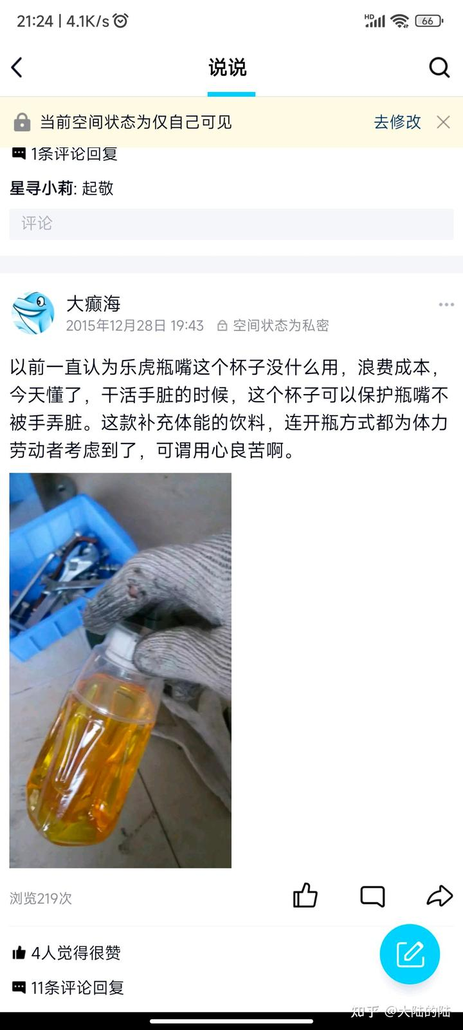

[发布于 2023-07-04 21:27](https://www.zhihu.com/question/39324406/answer/3103713059)