HOWTO

What is pyTarget?
pyTarget is a powerful iscsi initiator/target software, written in python and easily used under most popular systems. It can provides much more iscsi/scsi features for you while you are doing research, developing or testing about iscsi/scsi, such as virtual disk/tape etc. its use is governed by GPL License.

What’s new?
Current support the following features:
- support multi-target，multi-session and multi-connection (MC/s), when use multi-target, each target can be configured its own iscsi parameters independently.
- support ERL(error recovery level) = 2
- support None/CHAP authentication.
- support iscsi pdu header/data crc32c digest
- support to negotiate iscsi parameter by iscsi text request in full feature phase.
- support virtual disk
- support VTL(virtual tape library)
- support SES(scsi enclosrure service) and virtual enclosure
- support web UI (recommended firefox browser)
- support scsi disk plist/glist, bad block inquiry and bad block reassign
- others

System requirements
- xxx.binary-for-windows-x86.rar
Binary executable package, build for windows platform and run without python environment.
- xxx.src.tar.bz2
pyTarget source package, run under python-2.6 environment. Make sure that you have already installed python 2.6 or later.

Quick Start
- Change IP field to your local IP address in config.xml as following illustration.
- There are default two IQNs for initiator:
Iqn.2006-11.1 is for disk
Iqn.2006-11.2 is for tape
- Download and install VTL driver if you need to use tape
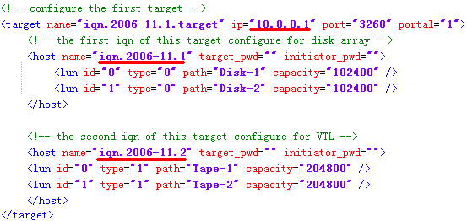

Setting up iSCSI Target

Configure console
Select an appropriate value to the debug_level in config.xml
<console ip="" port="3260" debug_level="5" />
- IP: Recommend keeping it empty, indicates that target is active in all local NICs/IPs, otherwise, target is only active in your given NIC/IP.
- Port: iSCSI target port for initiator to discovery, recommend keeping default value
- Debug_level: target console debug level(0-6)

Configure iscsi target
Add a new target item into config.xml file like following:
<target name="iscsi_target_name" ip="10.0.0.1" port="3260" portal="1">
</target>
- Name: iscsi target name, which will be return to initiator while discovery, keep it unique with config.xml
- IP: the IP field of TargetAddress, which will be return to initiator while discovery. Change to your current system ip address.
- Port: the port field of TargetAddress, recommend keeping 3260
- Portal: the portal field of TargetAddress

Add iscsi parameters into this target like following:
<target name="iscsi_target_name" ip="10.0.0.1" port="3260" portal="1">
<item key="MaxConnections" value="8" />
<item key="InitialR2T" value="No" />
<item key="ImmediateData" value="Yes" />
<item key="FirstBurstLength" value="65536" />
<item key="MaxBurstLength" value="262144" />
<item key="DefaultTime2Wait" value="2" />
<item key ="DefaultTime2Retain" value="20" />
<item key ="MaxOutstandingR2T" value="16" />
<item key ="DataPDUInOrder" value="Yes" />
<item key ="DataSequenceInOrder" value="Yes" />
<item key ="ErrorRecoveryLevel" value="2" />
<item key ="MaxRecvDataSegmentLength" value="65536" />
</target>

All of these items, you can choose suitable values and fill in its value field, but don’t need to change its key field. Learn more please refer to RFC-3720 document, section 12.

You can also choose to add an iscsi target from web ui in runtime
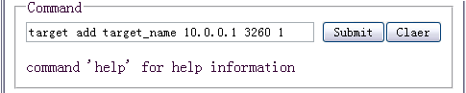
format: target add target_name ip port portal

Configure target host
Add a new host item into target like following:
<target name="iscsi_target_name" ip="10.0.0.1" port="3260" portal="1">
<host name="iqn.2006-11.1" target_pwd="" initiator_pwd="">
</host>
… …
</target>

- Name: IQN for initistor discovery/login this target. Keep this name unique within its target.
- If need initiator authentication while discovery and login, you can set target secret in target_pwd field and initiator secret in initiator_pwd field. Keep both of them empty indicates no authentication.

You can also choose to add an host from web ui in runtime
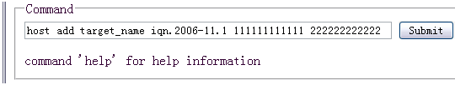
Format: host add iscsi_target_name host_name [target_secret] [initiator_secret]

Configure iscsi lun

Add new disks into host like following:
<host name="iqn.2006-11.1" target_pwd="" initiator_pwd="">
<lun id="0" type="0" path="Disk-1" capacity="102400" />
<lun id="1" type="0" path="Disk-2" capacity="102400" />
</host>

- Choose a suitable lun id for virtual scsi disk, and fill in id field, which should begin at 0 and be unique within its host. It is a probably issue that most iscsi initiator/OS can’t initialization the lun which begin with non-zero id.
- The type field show as following table:
type field | lun type
0 | DISK
0x80 | PROTECT_DISK (read only)
- Choose a valid path for virtual disk file and fill in path field
- Capacity field indicates disk capacity, 1M=2 * 1024 = 2048

Add new tapes into host like following:
<host name="iqn.2006-11.1" target_pwd="" initiator_pwd="">
<lun id="0" type="0" path="Tape-1" capacity="102400" />
<lun id="1" type="0" path="Tape-2" capacity="102400" />
</host>

- Choose a suitable lun id for virtual scsi tape, and fill in id field, which should begin at 0 and be unique within its host. It is a probably issue that most iscsi initiator/OS can’t initialization the lun which begin with non-zero id.
- The type field show as following table:
type field | lun type
1 | TAPE
0x81 | PROTECT_TAPE (read only)
- Choose a valid path for virtual disk file and fill in path field
- Capacity field indicates disk capacity, 1M=2 * 1024 = 2048

All scsi device types currently support as following:
type field | lun type
0 | DISK
1 | TAPE
8 | MEDIUM_CHANGER
13 | ENCLOSURE
0x80 | PROTECT_DISK (read only)
0x81 | PROTECT_TAPE (read only)

