Regression Results

Simple Linear Regression Results for % Below Poverty Status
MCL | PCA | TCE
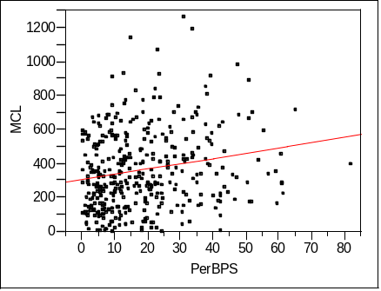 | 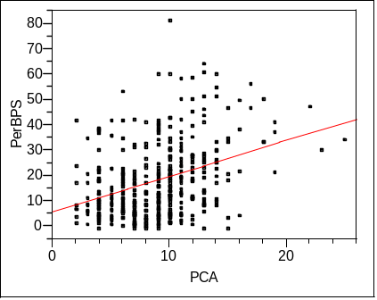 | 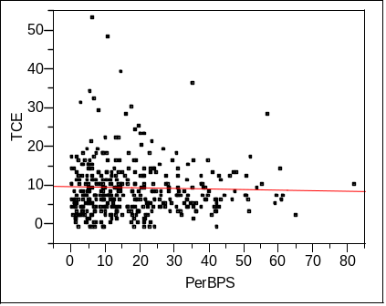

R² Values
MCL | PCA | TCE
0.040372* | 0.127598* | 0.000918 ***

* Significant at the P < 0.0001 level
*** Not significant

Simple Linear Regression Results for Percent at Risk (age < 5 or > 65)
MCL | PCA | TCE
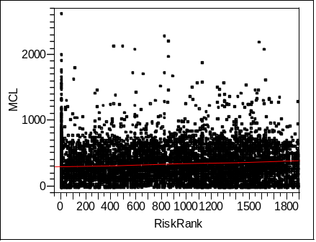 | 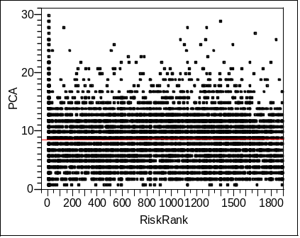 | 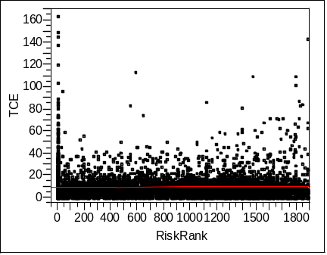

Due to large number of sampling points in very low (0 – 5 percent) and very high (95 – 100 percent) ranges, regression was performed on the X value rank. All Dependent variables where transformed with to SQRT (Y) to correct for normality of residuals.

R² Values (Adjusted R² reported)
MCL | PCA | TCE
0.012385* | 0.000117*** | 0.000231***

* Significant at the P < 0.0001 level
** Significant at the P < 0.01 level
*** Not significant

Simple Linear Regression Results for Percent White
MCL | PCA | TCE
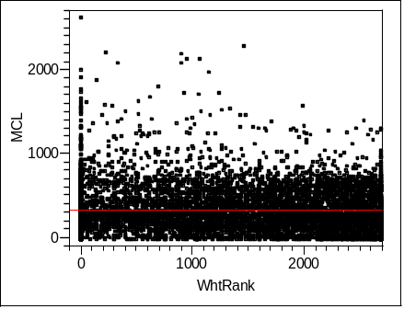 | 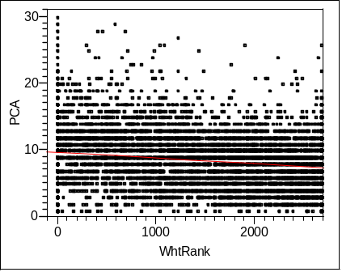 | 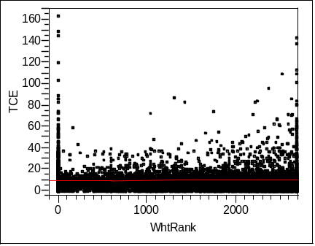

Due to large number of sampling points in very low (0 – 5 percent) and very high (95 – 100 percent) ranges, regression was performed on the X value rank. All Dependent variables where transformed with to SQRT (Y) to correct for normality of residuals.

R² Values (Adjusted R² reported)
MCL | PCA | TCE
0.000038*** | 0.042994* | 0.001295**

* Significant at the P < 0.0001 level
** Significant at the P < 0.001 level
*** Not significant

Analysis of the residuals for the Percent at Risk and Percent White yielded a non-normal distribution. Both log and square root Transformations to the dependent variables were applied. Whiles these transformations yielded normally distributed residuals with the same significance but inflated r² values. I therefore kept the non-transformed statistics.

Logistic Regression Results for Toxic Release Inventory by Tract Analysis

BPS | % @ Risk | % White
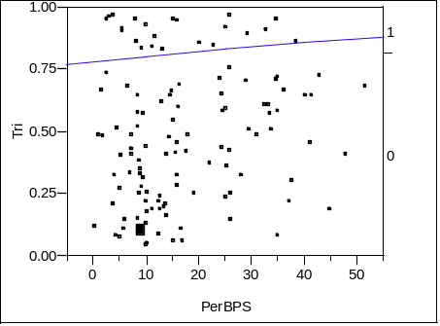 | 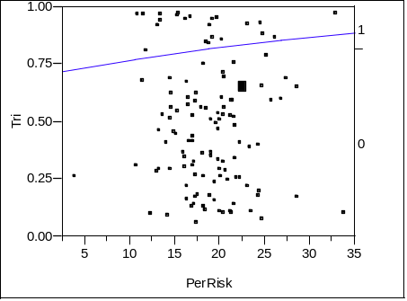 | 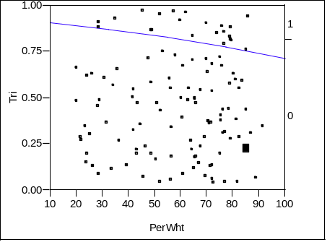

R² Values
BPS | % @ Risk | % White
0.0038*** | 0.0038*** | 0.0125***

* Significant at the P < 0.0001 level
*** Not significant

