Cardiorespiratory Fitness Algorithm
(eMERGE Mayo Network Phenotype)

Part I Cardiorespiratory Fitness Phenotype Sample Selection Steps
- Exclude records indicating pharmacologic stress tests (any of the CPT-4 codes: J0152; J0150; J1245; J1250) anytime in the medical history;
- In the remaining medical records, flag any record indicating cardiac stress test by using combinations of relevant codes detected simultaneously on the same date as listed below. Then set the first detect date as the test date for that patient.
S1: ECG (any of the CPT-4 codes: 93015; 93016; 93017; 93018) + Echo (CPT-4 code 93350); OR Echo code 93351 only;
S2: ECG (any of the CPT-4 codes: 93015; 93016; 93017; 93018) + Cardiac nuclear test (CPT-4 codes: A9500);
S3: ECG (any of the CPT-4 codes: 93015; 93016; 93017; 93018) + Oxygen uptake (any of the CPT-4 codes: 94680; 94681);
S4: ECG (any of the CPT-4 codes: 93015; 93016; 93017; 93018) only.
S5: If the patient is flagged as S1 and S3 simultaneously, set that patient as S5.
- If the relevant codes for comorbid conditions are detected within the time frame [-anytime, test date, +1year], flag the conditions as listed below (ICD-9 diagnose and procedure codes listed in Part II)
F1: coronary heart disease (CHD): any CHD codes detected ≥ 2 times in different years;
F2: congestive heart failure (CHF): any CHF codes detected ≥ 2 times in different years;
F3: cardiomyopathy: any cardiomyopathy codes
F4: Peripheral arterial disease (PAD): any PAD codes given as primary or secondary diagnose;
F5: chronic obstructive pulmonary disease (COPD): any COPD codes given as primary or secondary diagnose;
F6: Ever smokers (including current and past smokers. Use the smoking status in the current eMERGE dataset)
(* One patient may be flagged for several comorbid conditions)
4. With all the patients identified after step 2 and list all the flagged conditions for exercise stress test (S1-S5) & comorbid conditions (F1-F6) for each patient.

Flowchart for cardiorespiratory fitness phenotype sample selection

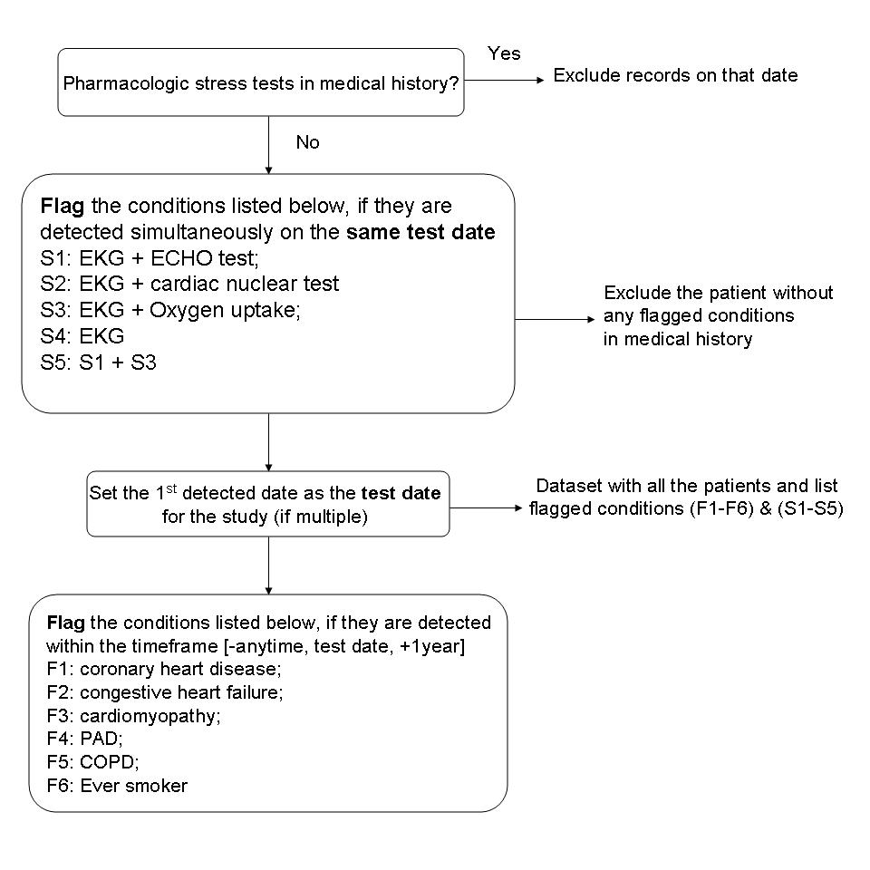

Part II Code dictionary

1. Pharmacologic stress test codes (CPT-4)

J0152; J0150 | Adenosine
J1245 | Dipyridamole
J1250 | Dobutamine
2. Cardiac stress test codes (CPT-4)

93015;93016;93017;93018 | ECG
93350;93351 | Echo
94680;94681 | Oxygen uptake
A9500 | Cardiac nuclear test

3. Comorbid conditions
3.1 Coronary Heart Disease Codes (CHD) (ICD-9 diagnosis and procedural codes)
Acute myocardial infarction | 410.xx
 | 410.00
 | 410.01
 | 410.02
 | 410.10
 | 410.10
 | 410.11
 | 410.12
 | 410.20
 | 410.20
 | 410.21
 | 410.22
 | 410.30
 | 410.30
 | 410.31
 | 410.32
 | 410.40
 | 410.40
 | 410.41
 | 410.42
 | 410.50
 | 410.50
 | 410.51
 | 410.52
 | 410.60
 | 410.60
 | 410.61
 | 410.62
 | 410.70
 | 410.70
 | 410.71
 | 410.72
 | 410.80
 | 410.80
 | 410.81
 | 410.82
 | 410.90
 | 410.90
 | 410.91
 | 410.92
Ischemic heart disease | 411.xx
 | 411.00
 | 411.10
 | 411.80
 | 411.81
 | 411.89
History of myocardial infarction | 412
Angina | 413.xx
 | 413.00
 | 413.10
 | 413.90
Chronic ischemic heart disease | 414.xx
 | 414.0
 | 414.00
 | 414.01
 | 414.02
 | 414.03
 | 414.04
 | 414.05
 | 414.06
 | 414.07
 | 414.20
 | 414.80
 | 414.90
Percutaneous coronary intervention | 36.0x
 | 36.01
 | 36.02
 | 36.03
 | 36.04
 | 36.05
 | 36.06
 | 36.07
 | 36.09
CABG | 36.1x
 | 36.1
 | 36.11
 | 36.12
 | 36.13
 | 36.14
 | 36.15
 | 36.16
 | 36.17
 | 36.19

3.2 Congestive Heart Failure (CHF) (ICD-9 diagnosis codes)
Congestive heart failure | 428
 | 428.0
Systolic heart failure | 428.1
 | 428.2
 | 428.20
 | 428.21
 | 428.22
Heart failure (non-specified) | 428.4
 | 428.40
 | 428.41
 | 428.42
 | 428.43
 | 428.9

3.3 Cardiomyopathy Codes (ICD-9 diagnosis codes)
Cardiomyopathy or myocarditis | 425
Hypertrophic cardiomyopathy | 425.1
 | 425.2
Myocarditis | 425.3
Dilated cardiomyopathy | 425.4
Other forms of cardiomyopathy | 425.5
 | 425.7
 | 425.8
 | 425.9
3.4 COPD codes (ICD-9 diagnosis codes)
Emphysema | 492.0, 492.8
Chronic obstructive bronchitis | 491.21, 491.22
Chronic obstructive asthma | 493.22
Chronic airway obstruction | 496

3.5 PAD codes (ICD-9 diagnosis codes):
Claudication: | 440.21
Leg pain | 440.22
Leg ulcer | 440.23
Gangrene | 440.24

Part III Measurements in exercise cardiac stress test
Procedure Information: | treadmill / supine bike
Protocol type | Bruce / Naughton  With / without O2 uptake measured;
Exercise capacity | Exercise time; FAC; estimated METS;
BP response | BP at rest; BP at peak % BP at 3-min post-exercise;  peak DP
HR response | HR at rest; HR at peak; HR at 1-min post-exercise;  HR at recovery;
Exercise ECG for ischemia | Negative; positive; abnormal & non-diagnostic for ischemia
VO2 capacity | Peak VO2; Peak VO2 predicted;
Effort | RER
Cardiac & pulmonary response | VO2 rise; O2 pulse rise; Peak ventilation; breathing reserve; SaO2%; VE / VCO2; anaerobic threshold

