Diabetic Retinopathy

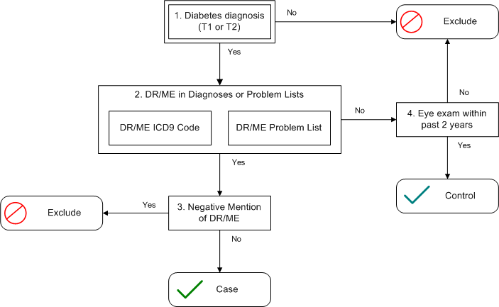

Algorithm Configuration
Prior to beginning, you should select a static reference date (such as the date of the first time you run the algorithm) that will be used as the most recent date in the medical record that will be searched. This allows the algorithm to produce a consistent cohort over multiple runs, as patients coming in and diagnosed with a relevant condition after a run may throw off previous counts and abstraction results.

1. Patient has a diagnosis of diabetes (Type 1 or Type 2)
Has the patient been confirmed with a diagnosis of Type 1 or Type 2 diabetes? The full algorithm to represent this is considered a pluggable algorithm, and is not included within this algorithm definition. The Northwestern University T2DM algorithm is an acceptable choice within this eMERGE phenotyping effort, as it includes ways to identify individuals with probable Type 1 in addition to Type 2.

2. Confirmed diagnosis/problem mention of diabetic retinopathy
Looking forward past the date of diagnosis of DM from step 1, determine the presence of diabetic retinopathy and/or macular edema.

The patient must have at least one of the following ICD9 codes listed below:
Group | ICD9 Code(s)
Background | 362.01 Background diabetic retinopathy  362.10 Unspecified background retinopathy
Macular edema | 362.07 Diabetic macular edema
Nonproliferative | 362.03 Nonproliferative diabetic retinopathy NOS  362.04 Mild nonproliferative diabetic retinopathy  362.05 Moderate nonproliferative diabetic retinopathy  362.06 Severe nonproliferative diabetic retinopathy
Proliferative | 362.02 Proliferative diabetic retinopathy
OR, the patient has any of the codes or terms listed in a problem list. Depending on how problem lists are stored in the medical record, this may require natural language processing (NLP) to determine the problems. Additional terms that may appear in the search and are considered valid are:
- Diabetic retinopathy, pre-proliferative
- Secondary diabetes with retinopathy

3. Negative mention of diabetic retinopathy
Looking at the most recent confirmed diagnosis or problem list mention from step 2, determine if a negated mention of diabetic retinopathy or diabetic macular edema appear in the chart after that time. If available, codes indicating the absence of diabetic retinopathy and/or macular edema may be used (i.e. “No evidence of diabetic retinopathy”). For institutions where negated codes like this do not exist or are not used, the use of natural language processing (NLP) would be needed to be able to find a negative mention of one of the terms in step 2 above.

4. Eye exam within the past 2 years
The patient is shown to have had at least one eye exam within the past two years of the reference date. If a patient is deceased, it will be within two years prior to date of death. For this algorithm an eye exam is defined as either:

- Any encounter with a provider in an Optometry or Ophthalmology department
  - If appointment data are available, identify appointments in an Optometry or Ophthalmology department, or an encounter with a provider with a specialty of Optometry or Ophthalmology.

Or

- Any of the following CPT codes for Evaluation & Management (E&M) that were submitted by a provider in an Optometry or Ophthalmology department.
  - New Patient
    - 92002 Intermediate
    - 92004 Comprehensive
    - 99201 Initial Office Visit,Level 1
    - 99202 Initial Office Visit,Level 2
    - 99203 Initial Office Visit,Level 3
    - 99204 Initial Office Visit,Level 4
    - 99205 Initial Office Visit,Level 5
  - Established Patient
    - 92012 Intermediate
    - 92014 Comprehensive
    - 99211 Office O/P Est 5 Min
    - 99212 Office Visit,Level 2
    - 99213 Office Visit,Level 3
    - 99214 Office Visit,Level 4
    - 99215 Office Visit,Level 5
  - Consultation
    - 99241 Consultation,Level 1
    - 99242 Consultation,Level 2
    - 99243 Consultation,Level 3
    - 99244 Consultation,Level 4
    - 99245 Consultation,Level 5

Variables of Interest
The data dictionary that accompanies this algorithm describes three data files that should be included for analysis. The first is a main phenotype file containing demographics, as well as indications of various diagnoses. For the diagnoses, we are looking for the most progressed form of diabetic retinopathy, macular edema, exudative retinopathy and retinal ischemia, as well as the age of that diagnosis. The order of codes from least to most progressed are listed below.

Variable | ICD9 Codes (least to most progressed)
Diabetic_Retinopathy | 362.10 Unspecified background retinopathy  362.01 Background diabetic retinopathy  362.03 Nonproliferative diabetic retinopathy NOS  362.04 Mild nonproliferative diabetic retinopathy  362.05 Moderate nonproliferative diabetic retinopathy  362.06 Severe nonproliferative diabetic retinopathy  362.02 Proliferative diabetic retinopathy
Macular_Edema | 362.07 Diabetic macular edema
Retinal_Ischemic | 362.84 Retinal ischemia  362.85 Retinal nerve fiber bundle defects
Exudative_Retinopathy | 362.12 Exudative retinopathy  362.82 Retinal exudates and deposits

