Heart Failure
With Differentiation between Reduced and Preserved Ejection Fraction
Phenotype Algorithm Pseudo Code
Mayo Clinic
Version: March 4, 2014

Contacts:
Suzette J. Bielinski (Bielinski.suzette@mayo.edu, 507-538-4914)
Jyotishman Pathak (Pathak.jyotishman@mayo.edu, 507-538-8384)

Updates:
- March 4, 2014:
  - Updated pseudo code to include instructions for categorizing free test ejection fraction results.
  - Data Dictionary was altered to include optional reporting of free text EF results when numeric EF measurements are unavailable.
  - Height and weight units were changed to cm and kg in the data dictionary to correspond to eMERGE standard practice.

Introduction:
Heart failure (HF) is a complex syndrome characterized by the inability of the heart to supply sufficient blood flow to the body. HF is diagnosed clinically and further dichotomized by left ventricular ejection fraction (i.e. reduced or preserved). In 2010, HF affected 6.6 million Americans at a cost of 34.4 billion . However, the syndromic nature of HF presents challenges in identification of HF cases and controls from EHR data for research given that the diagnosis is clinical. The Electronic Medical Records and Genomics (eMERGE) Network³ consortium has demonstrated the applicability and portability of EHR derived phenotype algorithms using different types and modalities of clinical data for algorithm execution including billing and diagnoses codes, natural language processing (NLP), laboratory measurements, patient procedure encounters, and medication data.

Development:
Using a gold standard cohort of 706 manually abstracted HF cases defined according to Framingham Heart Failure Criteria⁴ from the Heart Failure in the Community Cohort (R01 HL72435), structured EHR data were combined with analyses of the clinical note (unstructured) to identify the set of parameters needed to reidentify all the cases. HF terms were identified using natural language processing (NLP) (i.e. dictionary lookup, negation/probable identification with ConText⁵⁻⁷) to identify positive hits of HF from the major and secondary problem lists of the clinical note.

Algorithm and Covariates:
This algorithm requires the following types of information:
- Patient demographics
- Encounter history
- ICD diagnosis codes
- Structured problem list or unstructured problem list (processed using NLP)
- Echocardiography measurements
- Medications
Some covariates are repeated measurements requiring associated dates and others are a single measure.

Collection of Covariates
Detailed definitions of all covariates are included in the data dictionary. Note that some covariates are captured as repeated measures and include ejection fraction, myocardial infarction, BMI, and medication use. Medication history includes the following list of drugs. A complete list of drug names is included in the data dictionary.
- Angiotensin Converting Enzyme Inhibitors (ACE)
- Angiotensin II Receptor Blockers (ARB)
- Beta Blockers (BB)
- Calcium Channel Blockers (CCB)

Implementation Notes:
- Appendix A Mayo Clinic Implementation: provides a description of how the algorithm was implementation a CDA formatted document structured EMR with structured echo data.
- Appendix B Group Health Implementation: provides a description of how the algorithm was implementation a non-CDA formatted EMR with unstructured echo data.
- Appendix C Alternative Case Definition: provides a description of an optional NLP only case definition. Consider at institutions with highly transient patient populations.

For Mayo and Group Health, the NLP component of the HF algorithm was implemented using MedTagger-IE, a pattern-based information extraction framework, which will be available open source under Open Health Natural Language Processing (OHNLP) consortium (Liu H, Bielinski SJ, Sohn S, Murphy S, Wagholikar KB, Jonnalagadda SR, Ravikumar KE, Wu ST, Kullo IJ, Chute CG. An information extraction framework for cohort identification using electronic health records. AMIA Summits Transl Sci Proc. 2013;2013:149-153. PMCID: PMC3845757).
Step 1: Identifying Heart Failure Case Definition (both conditions must be met)

Presence of ICD9-CM Diagnosis Codes for HF
- Primary Heart Failure Codes = (428.X)

AND

Positive mention of HF in the problem list through either NLP or structured problem list
- Unstructured problem list (NLP) – at least one positive mention of a HF term in diagnosis-related sections. Positive mention is defined using ConText for assigning statuses to each NLP result – positive, probable, and negative (Chapman, Chu et al. 2007; Harkema, Dowling et al. 2009; Chapman, Lee et al. 2011). Thus a positive hit for this requirement equates to a non-negative and non-probable result. Mapping of terms is insensitive to upper/lower case.
      - multi-organ failure or multiorgan failure
      - cardiac failure
      - CHF
      - heart failure
      - ventricular failure
      - Structured problem list – The descendant traversal of SNOMEDCT code 84114007 (heart failure).

Step 2: Date of First Documented Heart Failure

Data Processing for Problem List
- Unstructured problem list (NLP) - assign the earliest note date among those notes with non-negative and non-probable HF terms detected in diagnosis-related sections.
- Structured problem list - assign the earliest date among the corresponding HF codes appearing in the problem list.

Case Date Assignment
  - If the earliest problem list date and earliest ICD9 date fall within 1 year of each other assign the patient the earlier of the two dates.
  - If the earliest problem list date and earliest ICD9 date are assigned > 1 year apart then do as follows
    - Use the first two dates that occur within a rolling year between any combination of problem list dates and ICD9 dates. If two dates found within a rolling year, use the earlier one.
    - Exclude cases where a date could not be assigned because they did not have any ICD9 nor problem list dates within a rolling year of each other (Note: If the same date appeared twice within the problem list dates, this was ignored).

Step 3: Classifying Heart Failure in terms of Ejection Fraction
Classify the type of HF using the priority metric below. Some patients may have multiple echo measurements within a given time window – use the lowest EF recorded in the time window.

Numeric EF Results - Priority Metric
- Lowest EF measured 0-182 days (approximately a 6 month period) after the HF date. If missing, go to number 2.
- Lowest EF measured 0-182 days (approximately a 6 month period) prior to the HF date. If missing go to number 3.
- Lowest EF measured 183-365 days after the HF date. If missing go to number 4.
- Lowest EF measured 183-365 days prior to HF date. If missing, set HF type to none (HF Type = 0).

Coding Rules to Assign Heart Failure Type:
  - HF with reduced EF = ejection fraction < 50% (HF Type = 1)
  - HF with preserved EF = ejection fraction ≥ 50% (HF Type = 2)
  - No qualifying EF measurements within any of the time frames considered(HF Type = 0)

Free Text Ejection Fraction Results - Priority Metric
(Optional – Use only if numeric EF measurements are not available)
EF Result Categories | Free Text Variations
Preserved | normal, supernormal, low-normal, moderate
Reduced | abnormal, reduced, low, severe, decreased
- EF Result 0-182 days after the HF date
  - If EF preserved then HF Type = 2
  - If EF reduced then HF Type = 1
  - If missing, go to number 2.
- EF Result 0-182 days prior the HF date
  - If EF preserved then HF Type = 2
  - If EF reduced then HF Type = 1
  - If missing, go to number 3.
- EF Result 183-365 days after the HF date
  - If EF preserved then HF Type = 2
  - If EF reduced then HF Type = 1
  - If missing, go to number 4.
- EF Result 183-365 days prior the HF date
  - If EF preserved then HF Type = 2
  - If EF reduced then HF Type = 1
  - If missing, set HF type to none (HF Type = 0).

Step 4: Identifying Heart Failure Controls (all conditions must be met):

- Absence of any heart failure ICD9 codes in medical record

AND

- Absence of positive heart failure terms in the EMR via NLP at any section or absence of heart failure codes in the structured problem lists

AND

- EF ≥ 50% if measured or patient does not have echocardiographic measurements

AND
- Has ≥5 years of continuous enrollment/contact since age 35.
Note: This is the same definition used in the Zoster algorithm. “Continuous enrollment/contact” is implemented in an integrated group practice (HMO) setting as a period of continuous enrollment ignoring gaps of up to 90 days (which tend to reflect administrative data lags rather than actual interruptions in access to care). In fee-for-service or non-integrated care settings, continuous enrollment is implemented as consecutive 5-year periods with at least one encounter per period. At Mayo Clinic we used ICD9 and CPT dates to define encounters. Encounters may be rolled up to the calendar date for purposes of establishing encounters during a period.

Heart Failure Algorithm Flow Chart

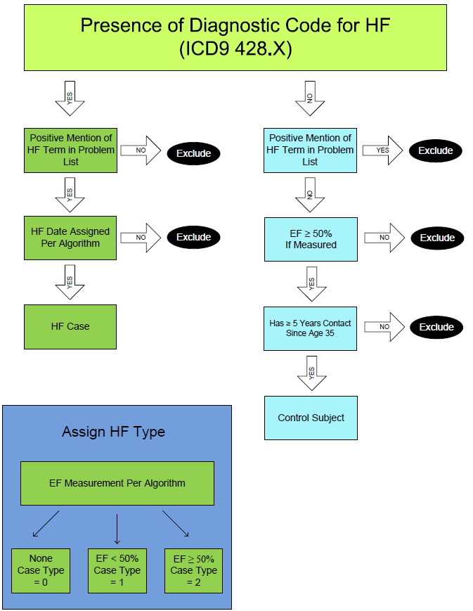
References:
1. Roger VL, Go AS, Lloyd-Jones DM, Benjamin EJ, Berry JD, Borden WB, Bravata DM, Dai S, Ford ES, Fox CS, Fullerton HJ, Gillespie C, Hailpern SM, Heit JA, Howard VJ, Kissela BM, Kittner SJ, Lackland DT, Lichtman JH, Lisabeth LD, Makuc DM, Marcus GM, Marelli A, Matchar DB, Moy CS, Mozaffarian D, Mussolino ME, Nichol G, Paynter NP, Soliman EZ, Sorlie PD, Sotoodehnia N, Turan TN, Virani SS, Wong ND, Woo D, Turner MB. Heart disease and stroke statistics--2012 update: A report from the american heart association. Circulation. 2012;125:e2-e220
2. Heidenreich PA, Trogdon JG, Khavjou OA, Butler J, Dracup K, Ezekowitz MD, Finkelstein EA, Hong Y, Johnston SC, Khera A, Lloyd-Jones DM, Nelson SA, Nichol G, Orenstein D, Wilson PW, Woo YJ. Forecasting the future of cardiovascular disease in the united states: A policy statement from the american heart association. Circulation. 2011;123:933-944
3. Kho AN, Pacheco JA, Peissig PL, Rasmussen L, Newton KM, Weston N, Crane PK, Pathak J, Chute CG, Bielinski SJ, Kullo IJ, Li R, Manolio TA, Chisholm RL, Denny JC. Electronic medical records for genetic research: Results of the emerge consortium. Science Translational Medicine. 2011;3:79re71
4. Roger VL, Weston SA, Redfield MM, Hellermann-Homan JP, Killian J, Yawn BP, Jacobsen SJ. Trends in heart failure incidence and survival in a community-based population. Jama. 2004;292:344-350
5. Harkema H, Dowling JN, Thornblade T, Chapman WW. Context: An algorithm for determining negation, experiencer, and temporal status from clinical reports. Journal of biomedical informatics. 2009;42:839-851
6. Chapman WW, Chu D, Dowling JN. Context: An algorithm for identifying contextual features from clinical text. Proceedings of the Workshop on BioNLP 2007: Biological, Translational, and Clinical Language Processing. 2007:81-88
7. Chapman BE, Lee S, Kang HP, Chapman WW. Document-level classification of ct pulmonary angiography reports based on an extension of the context algorithm. Journal of biomedical informatics. 2011;44:728-737

Appendix A: Mayo Clinic Implementation:

NLP Specific Details: The NLP component of the case definition was implemented by searching the Major and Secondary problem list section of the clinical note for at least one positive mention of one of the heart failure terms. Positive mention is defined using ConText for assigning statuses to each NLP result – positive, probable, and negative ⁵⁻⁷. Thus a positive hit for this requirement equates to a non-negative and non-probable result. Mapping of terms is insensitive to upper/lower case. All NLP dates associated with probable heart failure as defined by ConText were excluded. Among the remaining dates, we assigned the earliest NLP date among those associated with the major problem list and in the case where there was no note date associated with the major problem list; the earliest NLP date among those associated with the secondary problem list was used.

Echocardiography Results: Mayo Clinic echo data is stored in a structured database. Variable corresponding to ejection fraction (EF) measurements were identified. It is common for several EF measurements to be taken during a single exam thus the average of all available EF measurements from a single exam was used.

Appendix B: Group Health Implementation:

NLP Specific Details: The clinical notes are in non-CDA formatted documents, thus SecTag was used to detect Diagnosis and other sections (i.e. Chief Complaints or Impressions as the Secondary Problem List section).

Echocardiography Results: Group Health echo data is unstructured thus NLP was deployed to search the radiology reports for EF measurements. The following list of *regular expressions for reporting EF was used.

- Calculated EF ##%
- Calculated LVEF ##%
- Calculated LV ejection fraction ##%
- Calculated Left Ventricular ejection fraction ##%
- Calculated Ejection Fraction ##%
- Calculated Ejection Fraction ##%. Visual estimate ##%-##%
- Estimated EF ##%
- Estimated EF = ##%
- Estimated EF ##%-##%
- Estimated Ejection Fraction ##%
- Estimated Ejection Fraction ##%-##%
- Estimated Left Ventricular Ejection Fraction ##%
- Estimated Left Ventricular Ejection Fraction ##%-##%
- Estimated Left Ventricular Ejection Fraction range ##%-##%
- EF ##%
- Ejection Fraction ##%
- LVEF ##%
- LVEF ~ ## - ##%Left Ventricular Ejection Fraction ##%
- Visual Estimate of LVEF ##%
- Visual estimate of Left Ventricular Ejection Fraction ##%
- Visual Estimate of EF ##%
- Visual Estimate of Ejection Fraction ##%

*The regular expression list above includes the variations identified at Mayo Clinic and Group Health and thus is not an exhaustive list of every possible combination of the use of characters such as “=” or “~”.
Appendix C: Alternative Case Definition:

As part of the algorithm development, an alternative case definition using NLP evidence in the absence of an ICD9 diagnosis HF code (i.e. 428.X) was tested. This alternative case definition at Mayo Clinic required a positive NLP hit for HF terms 1 time in the Major problem list AND ≥ 5 times in Secondary problem list. HF date assignment considered only the NLP dates and those patients without two dates in a rolling year are excluded. Despite good overall performance), the yield of cases was minimal (n = 13 at Mayo Clinic). Abstraction of these cases revealed that all of the 13 patients identified by this definition were true cases and all were transient/referral patients. Therefore the NLP only case definition was not included in the final algorithm. However, for sites with a large referral or transient population, the alternative case definition should be considered as it may result in higher yield as compared to the stable population at Mayo Clinic.

