Genome-Wide Study of Cataract and Low HDL
in the Personalized Medicine Research Project

Below is a flowchart and pseudo code used to select Marshfield’s HDL cohort. We thought a flowchart may be helpful in providing an overview of our process steps. Pseudo code can be found on the following pages. Included is information specific to each reference identified within the applicable flowchart symbols.

If you have questions regarding any of the information presented on this page, you may contact either:
Peggy Peissig at peissig.peggy@marshfieldclinic.org or call: 715.221.8322
James Linneman at linneman.james@marshfieldclinic.org or call 715.221.7271

FLOWCHART of HDL Phenotyping Process

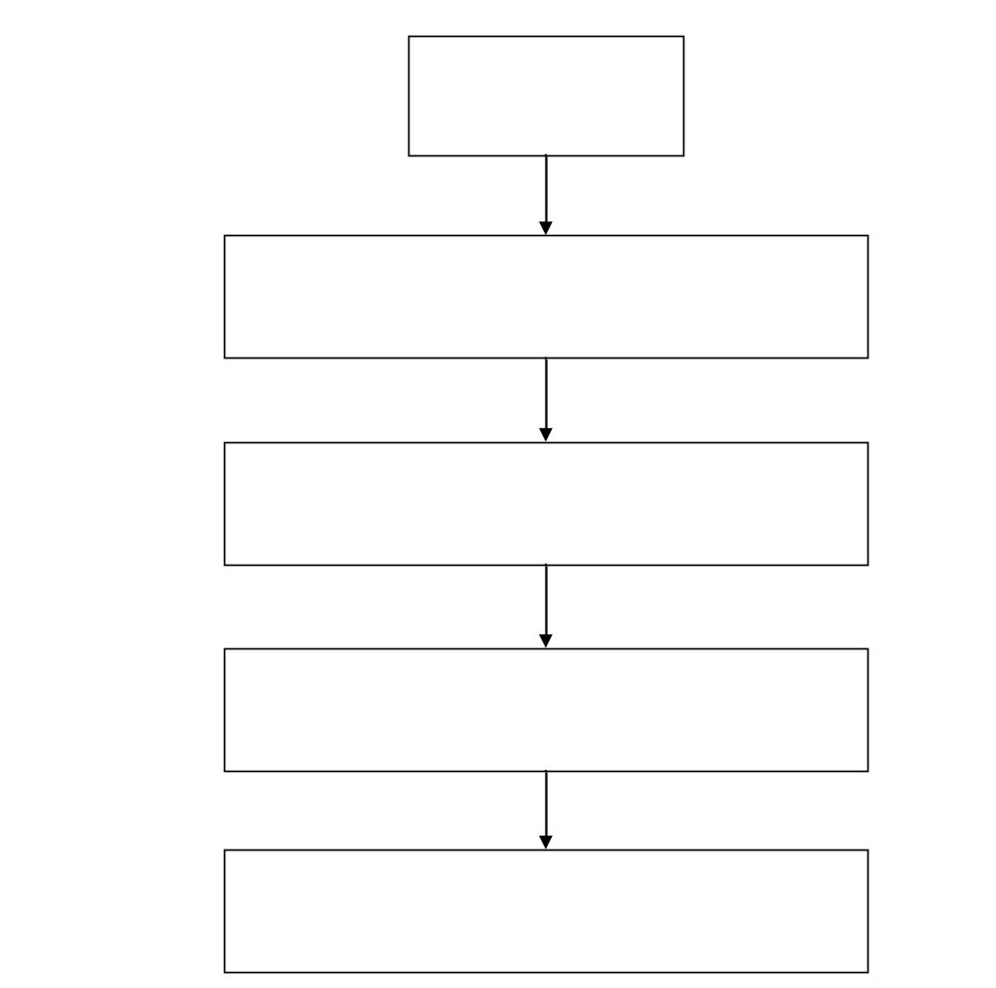
FLOWCHART of HDL Phenotyping Process
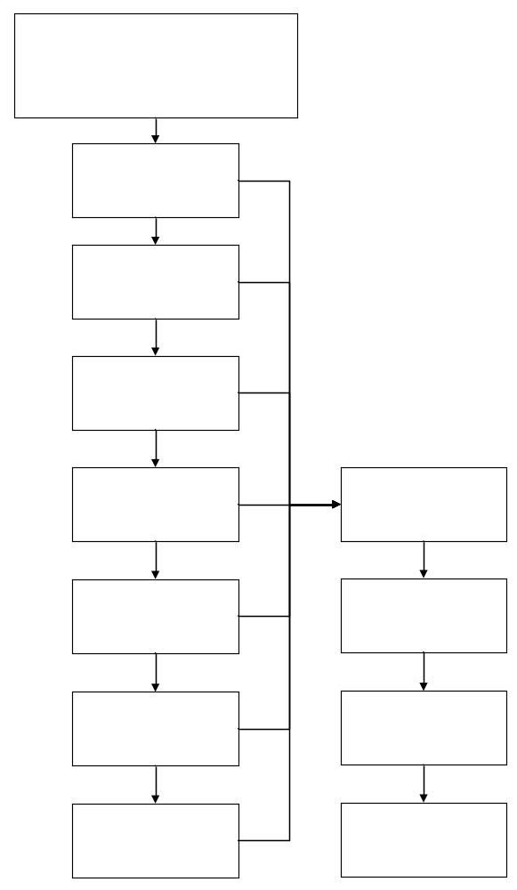
FLOWCHART of HDL Phenotyping Process

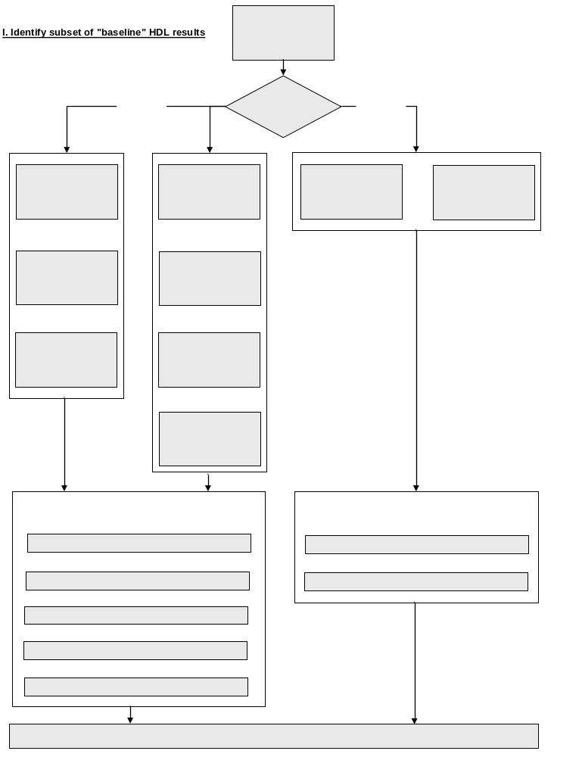

Pseudo code for the HDL Phenotype

PMRP cohort

-Select all subjects from the PMRP cohort who have:
Consented
Did not withdraw from the study
Include subjects with contact_for_research = ‘N’
Include subjects where questionnaires have been scanned.

I. Identify baseline HDL results

1a Date of earliest cancer diagnosis in registry (cancer_dx1_date)

1b Earliest Diabetes indication date (diabetes_censor_date)
Use diagnoses from 1960 to present
* Diabetic diagnoses codes *;
Diabetes
1960-1968: 260.0
1969-06/1974: 250.0
07/1974-1978: 250.0
1979-present: 250.00-250.03

Diabetic Neuropathy
1960-1968: 260.2
1969-06/1974: 250.3
07/1974-1978: (not specified)
1979-present: 250.60-250.63, 357.2

Diabetic Retinopathy
1960-1968: 260.1
1969-06/1974: 250.3
07/1974-1978: (not specified)
1979-present: 250.50-250.53, 362.01-362.02

Diabetic Nephropathy
1960-1968: 260.9
1969-06/1974: 250.3
07/1974-1978: 250.6
1979-present: 250.40-250.43, 583.81

* If diabetic diagnoses codes present;
If 1 or more diabetic diagnoses codes present then do;
if subject has 1 or more random glucose tests >= 200 mg/dl "OR"
subject has 1 or more HbA1c tests > 6.0 (ULN) "OR"
subject has 2 or more fasting glucose tests >= 126 mg/dl on 2 different dates "OR"
subject has 1 or more mentions in clinical notes for Metformin, Sulfonylurea, Insulin, or Thiazolidinediones.
then diabetic=Yes;
end;

* If diabetic diagnoses codes absent;
else if no diabetes diagnoses codes present then do;
if subject has 1 or more HbA1c tests "AND"
subject has 1 or more Random glucose tests >= 200 mg/dl
then diabetic=Yes;
end;

To determine earliest diabetes indication date;
If diabetic = "Yes" then do;
* If diabetic diagnoses codes present;
If 1 or more diabetic diagnoses codes present then do;
earliest diabetes indication date = the earliest of the following dates: first diabetes diagnosis date,
first random glucose date, first HbA1c date, the 2nd qualifying fasting glucose date where glucose >= 126, or the first diabetes medication date.
end;
* If diabetic diagnoses codes absent;
else if no diabetes diagnoses codes present then do;
earliest diabetes indication date = the earliest of the following dates: first random glucose date,
or the first HbA1c date.
end;
end;

1c Earliest Hyper/Hypothyroidism date (thyroid_censor_date)
Use diagnoses from 1960 to present
* Hyper/Hypothyroidism diagnoses codes *;

Hyperthyroidism
1960-1968: 252.0-252.1
1969-06/1974: 242.0-242.1
07/1974-1978: 242.0-242.2, 242.9
1979-present: 242.00-242.33, 242.90-242.93

Hypothyroidism Congenital
1960-1968: 253.9 253.0
1969-06/1974: 244 243
07/1974-1978: 244.0-244.9 243
1979-present: 244.0-244.9 243

Medications mapped to generic name "Levothyroxine"

Lab results for TSH

If 2 or more of the same diagnosis code present, "OR" Levothyroxine medications mention in clinical notes, "OR" 1 or more TSH lab results outside the normal range

TSH Normal Ranges:
From To Low High
11/13/1986 2/6/1990 0.29 5.00
2/7/1990 5/27/1993 0.46 3.60
5/28/1993 3/31/1995 0.55 4.10
4/1/1995 5/18/1999 0.46 4.88
5/19/1999 10/5/2004 0.40 5.70
10/6/2004 Current 0.35 4.50

then hyper/hypothyroidism="Yes";

To determine earliest Hyper/Hypothyroidism date;
If hyper/hypothyroidism = "Yes" then do;
earliest hyper/hypothyroidism date = the earliest of the following dates: first diagnosis date for the earliest hyper/hypothyroidism diagnosis having at least 2 diagnosis codes, "OR" the first Levothyroxine medication mention date in the clinical notes, "OR" the first TSH lab result date where the result is outside the normal range.
end;

1d Earliest Statin use date (statin1_date)
Earliest mention of Statin use in clinical notes
(Including all forms of Atorvastatin, Simvastatin, Pravastatin, Lovastatin, Cerivastatin, Rosuvastatin, Fluvastatin)

1e Earliest Gemfibrozil/Fibrate use date (fibrate1_date)
Earliest mention of Gemfibrozil/fibrate use in clinical notes
where AHFS_SPECIFIC_CATEGORY_DESC='Fibric Acid Derivatives';

1f Earliest Niacin use date (niacin1_date)
Earliest mention of Niacin use in clinical notes
where AHFS_SPECIFIC_CATEGORY_DESC='Antilipemic Agents, Miscellaneous' or
GENERIC_NAME in('INOSITOL/NIACIN','FOLIC ACID/NIACINAMIDE/CU/ZNOX','NIACINAMIDE');
(excluded NIACIN\LOVASTATIN as this was picked up as a Statin)
Determine if subject taking 500 mg or more per day.
Searched for common doses (in flanking text) of 250, 500, 1000, 1500, & 2000.
If dose = 250 and subject taking 2+ pills daily then considered on 500+ mg/day.
Removed 36 subjects who were known to be only on doses of less than 500 mg/day.
All other subjects considered on 500+/day.

1g Earliest Estrogen use date (estrogen1_date)
Earliest mention of the following Estrogen/Androgen drug use in clinical notes (regardless of age or gender) ALORA, CENESTIN, CLIMARA, CLIMARA PRO, COMBIPATCH, DELESTROGEN, ESTRACE, ESTRADERM, ESTRATAB,
ESTRATEST, ESTRATEST H.S., ESTROGEN, FEMHRT, MENEST, OGEN, ORTHO-EST, ORTHO-PREFEST, PREMARIN, PREMPHASE, VIVELLE, VIVELLE-DOT
Excluded any records where topical or cream was indicated in the flanking text.
Searched the flanking text in records where the drug name='ESTROGEN' for the following terms:
post menopause, post menopause, postmenopausal, on estrogen, went off estrogen, stop estrogen, on unopposed estrogen, estrogen replacement, history of estrogen use, estrogen patch, estrogen usage, estrogen therapy, estrogen pill, unopposed estrogen use, chronic estrogen use.
Kept records where drug name="ESTROGEN" and flanking text contained one of the above terms and there was no indicator of topical or cream in the flanking text.

2a Earliest censor date (censor_date1)
Earliest known date of diagnoses or medications that affect HDL
censor_date1=min(cancer_dx1_date, diabetes_censor_date, thyroid_censor_date,
fibrate1_date, niacin1_date, statin1_date, estrogen1_date,);

2b Determine HDL's prior to earliest censor date
If date of HDL lab is before censor date or subject has no censor date than HDL considered baseline (unaffected).
if lab_date < censor_date1 or censor_date1=. then hdl_prior_censor=1;

2c Determine HDL's during hospital stays
Get hospital admit and discharge dates and determine if HDL was obtained during a hospital stay.

2d Determine baseline HDL's
Keep HDL's that were not obtained during a hospital stay.

II. Estimation of Individual Baseline HDL Levels and Standard Errors

Assumptions:
1) Baseline HDL levels among individuals are highly heterogeneous due to genetic factors and to differences in diet and other lifestyle factors.
2) Baseline HDL laboratory results within an individual are subject to gross outliers, due primarily to acute changes in health status and to variation in diet and time fasting.
3) The availability of HDL data varies greatly among individuals.

Methods:
1) HDL results were subset to outpatient results for adults (≥ 18 years).
2) If an individual had multiple HDL results on a given day, the median for the day was used.
3) Individuals were excluded if they did not have HDL results for at least two days.
4) The overall median HDL across time was calculated for each individual, as was the standard deviation (SD) among the individual's results.
5) Since some individuals may have as few as two results, and since the SD is poorly estimated in small samples, the pooled within-individual SD (SD_{p}) was also calculated for the cohort.
6) The estimated standard error for each individual was based on the larger of the two estimates of the SD: SE_{i} = maximum(SD/√n_{i}, SD_{p}/√n_{i}).

III. Adjustment for Population Trends

Assumptions:
1) Changes in age and body size (as measured by body mass index, BMI) can substantially affect an individual's baseline HDL level.
2) Availability of data within an individual will often show limited ranges for age and BMI, precluding individual effect estimates.
3) Population trends in age and BMI (see Figures 1 and 2) can be used to meaningfully adjust individual baseline HDL estimates to remove variability due to age and body size differences among individuals.
4) Age can be determined electronically to a high degree of precision from dates of birth and result dates, but the electronically gleaned heights and weights used to calculate BMI are subject to a relatively high rate of gross errors that will require site-specific screening methods.

Methods:
1) Heights and weights were screened, first on a population basis and then on an individual subject basis. Since the early Marshfield data came from a text mining algorithm, the first step involved reviewing strong outliers and adding specific text screens to improve the algorithm. Weights for pregnant females during a period from 210 days prior to delivery through 30 days following delivery were excluded. Data were then normalized to the NHANES¹ data to provide age and gender specific z-scores. Prior to normalization, the tabled centiles were smoothed using the LMS method. All z-scores greater than 8 in absolute value were assumed to be errors and were excluded. Next, heights and weights were screened within individuals by considering previous and/or subsequent values and excluding values which result in sharp changes (e.g. a weight which exceeds both the previous and subsequent measures by more than 10 lbs and 10%, and at least one reflects a change of 10% per day or 40% total).

Anthropometric Reference Data for Children and Adults: U.S. Population, 1999–2002,
by Margaret A. McDowell, M.P.H., R.D.; Cheryl D. Fryar, M.S.P.H.; Rosemarie Hirsch, M.D.; and Cynthia L. Ogden, Ph.D., Advance Data from Health and Vital Statistics July 7, 2005, Centers for Disease Control, www.cdc.gov/nchs/data/ad/ad361.pdf.
Cole TJ, Green PJ (1992). Smoothing reference centile curves: the LMS method and penalized likelihood. Stat Med. 11(10):1305-19.

The screening parameters were subjectively tuned by reviewing scatter plots of serial heights and weights in random samples of individuals from the cohort. After separately screening heights and weights, BMIs were calculated after merging the screened values by individual and date. Since weight is measured more frequently than height and adult height is relatively constant, when height was not available on the same day as a weight, the closest height before and/or after was identified and BMI was calculated using a time-weighted average height. Finally, the resulting BMIs were normalized and screened, excluding all z-scores greater than 6 in absolute value and, subsequently, values which result in sharp changes within individuals (as with height and weight).

2) A repeated measures model was fit, separately for males and females, with baseline HDL as the response and age and the screened BMI measures as predictors (through cubic splines, with knots at ages 30, 50, and 70, and at BMIs of 25, 30, and 35). BMIs were required to be within 30 days of the HDL, and the median BMI was used if more than one measure was available within 30 days. The estimated population trends were used to adjust the median baseline HDLs for the corresponding median age and median BMI at the time of the baseline HDLs. Subjects with no valid BMI results had the HDL adjusted by age only. The goal of the adjusted baseline HDL is to approximate HDL for each individual at age 50 with BMI 25 while not exposed to statins or other confounding factors.

IV. Subset Low HDL Cases and Non-Low HDL Controls

Methods:
1) Approximate confidence regions were established around each individual's adjusted and unadjusted baseline HDL estimate. The confidence region was based on the product of a standard normal centile (e.g. 1.96 for 95% confidence) and the estimate of the standard error for the individual.

2) The best candidates are deemed to be those for whom neither the adjusted or unadjusted confidence regions overlap the gender specific NCEP cutoffs. Ideal cases are those estimated to be well below the HDL cutoffs, while ideal controls are estimated to be well above the cutoffs (see Figures 3 and 4).
Figure 1.

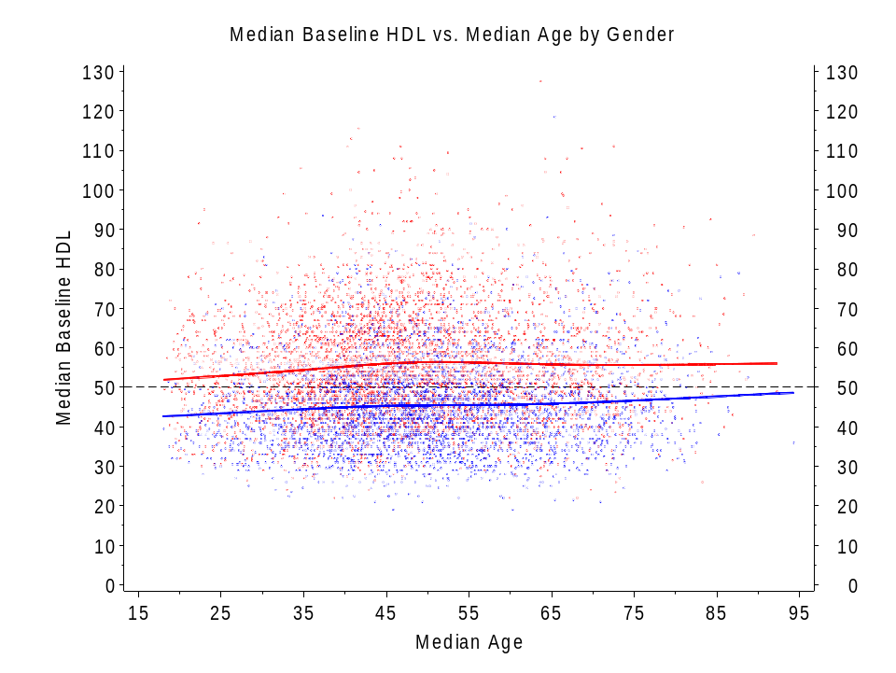
Legend to Figure 1: Scatter plot of median baseline HDL versus median age (for the corresponding HDL dates). Red symbols show 4,553 unique female subjects, and blue symbols show 3,556 unique male subjects, and in each case a graphical smoother (cubic spline routine) is used to illustrate the trend.

Figure 2.

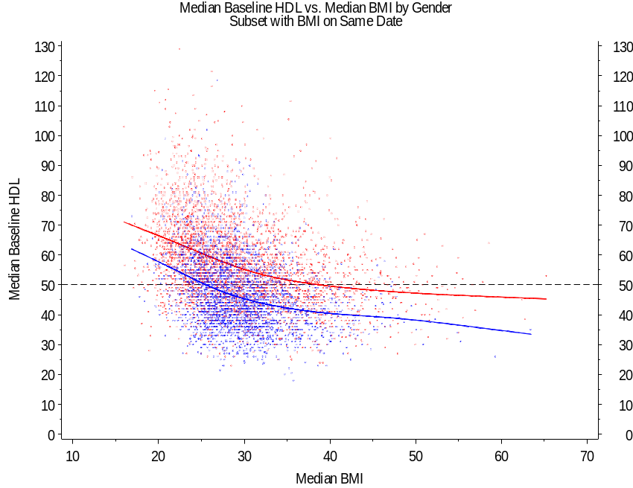
Legend to Figure 2: Scatter plot of median baseline HDL versus median BMI (for the corresponding HDL dates). Red symbols show 3,478 unique female subjects, and blue symbols show 2,910 unique male subjects, and in each case a graphical smoother (cubic spline routine) is used to illustrate the trend.
Figure 3.

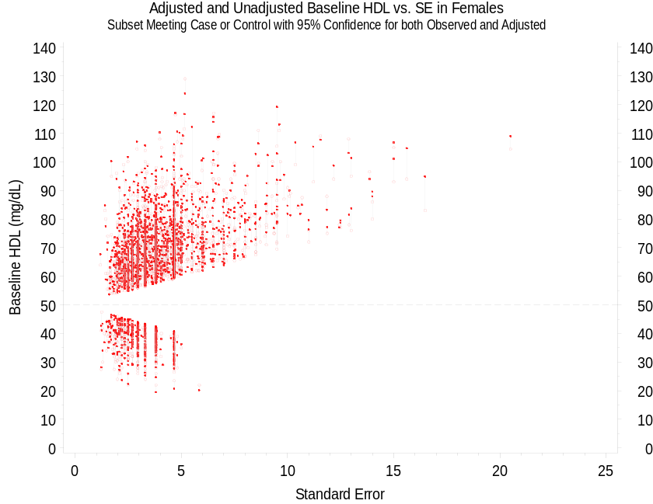

Legend to Figure 3: Scatter plot of adjusted and unadjusted baseline HDL versus standard error in the subset where both estimates differ from the NCEP cutoff with approximate 95% confidence. Joined symbols show 2,109 unique female subjects, with closed circles for the adjusted estimates and open circles for the unadjusted estimates.

Figure 4.

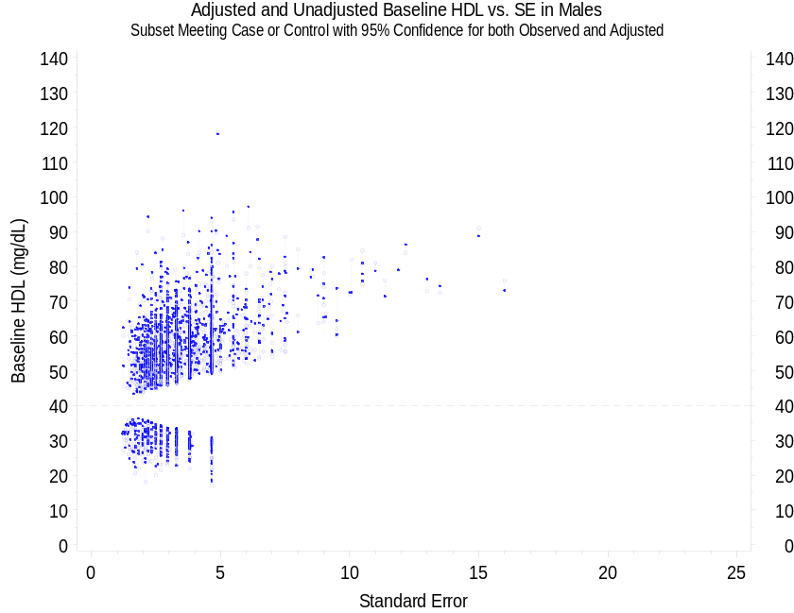

Legend to Figure 4: Scatter plot of adjusted and unadjusted baseline HDL versus standard error in the subset of male subjects where both estimates differ from the NCEP cutoff with approximate 95% confidence. Joined symbols show 1,561 unique male subjects, with closed circles for the adjusted estimates and open circles for the unadjusted estimates.

