Mutivariable logistic regression model to predict presence of PAD.
The model was based on our analysis of the vascular test (ABI) results in the vascular lab database at Mayo Rochester. In this database of 22156 individuals studied over the last decade, 14408 had PAD and 7748 did not.

We used billing codes to predict presence of PAD in these patients. The results are shown below. The AUROC was 0.86.

Variable | DF | Estimate | StdErr | WaldChiSq | ProbChiSq | Score
Intercept | 1 | -1.58 | 0.04 | 1421.53 | 0.0000 | -6
CPT4Px73725 | 1 | 0.66 | 0.16 | 16.33 | 0.0001 | 3
CPT4Px75635 | 1 | 0.54 | 0.11 | 24.09 | 0.0000 | 2
CPT4Px75710 | 1 | 0.61 | 0.13 | 21.55 | 0.0000 | 2
CPT4Px75716 | 1 | 0.75 | 0.12 | 36.69 | 0.0000 | 3
CPT4Px93922 | 1 | 0.53 | 0.04 | 159.73 | 0.0000 | 2
ICD9Px8848 | 1 | 0.65 | 0.13 | 23.94 | 0.0000 | 3
ICD9Dx44020 | 1 | 1.25 | 0.05 | 708.82 | 0.0000 | 5
ICD9Dx44021 | 1 | 2.16 | 0.05 | 2039.31 | 0.0000 | 9
ICD9Dx44022 | 1 | 1.04 | 0.11 | 83.75 | 0.0000 | 4
ICD9Dx44023 | 1 | 1.62 | 0.07 | 567.05 | 0.0000 | 6
ICD9Dx44024 | 1 | 1.91 | 0.18 | 106.94 | 0.0000 | 8
ICD9Dx4408 | 1 | 0.74 | 0.16 | 21.91 | 0.0000 | 3
ICD9Dx4409 | 1 | 0.93 | 0.04 | 432.30 | 0.0000 | 4
ICD9Dx4439 | 1 | 0.84 | 0.04 | 462.36 | 0.0000 | 3

We then created an integer score based on the beta-coefficients and used that score to predict presence of PAD. The results are shown in the ROC curve below. The AUROC was 0.86. A score of 8 had ~80% sensitivity and specificity for the prediction of PAD.
A description of the codes is provided in the table below.

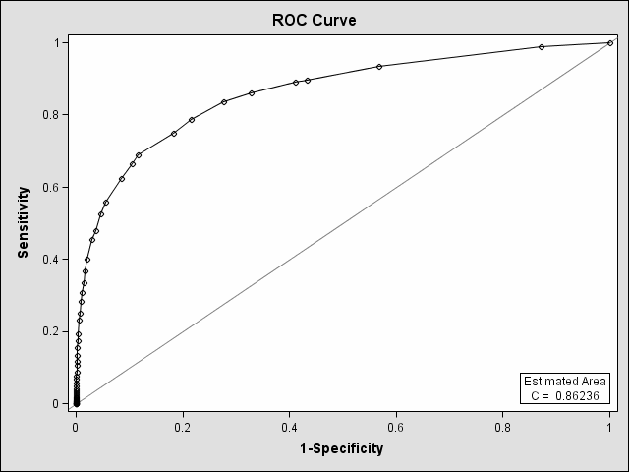

Code | Estimate | Score | Code Description
CPT4Px73725 | 0.66 | 3 | MRA Lower extremity w/ or w/o contrast
CPT4Px75635 | 0.54 | 2 | CT angiogram - abdominal aorta and bilateral iliofemoral lower extremity runoff
CPT4Px75710 | 0.61 | 2 | Angiography, extremity, unilateral, radiological supervision and interpretation
CPT4Px75716 | 0.75 | 3 | bilateral angiograph extremity
CPT4Px93922 | 0.53 | 2 | Non-invasive physiologic studies of lower extremity arteries, single level, bilateral
ICD9Px8848 | 0.65 | 3 | Arteriography of femoral and other lower extremity arteries
ICD9Dx44020 | 1.25 | 5 | Atherosclerosis of native arteries of the extremities, unspecified
ICD9Dx44021 | 2.16 | 9 | Atherosclerosis of native arteries of the extremities with intermittent claudication
ICD9Dx44022 | 1.04 | 4 | Atherosclerosis of native arteries of the extremities with rest pain
ICD9Dx44023 | 1.62 | 6 | Atherosclerosis of native arteries of the extremities with ulceration
ICD9Dx44024 | 1.91 | 8 | Atherosclerosis of native arteries of the extremities with gangrene
ICD9Dx4408 | 0.74 | 3 | Atherosclerosis of other specified arteries
ICD9Dx4409 | 0.93 | 4 | generalized and unspecified atherosclerosis
ICD9Dx4439 | 0.84 | 3 | Peripheral vascular disease, unspecified

