Peripheral Arterial Disease (PAD)

Peripheral Arterial Disease (PAD) is prevalent with approximately 10-12 million adults in US affected. For those with PAD, morbidity and mortality are high and quality of life is markedly impaired. The genetic basis of PAD is poorly understood and is the focus of the Mayo Clinic Electronic Medical Records and Genomics (eMERGE) Network study.

In this document, we provide pseudocode modeling a standardized diagnostic algorithm for PAD. A set of ‘gold-standard’ rules were developed for the Mayo Clinic population as well as billing rules for transportability to sites without vascular laboratory data. Depending on the values of relevant variables, the rules classify a patient into one of the 2 classes: presence of PAD, and absence of PAD.

Ankle-brachial index (ABI) for ascertaining PAD

The ankle-brachial index (ABI) was measured in Mayo Clinic’s non-invasive vascular laboratory in Rochester MN using a standardized protocol. Following a 5-min rest, subjects were evaluated in the supine position. Appropriately-sized BP cuffs were placed on each arm and ankle, and a Doppler ultrasonic instrument (Medisonics, Minneapolis MN) was used to detect arterial signals. The cuff was inflated to 10 mm Hg above SBP and deflated at 2 mm Hg/s. The first reappearance of the arterial signal was taken as the SBP. To calculate the ABI, the SBP at each ankle site (posterior tibial and dorsalis pedis arteries) was divided by the higher of the two brachial pressures. The lower of the average ABIs from the two legs was used to define PAD. An ABI cut-point of less than or equal to 0.90 was used to diagnose PAD. Subjects with poorly compressible arteries due to medial arterial calcification were also classified as having PAD. The criteria for poorly compressible arteries in the Mayo vascular lab are as follows: an ABI >1.4, an ankle BP >255 mmHg, or having non-reproducible ankle BP measurements.
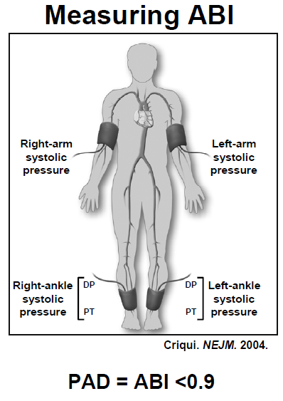

EMR Extraction of ABI Phenotype
To define a ‘definite’ PAD case population, patients will meet the algorithmic vascular lab criteria in Section 1 or will have any of the two related codes or presence of indicative phrases in Sections 2-5. To define a ‘probable’ PAD case population for further investigation, patients will beet any one of the related codes or presence of indicative phrases in Sections 2-5.

Section 1: Vascular Lab Criteria
Ankle brachial index <0.9 at rest or post exercise; ankle systolic blood pressure >255 mmHg, or any ABI >1.4
Exclude non-atherosclerotic causes of PAD:
≥2 occurrences of the following codes
747.22, 237.7, 443.1, 446.0, 446.4, 446.5, 446.6, 446.7, 447.6, 710.1, 747.1, 747.64.

Section 2: ICD-9-CM Diagnosis Codes For PAD
440.2×, 440.3×, or 440.8×.

Section 3: Procedure Codes Related To PAD
One of the ICD-9-CM/CPT-4 procedure codes for lower extremity artery angiography: 88.48, 75710, 75711, 75712, 75716, 75717, 75718, 75630, 75631. PLUS one (concurrent) of the codes below for non coronary vessel stents: 39.50, 39.90, 37205, 37206, 37207, 37208, 37184, 37185, 37186.

OR
One of the ICD-9-CM/CPT-4 procedure codes for lower extremity artery surgical and percutaneous vascular interventions: 38.18, 39.50, 39.25, 39.29, 38.08, 38.38, 38.48, 39.49; 39.56, 39.57, 39.58, 39.90, 35302, 35303, 35304, 35305, 35306, 35331, 35351, 35355, 35361, 35363, 35371, 35372, 35381, 35452, 35454, 35456, 35459, 35470, 35472, 35473, 35474, 35481, 35482, 35483, 35485, 35491, 35492, 35493, 35495, 35521, 35533, 35537, 35538, 35539, 35540, 35541, 35546, 35548, 35549, 35551, 35556, 35558, 35563, 35565, 35566, 35571, 35582, 35583, 35585, 35587, 35621, 35623, 35637, 35638, 35641, 35646, 35647, 35651, 35654, 35656, 35661, 35663, 35665, 35666, 35671, 35226, 35256, 35286, 35700, 35721, 35741, 35876, 35879, 35881, 35883, 35884, 37184, 37185, 37186, 37205, 37206, 37207, 37208.
Exclude if one of the following ICD-9-CM codes for alternate reasons for surgery is also present: 736.3×, 736.4×, 736.5, 736.6, 736.7×, 736.8×, 736.9, 735.×, 754.3×, 754.4×, 754.5×, 754.6×, 754.7×, 755.02, 755.13, 755.14, 755.3, 755.4, 755.6×, 755.8, 759.7, 759.89, 895.××, 896.××, 897.××, 820.××, 821.××, 822.××, 823.××, 824.××, 825.××, 826.××, 827.××, 828.××, 829.××, 835.××, 836. ××, 837.××, 838.××, 904.××, 928.××, 929.××, 959.6, 959.7, 996.4×, 996.66, 996.67, 996.77, 996.78.

OR
One of the ICD-9-CM/CPT-4 procedure codes for lower extremity amputation: 84.1×, 84.91, 27295, 27590, 27591, 27592, 27598, 27880, 27781, 27782, 27888, 27889, 28800, 28805.
Exclude if one of the following ICD-9-CM codes for non-vascular amputation is also present: 170.6, 170.7, 170.8, 170.9, 171.3, 172.7, 173.7, 198.5, 344.1, 711.0, 728.86, 733.2, 736.3×, 736.4×, 736.5, 736.6, 736.7×, 736.8×, 736.9, 735. ×, 754.3×,754.4×,754.5×,754.6×,754.7×,755.02, 755.13, 755.14, 755.3, 755.4, 755.6×, 755.8, 759.7, 759.89, 820.××, 821.××, 822.××, 823.××, 824.××, 825.××, 826.××, 827.××, 828.××, 829.××, 835.××, 836. ××, 837.××, 838.××, 890. ××, 891, 895.××, 896.××, 897.××, 904.××, 905.4, 928.××, 929.××,959.6, 959.7,996.4×, 996.66, 996.67, 996.77, 996.78.

Mutivariable logistic regression model to ascertain PAD.
This model was based on billing codes and analysis of the vascular test (ABI) results in the vascular lab database at Mayo Rochester. In this database of 22156 individuals studied over the last decade, 14408 had PAD and 7748 did not.

This model uses the following billing code variables to predict presence of PAD in these patients.
Variable | DF | Estimate | StdErr | WaldChiSq | ProbChiSq | Score
Intercept | 1 | -1.58 | 0.04 | 1421.53 | 0.0000 | -6
CPT4Px73725 | 1 | 0.66 | 0.16 | 16.33 | 0.0001 | 3
CPT4Px75635 | 1 | 0.54 | 0.11 | 24.09 | 0.0000 | 2
CPT4Px75710 | 1 | 0.61 | 0.13 | 21.55 | 0.0000 | 2
CPT4Px75716 | 1 | 0.75 | 0.12 | 36.69 | 0.0000 | 3
CPT4Px93922 | 1 | 0.53 | 0.04 | 159.73 | 0.0000 | 2
ICD9Px8848 | 1 | 0.65 | 0.13 | 23.94 | 0.0000 | 3
ICD9Dx44020 | 1 | 1.25 | 0.05 | 708.82 | 0.0000 | 5
ICD9Dx44021 | 1 | 2.16 | 0.05 | 2039.31 | 0.0000 | 9
ICD9Dx44022 | 1 | 1.04 | 0.11 | 83.75 | 0.0000 | 4
ICD9Dx44023 | 1 | 1.62 | 0.07 | 567.05 | 0.0000 | 6
ICD9Dx44024 | 1 | 1.91 | 0.18 | 106.94 | 0.0000 | 8
ICD9Dx4408 | 1 | 0.74 | 0.16 | 21.91 | 0.0000 | 3
ICD9Dx4409 | 1 | 0.93 | 0.04 | 432.30 | 0.0000 | 4
ICD9Dx4439 | 1 | 0.84 | 0.04 | 462.36 | 0.0000 | 3

An integer score based on the beta-coefficients was created and used to predict presence of PAD.
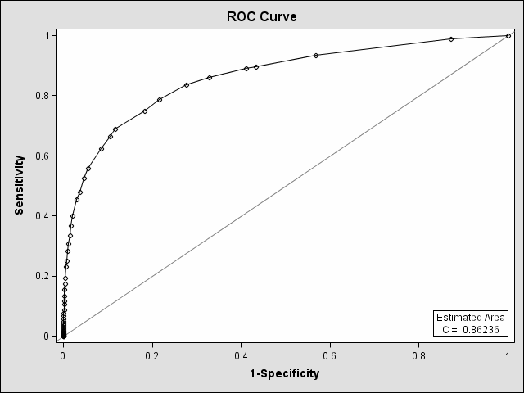

The results of our study are shown in the ROC curve below. The AUROC was 0.86. A score of 8 had ~80% sensitivity and specificity for the prediction of PAD.

A description of the billing codes is provided in the table below.

Code | Estimate | Score | Code Description
CPT4Px73725 | 0.66 | 3 | MRA Lower extremity w/ or w/o contrast
CPT4Px75635 | 0.54 | 2 | CT angiogram - abdominal aorta and bilateral iliofemoral lower extremity runoff
CPT4Px75710 | 0.61 | 2 | Angiography, extremity, unilateral, radiological supervision and interpretation
CPT4Px75716 | 0.75 | 3 | bilateral angiograph extremity
CPT4Px93922 | 0.53 | 2 | Non-invasive physiologic studies of lower extremity arteries, single level, bilateral
ICD9Px8848 | 0.65 | 3 | Arteriography of femoral and other lower extremity arteries
ICD9Dx44020 | 1.25 | 5 | Atherosclerosis of native arteries of the extremities, unspecified
ICD9Dx44021 | 2.16 | 9 | Atherosclerosis of native arteries of the extremities with intermittent claudication
ICD9Dx44022 | 1.04 | 4 | Atherosclerosis of native arteries of the extremities with rest pain
ICD9Dx44023 | 1.62 | 6 | Atherosclerosis of native arteries of the extremities with ulceration
ICD9Dx44024 | 1.91 | 8 | Atherosclerosis of native arteries of the extremities with gangrene
ICD9Dx4408 | 0.74 | 3 | Atherosclerosis of other specified arteries
ICD9Dx4409 | 0.93 | 4 | generalized and unspecified atherosclerosis
ICD9Dx4439 | 0.84 | 3 | Peripheral vascular disease, unspecified

Section 4: NLP Of Radiology Reports
Assess presence of phrases indicative of lower limb artery stenosis/occlusion in one or more sentences through Natural Language Processing (NLP) annotation techniques.

Key words for lower extremity arteries: left leg; right leg; left lower extremity; right lower extremity; bilaterally; Iliac artery (arteries); femoral artery (arteries); SFA; Superficial (arteries); Profunda (arteries); Deep femoral (arteries); Popliteal (arteries); tibioperoneal trunk (trunks); peroneal (arteries); Anterior tibial (arteries); AT; Posterior tibial (arteries); PT; runoff; femoral- femoral (arteries); femoral-to-peroneal artery; fem-pop; fem-fem; calf artery (arteries); common femoral; external iliac; common iliac artery; internal iliac arteries; iliac systems; origin of iliac; CFA; femoropopliteal artery; ileofemoral; aortobifemoral; axillobifemoral; aortobiiliac; aortobi-iliac

Key words for occlusive arterial disease: extensive collateral formation; collateral; occluded; occlusion; occludes; proximal occlusion; complete occlusion; one-vessel runoff; one-vessel run-off; single vessel runoff; single vessel run-off; high-grade stenosis; high grade stenosis; severe atherosclerotic stenosis; significant stenosis; moderate stenosis; moderate focal stenosis; multi-focus stenosis; moderate focal stenosis; severe narrowing; moderate narrowing; moderate atheromatous changes; moderate atheromatous plaque; not demonstrate flow; significant atheromatous plaque; severe plaque; significant atheromatous; moderate atheromatous changes; severe atherosclerotic disease; ASO; PTA; angioplasty; recanalization; endarterectomy

Section 5: Use Of Medications For Claudication:
Assess presence of medications for Claudication.
Cilostozol (Pletal) or Pentoxifylline (Trental, Pentoxil, Pentopak).

