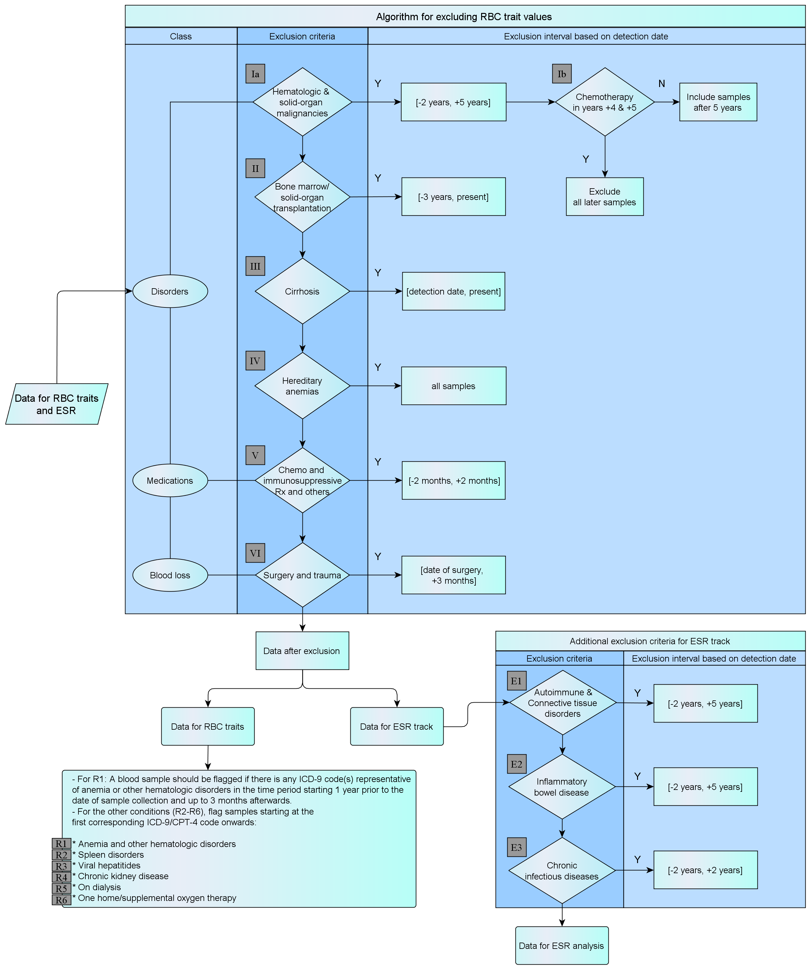
- Latin numerals correspond to the common track exclusion steps.
- “R” represents the flagging steps for the RBC track.
- “E” represents the additional exclusion steps for the ESR track.

Mayo RBC and ESR Sample Selection Algorithm
Sample Selection Process for RBC Indices and ESR Analysis

Laboratory results for ESR and RBC indices (hemoglobin, MCV, MCH, RDW… etc) should be extracted from the Laboratory databases. For Mayo, from January 1994 till October 2009, ESR and RBC test results were populated for our 3336 participants. All samples were collected on an outpatient basis. Samples collected during an inpatient hospitalization (admit date ≤ collection date ≤ discharge date) should be excluded unless this sample was the only one available for a patient. Since ESR levels and RBC indices can be affected by a variety of medical and therapeutic conditions, we implemented several strategies in order to detect and exclude samples that were taken at times of active disorders that may affect the variables being analyzed. We first followed a general set of exclusion rules for RBC indices analysis and then applied an additional set of rules for ESR pool of samples.

Identification of culprit medical conditions
The International classification of Disease 9 Clinical Management (ICD-9-CM), procedural ICD-9, and Current Procedural Terminology (CPT-4) coding systems were thoroughly reviewed for clinical conditions that may affect ESR and RBC indices. We then extracted the codes that correspond to hematologic/solid organ malignancies, organ transplantation, anemias, chronic kidney disease, cirrhosis, and other medical conditions. A list of the populated conditions and corresponding ICD-9/ CPT-4 codes are listed in Appendix A.

General Selection Process for RBC Indices and ESR Samples
Ia
- Samples from patients with hematologic and solid-organ malignancies were excluded in the time period starting 2 years before and up to 5 years after the date of the first corresponding ICD-9-CM code.
- Afterwards, we screened patients with malignancies for the administration of chemotherapy in the fourth and fifth years after the first ICD-9 CM that corresponds to the malignancy. CPT-4 and ICD-9 procedural codes were reviewed for codes representative of parenteral chemotherapy. For orally administered medications that may affect RBC indices, we populated a list of the commonly used medications using both generic and brand names in addition to other medications used in these conditions such as epoetin and colony stimulating factors. We then used natural language processing to screen the EMR of study participants for the use of these medications. A detailed list of the previously mentioned ICD-9/CPT-4 codes and oral medications can be found in Appendix B. If such use of chemotherapeutic medications was detected, all later samples were excluded. If no chemotherapy was administered during the aforementioned period of time, the patients were considered to be free of disease and later samples were included in the analyses.
Ib
II
- Blood samples from patients who underwent bone marrow or solid organ transplantation were excluded if they were collected after the transplantation. Blood samples taken up to 3 years prior to transplantation were also excluded as they are probably not representative of the patient’s hematologic baseline.
III
- Test results for patients with cirrhosis were excluded starting from the earliest ICD-9 CM code representative of cirrhosis.
IV
- We also excluded all laboratory results belonging to patients with hereditary anemias such as sickle cell anemia, thalassemias, hemoglobin C and H diseases…etc.

- Patients taking medications affecting ESR and RBC indices: We used the medications listed in Appendix B2 to screen our study participants for the use of medications that can potentially affect RBC indices (mainly taken for autoimmune/connective tissue disorders and epilepsy). NLP was implemented to that regard. Samples collected from patients taking these medications were excluded if they fell in a 4-month period centered upon the date at which such use was detected in the EMR.
V
VI
- Trauma, perioperative blood loss, and surgical stress can affect ESR as well as RBC indices. We used general anesthesia CPT-4 codes to detect trauma or major surgeries that will probably be associated with significant loss of blood. Appendix C contains a detailed list of the selected codes. Laboratory results for patients who underwent major surgeries (as evident through corresponding general anesthesia CPT-4 codes) were excluded if the samples were collected in the postoperative period and up to 3 months after the date of the CPT-4 code.

RBC analysis track

After applying the aforementioned general exclusion rules, the remaining samples were used for RBC indices analyses. Samples collected from patients with chronic kidney disease were not excluded and their test results were adjusted according to the patient’s renal function. Samples from patients with the following conditions should be flagged to make them more accessible for later subgroup analyses:
- Samples from patients with anemia and other hematologic disorders should be flagged if there is any corresponding ICD-9 code(s) in the time period starting 1 year prior to the date of sample collection and up to 3 months afterwards.
R1
- Samples from patients with the following conditions should be flagged starting at the date of the corresponding ICD-9 code onwards:
R2
- Spleen disorders
R3
- Viral hepatitides
R4
- Chronic kidney disease
R5
- On dialysis
R6
- On home/supplemental oxygen therapy

ESR analysis track

Since inflammation whether infectious or autoimmune in etiology can result in deranged ESR levels, we excluded ESR test results in the following conditions:
- Samples from patients with autoimmune, connective tissue, and inflammatory bowel disorders should be excluded if they were collected in the time period spanning 2 years prior to the date of the first corresponding ICD-9-CM code and up to 5 years after that date.
E2
E1
E3
- For patients with chronic infectious disorders we excluded ESR results in the time period of 4 years centered upon the first corresponding ICD-9-CM code. Previous and later ESR results, if available, were included in the analysis.

Appendix A

The following represents a summary of the most commonly encountered disorders that may affect ESR and RBC indices as well as their corresponding ICD-9 CM codes.
R1 Anemias and Other Hematologic Disorders | ICD-9 CM Code
Anemia | 280.9  281.1  281.3  281.4  281.9  282.2  282.9  284.9  285.9  336.2
Iron deficiency anemia | 280.0  280.1  280.8  280.9  281.8
Pernicious anemia  Vitamin B12 deficiency  Folic acid deficiency | 281.0  281.1  281.2  281.3  281.9  282.2  648.2
Hemolytic anemia | 283.0  283.19  283.10  283.2  282.3  283.9
Hemolytic uremic syndrome | 283.11
Anemia of chronic disease | 285.29
Malignancy associated anemia | 285.22
Aplastic anemia | 244.9  284.01  284.89  284.9
Sideroblastic anemia | 285.0  238.72  238.73
Myelophthisic anemia |  | 284.2
Pyridoxine-responsive anemia |  | 285.0
Pancytopenia |  | 284.1
Fanconi anemia |  | 284.09
Acquired and congenital pure red cell aplasia |  | 284.81  284.01
Thrombotic thrombocytopenic purpura |  | 446.6
Cold agglutinins |  | 283.0
Mixed Cryoglobulinemia |  | 273.2
Paroxysmal nocturnal hemoglobinuria |  | 283.2
Lead/ arsenic poisoning |  | 961.1  984.0  984.1  984.8  984.9  985.1
Methanol poisoning |  | 980.1  987.8
Disorders of iron metabolism (hemochromatosis, bronze diabetes, etc…) |  | 275.0
R2 Spleen Disorders
Spleen Disorders  (splenectomy, asplenia, splenomegaly, and hypersplenism) |  | 41.43  41.5  285.8  289.4  289.50  289.51  289.52  289.53  759.0  789.2
IV Hereditary Anemias
Sickle cell anemia |  | 282.5  282.60  282.62  282.63  282.64  282.68  282.69
Thalassemias |  | 282.41  282.42  282.49
Hereditary spherocytosis |  | 282.0  282.5  282.7
Hereditary elliptocytosis |  | 282.1
Hemoglobin C disease |  | 282.63  282.64
Hemoglobin H disease |  | 282.49
Ia Hematologic Malignancies
Leukemia |  | 200.x*  201.x  202.x  204.x  205.x  206.x  207.x  208.x
Multiple myeloma |  | 203.x
Polycythemia vera  (including secondary polycythemia) |  | 238.4  289.0
Waldenstrom macroglobulinemia  Other paraproteinemia |  | 273.0  273.1  273.2  273.3  273.8  273.9
Ia Solid Organ Malignancies
Malignant neoplasm of the esophagus |  | 150.x
Malignant neoplasm of the stomach |  | 151.x
Malignant neoplasm of the colon |  | 153.x
Malignant neoplasm of rectum, rectosigmoid junction, and anus |  | 154.x
Malignant neoplasm of the liver and intrahepatic bile ducts |  | 155.x
Malignant neoplasm of pancreas |  | 157.x
Malignant neoplasm of the trachea, bronchus, and lung |  | 162.x
Malignant neoplasm of the female breast |  | 174.x
Malignant neoplasm of the prostate |  | 185
Malignant neoplasm of the kidney and other and unspecified urinary organs |  | 189.x
Secondary malignant neoplasm of respiratory and digestive systems |  | 197.x
Secondary malignant neoplasm of other specified sites |  | 198.x
Hepatic Disorders
Cirrhosis III |  | 571.x
Viral hepatitides R3 |  | 070.x
E2 Inflammatory Bowel Disease
Crohn’s disease |  | 555.x
Ulcerative colitis |  | 556.x
E1 Autoimmune/Connective Tissue Disorders
Ankylosing spondylitis |  | 720.x
Behçet disease |  | 136.1  711.2
Buerger disease (thromboangiitis obliterans) |  | 443.1
CREST |  | 710.1
Essential cryoglobulinemic vasculitis |  | 273.2
Felty syndrome |  | 714.1
Henoch-Schönlein purpura |  | 287.0
Polymyalgia rheumatica |  | 725
Polymyositis/dermatomyositis |  | 710.3  710.4  359.7x
Rheumatoid arthritis |  | 714.x
Sarcoidosis |  | 135
Scleroderma |  | 710.1
Sjögren syndrome |  | 710.2
Systemic Lupus erythematosus |  | 710.0
Vasculitis  (Churg-Strauss syndrome, cutaneous leukocytoclastic vasculitis, Goodpasture syndrome, hypersensitivity angiitis, Kawasaki disease, polyarteritis nodosa, Takayasu’s disease, temporal arteritis, Wegener granulomatosis…) |  | 446.x  447.6
Renal Disorders
Chronic kidney disease (moderate and severe) R4 |  | 585.3  585.4  585.5  585.6  585.9  788.9
Glomerulonephritis (proliferative, membranoproliferative, crescentic….) R4 |  | 580.x  581.0  581.1  581.2  582.x
Hemodialysis (ICD-9 procedural codes) R5  Peritoneal dialysis (ICD-9 procedural codes) R5 |  | 39.95  54.98
Dialysis (CPT-4 codes) R5 |  | 90921  90925  90935  90937  90940  90945  90947  90960  90961  90962  90966  90970  90989  90993  90997  90999  99512
R6 Long Term Oxygen Therapy
Patients on long term supplemental oxygen therapy (ICD-9 code) | V46.2
Patients undergoing home oxygen therapy, respiratory care, assessment, and therapy (CPT-4 code) | 99503
*This represents all secondary ICD-9 CM codes under the main code.
E3 Infectious Diseases
Bacterial endocarditis | 421.x
Bronchiectasis | 494.x
Lung abscess | 513.x
Osteomyelitis | 730.x
Tuberculosis | 010.x – 0.18.x

- The following procedural ICD-9 and CPT-4 codes aim to detect patients who underwent bone marrow and/or solid organ transplantation.

Procedure II | ICD-9  Procedural Code
- Bone marrow transplant  Allogeneic | 41.00  41.03
- Allogenic stem cell transplant | 41.05
- Combined heart-lung transplant | 33.6
- Allotransplantation of langerhans islets cells | 52.85
- Kidney transplant NEC | 55.69
- Liver transplant | 50.59  50.51
- Lung transplant (single or bilateral) | 33.50
- Pancreas transplant  Heterotransplant | 52.80  52.83
- Transplant of islets of Langerhans (cells) | 52.86

Procedure II | CPT-4 Code
- Lung transplant, single, without cardiopulmonary bypass  - With cardiopulmonary bypass | 32851  32852
- Double lung transplant, without cardiopulmonary bypass  - With cardiopulmonary bypass | 32853  32854
- Heart-lung transplant with recipient cardiectomy-pneumonectomy | 33935
- Heart transplant, with or without recipient cardiectomy | 33945
- Renal allotransplantation, implantation of graft; without recipient nephrectomy  - With recipient nephrectomy | 50360  50365
- Liver allotransplantation; orthotopic, partial or whole, from cadaver or living donor, any age  - Heterotopic, partial or whole, from cadaver or living donor, any age | 47135  47136
- Transplantation of pancreatic allograft | 48554
- Bone marrow or blood-derived peripheral stem cell transplantation; allogenic | 38240

Appendix B

The following ICD-9 and CPT-4 codes aim to detect patients receiving parenteral chemotherapy that may affect RBC and/or WBC indices. These codes include ICD-9 procedural code (99.25) and CPT-4 codes listed in Table B1. However, there are several oral medication that are used in patients with malignancies, post-transplantation, and in autoimmune disorders. There are no ICD-9 or CPT-4 codes that correspond to the use of such medications. Table B2 includes a list of medications that are commonly used in the clinical settings described above. Natural language processing was used to detect the use of the medications listed in Table B2.

ICD-9 procedural code (Ib only): 99.25 covers all infusions of chemotherapeutic agents

Table B1. Description of the Chemotherapeutic Procedure (Ib only) | CPT-4 Code
- Chemotherapy administration, subcutaneous or intramuscular; non-hormonal anti-neoplastic  - Hormonal anti-neoplastic | 96401  96402
- Chemotherapy administration; intralesional, up to and including 7 lesions  - Intralesional more than 7 lesions  - Intravenous, push technique, single or initial substance/ drug  - Intravenous, push technique, each additional substance/ drug | 96405  96406  96409  96411
-Chemotherapy administration, intravenous infusion technique, up to 1 hour, single or initial drug/ substance  - Same as above for each additional hour | 96413  96415
-Initiation of prolonged chemotherapy infusion (>8 hrs)  - For each additional sequential infusion | 96416  96417
- Chemotherapy administration, intra-arterial; push tech  - Infusion tech, up to 1 hr  - Infusion tech, each additional hr  - Infusion tech, initiation of prolonged infusion | 96420  96422  96423  96425
- Chemotherapy administration into pleural cavity | 96440
- Chemotherapy administration into peritoneal cavity | 96445
- Chemotherapy administration into CNS (intrathecal) | 96450
- Chemotherapy injection, subarachnoid or intraventricular via subcutaneous reservoir | 96542
- Unlisted chemotherapy procedure | 96549

Table B2. Generic and Brand Names of Commonly Used Chemotherapeutic, Immunosuppressive, Antiepileptic Medications Ib & V
- Epoetin Alfa [Epogen, Procrit, Eprex]
- Darbepoetin Alpha [Aranesp]
- Filgrastim [Neupogen]
- Pegfilgrastim [Neulasta]
- Sargramostim [Leukine]
- Methotrexate [MTX, amethopterin, Rheumatrex, Trexall, Folex PFS, Mexate]
- Azathioprine [Imuran, Azasan]
- 6-Mercaptopurine (6MP) [Purinethol, mercaptopurinum]
- Cyclophosphamide [Cytoxan, Neosar, Clafen]
- Hydroxyurea (Hydroxycarbamide) [Droxia, Hydrea, Mylocel]
- Imatinib [Gleevec]
- Dasatinib [Sprycel]
- Nilotinib [Tasigna]
- Busulfan [Busulfex, Myleran, Mitosan]
- Etoposide [VePesid, Toposar]
- Lomustine [Ceenu]
- Thioguanine (Tioguanine) [Tabloid, 6TG]
- Lenalidomide [Revlimid]
- Chlorambucil [Leukeran, linfolizin, amboclorin, ambochlorin]
- Melphalan [Alkeran]
- Trofosfamide [Ixoten]
- Mycophenolate mofetil (Mycophenolic acid) [CellCept]
- Capecitabine [Xeloda]
- Tegafur [Florafur, Fluorofur]
- Carmofur [HCFU]
- Cyclosporine [Gengraf, Restasis, Sandimmune, Neoral, SangCya]
- Tacrolimus [Prograf, Protopic]
- Phenytoin [Dilantin, Diphentoin, Lorantoin, Phenytek]
- Fosphenytoin [Cerebyx, Prodilantin]
- Valproic acid [Depakote, Depacon, Dalpro, Deproic, Depakene, Divalproex, Stavzor]

Appendix C VI

The following Current Procedural Terminology (CPT-4) codes represent anesthesia codes for surgeries that are likely to be associated with major blood loss and post-operative anemia. All of the following codes should be used in step VI.

Surgery for which anesthesia was administered | CPT-4 Code
Head
-Anesthesia for procedures on nose and accessory sinuses  Radical surgery | 00162
-Excision of retropharyngeal tumor  Radical surgery | 00174  00176
-Anesthesia for procedures on facial bones or skull; NOS  Radical surgery | 00190  00192
-Anesthesia for intracranial procedures; NOS  -Craniotomy or craniectomy for evacuation of hematoma  -Burr holes, including ventriculography  -Cranioplasty or elevation of depressed skull fracture, extradural (simple or complicated)  -Vascular procedures | 00210  00211  00214  00215  00216
Neck
-Anesthesia for all procedures on the integumentary system, muscles and nerves of head, neck, and posterior trunk, NOS | 00300
-Anesthesia for all procedures on esophagus, thyroid, larynx, trachea and lymphatic system of neck; NOS (> 1 years old) | 00320
-Anesthesia for procedures on major vessels of neck; NOS | 00350

Thorax (Chest Wall and Shoulder Girdle)
-Anesthesia for procedures on the integumentary system on the extremities, anterior trunk and perineum?; NOS | 00400
-Radical or modified radical procedures on breast | 00404
-Radical or modified radical procedures on breast with internal mammary node dissection | 00406
-Radical surgery of the thorax | 00452
-Thoracoplasty (any type) | 00472
-Radical procedures (eg. pectus excavatum) | 00474
Intrathoracic Surgeries
-Anesthesia for all procedures on esophagus | 00500
-Anesthesia for tracheobronchial reconstruction | 00539
-Anesthesia for thoracotomy procedures involving lungs, pleura, diaphragm, and mediastinum (including surgical thoracoscopy); NOS  -As above utilizing lung ventilation  -Decortications  -Pulmonary resection with Thoracoplasty  -Intrathoracic procedures on the trachea and bronchi | 00540  00541  00542  00546  00548
-Anesthesia for procedures on heart, pericardial sac, and great vessels of chest; without pump oxygenator  -As above with pump oxygenator (>1 yo) for all non-coronary bypass procedures or for re-operation for CABG  -With pump oxygenator with hypothermic circulatory arrest | 00560  00562  00563
-Anesthesia for direct CABG without pump oxygenator  -With pump oxygenator | 00566  00567
-Anesthesia for heart transplant or heart/ lung transplant | 00580
Spine and Spinal Cord
-Anesthesia for procedures on thoracic spine and cord, via an anterior transthoracic approach; utilizing lung ventilation | 00626
-Anesthesia for procedures in the lumbar region; NOS | 00630
-Anesthesia for extensive spinal cord procedures (eg, spinal instrumentation or vascular procedures) | 00670

Upper Abdomen
-Anesthesia for transabdominal repair of diaphragmatic hernia | 00756
-Anesthesia for all procedures on major abdominal blood vessels | 00770
-Anesthesia for intraperitoneal procedures in upper abdomen including laparoscopy; NOS | 00790
-Partial hepatectomy or management of liver hemorrhage (excluding liver biopsy) | 00792
-Pancreatectomy, partial or total | 00794
-Liver transplant (recipient) | 00796
-Gastric restrictive procedure for obesity | 00797
Lower Abdomen
-Anesthesia for intraperitoneal procedures in lower abdomen including laparoscopy; NOS  -Abdominoperineal resection  -Radical hysterectomy  -Pelvic exenteration | 00840  00844  00846  00848
-Anesthesia for extraperitoneal procedures in lower abdomen, including urinary tract; NOS  -Renal procedures including upper one-third of ureter, or donor nephrectomy  -Total cystectomy  -Radical prostatectomy (suprapubic/ retropubic)  -Adrenalectomy | 00860  00862  00864  00865  00866
-Renal transplant (recipient) | 00868
-Anesthesia for procedures on major lower abdominal vessels; NOS | 00880
Perineum
-Radical perineal procedure  -Perineal prostatectomy  -Post-transurethral resection bleeding | 00904  00908  00916
-Anesthesia for vaginal hysterectomy | 00944

Pelvis (Except Hip)
-Anesthesia for interpelviabdominal (hindquarter) amputation | 01140
-Anesthesia for radical procedures for tumor of pelvis, except hindquarter amputation | 01150
-Anesthesia for open repair of fracture disruption of pelvis or column fracture involving acetabulum | 01173
Upper Leg (Except Knee)
-Anesthesia for open procedures involving hip jopint; NOS  -Hip disarticulation  -Total hip arthroplasty  -Revision of total hip arthroplasty | 01210  01212  01214  01215
-Anesthesia for open procedures involving upper 2 thirds of femur; NOS  -Amputation  -Radical resection | 01230  01232  01234
-Anesthesia for all procedures involving veins of upper leg, including exploration | 01260
-Anesthesia for procedures involving arteries of upper leg, including bypass graft; NOS | 01270
Knee and Popliteal Area
-Anesthesia for all open procedures on lower one third of femur | 01360
-Anesthesia for all open procedures on upper ends of tibia, fibula, and/or patella | 01392
-Total knee arthroplasty  -Disarticulation at knee | 01402  01404
-Anesthesia for procedures on arteries on knee and Popliteal area; NOS  -Popliteal thrombendarterectomy, with or without patch graft  -Popliteal excision and graft or repair for occlusion or aneurysm | 01440  01442  01444

Lower Leg (Below Knee, Includes Ankle and Foot)
-Radical resection (including below knee amputation)  -Osteotomy or ostepoplasty of tibia and/or fibula  -Total ankle replacement | 01482  01484  01486
-Anesthesia for procedures on arteries of lower leg, including bypass graft; NOS | 01500
Shoulder and Axilla
-Shoulder disarticulation  -Interthoracoscapular (forequarter) amputation  -Total shoulder replacement | 01634  01636  01638
-Anesthesia for procedures on arteries of shoulder and axilla; NOS  -Axillary-brachial aneurysm  -Bypass graft  -Axillary-femoral bypass graft | 01650  01652  01654  01656
Upper Arm and Elbow
-Osteotomy of humerus  -Radical procedures  -Excision of cyst or tumor of the humerus  -Total elbow replacement | 01742  01756  01758  01760
-Anesthesia for procedures on arteries of upper arm and elbow; NOS | 01770

