Plain Old Contest
No calculators

1) Find the area of the triangle bounded by the lines y = x, y = 2x – 6, and the y – axis.

2) In the mystical country of Pergosia, a diad is worth twice as much as a uniad. A triad is worth 5 times as much as a diad. A quad is worth 120 times as much as a uniad. At the airport on my way back, I got $8.35 for my 3 uniads, 2 diads, 4 triads, and one quad. At that conversion rate, how much is a diad worth in cents?

3) Let f(n) be the value of n if its digits were reversed. For example: f(950) = 059 = 59. How many three-digit integer values of x exist such that x = f(x)?

4) In the diagram below, AC = CD, BC = 12, and DE = 8. Find the area of ABC. 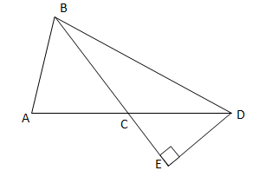

5) 5^22 = 2,384,185,791,015,625. How many factors (including 1 and 5^22) does it have?

6) 7 congruent circles of radius 6 are put together. Then, the area in the middle of this shape is removed, as shown. What is the perimeter of the resulting flower shape? Give an answer in terms of π. 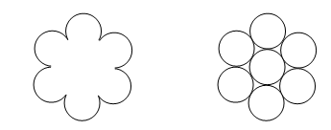

7) A four-digit number is divisible by 11. The sum of its digits is 19. If it leaves a remainder of 63 when divided by 100, find the number.

8) On an algebra test, Mark was asked to solve the following set of equations for a and b.
2a + b = 5
?a + 3b = 17
Where the question mark represents another number. After a few minutes of work, Mark let out a frustrated sigh and said “That’s impossible! There’s no solution!” Mark was right: there were indeed no solutions to his set of equations. What number is represented by the question mark?

9) In a Fibonacci-like series, every term after the second is the sum of the two previous terms. Every member of the series has to be a positive whole number. If the 8th term in a Fibonacci-like series is 103, find the third term.

10) I have the number magnets 0, 2, 3, 4, 5, 6, 7, and 8. I have one of each magnet. How many 4-digit numbers with digits that are decreasing from left to right can I make with these magnets? For example, 7630 is a valid number.

11) A man is 2 / 5 of the way across a bridge. He sees a train coming (the train is not on the bridge yet). No matter which way he runs, he will reach the end of the bridge just as the train reaches that end. If the train travels at 60 mph, how fast does the man run?

12) The following net, consisting of 4 congruent isosceles trapezoids and 2 squares, is folded into a solid shape. Find the volume of the resulting shape, in simplest radical form. 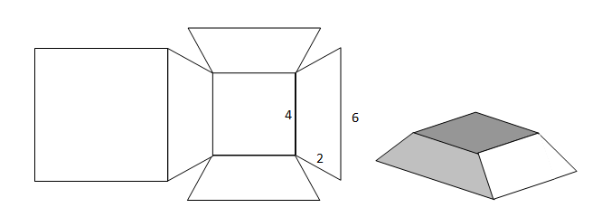
13) How many positive integers leave a remainder of 31 when divided into 2011?

14) I have two circles, each of radius 1. The distance between their two centers is 6 units. I draw a line that is tangent to both circles. I draw a 3rd circle, tangent to both circles and to the line. What is the radius of the third circle?

