Problem Set #3

**Problem 1 (15pts)**

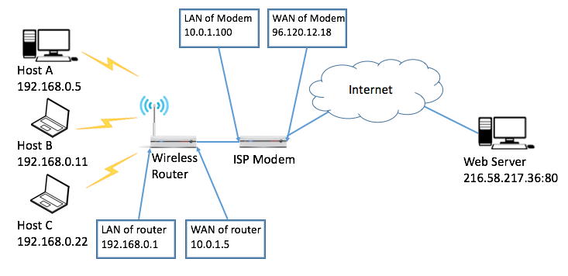

Figure 1. Network setup.

The Figure 1 above is a typical home network setup. An ISP Modem provides internet service; a wireless router is connected to the ISP Modem via Ethernet. Hosts A, B and C are connected to the wireless router to access the Internet.

1. (5 points) In order for the hosts A, B, and C to access the Web Server, Network Address Translation (NAT) with random port mapping needs to be enabled for both the Wireless Router and the ISP Modem. Assume Hosts will pick a random port number between 8000 and 9000, the Wireless Router can choose a random port number between 2000 and 2500, and the ISP Modem can choose a random port number between 3000 and 4000. Please fill in the NAT table for the Wireless Router and the ISP Modem below.

|  |  |
| --- | --- |
| NAT Table of Wireless Router | |
| LAN side | WAN side |
| 192.168.0.5:8008 | 10.0.1.5:2002 |
| 192.168.0.11:8010 | 10.0.1.5:2004 |
| 192.168.0.22:8012 | 10.0.1.5:2005 |

|  |  |
| --- | --- |
| NAT Table of ISP Modem | |
| LAN side | WAN side |
| 10.0.1.5:2002 | 96.120.12.18:3002 |
| 10.0.1.5:2004 | 96.120.12.18:3005 |
| 10.0.1.5:2005 | 96.120.12.18:3008 |

1. (10 points) Now we look into the details about how packets are exchanged between Host B and Web Server. Assume Host B sends a HTTP request packet to Web Server. And Web Server then sends HTTP content back to Host B. Please fill in the tables below to show how the packet’s IP header changed along the route. (Please formulate your answer based on your answers for (a). )

|  |  |
| --- | --- |
| HTTP request Before entering Router | |
| Src IP | 192.168.0.11 |
| Src Port | 8010 |
| Dst IP | 216.58.217.36 |
| Dst Port | 80 |

|  |  |
| --- | --- |
| HTTP request After exiting Router | |
| Src IP | 10.0.1.5 |
| Src Port | 2004 |
| Dst IP | 216.58.217.36 |
| Dst Port | 80 |

|  |  |
| --- | --- |
| HTTP request After exiting Modem | |
| Src IP | 96.120.12.18 |
| Src Port | 3005 |
| Dst IP | 216.58.217.36 |
| Dst Port | 80 |

|  |  |
| --- | --- |
| HTTP response Before entering Modem | |
| Src IP | 216.58..217.36 |
| Src Port | 80 |
| Dst IP | 10.0.1.5 |
| Dst Port | 2004 |

|  |  |
| --- | --- |
| HTTP response After exiting Modem | |
| Src IP | 216.58.217.36 |
| Src Port | 80 |
| Dst IP | 192.168.0.11 |
| Dst Port | 8010 |

1. (10 points) Suppose now Host A also runs a webserver on port 8888, it is attached to a domain name <http://www.mylocalhomeserver.com>, explain **what NAT entries** should be added so that people from the internet can assess this webserver via URL. You can assume that the above domain name is registered properly.

Since both the ISP modem and the router use NAT, a new NAT table entry will be manually configured in each. In order for the webserver to be reachable via URL, the external port on the modem must be 80 (otherwise you would need to specify the port of the URL)

Thus, the new entry on the modem would be.

|  |  |
| --- | --- |
| NAT Table of ISP Modem | |
| LAN side | WAN side |
| 10.0.0.5:8008 | 96.120.12.18:80 |

That is, all external traffic directed at port 80 of the ISP modem is directed to port 8888 of the wireless router. Similarly, the wireless router then needs to direct traffic to Host A.

This can be done with the following new NAT table entry :

|  |  |
| --- | --- |
| NAT Table of Wireless Router | |
| LAN side | WAN side |
| 192.168.0.5:8888 | 10.0.1.5:8888 |

1. (10 points) The wireless link at the last mile is very error prone and you would like to improve the performance. What would you do in this case?

There are several options for improving the wireless link performance. One approach is to try to improve the signal-to-noise ratio on the network by increasing the transmission power of  
the wireless router and the server’s wireless card. However, this approach can lead to more interference due to the network propagating and overlapping with other signals. As such, it is  
important to ensure that the network is operating on a channel with low utilization. Depending on the amount of interference, it may be better to instead add an additional access point closer  
to the server. This allows for the power to remain low while still maintaining a strong connection. Finally, if none of these approaches is sufficient, moving the server to an Ethernet connection would greatly reduce the errors, as well as free up more wireless bandwidth for other hosts on the network.

**Problem 2 (10pts)**

Suppose a router has three input flows and one output flow. It receives the packets listed in the Table 1. below, all at about the same time, in the order listed, during a period in which the output port is busy but all queues are otherwise empty. Give the order in which the packets are transmitted, assuming:

1. (5 points) Fair queuing

We can calculate 𝐹𝑖 for the queued packets. Since all packets arrived at roughly the same time, this calculation is simple:

Starting with the lowest 𝐹𝑖, the packets are sent in order 𝐹𝑖: 3, 1, 6, 7, 4, 2, 8, 5.

1. (5 points) Weighted fair queuing with flow 2 having twice as much share as flow 1, and flow 3 having 1.5 times as much share as flow 1. Note that ties are to be solved in the order of flow1, flow2 and flow3.

**Problem 3 (20pts)**

Figure 2. Congestion Window Size

Assuming TCP Reno is the protocol experiencing the behavior shown above, answer the following questions:

1. Identify the RTT rounds when TCP runs Slow Start (e.g., from the 1th round to which round?)
2. Identify the RTT rounds when TCP runs Congestion Avoidance
3. After the 14th RTT round, is segment loss detected by a triple duplicate ACK or by a timeout and why?
4. During which RTT round the 170th segment is sent?
5. Assuming a packet loss is detected after the 23th RTT round by the receipt of triple duplicate ACKs, what will be the value of the congestion window?

(a) Rounds 1-6 are Slow Start.  
(b) Congestion avoidance is performed between the 6th and 19th RTT.  
(c) After the 14th RTT, congestion was detected using a triple duplicate ACK. This is because if a timeout occurred, the cwnd would be set to a value of 1.  
(d) During slow start (RTT 1-6), 1+2+4+8+16+32=63 segments are sent. During RTT 7-9, 33+34+35=102 more are sent, totaling 165 segments sent. Thus, the 170th segment is sent during RTT 10, when the next 36 segments are sent.  
(e) Assuming a packet loss is detected after the 23rd RTT round, the congestion window would  
be divided by two to a value of 4.

**Problem 4 (15pts)**

Figure 3. below shows how 2 disconnected LAN are connected by IP tunnel (the dash line). For each interface the IP and MAC addresses are shown in the figure. (HW1- HW14 are used to represent hardware addresses)

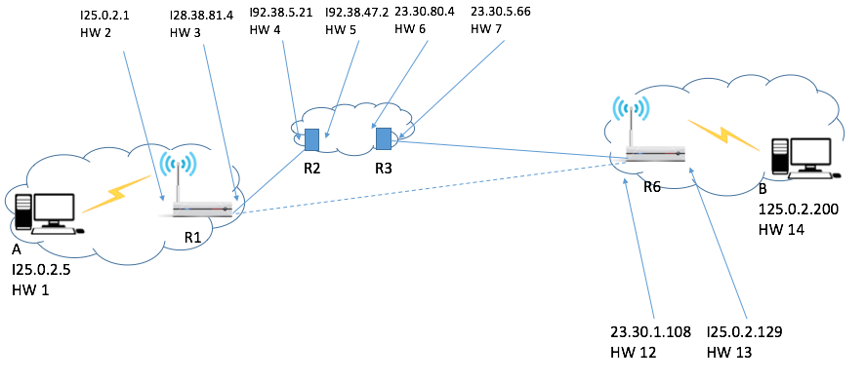

Figure 3. Network setup

Now Host B sends a packet to Host A. Please show how the packet travels along the route, please describe header information along the route (B->R6, R6-> R3, R3->R2, R2->R1, R1->A).

B creates packet with Ethernet/IP headers:  
SRC IP DST IP SRC MAC DST MAC  
125.0.2.200 125.0.2.5 HW 14 HW 13  
R6 wraps B’s packet with an additional IP packet (the original IP header is now within them payload of the IP packet) with a destination of the other tunnel router. The headers then become:  
SRC IP DST IP SRC MAC DST MAC  
23.30.1.108 128.38.81.4 HW 12 HW 7  
The wrapped packet then passes through the internet normally:  
SRC IP DST IP SRC MAC DST MAC  
23.30.1.108 128.38.81.4 HW 7 HW 6  
23.30.1.108 128.38.81.4 HW 6 HW 5  
23.30.1.108 128.38.81.4 HW 5 HW 4  
23.30.1.108 128.38.81.4 HW 4 HW 3  
When R1 receives the packet, it discards the wrapping IP packet. Then, it forwards the inner IP packet as usual to A:  
SRC IP DST IP SRC MAC DST MAC  
125.0.2.200 125.0.2.5 HW 2 HW 1

**Problem 5 (10pts)**

Derive the expected throughput of the following TCP congestion control algorithm: The additive increment factor is **α**. Multiplicative decrease factor **β**, which means after loss, the windows size will change from **W** to **(1-β)W**. Please order the throughput for each flow. AIMD(a,b) means the cwnd increases a per each round trip time and the cwnd set to (1-b)W from W when the loss happens.

Flow1: AIMD(a=1,b=0.5), RTT=10ms, loss rate = 10-6

Flow2: AIMD(a=2,b=0.2), RTT=100ms, loss rate = 10-8

Flow3: AIMD(a=5,b=0.8), RTT=300ms, loss rate = 10-9

Flow4: AIMD(a=8,b=0.4), RTT=1000ms, loss rate = 10-4

Flow5: AIMD(a=6,b=0.5), RTT=100ms, loss rate = 10-10

**Problem 6 (10pts)**

Suppose that TCP uses the combination of quick acknowledgements (quick ack) and delayed acknowledgements (delayed ack). The quick ack only triggers up to 8 packets (the cwnd at the sender becomes 16 after receiving 8 quick acks) starting from 1 packet during slow start. The maximum capacity of the link is 5000 KBps, the RTT is 10ms, and 1MSS = 1KB. Note that KBps is KB per second).

1. (5 points) About what is cwnd at the time of first packet loss?

Note, the BDP of the link is 5000 𝐾𝐵𝑝𝑠 ⋅ 10 𝑚𝑠 = 50 𝐾𝐵. Thus, Since the flow will begin with a slow start, each of the quick acks increases the cwnd by 1.  
The first RTT sends 1 packet (1 KB), quick ack increases cwnd to 2 KB.  
Second RTT sends 2 packets (2 KB), quick acks increase cwnd to 4 KB.  
Third RTT sends 4 packets (4 KB), quick acks increase cwnd to 8 KB.  
Fourth RTT sends 8 packets (8 KB),quick acks increase cwnd to 16 KB.  
Fifth RTT sends 16 packets (16 KB), which is over the quick ack limit. Thus, the receiver sends 8 delayed acks. The behavior of the sender upon receiving these delayed ACKs is implementation-defined, but for the purposes of this problem, we assume the TCP implementation follows the recommendation in RFC 5681, which recommends that upon receiving an ack for 𝑁 bytes of previously unacknowledged data, the sender should update cwnd as 𝑐𝑤𝑛𝑑 += min (𝑁,𝑀𝑆𝑆). That is, each of the delayed acks increases cwnd by 1 KB.  
Thus, cwnd is updated to 24. Sixth RTT sends 24 packets (24 KB), receives 12 delayed acks, updating cwnd to 36 KB.  
Seventh RTT sends 36 packets (36 KB), receives 18 delayed acks, updating cwnd to 54 KB.  
Finally, the eighth RTT sends 54 packets (54 KB), which is greater than the BDP of the link.  
Thus, the 51st packet will be dropped and cwnd is 54 KB at the time of first packet loss

1. (5 points) About how long until sender discovers first loss?

First, assume that packets 52-54 are successfully received. Then, the receiver should immediately send duplicate acks (requesting packet 51) for each of these packets per RFC 5681. That is, the receiver should send one duplicate ack for each of the three packets, rather than sending delayed acks, which would result in only two duplicate acks. In this case, the sender will receive three duplicate acks, triggering a fast retransmit and cutting cwnd in half. Thus, the sender will identify that packet 51 was lost after approximately one RTT, or 10 ms. On the other hand, suppose any of packets 52-54 are also lost due to congestion. Then, the receiver will send fewer than three duplicate acks. In this case, the sender must wait until the retransmission timer reaches the retransmission time out (RTO). The exact value of the RTO depends on implementation, but RFC 6298 says the RTO must be set to 𝑅𝑇𝑇 + max (𝐺, 4 ⋅ 𝑅𝑇𝑇𝑉𝐴𝑅), where 𝐺 is the clock granularity and 𝑅𝑇𝑇𝑉𝐴𝑅 is an estimate of the variance in the RTT. Further, RFC 6298 says that the RTO should be rounded to at least 1 second. Thus, the sender will not detect the loss until the RTO is reached, which is at least 1 RTT, or 10 ms, (assuming 𝑅𝑇𝑇𝑉𝐴𝑅 = 0) but is more likely at least 1 second.