**Лабораторная работа по теме “Язык запросов SQL”**

**a.**

select name, telegram_contact from student

where city in ('Казань', 'Москва')

order by name desc;

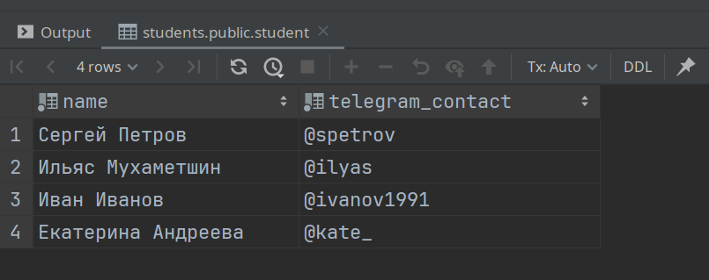

**b.**

select 'университет: ' || name || '; количество студентов: ' || size as "Полная информация" from college

order by name;

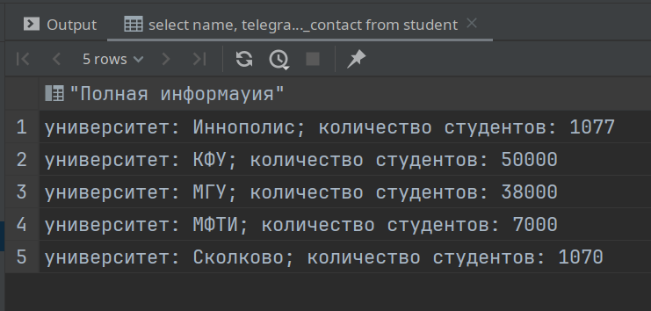

**c.**

select name, size from college

where id in (10, 30, 50)

order by size, name

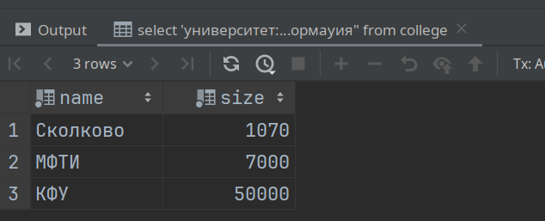

**d.**

select name, size from college

where id not in (10, 30, 50)

order by size, name

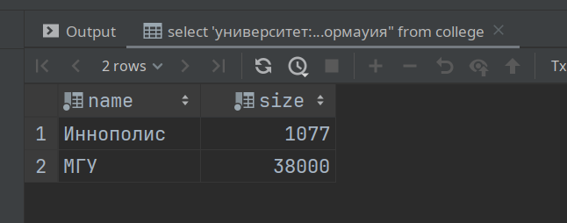

**e.**

select name, amount_of_students from course

where amount_of_students between 27 and 310

order by name desc, amount_of_students desc

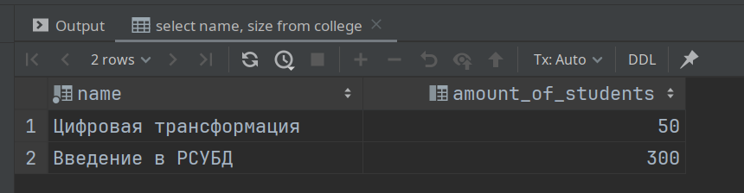

**f.**

select name from course

union

select name from student

order by name desc

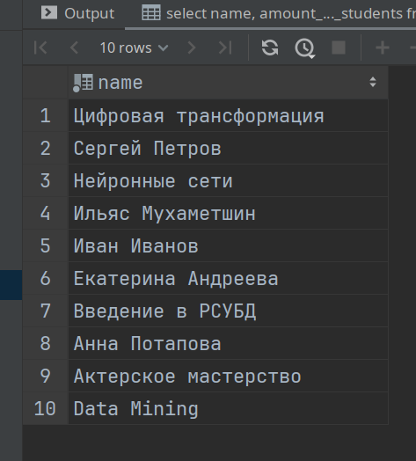

**g.**

select name, 'университет' as "object_type" from college

union

select name, 'курс' from course

order by object_type desc, name

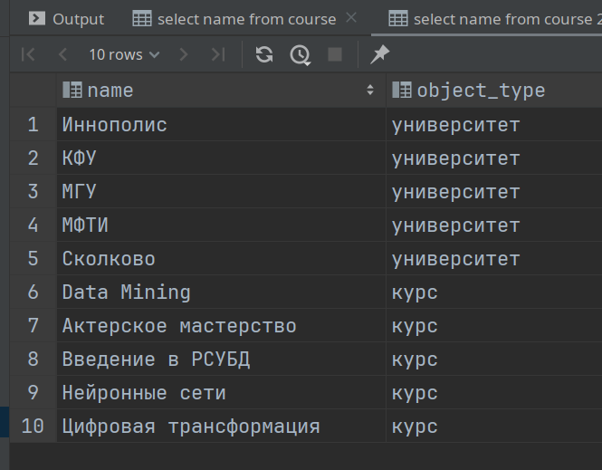

**h.**

select name, amount_of_students from course

order by

CASE

WHEN amount_of_students = 300 THEN 0

ELSE amount_of_students

END

limit 3

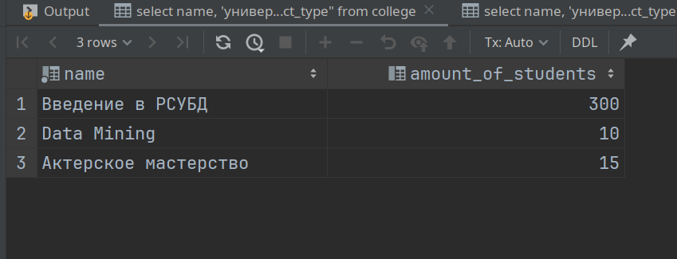

**i.**

insert into course(id, name, amount_of_students, college_id)

values (60, 'MachineLearning', 17, (select college_id from course where name = 'Data Mining'))

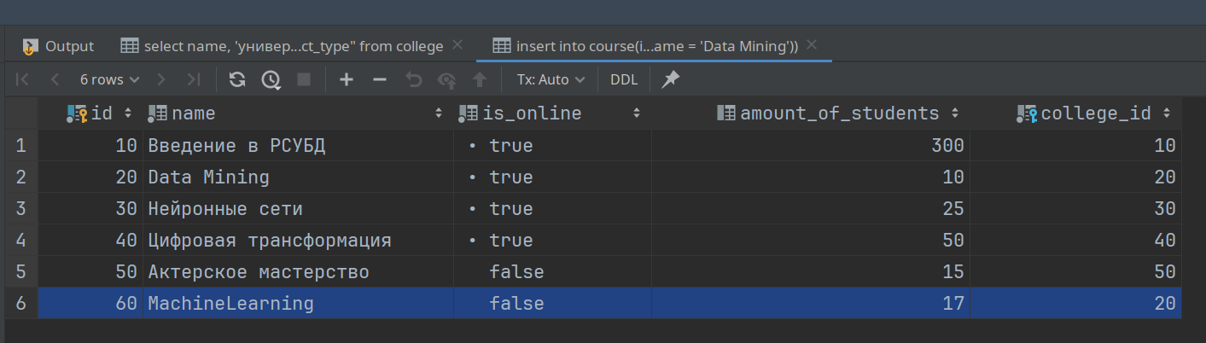

**j.**

(select id from course except select id from student_on_course)

union

(select id from student_on_course except select id from course)

order by id

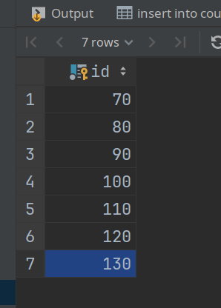

**k.**

select student.name as "student_name", course.name as "course_name", college.name as "student_college", student_on_course.student_rating as "student_rating" from student_on_course

join student on student_on_course.student_id = student.id

join college on student.college_id = college.id

join course on student_on_course.course_id = course.id

where student_rating > 50 and college.size > 5000

order by student_name, course_name

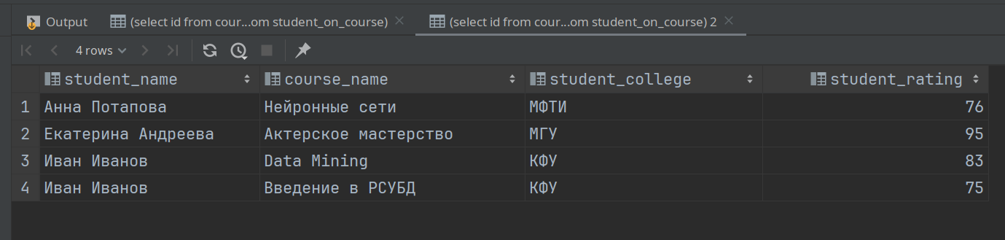

**l.**

select names[2] as "student_1", names[1] as "student_2", city from (

select array_agg(name) as names, city

from student

group by city

)_

where names[2] is not null and names[1] is not null

order by student_1

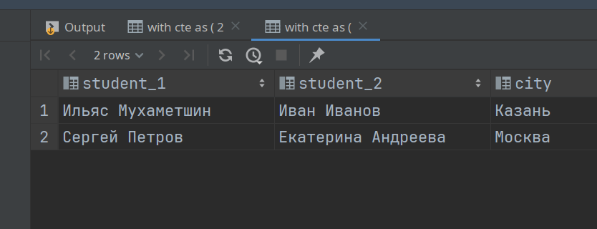

**m.**

select

case

when student_rating < 30 then 'неудовлетворительно'

when student_rating >= 30 and student_rating < 60 then 'удовлетворительно'

when student_rating >= 60 and student_rating < 85 then 'хорошо'

else 'отлично'

end as "оценка",

count(*) as "количество студентов"

from student_on_course

group by "оценка"

order by "количество студентов"

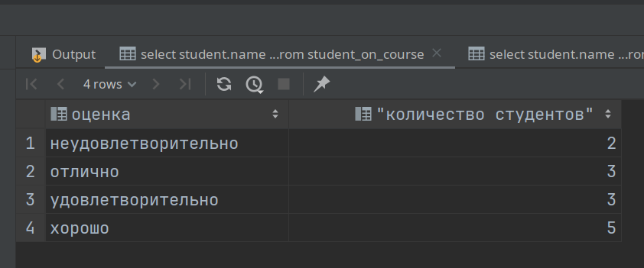

**n.**

select

course.name as "курс",

case

when student_rating < 30 then 'неудовлетворительно'

when student_rating >= 30 and student_rating < 60 then 'удовлетворительно'

when student_rating >= 60 and student_rating < 85 then 'хорошо'

else 'отлично'

end as "оценка",

count(*) as "количество студентов"

from student_on_course

join course on student_on_course.course_id = course.id

group by "курс", "оценка"

order by "курс", "количество студентов"

