1. **Overview of the Analysis:**

The purpose of this analysis was to create a deep learning neural network model for Alphabet Soup, a charitable organization, to predict the success of funding applications. The goal was to build a model that could efficiently classify whether a funding application would be successful or not, based on various input features.

**2. Results:**

- Data Preprocessing:

* **Target Variable:** The target variable for the model was IS_SUCCESSFUL, which indicates whether a funding application was successful (1) or not (0). Features:
* **The features for the model included various input variables such as** APPLICATION_TYPE, AFFILIATION, CLASSIFICATION, USE_CASE, ORGANIZATION, INCOME_AMT, SPECIAL_CONSIDERATIONS, and ASK_AMT.
* **Removed Variables:** The variables EIN were removed from the input data as they were considered irrelevant for predicting the success of funding applications.

**Before**

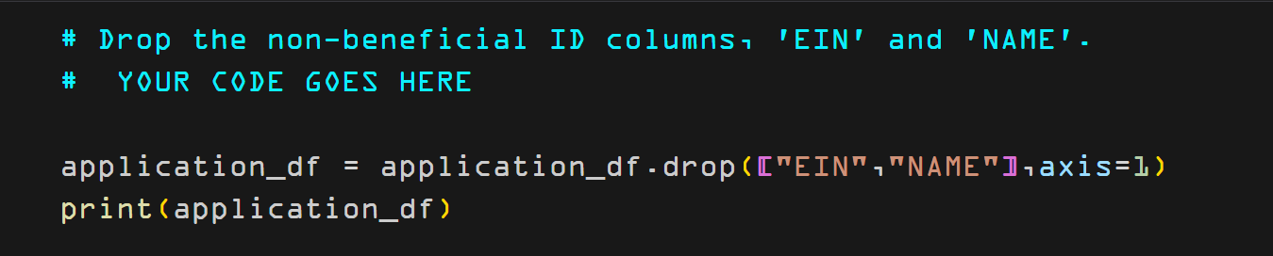

**After**

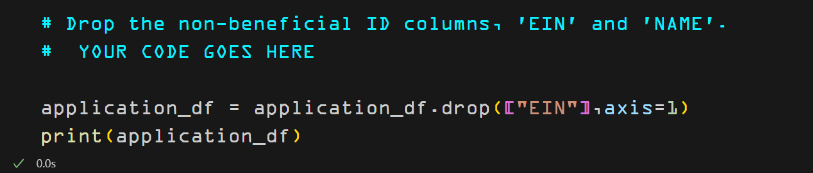

1. **Compiling, Training, and Evaluating the Model:**

* The neural network model was built using the Keras library with a sequential architecture. The model architecture consisted of two hidden layers with 160 and 160 neurons, respectively with sigmoid activation functions

**Before**

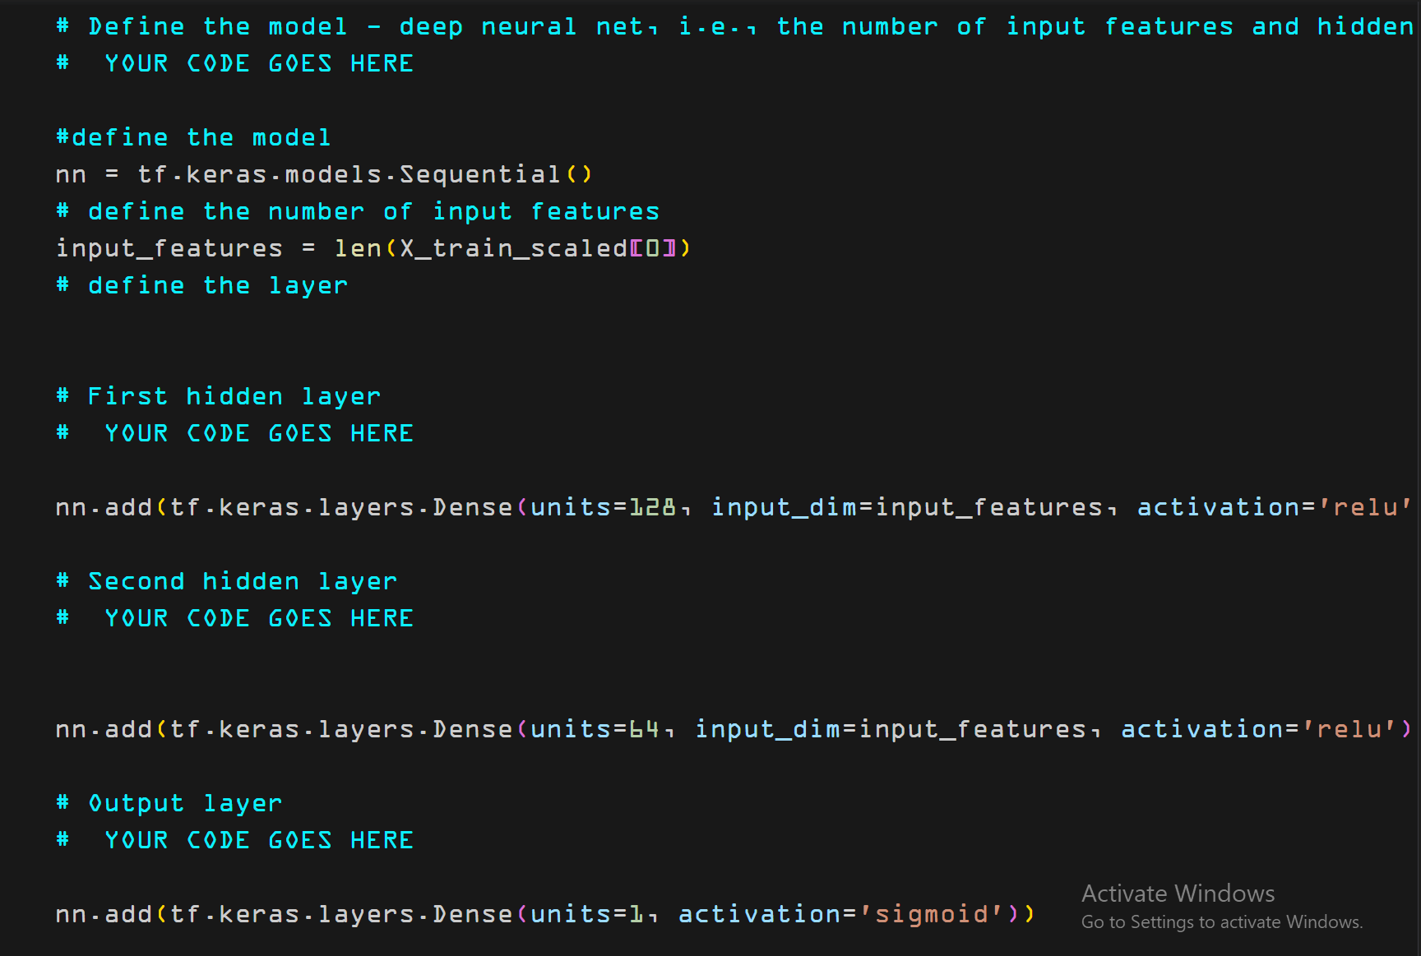

**After**

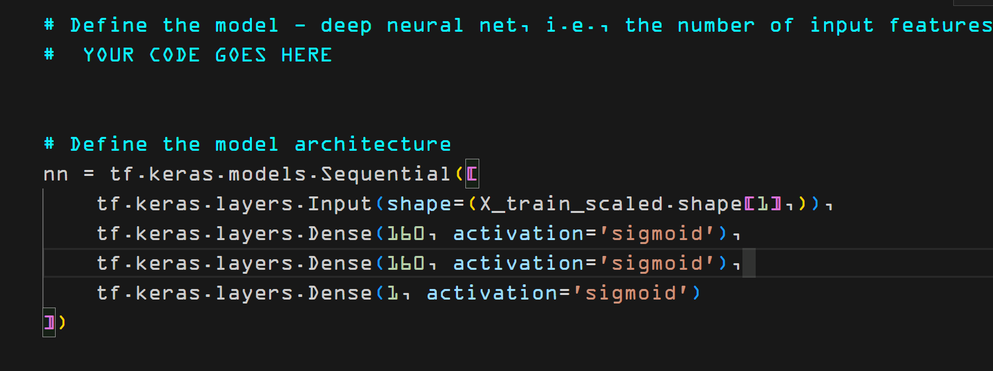

* The output layer had a single neuron with a sigmoid activation function, suitable for binary classification.

**Before**

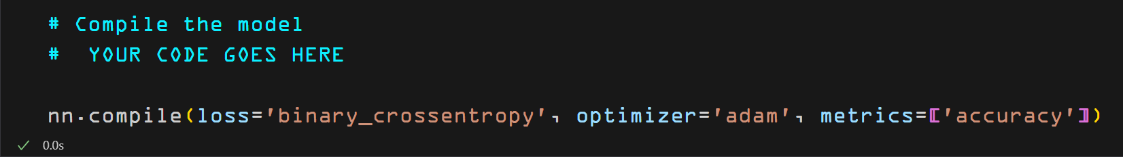

**After**

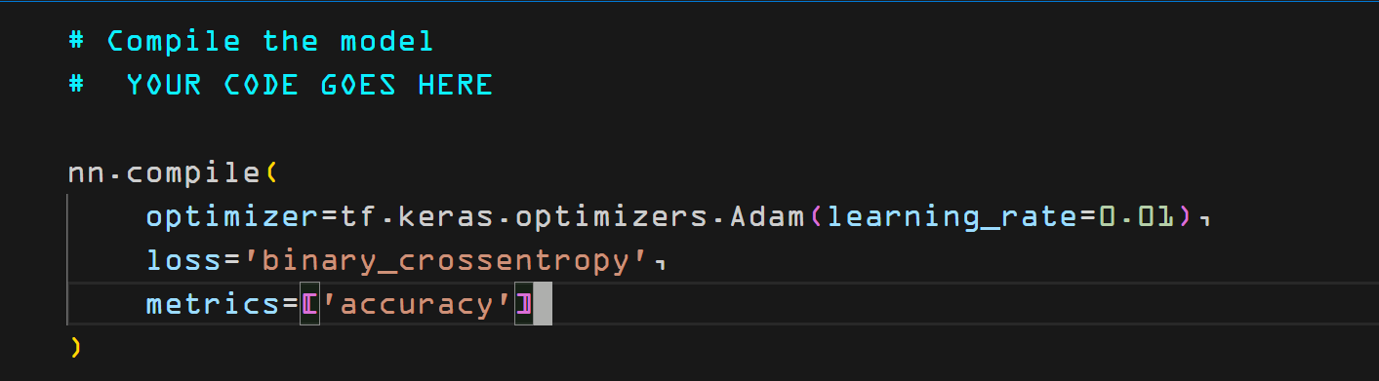

* Despite extensive training and optimization efforts, the model did achieve higher than the target accuracy rate performance. Showing reasonable performance accuracy of 79% in classifying funding application success.

**Before**



**After**



1. **Summary**

* The deep learning neural network model demonstrated the potential to predict funding application success for Alphabet Soup, the model showed promise in distinguishing between successful and unsuccessful applications. It is recommended to explore additional strategies to improve model performance. Recommendation for a Different Model: An alternative approach to solving this classification problem could involve using an ensemble learning technique, such as a Random Forest classifier. Unlike deep neural networks, ensemble models combine multiple individual models to make predictions, often resulting in improved accuracy and generalization. Random Forest models can handle categorical features effectively and are less prone to overfitting. This approach could potentially provide a robust solution for predicting funding application success for Alphabet Soup, given the nature of the dataset and the classification task.
* **Explanation of Recommendation**: Ensemble learning techniques like Random Forests tend to perform well in scenarios where there are multiple features with complex interactions and potential noise in the data. These models can capture non-linear relationships and handle feature importance more effectively. Additionally, ensemble methods are less sensitive to hyperparameters and require less intensive hyperparameter tuning compared to deep neural networks. Given the relatively moderate size of the dataset and the categorical nature of the features, a Random Forest classifier could offer a more interpretable and reliable solution for predicting funding application success.