# 微信小程序——蜂鸟叮咚

## 配置环境

系统环境：Windows 10

体验环境：Android/iOS系统的微信APP

工具：

* 微信开发者工具Stable 1.05.2110110
* Visual Studio Code 2021

## 整体思想

写三个页面，分别是index，list，entry，分别代表小程序首页、列表的内容和适老化入口。

## 实现逻辑

* 配置json文件

在app.json中加入以下代码，说明小程序的信息。

{  
 "pages": [  
 "pages/index/index",  
 "pages/index/list",  
 "pages/index/entry",  
 "pages/logs/logs"  
 ],  
 "window": {  
 "backgroundTextStyle": "light",  
 "navigationBarBackgroundColor": "#ffd705",  
 "navigationBarTitleText": "蜂鸟叮咚",  
 "navigationBarTextStyle": "black"  
 },  
 "sitemapLocation": "sitemap.json"  
}

* 首页index
  + index.wxml通过navigator标签获取内部页url来跳转其他页面，view标签查看文本和图片
* <!--index.wxml-->  
  <view class="container">  
   <image class="banner" mode="aspectFit" src="/img/logo.png"></image>  
   <!--<view style=" display: flex;flex-direction: column; align-items: center;">  
   <image class="t" mode="aspectFit" src="/img/t1.png"></image>  
   <text>美食</text>  
   </view>-->  
   <!--<view class="bnrs-indic-wrap">  
   </view>-->  
   <navigator url="entry">  
   <button><view class="enter" style="color: rgb(238, 121, 11); font-size: 20px;">适老化入口</view></button>  
   </navigator>  
   <navigator url="list">  
   <view style="display: flex;">  
   <view class="icon">  
   <image class="t" mode="aspectFit" src="/img/t1.png"></image>  
   <text class="text">美食</text>  
   </view>  
   <view class="icon">  
   <image class="t" mode="aspectFit" src="/img/t2.png"></image>  
   <text class="text">超市</text>  
   </view>  
   <view class="icon">  
   <image class="t" mode="aspectFit" src="/img/t3.png"></image>  
   <text class="text">鲜果购</text>  
   </view>  
   <view class="icon">  
   <image class="t" mode="aspectFit" src="/img/t4.png"></image>  
   <text class="text">甜点饮品</text>  
   </view>  
   </view>  
   <view style="display: flex;">  
   <view class="icon">  
   <image class="t" mode="aspectFit" src="/img/t5.png"></image>  
   <text class="text">正餐优选</text>  
   </view>  
   <view class="icon">  
   <image class="t" mode="aspectFit" src="/img/t6.png"></image>  
   <text class="text">蜂鸟专送</text>  
   </view>  
   <view class="icon">  
   <image class="t" mode="aspectFit" src="/img/t7.png"></image>  
   <text class="text">夜宵</text>  
   </view>  
   <view class="icon">  
   <image class="t" mode="aspectFit" src="/img/t9.png"></image>  
   <text class="text">医药</text>  
   </view>  
   </view>  
   <view class="top-placeholder">  
   <text class="text">附近商家</text>  
   </view>  
   </navigator>  
    
   <view class="split-h" style=" overflow: hidden;position:relative">  
   <text style="position: absolute; color: #6b450a;background: #fdd943; transform: rotate(-45deg);font-size:10pt;margin-top:-30px;margin-left:-22px;width:60px;height:30px;text-align: center;line-height:45px; ">品牌</text>  
   <image src="http://p1.meituan.net/0.120.100/xianfu/d3a267d8418c66850c3a7b8358aa8c408360.jpeg" style="width:94px;height:74px"></image>  
   <view style="flex:1">  
   <view>  
   <text style="font-size:12pt">南京大排档</text>  
   <image style="width:15px;height:15px" src="http://p1.meituan.net/xianfu/32200c3060be7903f62c9076308619ee734.png"></image>  
   </view>  
   <view style="align-items: center;display: flex; margin-top:5px;flex: 1;">  
   <view class="star"></view>  
   <view class="star"></view>  
   <view class="star"></view>  
   <view class="star"></view>  
   <view class="star"></view>  
   <text style="font-size:10pt;color:#656565">月售132单</text>  
   </view>  
   <view class="">  
   <text style="font-size:10pt;color:#656565">起送价￥25|配送￥2</text>  
   </view>  
   </view>  
   <view>  
   <view style="text-align:right">  
   <text style="font-size:10pt;color:#656565;">5.1km</text>  
   </view>  
   <view style="text-align:right">  
   <text style="font-size:10pt;color:#656565">43分钟</text>  
   </view>  
   <view class="">  
   <text class="allocation">蜂鸟专送</text>  
   </view>  
   </view>  
   </view>  
    
    
   <view style="height:10px;background-color: #efefef;"></view>  
    
    
   <view class="split-h">  
   <image src="http://p0.meituan.net/0.120.100/xianfu/cee03686ce4a833e7a61fabbc59da0ab6144.jpg" style="width:94px;height:74px"></image>  
   <view style="flex:1">  
   <view>  
   <text style="font-size:12pt">拼豆夜宵（车公庄）</text>  
   <image style="width:15px;height:15px" src="http://p1.meituan.net/xianfu/32200c3060be7903f62c9076308619ee734.png"></image>  
   </view>  
   <view style="align-items: center;display: flex; margin-top:5px;flex: 1;">  
   <view class="star"></view>  
   <view class="star"></view>  
   <view class="star"></view>  
   <view class="star"></view>  
   <view class="star"></view>  
   <text style="font-size:10pt;color:#656565">月售983单</text>  
   </view>  
   <view class="">  
   <text style="font-size:10pt;color:#656565">起送价￥30|配送￥5</text>  
   </view>  
   </view>  
   <view>  
   <view style="text-align:right">  
   <text style="font-size:10pt;color:#656565;">2.1km</text>  
   </view>  
   <view style="text-align:right">  
   <text style="font-size:10pt;color:#656565">24分钟</text>  
   </view>  
   <view class="">  
   <!--<text class="allocation">蜂鸟专送</text>-->  
   </view>  
   </view>  
   </view>  
   <view style="height:10px;background-color: #efefef;"></view>  
    
   <view class="split-h" style=" overflow: hidden;position:relative">  
   <text style="position: absolute; color: #6b450a;background: #fdd943; transform: rotate(-45deg);font-size:10pt;margin-top:-30px;margin-left:-22px;width:60px;height:30px;text-align: center;line-height:45px; ">品牌</text>  
   <image src="http://p0.meituan.net/0.120.100/xianfu/d19a01f08e2f241ae5b1151d3def25427985.jpeg" style="width:94px;height:74px"></image>  
   <view style="flex:1">  
   <view>  
   <text style="font-size:12pt">管氏翅吧（新街口店）</text>  
   <image style="width:15px;height:15px" src="http://p1.meituan.net/xianfu/32200c3060be7903f62c9076308619ee734.png"></image>  
   </view>  
   <view style="align-items: center;display: flex; margin-top:5px;flex: 1;">  
   <view class="star"></view>  
   <view class="star"></view>  
   <view class="star"></view>  
   <view class="star"></view>  
   <view class="star"></view>  
   <text style="font-size:10pt;color:#656565">月售206单</text>  
   </view>  
   <view class="">  
   <text style="font-size:10pt;color:#656565">起送价￥25|配送￥8(夜间)</text>  
   </view>  
   </view>  
   <view>  
   <view style="text-align:right">  
   <text style="font-size:10pt;color:#656565;">5.1km</text>  
   </view>  
   <view style="text-align:right">  
   <text style="font-size:10pt;color:#656565">45分钟</text>  
   </view>  
   <view class="">  
   <text class="allocation">蜂鸟专送</text>  
   </view>  
   </view>  
   </view>  
   <view style="height:10px;background-color: #efefef;"></view>  
    
   <view class="split-h">  
   <image src="http://p0.meituan.net/0.120.100/xianfu/fd3a8462080c71f60f2581c2e7c1d3f43010.jpeg" style="width:94px;height:74px"></image>  
   <view style="flex:1">  
   <view>  
   <text style="font-size:12pt">北京麦当劳展览路餐厅</text>  
   <image style="width:15px;height:15px" src="http://p1.meituan.net/xianfu/32200c3060be7903f62c9076308619ee734.png"></image>  
   </view>  
   <view style="align-items: center;display: flex; margin-top:5px;flex: 1;">  
   <view class="star"></view>  
   <view class="star"></view>  
   <view class="star"></view>  
   <view class="star"></view>  
   <view class="star"></view>  
   <text style="font-size:10pt;color:#656565">月售1663单</text>  
   </view>  
   <view class="">  
   <text style="font-size:10pt;color:#656565">起送价￥15|配送￥4</text>  
   </view>  
   </view>  
   <view>  
   <view style="text-align:right">  
   <text style="font-size:10pt;color:#656565;">4.4km</text>  
   </view>  
   <view style="text-align:right">  
   <text style="font-size:10pt;color:#656565">31分钟</text>  
   </view>  
   <view class="">  
   <!-- <text class="allocation">蜂鸟专送</text> -->  
   </view>  
   </view>  
   </view>  
   <view style="height:10px;background-color: #efefef;"></view>  
    
    
    
    
    
    
    
  </view>
  + index.wxss控制页面字体颜色边距等属性，为index.wxml提供样式
* /**index.wxss**/  
    
  /*.userinfo {  
   display: flex;  
   flex-direction: column;  
   align-items: center;  
  }  
    
  .userinfo-avatar {  
   width: 128rpx;  
   height: 128rpx;  
   margin: 20rpx;  
   border-radius: 50%;  
  }  
    
  .userinfo-nickname {  
   color: #aaa;  
  }  
    
  .usermotto {  
   margin-top: 200px;  
  }*/  
    
  .banner {  
   width: 90%;  
   height: 160px;  
   margin-top: -10px;  
  }  
    
  .enter {  
   margin-top: -10px;  
   margin-bottom: 5px;  
  }  
    
  .icon {  
   margin-top: -20px;  
   width: 30%;  
   display: flex;  
   flex-direction: column;  
   align-items: center;  
  }  
    
  .icon .t {  
   width: 80px;  
   height: 80px;  
  }  
    
  .icon .text {  
   font-size: 10pt;  
   margin-bottom: 10px;  
   margin-top: -5px;  
  }  
    
  .bnrs-indic-wrap {  
   bottom: 8px;  
   width: 100%;  
   text-align: center;  
   line-height: 8px;  
   z-index: 20;  
   bottom: -10px;  
   height: 20px;  
   font-size: 1px;  
   border: 1px solid #000;  
   -webkit-tap-highlight-color: rgba(0, 0, 0, 0);  
   word-wrap: break-word;  
   word-break: break-all;  
   padding: 0;  
   margin: 0;  
  }  
    
  /*.bnrs-indic {  
   width: 6px;  
   height: 6px;  
   border: 1px solid #fff;  
   margin: 0 2px;  
  }*/  
    
  .bnrs-indic-wrap .indic-focus {  
   background-color: #fff;  
  }  
    
  .top-placeholder {  
   width: 100%;  
   height: 30px;  
   background-color: #efefef;  
  }  
    
  .top-placeholder .text {  
   border-left: 3px solid #ffd705;  
   font-size: 10pt;  
   line-height: 30px;  
   padding-left: 10px;  
  }  
    
    
    
    
  .split-h{display: flex; align-items: center;padding-right: 15px}  
    
    
  .star{  
  background: url(https://gimg2.baidu.com/image_search/src=http%3A%2F%2Fgss0.baidu.com%2F9vo3dSag_xI4khGko9WTAnF6hhy%2Fzhidao%2Fpic%2Fitem%2F34fae6cd7b899e5126f5b89947a7d933c9950dc7.jpg) no-repeat;  
   background-size: cover;  
   width: 17px;  
   height: 17px;  
   float: left;  
   margin-right: -2px;  
   background-position: 0 -2px;  
    
    
  }  
    
    
  .allocation {  
   background-color: #ffd600;  
   display: inline-block;  
   padding: 2px 6px;  
   font-size: 9pt;  
   color: #784203;  
   font-weight: normal;  
   border-radius: 3px;  
   vertical-align: baseline;  
  }
  + index.js获取前端动作行为的事件来操控
* //index.js  
  //获取应用实例  
  var app = getApp()  
  Page({  
   data: {  
   motto: 'Hello World',  
   userInfo: {}  
   },  
   //事件处理函数  
   bindViewTap: function() {  
   wx.navigateTo({  
   url: '../logs/logs'  
   })  
   },  
   onLoad: function () {  
   console.log('onLoad')  
   var that = this  
   //调用应用实例的方法获取全局数据  
   app.getUserInfo(function(userInfo){  
   //更新数据  
   that.setData({  
   userInfo:userInfo  
   })  
   })  
   }  
  })
* list
  + list.wxml
* <!--pages/index/list.wxml-->  
  <view class="flex">  
   <view style="flex:1">  
   <text class="smalltext t ">美食</text>  
   <text class="down"></text>  
   </view>  
   <view style="flex:1">  
   <text class="smalltext t ">时间</text>  
   <view class="down"></view>  
   </view>  
   <view style="flex:1">  
   <text class="smalltext t ">地点</text>  
   <view class="down"></view>  
   </view>  
    
    
   <!--<text class="smalltext t" style="flex:1">综合排序</text>  
  <text class="smalltext t" style="flex:1">筛选</text>-->  
  </view>  
  <view class="split-h">  
   <image src="http://p0.meituan.net/0.120.100/xianfu/fd3a8462080c71f60f2581c2e7c1d3f43010.jpeg" style="width:94px;height:74px"></image>  
   <view style="flex:1">  
   <view>  
   <text style="font-size:12pt">北京麦当劳展览路餐厅</text>  
   <image style="width:15px;height:15px" src="http://p1.meituan.net/xianfu/32200c3060be7903f62c9076308619ee734.png"></image>  
   </view>  
   <view style="align-items: center;display: flex; margin-top:5px;flex: 1;">  
   <view class="star"></view>  
   <view class="star"></view>  
   <view class="star"></view>  
   <view class="star"></view>  
   <view class="star"></view>  
   <text style="font-size:10pt;color:#656565">月售1663单</text>  
   </view>  
   <view class="">  
   <text style="font-size:10pt;color:#656565">起送价￥15|配送￥4</text>  
   </view>  
   </view>  
   <view>  
   <view style="text-align:right">  
   <text style="font-size:10pt;color:#656565;">4.1km</text>  
   </view>  
   <view style="text-align:right">  
   <text style="font-size:10pt;color:#656565">31分钟</text>  
   </view>  
   <view class="">  
   <text class="allocation">蜂鸟专送</text>  
   </view>  
   </view>  
  </view>  
  <view style="height:10px;background-color: #efefef;"></view>
  + list.wxss
* /* pages/index/list.wxss */  
  .split-h{display: flex; align-items: center;padding-right: 15px}  
    
    
  .star{  
  background: url(https://gimg2.baidu.com/image_search/src=http%3A%2F%2Fgss0.baidu.com%2F9vo3dSag_xI4khGko9WTAnF6hhy%2Fzhidao%2Fpic%2Fitem%2F34fae6cd7b899e5126f5b89947a7d933c9950dc7.jpg) no-repeat;  
   background-size: cover;  
   width: 17px;  
   height: 17px;  
   float: left;  
   margin-right: -2px;  
   background-position: 0 -2px;  
    
    
  }  
    
    
  .allocation {  
   background-color: #ffd600;  
   display: inline-block;  
   padding: 2px 6px;  
   font-size: 9pt;  
   color: #784203;  
   font-weight: normal;  
   border-radius: 3px;  
   vertical-align: baseline;  
  }  
    
  .t{  
   text-align: center;  
   font-size: 10pt;  
   padding: 5px;  
  }  
    
  .down{  
  /*content: '';*/  
    
    
   width: 5px;  
   height: 5px;  
   border: 1px solid #9b9b9b;  
   border-width: 0 1px 1px 0;  
   -webkit-transform: rotate(45deg);  
   margin-top: -10px;  
  }
* entry

我们想要机器人无接触配送服务更适合老人的心理和习惯，所以我们要在蜂鸟叮咚小程序处处体现关心老人的特点，比如用了entry页面来增大字体等方便老人阅读。

## 框架图

主体框架如下：

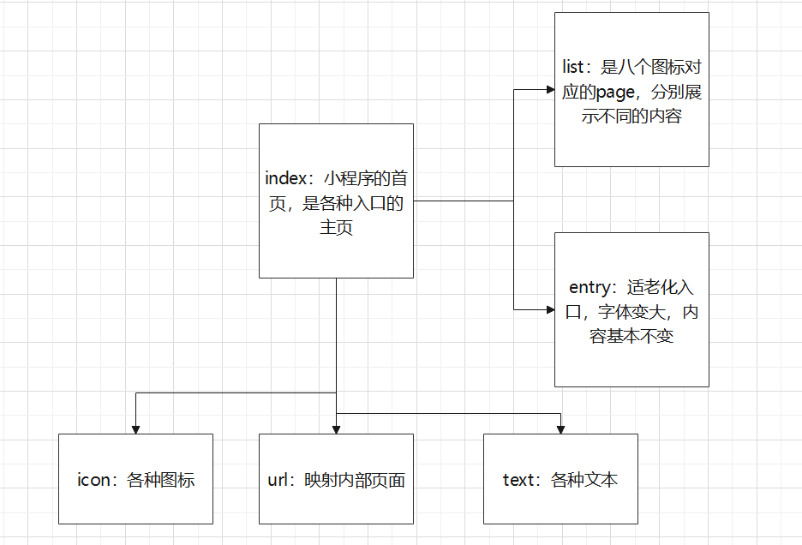

## 效果图

首页效果：

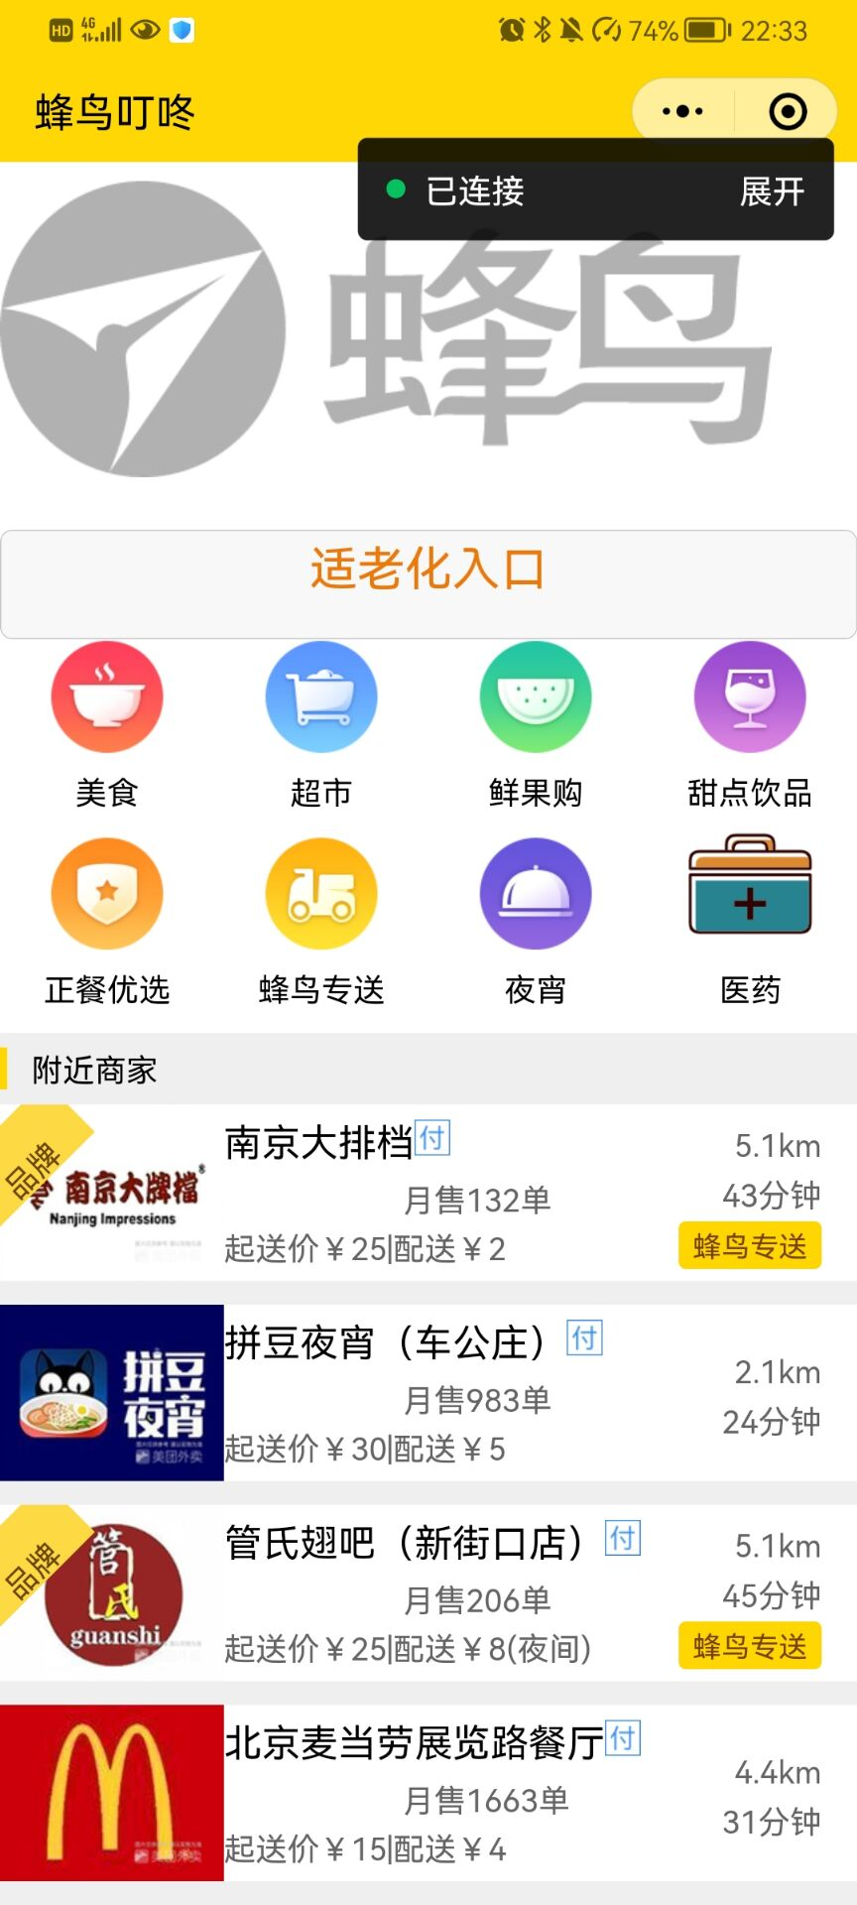

适老化界面：

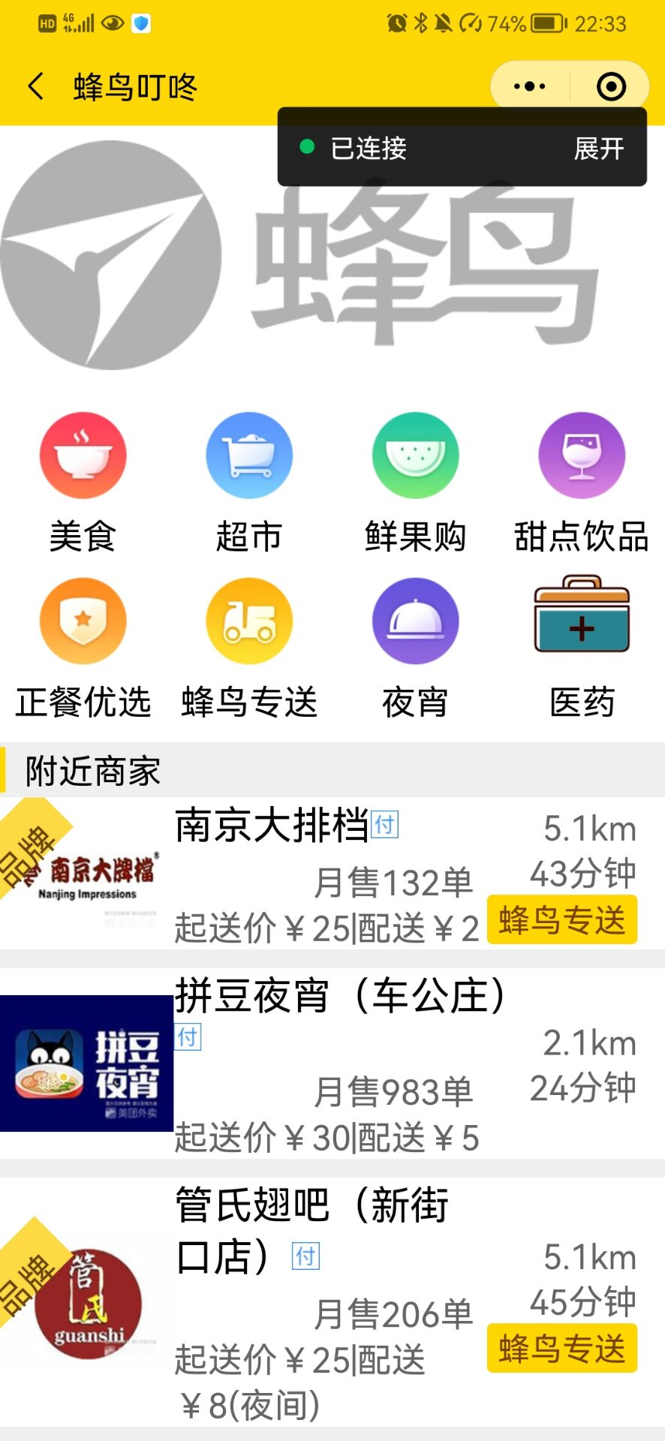

”美食“图标入口点进去的界面：

