
[CSE341] Software Testing, Validation and Verification
PROJECT REPORT

Submitted to
Dr. Islam Elmaddah
Submitted by
Ferass Ahmed Mostafa - 23p0304
Radwa Sayed Ahmed - 24P0145
Sandra Waleed Mohamed - 24P0135

1.0 Introduction
This project focuses on testing a simplified Banking System that supports client onboarding, deposits, withdrawals, transfers, and administrative workflows. The system also manages account states such as Verified, Suspended, and Closed.
To ensure correctness and reliability, we apply different testing techniques including black-box, white-box, UI, state-based testing, and TDD. These approaches help validate core functionalities, check boundary cases, and verify state transitions.
The goal is to improve software quality by detecting defects early, ensuring consistent behavior, and building confidence in the system's ability to handle real-world banking scenarios.

2.0 Files Structure
src
├── main
│ ├── java
│ │ ├── com
│ │ │ ├── Backend
│ │ │ │ ├── DAO
│ │ │ │ │ ├── AccountDAO.java
│ │ │ │ │ ├── ClientDAO.java
│ │ │ │ │ ├── EmployeeDAO.java
│ │ │ │ │ ├── TransactionDAO.java
│ │ │ │ ├── Database
│ │ │ │ │ ├── Data.java
│ │ │ │ │ ├── TestData.java
│ │ │ │ ├── Entities
│ │ │ │ │ ├── Account.java
│ │ │ │ │ ├── Client.java
│ │ │ │ │ ├── Employee.java
│ │ │ │ │ ├── Transaction.java
│ │ │ ├── controllers
│ │ │ │ ├── Admin
│ │ │ │ │ ├── Forms
│ │ │ │ │ │ ├── AdminAccount_FormController.java
│ │ │ │ │ │ ├── AdminTransaction_FormController.java
│ │ │ │ │ ├── Pages
│ │ │ │ │ │ ├── AdminAccount_PageController.java
│ │ │ │ │ │ ├── AdminCustomers_PageController.java
│ │ │ │ │ │ ├── AdminTransaction_PageController.java
│ │ │ │ ├── Client
│ │ │ │ │ ├── Cards
│ │ │ │ │ │ ├── Notification_CardController.java
│ │ │ │ │ │ ├── Transaction_CardController.java
│ │ │ │ │ ├── Forms
│ │ │ │ │ │ ├── DepositMoney_FormController.java
│ │ │ │ │ │ ├── Profile_FormController.java
│ │ │ │ │ │ ├── SendMoney_FormController.java
│ │ │ │ │ │ ├── WithdrawMoney_FormController.java
│ │ │ │ │ ├── Pages
│ │ │ │ │ │ ├── Dashboard_PageController.java
│ │ │ │ │ │ ├── Transaction_PageController.java
│ │ │ │ │ ├── ForgotPassword_PageController.java
│ │ │ │ │ ├── Login_PageController.java
│ │ │ │ │ ├── Signup_PageController.java
│ │ │ │ ├── AlertBox.java
│ │ │ │ ├── BankingSystem.java
│ │ │ │ ├── Date.java
│ │ │ │ ├── SceneController.java
│ │ │ ├── module-info.java
│ ├── resources
│ │ ├── Frontend
│ │ │ ├── fxml
│ │ │ │ ├── Admin
│ │ │ │ │ ├── Forms
│ │ │ │ │ │ ├── AdminAccount_Form.fxml
│ │ │ │ │ │ ├── AdminTransaction_Form.fxml
│ │ │ │ │ ├── Pages
│ │ │ │ │ │ ├── AdminAccount_Page.fxml
│ │ │ │ │ │ ├── AdminCustomers_Page.fxml
│ │ │ │ │ │ ├── AdminTransaction_Page.fxml
│ │ │ │ ├── Client
│ │ │ │ │ ├── Cards
│ │ │ │ │ │ ├── Notification_Card.fxml
│ │ │ │ │ │ ├── Transaction_Card.fxml
│ │ │ │ │ ├── Forms
│ │ │ │ │ │ ├── DepositMoney_Form.fxml
│ │ │ │ │ │ ├── Profile_Form.fxml
│ │ │ │ │ │ ├── SendMoney_Form.fxml
│ │ │ │ │ │ ├── WithdrawMoney_Form.fxml
│ │ │ │ │ ├── Pages
│ │ │ │ │ │ ├── Dashboard_Page.fxml
│ │ │ │ │ │ ├── Transaction_Page.fxml
│ │ │ │ │ ├── ForgotPassword_Page.fxml
│ │ │ │ │ ├── Login_Page.fxml
│ │ │ │ │ ├── Signup_Page.fxml
│ │ │ │ ├── Styles.css
├── test
│ ├── java
│ │ ├── AccountBlackBoxTest.java
│ │ ├── AccountStateTest.java
│ │ ├── AccountWhiteBoxTest.java
│ │ ├── CreditScoreFeatureTest.java

3.0 Black-Box Testing
Black-box testing treats the system as a "black box," meaning we focus only on inputs and outputs without looking into the internal implementation. The goal is to validate that the deposit, withdraw, and transfer methods behave correctly across valid and invalid inputs.
Test ID | Input | Precondition | Expected Output | Notes
TC1 | deposit(-100) | Account Verified | false | Invalid (negative amount)
TC2 | deposit(200) | Account Verified | true, balance = 200 | Valid deposit
TC3 | deposit(100) | Account Closed | false | Deposits blocked when closed
TC4 | withdraw(200) | Balance = 500, Verified | true, balance = 300 | Valid withdraw
TC5 | withdraw(200) | Balance = 100, Verified | false | Overdraft prevented
TC6 | withdraw(100) | Balance = 300, Suspended | false | Suspended accounts can't withdraw
TC7 | transfer(300, receiver=Verified) | Sender balance = 1000, both Verified | true, sender=700, receiver=800 | Successful transfer
TC8 | transfer(200, receiver=Verified) | Sender balance = 1000, sender=Unverified | false, balances unchanged | Sender not allowed
TC9 | transfer(300, receiver=Verified) | Sender balance = 100, receiver=500 | false, balances unchanged | Insufficient funds
TC10 | transfer(100, receiver=Invalid card) | Sender balance = 500, status = Verified | false, balance unchanged | Recipient not found
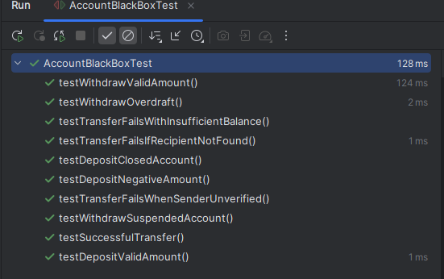
Figure 3.1 — Black-box test execution results

4.0 White-Box Testing
White-box testing examines the internal logic and control flow of the system. Unlike black-box testing, which only considers inputs and outputs, white-box testing ensures that every possible path or branch in the code is executed at least once.
Test ID | Input | Precondition | Expected Output | Notes
TC1 | deposit(-50) | status = Verified | false | Covers branch amount < 0
TC2 | deposit(0) | status = Verified | false | Covers branch amount == 0
TC3 | deposit(200) | status = Verified | true, balance increased | Covers branch amount > 0
TC4 | deposit(100) | status = Suspended | false | Covers branch status != Verified
TC5 | withdraw(300) | balance = 300, status = Verified | true, balance = 0 | Covers branch amount == balance
TC6 | withdraw(600) | balance = 500, status = Verified | false | Covers branch amount > balance
TC7 | withdraw(100) | balance = 500, status = Suspended | false | Covers branch status != Verified
TC8 | withdraw(100) | balance = 500, status = Closed | false | Covers branch status != Verified
TC9 | transfer(300 → receiver Verified) | sender balance = 1000, both Verified | true, sender=700, receiver=800 | Covers success path
TC10 | transfer(300 → receiver Verified) | sender balance = 100, receiver=500 | false, balances unchanged | Covers branch amount >= balance
TC11 | transfer(100 → invalid card) | sender balance = 500, status Verified | false, balance unchanged | Covers branch recipient == null
TC12 | transfer(100 → receiver Unverified) | sender Verified, receiver Unverified | false, balances unchanged | Covers branch recipient not verified
TC13 | transfer(200 → receiver Verified) | sender balance = 1000, sender Unverified | false, balances unchanged | Covers branch status != Verified
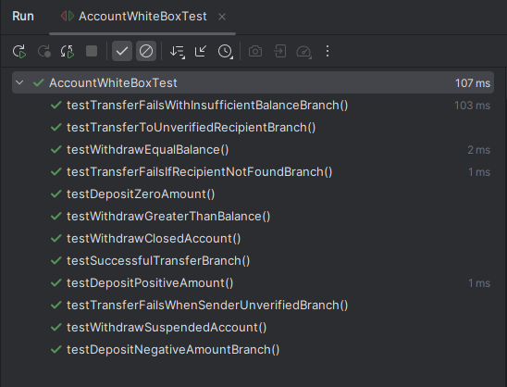
Figure 4.1 — White-box test execution results

5.0 UI Testing
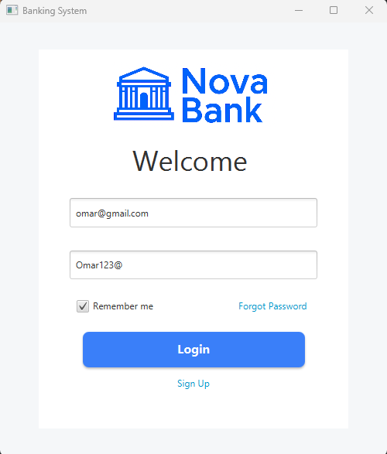
UI testing verifies that the graphical interface behaves as expected, checking input validation, navigation, and the overall user experience across the client and admin dashboards.

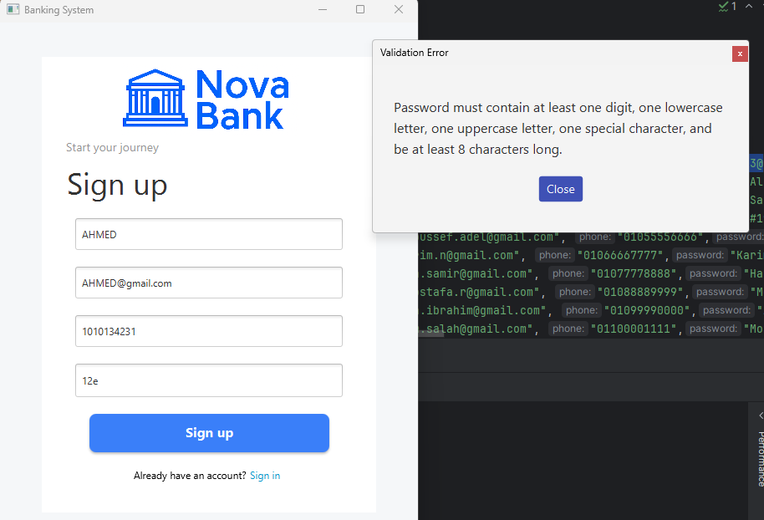
Figure 5.1 — Login and dashboard screens
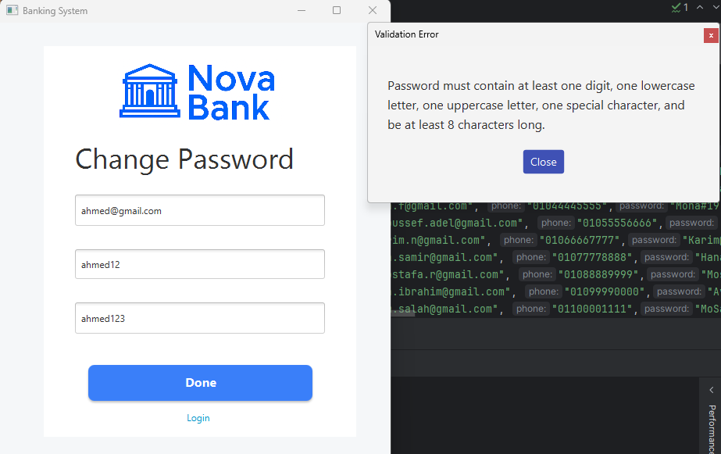
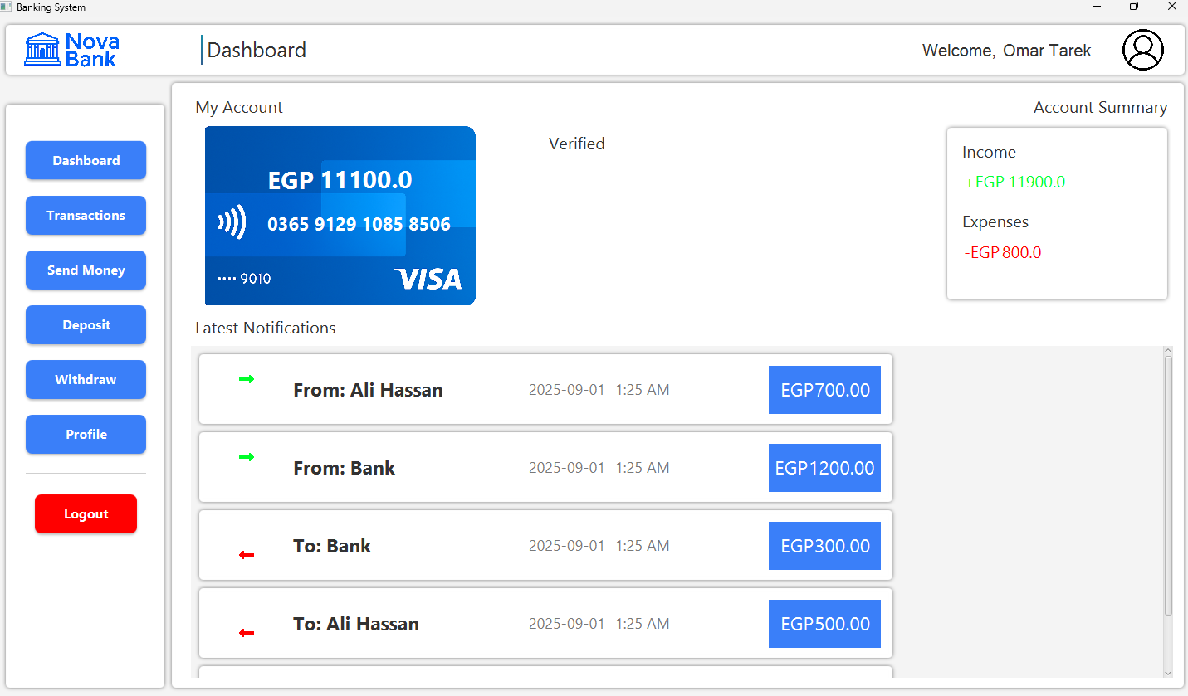
Figure 5.2 — Client transaction views
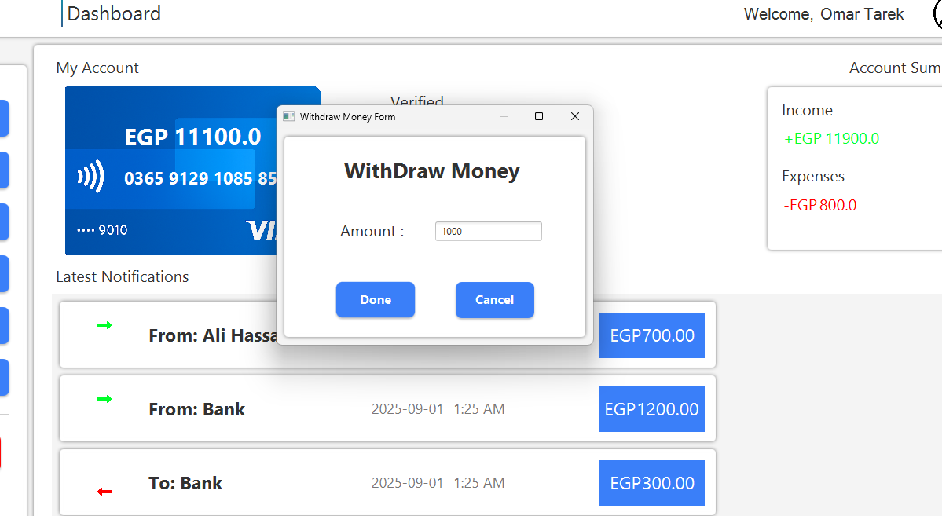
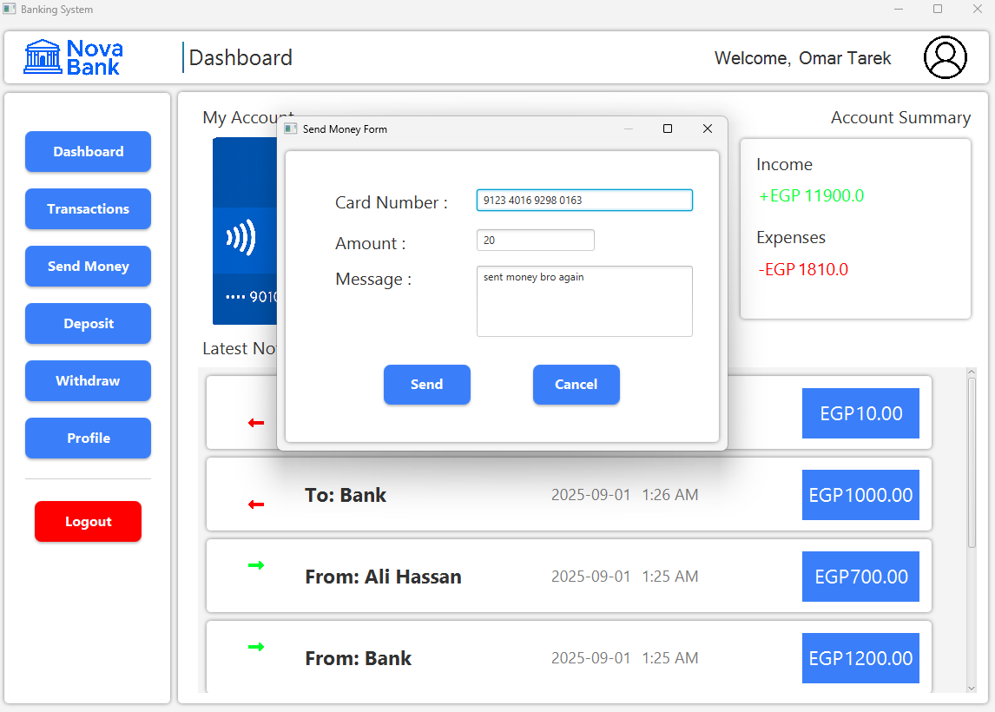
Figure 5.3 — Client dashboard and transaction pages
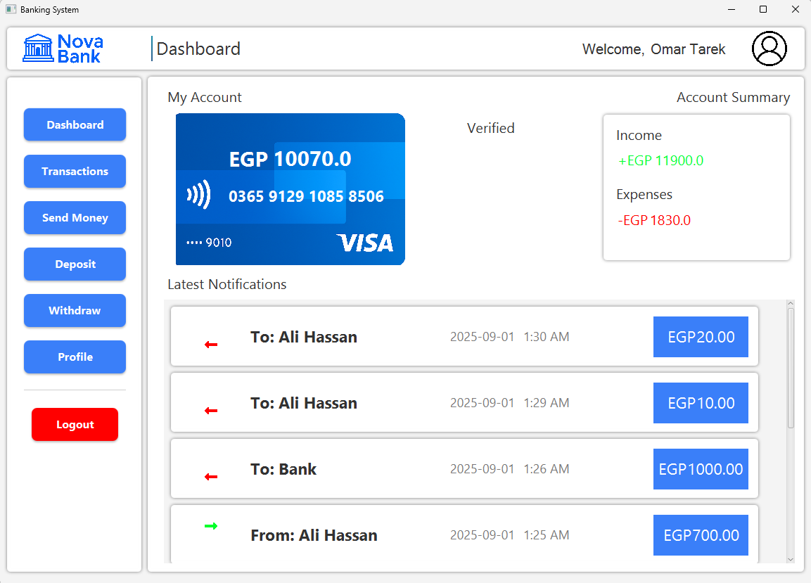
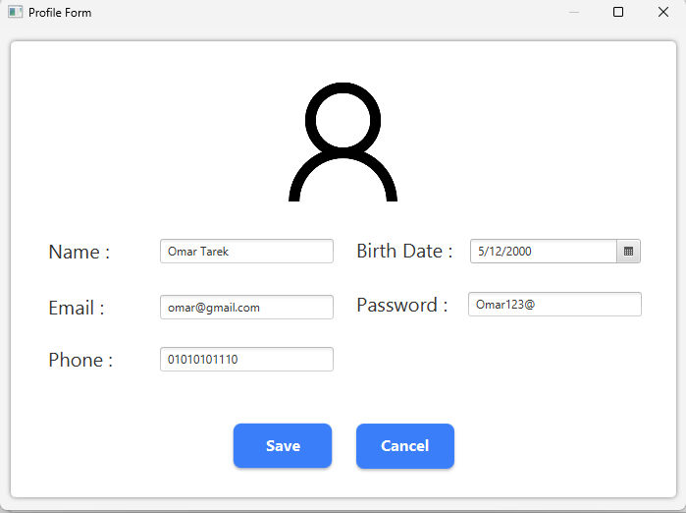
Figure 5.4 — Client forms
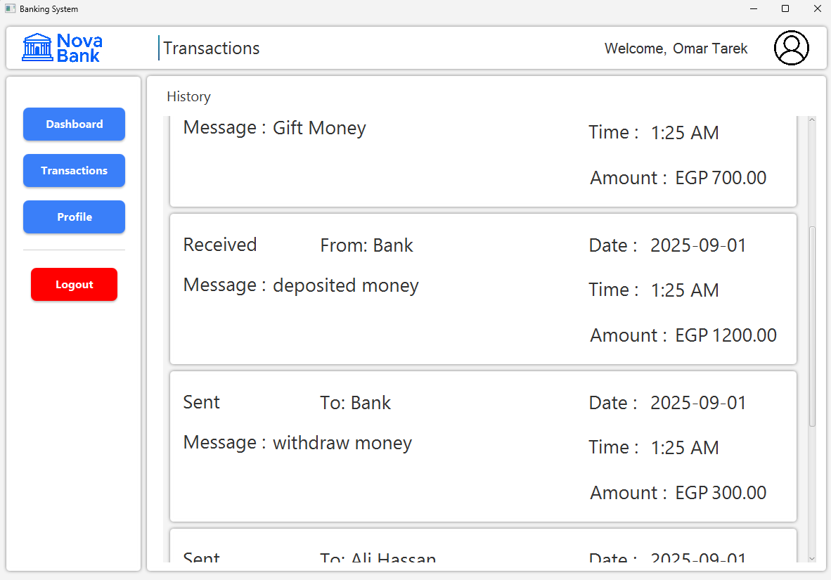
Figure 5.5 — Client page

Admin
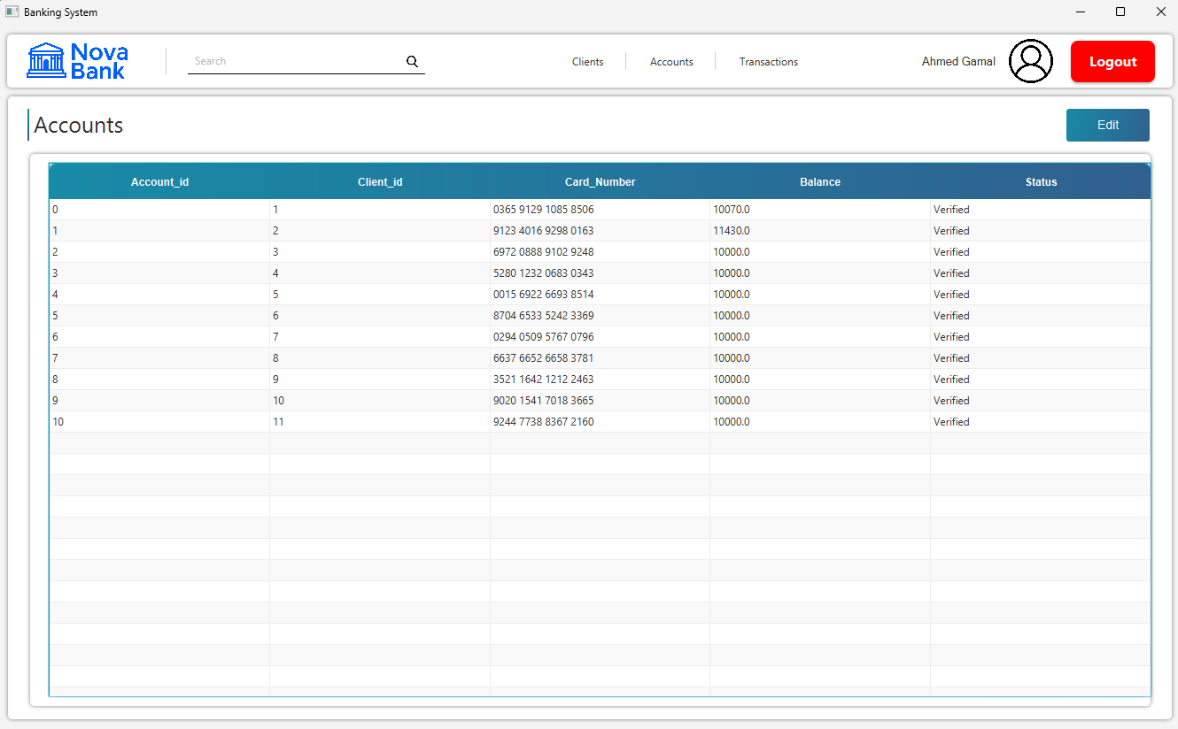
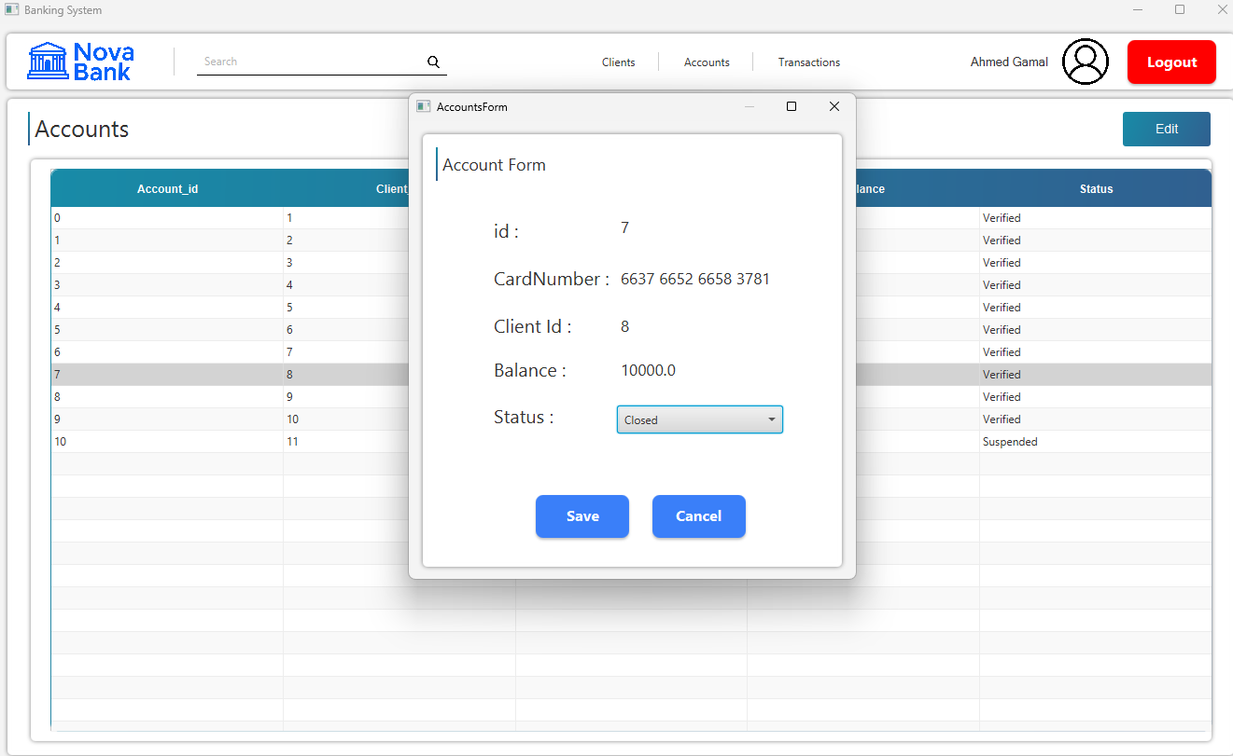
Figure 5.6 — Admin views (1/4)
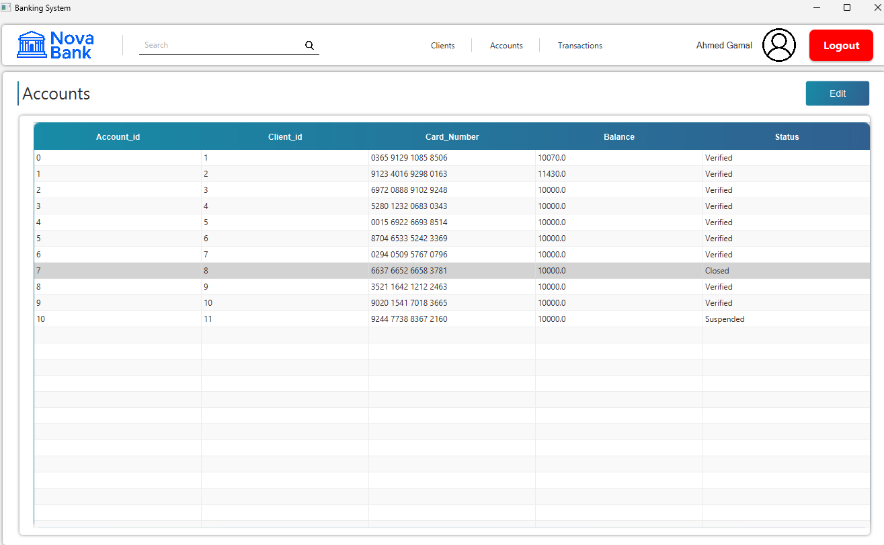
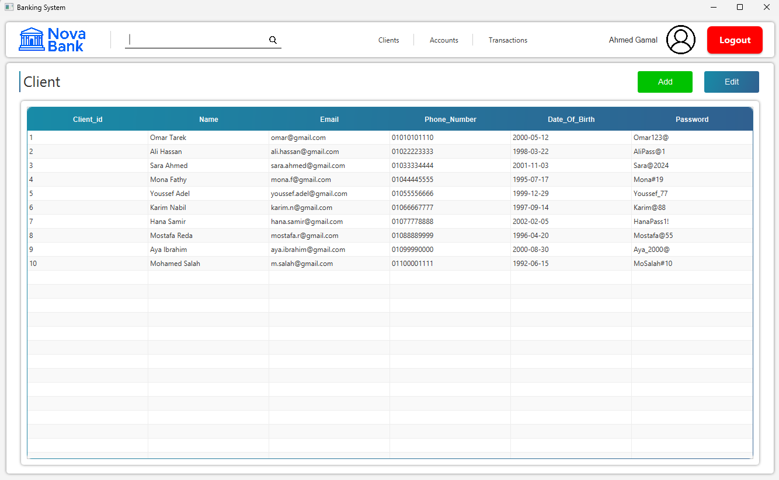
Figure 5.7 — Admin views (2/4)
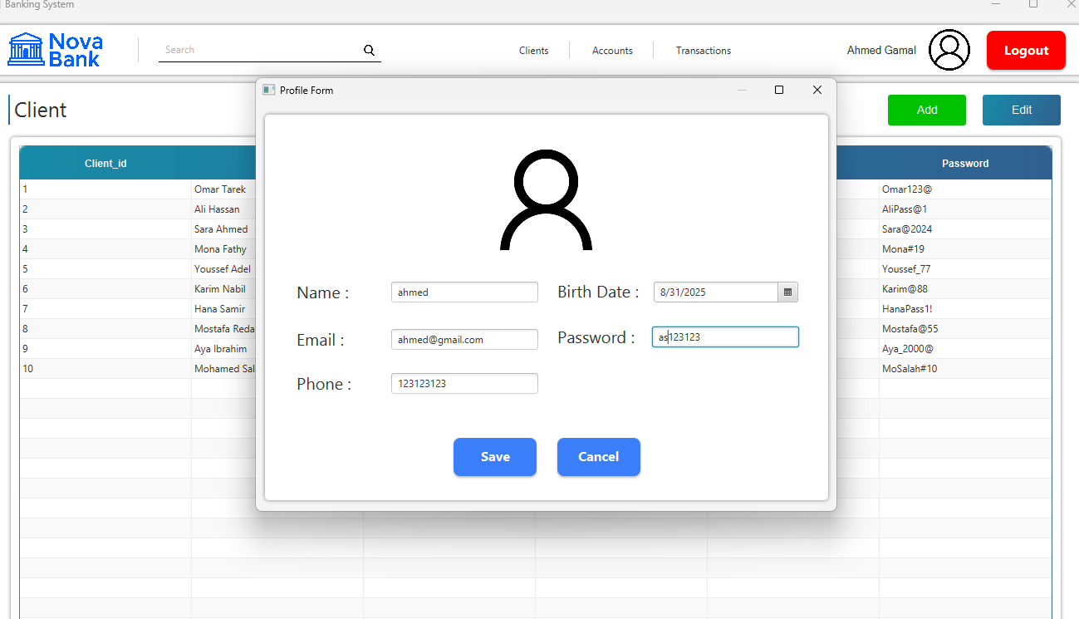
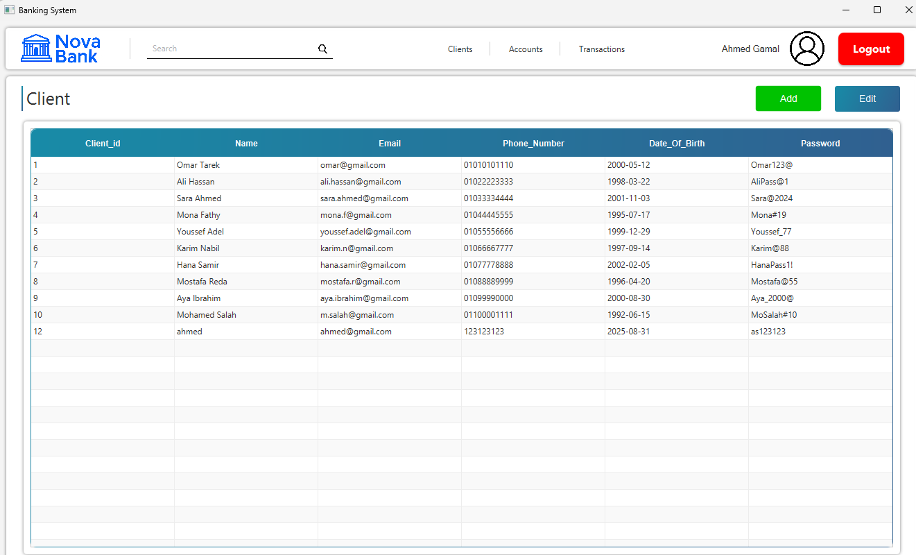
Figure 5.8 — Admin views (3/4)
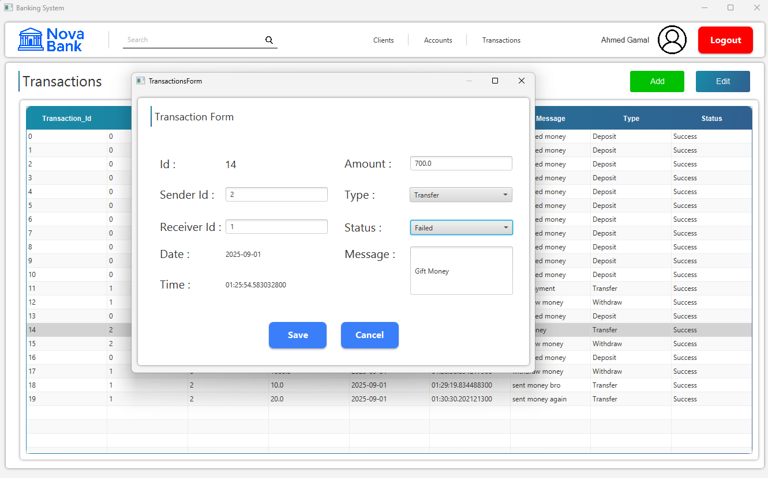
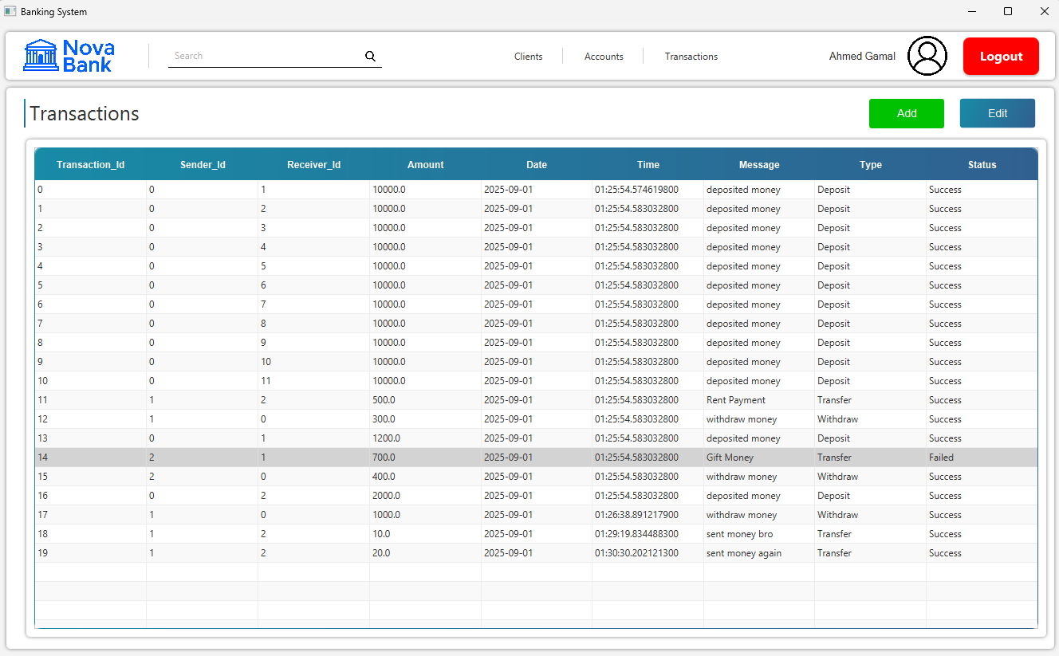
Figure 5.9 — Admin views (4/4)

6.0 State-Based Testing
State-based testing validates that the Account object correctly enforces the rules of state transitions. The account can move between Unverified, Verified, Suspended, and Closed according to business rules. Using state transition testing, we verified all allowed and forbidden transitions.
Test ID | Transition Attempt | Precondition | Expected Result | Notes
TC1 | Unverified → Verified | Initial state = Unverified | Allowed, state = Verified | Valid upgrade after account creation
TC2 | Unverified → Suspended | Initial state = Unverified | Allowed, state = Suspended | Account can be suspended before verification
TC3 | Unverified → Closed | Initial state = Unverified | Not allowed, state remains Unverified | Direct close is blocked
TC4 | Verified → Closed | State = Verified | Allowed, state = Closed | Verified account can be closed
TC5 | Verified → Suspended | State = Verified | Allowed, state = Suspended | Verified account can be suspended
TC6 | Verified → Unverified | State = Verified | Not allowed, state remains Verified | Downgrade to Unverified is blocked
TC7 | Closed → Suspended | State = Closed | Allowed, state = Suspended | Closed account can be reactivated as Suspended
TC8 | Closed → Verified | State = Closed | Not allowed, state remains Closed | Closed account cannot reopen directly as Verified
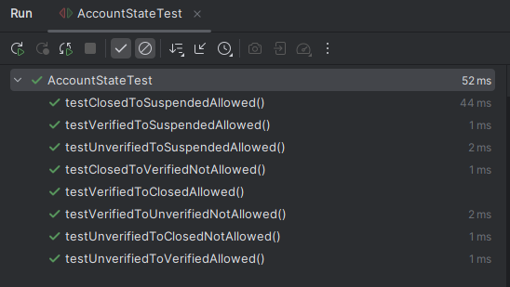

7.0 Test-Driven Development
This feature simulates how a credit score impacts loan eligibility. The tests verify that valid and invalid scores are handled correctly and that eligibility decisions are consistent with business rules.
Test ID | Input | Precondition | Expected Output | Notes
TC1 | creditScore (initial) | New account, not set | 0 | Default credit score is unset
TC2 | creditScore = 750 | None | 750 | Valid credit score set correctly
TC3 | creditScore = -20 | None | Negative value accepted (invalid) | Highlights need for validation
TC4 | creditScore = 500 | Loan check: score >= 600 | false (not eligible) | Low credit score blocks loan
TC5 | creditScore = 720 | Loan check: score >= 600 | true (eligible) | High credit score allows loan
