24-3-2022 Image Differences

* Biometric Face Recognition
* Basic concept
* Advantages
* Stages : capturing – extraction – adaption – comparing - matching

Simple case

Capture your own image/s

Segmentation

Why do we need to create several sub-images?

Vector & Raster

When do we prefer the raster?

When do prefer the vector?

**Knime: possible 1st solution for Face recognition**

* Take two images of yourself
* Make a small change in one image file
* Compare the two images by using the image difference checker (node)
* The sensitivity level can be changed

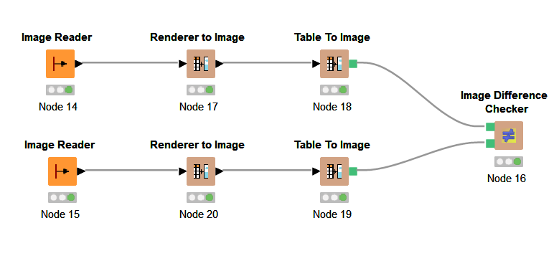

U must understand the way that the images are compared!!

**RENDERING**

What is the RENDERING process?

Do we really need to activate the rendering algorithm for our use?

According to the following terms:

*capturing – extraction – adaption – comparing - matching*

rendering related specifically to the term _______ < what do U think? >

WHY?

Image differenced

400*200 : 600 * 280

Can we compare?