Musanze Harvest Intelligence Service
Technical report - SWE 3513 Artificial Intelligence, Individual Assignment 2
Item | Value
Full name | Feras Saifaddin Ismail Mohammed
Registration number | 25/27916
Institutional username | ug2527916@ines.ac.rw
Verification code | AI-A2-7916
Seed LLLL | 7916
Institution | INES-Ruhengeri

1. Identity and decision problem
Stakeholder. The field officer of a potato cooperative in Musanze. Farm records arrive in inconsistent spreadsheets and internet access is unreliable, so the tool must train and predict locally.
Prediction questions. (1) How many tons will a farm harvest? (regression) (2) Is the farm at high production risk, meaning its yield per hectare is below the dataset median? (classification) (3) Which farms share similar conditions? (clustering)
Offline design. run_all.py recreates the data, trains every model and writes every artifact from one command. A FastAPI service exposes the saved models for a later mobile application.
Ethical boundary. This is a classroom decision-support prototype built on synthetic data. It does not replace an agronomist and must not be used to decide access to finance, insurance or public services. A human must review its output.
Synthetic data. Every record comes from the assignment formula and my registration-based seed. No real farm or person is represented.

2. Data and reproducibility
Column | Generation rule | Role
rainfall_mm | Uniform 600-1400 | Numeric feature
avg_temp_c | Uniform 12-26 | Numeric feature
soil_moisture_pct | Uniform 20-80 | Numeric feature
fertilizer_kg | Uniform 0-250 | Numeric feature
field_size_ha | Uniform 0.2-4.0 | Numeric feature
season | Random A or B | Categorical feature
cooperative_support | Random 0 or 1 | Binary feature
yield_tons | Assignment formula, noise SD 0.80, minimum 0.50 | Regression target
high_risk | 1 if yield per hectare is below its median | Classification target

Personal seed rule. The seed is the last four digits of my registration number, LLLL = 7916. The generator calls numpy.random.default_rng(7916). The base row count is 240 + (7916 mod 41) = 240 + 3 = 243. run_all.py rejects any seed that is not 7916.
Deliberate data problems. With m = round(0.05 x 243) = 12, the generator sets 12 values of soil_moisture_pct and 12 values of fertilizer_kg to missing, then appends 3 exact duplicate rows. The CSV has 246 rows. The validator found 12 and 12 missing values and 3 duplicate rows (artifacts/data_quality.json). Duplicates are dropped, leaving 243 rows. Missing values are imputed later, inside the pipeline.
Evidence | Value
Rows in CSV (before cleaning) | 246
Missing soil_moisture_pct / fertilizer_kg | 12 / 12
Duplicate rows removed | 3
Rows after cleaning | 243
Training / test rows | 194 / 49

SHA-256 fingerprint of the final CSV bytes (artifacts/data_fingerprint.txt):
571b39ec937c1cd244f9c7678156bdc80c39287e96cf57a29925a4f9ea136795
The CSV is written with float_format "%.4f" and LF line endings so the hash is the same on Windows and Linux. Running run_all.py twice gave the same fingerprint and identical metric files.

3. Pipeline design
Split. After duplicates are removed, one stratified split (on high_risk) with test_size 0.20 and random_state = 7916 gives 194 training rows and 49 test rows. The test set is used only for final reporting.
Preprocessing. One ColumnTransformer is built inside every model Pipeline and fitted on training rows only. Numeric features get median imputation then standard scaling. season is one-hot encoded with unknown categories ignored. cooperative_support is passed through. Because the transformer lives inside the saved Pipeline, training and inference apply identical steps.
Leakage controls. yield_tons, yield per hectare and high_risk are never used as classification inputs; assert_no_leakage() checks the feature list before training and a test covers it. No imputer, scaler or encoder is fitted before the split. Clustering uses no target; yield and risk appear in the cluster report only after the clusters are formed.
Model selection. Candidates are compared with 5-fold cross-validation on the training set only (RMSE for regression, F1 for classification). The baseline is reported but cannot be selected. Test scores are reported for every model but do not choose the winner.
Task | Baseline | Candidates | Selection rule
Regression | Mean predictor | Linear regression, random forest (300 trees), gradient boosting | Lowest CV RMSE
Classification | Majority class | Logistic regression, random forest (300 trees), gradient boosting | Highest CV F1 (positive class = high_risk)
Clustering | - | K-means, K = 2 to 6, on scaled features | Highest silhouette score

All random states are set to the seed (7916) and tree models use one thread, so results are deterministic.

4. Regression and classification

Regression - held-out test set (selected: linear_regression)
Model | CV RMSE (train) | Test MAE | Test RMSE | Test R2
mean_baseline | 2.7238 | 2.0363 | 2.3865 | -0.0001
linear_regression * | 0.9835 | 0.8108 | 1.0560 | 0.8042
random_forest | 1.3941 | 1.1134 | 1.3992 | 0.6562
gradient_boosting | 1.2540 | 0.9492 | 1.1683 | 0.7603

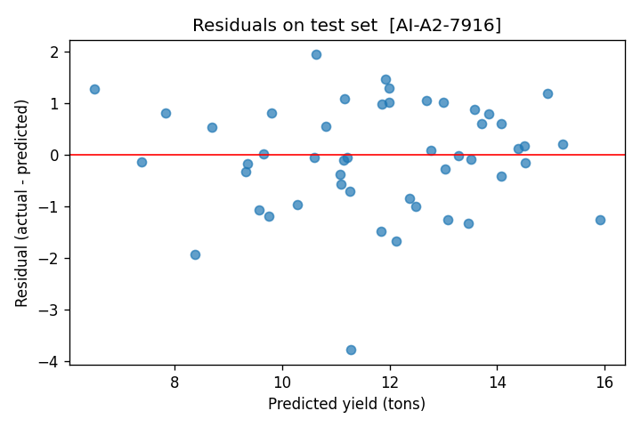
Residuals on the test set, linear_regression | AI-A2-7916
YOUR OWN INTERPRETATION - regression error (write 3-4 sentences, then delete this note)
Facts from artifacts/regression_metrics.json: largest error is test row 105. Actual 7.4992 t, predicted 11.2756 t (overpredicted by 3.7764 t).
Its inputs: rainfall 634.67 mm, temperature 12.94 C, soil moisture MISSING, fertilizer 169.25 kg, field 1.80 ha, season A, no cooperative support.
Explain why the model missed this farm, in your own words, and what the residual plot shows overall.

Classification - held-out test set (selected: logistic_regression)
Model | CV F1 | Precision | Recall | F1 | ROC-AUC | [[TN FP][FN TP]]
majority_baseline | 0.262 | 0.000 | 0.000 | 0.000 | 0.500 | [[25,0],[24,0]]
logistic_regression * | 0.954 | 0.885 | 0.958 | 0.920 | 0.995 | [[22,3],[1,23]]
random_forest | 0.913 | 0.885 | 0.958 | 0.920 | 0.987 | [[22,3],[1,23]]
gradient_boosting | 0.909 | 0.958 | 0.958 | 0.958 | 0.972 | [[24,1],[1,23]]

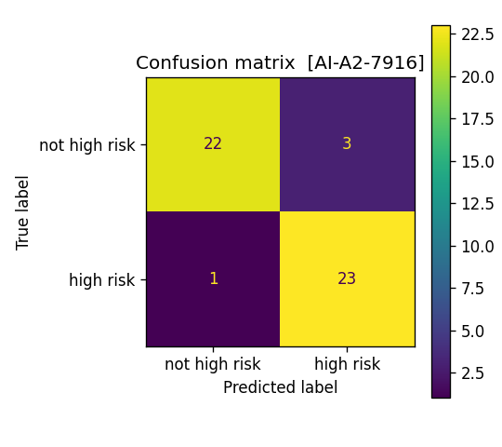
YOUR OWN INTERPRETATION - classification error (write 3-4 sentences, then delete this note)
Facts from artifacts/classification_metrics.json: the selected model made 4 errors on 49 farms (3 false alarms, 1 missed high-risk farm).
Most confident error: row 105, actual high risk, predicted not high risk, P(high risk) = 0.3847.
Explain what you think made this farm hard, in your own words.

5. Clustering
K-means was fitted on the scaled training features (no targets) for K = 2 to 6. K = 5 has the highest silhouette score (0.1563). The scores are all low, so the data has weak natural cluster structure. That is expected because the synthetic features were drawn independently, so the clusters are loose groupings, not natural farm types.
K | 2 | 3 | 4 | 5 | 6
Silhouette | 0.1370 | 0.1355 | 0.1504 | 0.1563 (selected) | 0.1541

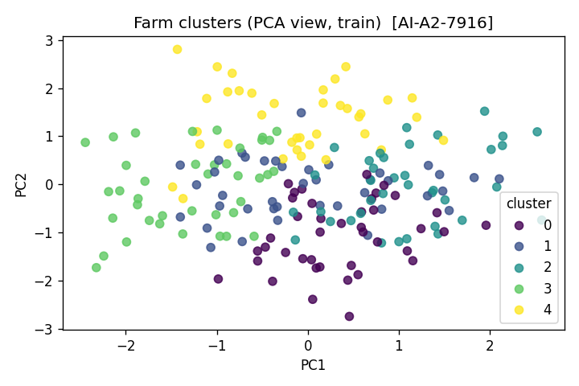
Farm clusters (K = 5, PCA view of training rows) | AI-A2-7916
Cluster | Farms | Profile (generated from the cluster means) | Mean yield (t) | High-risk rate
0 | 41 | Low soil moisture, high fertilizer, large fields, mostly season B, mostly no cooperative support | 13.10 | 90.2%
1 | 40 | High temperature, low soil moisture, small fields, mostly season B, mostly supported | 9.41 | 25.0%
2 | 37 | High temperature, high soil moisture, large fields, mostly season A, mostly no support | 13.14 | 56.8%
3 | 39 | Low rainfall, low temperature, low fertilizer, mostly season B, mostly supported | 9.75 | 48.7%
4 | 37 | High rainfall, low temperature, high soil moisture, mostly season B, mostly supported | 13.51 | 27.0%
Yield and risk columns are shown after clustering for description only; they were not used to form clusters.
YOUR OWN INTERPRETATION - one farm cluster (choose ONE cluster, write 3-4 sentences, then delete this note)
Pick one cluster from the table and say what it means for a field officer in practical terms.
Be honest that the silhouette scores are low.

6. API and testing
Endpoint | Purpose | Success | Failure
GET /health | Service status and whether models are loaded | 200 | -
GET /model-info | Verification code, seed, fingerprint, selected models, test metrics | 200 | 503 if models are missing
POST /predict | Typed farm record to yield, risk, probability, cluster | 200 | 422 for missing field, wrong type, out-of-range or unknown field

Valid request (samples/valid.json):
{"rainfall_mm": 1000.0, "avg_temp_c": 18.0, "soil_moisture_pct": 55.0, "fertilizer_kg": 120.0, "field_size_ha": 1.5, "season": "A", "cooperative_support": 1}
Response (HTTP 200): predicted_yield_tons 11.8816, high_risk 0 ("lower risk"), probability_high_risk 0.0719, cluster 3, verification_code AI-A2-7916, plus the disclaimer text.
Invalid request (samples/invalid.json) has rainfall 5000, temperature "hot", season "C" and no field_size_ha. The CLI lists all four problems and exits with code 2; the API returns HTTP 422 with the same details. The request model uses strict types, so a string such as "800" is rejected rather than silently converted.
Tests. tests/test_system.py holds 10 pytest tests, all passing: valid inference; missing field; wrong type; range error; reproducible fingerprint and row count; wrong seed; deliberate data problems detected and cleaned; schema and leakage checks; API /health, /model-info and valid /predict; API invalid /predict returns 422. Failure paths are tested, not only the happy path. The final run is recorded in evidence/AI_A2_2527916_TEST_LOG.pdf.
Failure behaviour. If models are missing, the CLI prints a message telling the user to run run_all.py and the API returns 503. It never returns a guessed prediction.

7. Model card and reflection
Intended use. Classroom decision support for a field officer: a rough yield estimate, a risk screen and farm grouping, all on synthetic data.
Prohibited use. Deciding loans, insurance, subsidies or any access to public services; replacing an agronomist; using the models on real farms without retraining and validating on real data.
Limitations. The data is synthetic and follows a known near-linear formula, so high scores say little about real farms. The test set has only 49 farms, so every metric carries wide uncertainty (for example, one extra error changes recall noticeably). Inputs outside the training ranges are rejected, not extrapolated. Clusters are weak groupings.
Risks. Over-trust in a confident probability; a missed high-risk farm (the selected classifier missed 1 of 24 in the test set) hiding a struggling farm; unfair outcomes if cooperative_support were ever used to ration resources.
Human oversight. Every output is advice for a person to review. The API response repeats the disclaimer, and the risk label says human review is required.
YOUR OWN REFLECTION - what you would improve with real data (write 4-6 sentences, then delete this note)
Think about: why the simple models won, what data you would collect, how you would check errors by district, and who should validate the system before any use.

