Declaration
Full name | Feras Saifaddin Ismail Mohammed
Registration number | 25/27916
Institutional username | ug2527916@ines.ac.rw
Verification code | AI-A2-7916
Course | SWE 3513 Artificial Intelligence - Individual Assignment 2
Project | Musanze Harvest Intelligence Service

I declare that I am submitting this project under my own name and registration number, and that I take full responsibility for it.
I used the AI assistant Claude (Anthropic) during this assignment. It generated the starting project (structure, Python code, tests and README), a spreadsheet, and a draft of the factual sections of the report from my own results, and it guided me step by step while I ran and tested the project. The details are in evidence/AI_USE.md.
I installed and ran the project on my own computer, and the results I report (dataset fingerprint, metrics, tests and API behaviour) come from those runs.
The dataset is synthetic and was generated from my registration digits (seed 7916). No real personal data was used.
I understand that during assessment I may be asked to explain the code, the results and the model choices, and to make a small change to the code, and that using AI assistance does not remove this requirement.
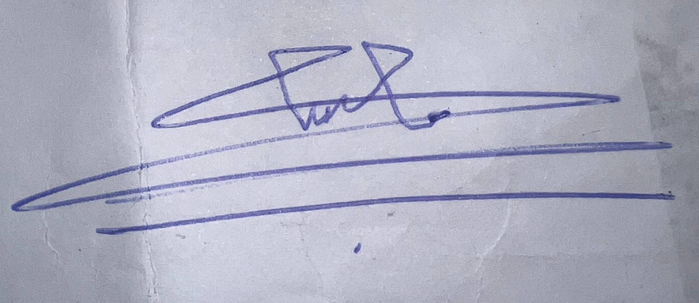
Signature: ______________________________
Date: ___19/10/2026___________________________

