Short Text Understanding Through Lexical-Semantic Analysis
By Wen Hua, , Zhongyuan Wang, Haixun Wang, Kai Zheng, Xiaofang Zhou
(Literature review)

Mirza Faraz Hassan
Csu-s5-113
BSCS
University of Lahore

Domain
In this paper, we focus on short text understanding, which is crucial to many applications, such as web search, microblogging, ads matching, etc. Unlike documents, short texts have some unique characteristics which make them difficult to handle.

Problem statement
First, short texts do not always observe the syntax of a written language. As a result, traditional natural language processing methods cannot be easily applied. Second, short texts usually do not contain sufficient statistical signals to support many state-of-the-art approaches for text processing such as topic modeling. Third, short texts are usually more ambiguous.

contribution of this research
- We demonstrate the pervasiveness of ambiguity in short texts and the limitations of traditional approaches in handling them.
- We achieve better accuracy of short text understanding, using knowledge-intensive approaches based on lexical-semantic analysis.
- We improve the efficiency of our approaches to facilitate real-time applications.

Related work
Text Segmentation:
The goal of segmentation is to divide a short text into a sequence of meaningful components.
POS Tagging:
A Part-Of-Speech Tagger (POS Tagger) is a piece of software that reads text in some language and assigns parts of speech to each word (and other token), such as noun, verb, adjective, etc., although generally computational applications use more fine-grained POS tags like 'noun-plural'. POS tagging determines the lexical type of a word in a text.
Concept Labeling:
Concept labeling determines the most appropriate concepts of an instance within specific context. E.g. Named Entity Recognition (NER) is a special case of concept labeling, which only focuses on named entities.

Methodology
Methodology consists of two parts: an online inference part for short text understanding and an offline part for knowledge acquisition.

Online Inference:
There are basically three tasks in online processing of short texts, namely text segmentation, type detection, and instance disambiguation.
- Text segmentation
We segment a short text into a sequence of terms.
- Except for stop words, each word belongs to one and only one term
- Terms are coherent (i.e., terms mutually reinforce each other).
- Type detection
For each term derived from a short text, type detection determines the best typed-term from the set of possible typed-terms. In the case of “watch free movie”, the best typed-terms for “watch”, “free”, and “movie” are watch[verb], free[adjective], and movie[concept] respectively.
- Instance Disambiguation
Instance disambiguation is the process of eliminating inappropriate concepts behind an ambiguous instance. We accomplish this task by re-ranking concept clusters of the target instance based on context information in a short text (i.e., remaining terms), so that the most appropriate concept clusters are ranked higher and the incorrect ones lower.

Offline Knowledge Acquisition
A prerequisite to short text understanding is knowledge about instance semantics as well as relatedness between terms. Therefore, we build an is a network and a co-occurrence network between words and phrases. We also pre-calculate some essential scores for online inference.
- Harvesting is A Network from Pro-base:
Pro-base is a huge semantic network of concepts (e.g., country and president), instances (e.g., China and Barack Obama) and attributes (e.g., population and age).
- Constructing Co-occurrence Network:
We construct a co-occurrence network to model semantic relatedness. The cooccurrence network can be regarded as an indirect graph, where nodes are typed-terms and edge weight w(¯x, y¯) formulates the strength of relatedness between typed-terms ¯x and ¯y.

Dataset
Conducted comprehensive experiments on real-world dataset to evaluate the performance of our approach to short text understanding. All the algorithms were implemented in C#, and all the experiments were conducted on a server with 2.90GHz Intel Xeon E5-2690 CPU and 192GB memory.
we manually picked 11 terms that have ambiguity in segmentations, types, or concepts (i.e., “april in paris”, “hotel california”, “watch”, “book”, “pink”, “blue”, “orange”, “population”, “birthday”, “apple”, “fox”), and randomly selected 1100 queries containing one of these terms from one day’s querylog (100 queries for each term). Furthermore, in order to verify the effectiveness of our framework on general short texts, we randomly sampled another 400 queries without any restriction. We removed 22 queries containing only one word which cannot be recognized by Pro-base. Altogether, we obtained 1478 queries through this process.

Technique
Divided the original dataset into 5 disjoint parts and invited 15 colleagues to label them (3 for each part). We defined three labeling tasks, namely labeling the correctness of text segmentation, type detection and concept labeling respectively. Note that different people might refer to the same topic with different expressions or in different levels which all make sense. For example, some might label “barack obama” as a president while others label him as a politician. Besides, although we have clustered Pro-base’s concepts into 5000 concept clusters, it is still infeasible for annotators to manually select one from thousands of concept clusters to label an instance. Therefore, we decided to run our algorithms first, provide annotators with the segmentation of each query as well as types and top-1 concept clusters of terms in that query, and then ask them to determine the correctness of provided results. In order to eliminate conflicts, final labels were based on majority vote.

Accuracy of text segmentation
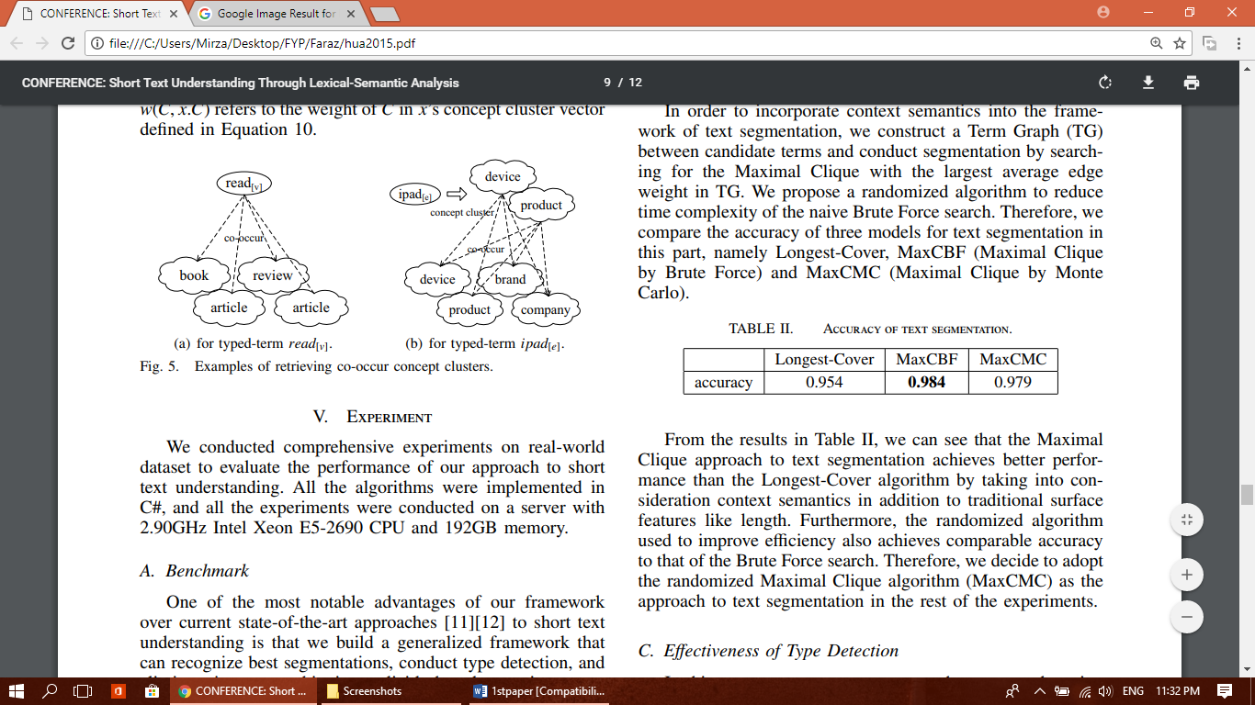

Accuracy of type detection
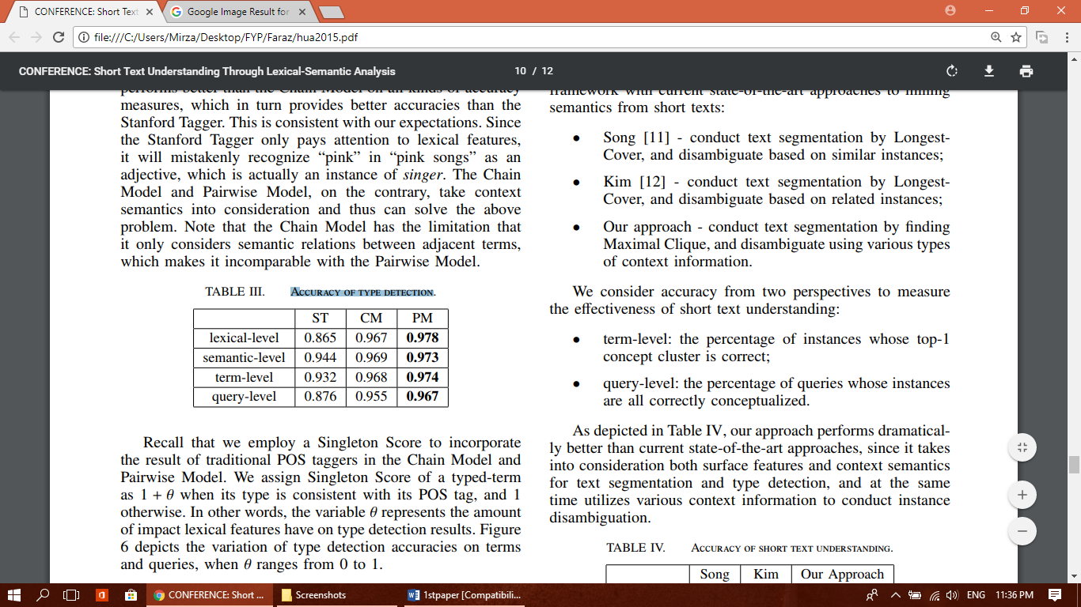

Accuracy of short text understanding
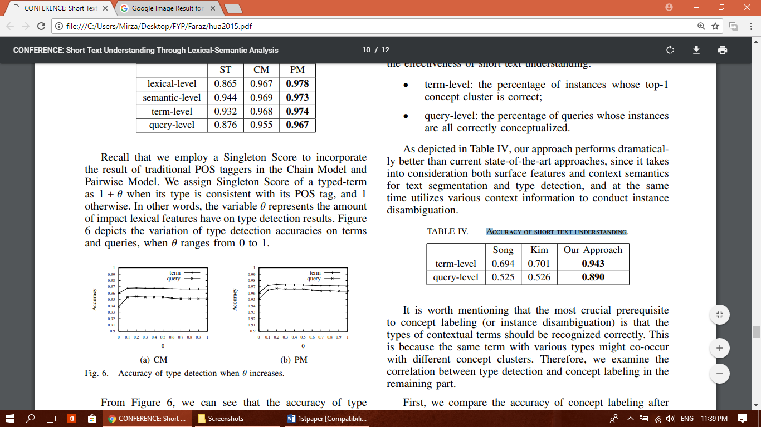

Conclussion
The experimental results demonstrate that our proposed framework outperforms existing state-of-the-art approaches in the field of short text understanding.

