PBIXRay MCP Server — Full Project Documentation
End-to-end reference: MCP stdio server, Flask REST/HTML dashboard, Next.js storytelling + DAX UI, and Ollama for LLM features.

1. What This Project Does
Layer | Role
PBIXRay (dependency) | Parses .pbix files and exposes tables, statistics, DAX, relationships, etc.
pbixray_server.py | Model Context Protocol (MCP) server: tools for AI clients (Claude Desktop, Cursor, etc.) over stdio.
pbixray_flask_app.py | HTTP API + legacy HTML dashboard: upload PBIX, extract model context, stream DAX generation (SSE), proxy Ollama model list.
web/ | Next.js 14 app: file drop → Flask upload, Storytelling tab (Vercel AI SDK → /api/chat → Ollama), DAX tab (SSE to Flask /api/dax/generate → Ollama).

2. Repository Layout
pbixray-mcp-server/
├── src/
│ ├── pbixray_server.py # MCP FastMCP entry (stdio)
│ ├── pbixray_flask_app.py # Flask: API + dashboard.html
│ └── storytelling/
│ └── ollama_story.py # build_story_context, generate_story_with_ollama (MCP storytelling tool)
├── web/ # Next.js UI (port 3000 by default)
│ ├── app/
│ │ ├── api/chat/route.ts # Storytelling: streamText → Ollama OpenAI-compatible API
│ │ ├── page.tsx # Renders src/App.jsx
│ │ └── layout.tsx
│ └── src/
│ ├── App.jsx # Tabs: Storytelling | DAX
│ ├── context/PBIXContext.jsx
│ ├── hooks/ # useStoryGeneration, useDAXGeneration, useOllamaModels
│ └── components/ # Layout, StorytellingPage, DAXGeneratorPage, ...
├── scripts/
│ ├── run_flask_dashboard.sh # venv + picks free port 5050–5099
│ ├── run_with_ollama.sh
│ └── run_story_ui.sh
├── tests/ # pytest (MCP/server behavior)
├── examples/config/ # Sample MCP client JSON
├── requirements.txt / pyproject.toml
└── README.md, INSTALLATION.md

3. High-Level Architecture
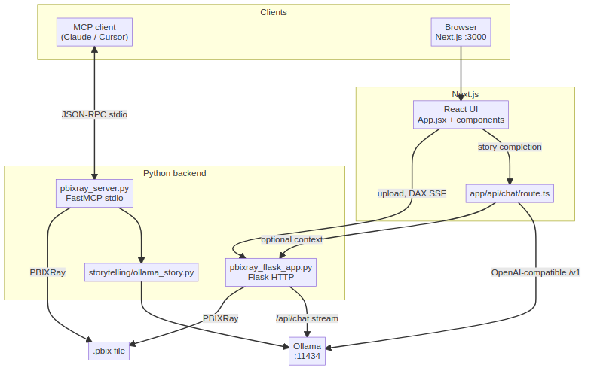
Mermaid diagram 1

4. Backend: MCP Server (src/pbixray_server.py)

4.1 Startup and transport
- CLI: python src/pbixray_server.py with optional --disallow, --max-rows, --page-size, --load-file.
- Runs mcp.run(transport="stdio") — all protocol traffic on stdin/stdout; logs go to stderr.
- secure_tool: wraps @mcp.tool so disallowed tool names still register but return an error string.

4.2 Global model state
- current_model: PBIXRay | None, current_model_path — set by load_pbix_file (and optional --load-file at startup via load_file_sync).

4.3 Tools (representative list)
Registered with FastMCP; heavy work often uses run_model_operation + thread pool + progress.
Tool | Purpose
load_pbix_file | Load .pbix by filesystem path
get_tables | List model tables
get_metadata | PBIX metadata
get_power_query | M code
get_m_parameters | M parameters
get_model_size | Size in bytes
get_dax_tables / get_dax_measures / get_dax_columns | DAX artifacts
get_schema | Column types
get_relationships | Relationships
get_table_contents | Paginated row data + filters
get_statistics | Column stats (optional filters)
generate_storytelling_narrative | Builds context via build_story_context, then generate_story_with_ollama
get_model_summary | JSON summary of loaded model

4.4 MCP request flow (conceptual)
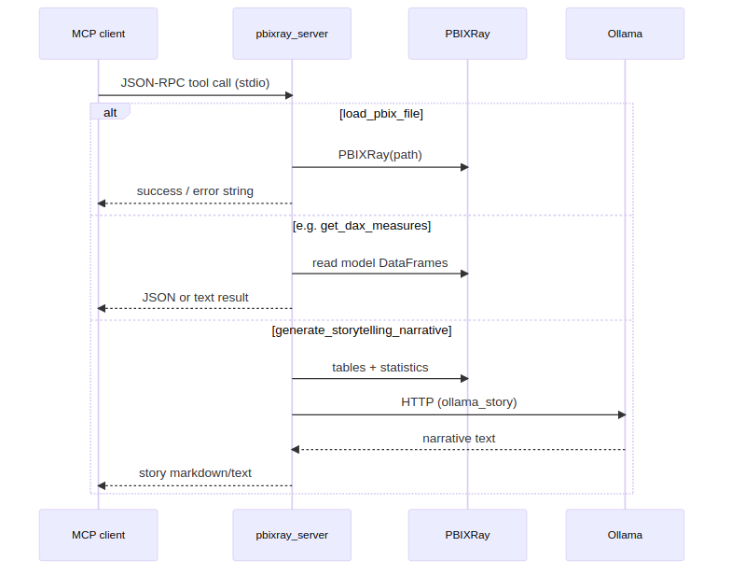
Mermaid diagram 2

5. Backend: Flask (src/pbixray_flask_app.py)

5.1 Responsibilities
- CORS on /api/* for localhost:3000 and 3001.
- extract_pbix_payload(resolved_path): opens PBIXRay, returns JSON including ok: true, tables, summary, stats_preview, context (story JSON from build_story_context), columns, measures, relationships, rawContext (long text for LLM prompts).

5.2 Routes
Method | Path | Description
GET | / | Renders dashboard.html with default PBIX path hint
GET | /storytelling | Redirects to STORY_UI_URL or /
GET | /api/pbix/context?pbix_path= | Full payload JSON for a path on disk
POST | /api/pbix/upload | Multipart file → temp .pbix → same payload + uploaded_name
POST | /api/dax/generate | JSON body: query, optional context, pbix_context, model → SSE stream from Ollama
GET | /api/ollama/models | Proxies GET {OLLAMA_BASE_URL}/api/tags
POST | /analyze | Form pbix_path → legacy HTML dashboard with stats

5.3 DAX SSE protocol
Server-Sent Events: each event line is data: {json}\n\n where JSON has type:
- start — includes req_id
- chunk — text delta from Ollama
- error — failure message
- done — stream finished
Ollama is called at {OLLAMA_BASE_URL}/api/chat with stream: true; optional DAX_OLLAMA_NUM_CTX, truncation via DAX_MAX_*_CHARS, timeouts via DAX_OLLAMA_READ_TIMEOUT_SEC, etc.

5.4 Flask flow: PBIX upload
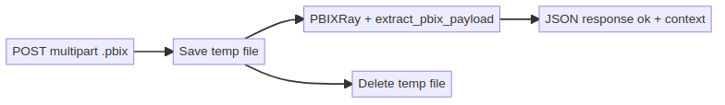
Mermaid diagram 3

6. Frontend: Next.js (web/)

6.1 Entry
- app/page.tsx imports src/App.jsx (client component).
- App.jsx: PBIXProvider wraps AppLayout with tabs storytelling | dax.

6.2 PBIX state (PBIXContext.jsx)
- uploadFile: XMLHttpRequest POST to {NEXT_PUBLIC_FLASK_URL}/api/pbix/upload with progress.
- On success (data.ok), stores tables, columns, measures, relationships, rawContext, storyContext.
- NEXT_PUBLIC_FLASK_URL default http://127.0.0.1:5052 (must match running Flask port).

6.3 Storytelling (useStoryGeneration.js + StorytellingPage.jsx)
- useCompletion from @ai-sdk/react with api: "/api/chat".
- Request body includes model from UI; server route can accept context (preloaded) or pbixPath to fetch context from Flask.

6.4 Chat API (web/app/api/chat/route.ts)
- Parse messages or single prompt.
- If no context, require pbixPath → fetch(FLASK_URL/api/pbix/context?pbix_path=...).
- createOpenAI({ baseURL: OLLAMA_BASE_URL/v1, apiKey: "ollama" }).
- streamText with system prompt (STORY_RULES + context JSON) → toDataStreamResponse().

6.5 DAX tab (useDAXGeneration.js)
- fetch Flask POST /api/dax/generate with Accept: text/event-stream, read stream, parse SSE data: lines, accumulate text, parseDaxSections for measure / explanation / suggestions.

6.6 End-to-end: user opens Storytelling with uploaded file
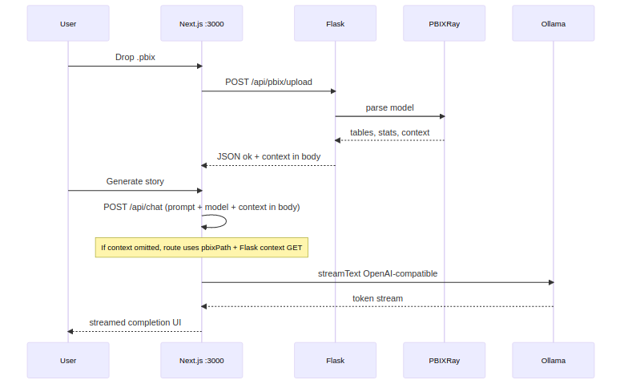
Mermaid diagram 4

6.7 End-to-end: DAX generation
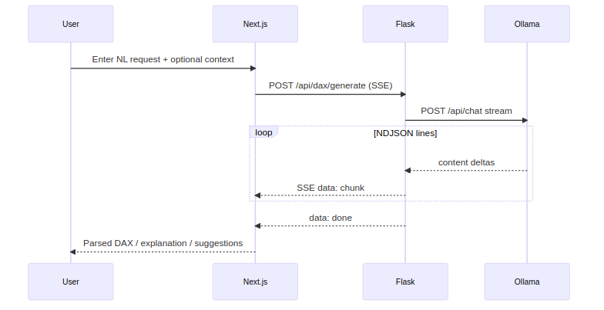
Mermaid diagram 5

7. Environment Variables

Flask / Python (DAX and logging)
Variable | Purpose
PBIX_DASHBOARD_PORT | Flask bind port (script may auto-pick 5050–5099)
STORY_UI_URL | Redirect target for /storytelling
OLLAMA_BASE_URL | Default http://127.0.0.1:11434
OLLAMA_MODEL | Default model name for DAX if not passed in body
DAX_MAX_USER_CONTEXT_CHARS / DAX_MAX_PBIX_CONTEXT_CHARS | Truncate prompt parts (0 = unlimited where supported)
DAX_OLLAMA_NUM_CTX | Ollama num_ctx option
DAX_OLLAMA_READ_TIMEOUT_SEC | Long-running generation timeout
DAX_LOG_LEVEL | Logger verbosity

Next.js (web/.env.local)
Variable | Purpose
FLASK_URL | Server-side fetch for /api/chat context
NEXT_PUBLIC_FLASK_URL | Browser upload + DAX SSE
OLLAMA_BASE_URL / OLLAMA_MODEL | Chat route defaults
NEXT_PUBLIC_DAX_DEBUG | 1 for verbose client DAX logs
Keep FLASK_URL and NEXT_PUBLIC_FLASK_URL aligned with the port printed by run_flask_dashboard.sh.

8. Running Locally (typical)
- Python venv (from repo root): install requirements.txt or pip install -e . per INSTALLATION.md.
- Ollama: running with the model you reference (e.g. llama3.2:3b).
- Flask: ./scripts/run_flask_dashboard.sh → note host:port.
- Web: cd web && npm install && npm run dev → set .env.local to match Flask port.
Optional: MCP only — source venv/bin/activate && python src/pbixray_server.py and point your MCP client at that command.

9. Testing
- tests/: pytest suite for server behavior (see docs/TESTING.md if present).
- Run from repo root with venv activated: pytest.

10. Related Documentation
- README.md — MCP tools table, WSL paths, client config examples.
- INSTALLATION.md — Detailed setup.
- CONTRIBUTING.md — Contribution guidelines.

11. Dependency Summary
- Python: mcp, pbixray, numpy, pandas, flask, flask-cors.
- Web: next, react, @ai-sdk/react, ai, @ai-sdk/openai, UI libraries (Tailwind, framer-motion, etc.).
This document is the single end-to-end map from MCP stdio through Flask to the Next.js UI and Ollama.

