A sample figure showing Content Spoofing towards File Server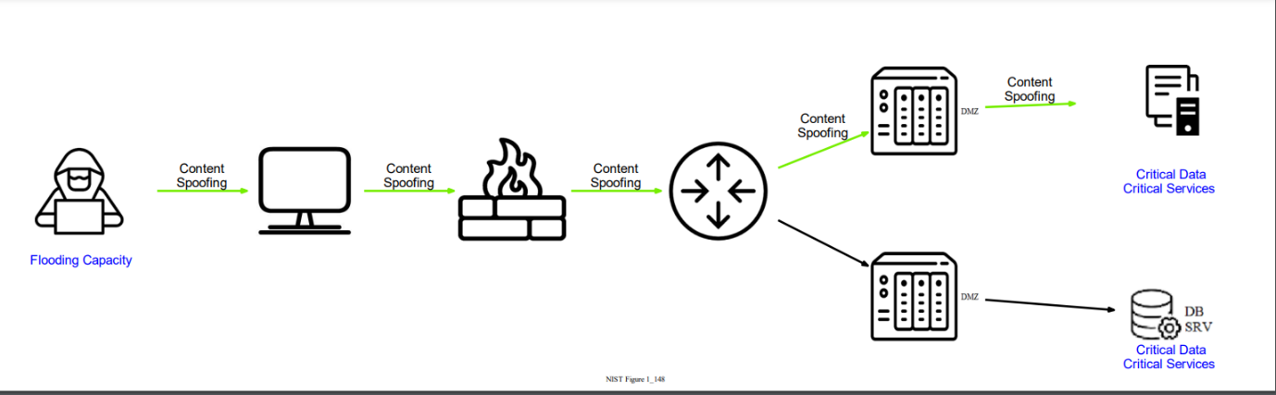

Note: The scenario is taken from NIST