FAST
A simple formula for prompting.
You'll see a lot of posts online that talk about the "perfect prompt." Forget those. You don't need that. What you need is a "good enough prompt" that focuses exactly on what YOU need. Here's a framework I put together that you can use while prompting.
By Fernando De Vega · AI in the Park
ai-in-the-park.vercel.app

F — Frame
Set the role and the situation. What role is AI playing? What's the context?

Examples
- You are a senior instructional designer.
- You are a UX writer helping me sharpen microcopy for a mobile onboarding flow.

Common mistake
Flattering framing ("the best in the world at...") that pushes AI into generic authority voice.

A — Ask
The actual request. A single sentence with one action verb.

Examples
- Draft a module-by-module outline for a training program.
- Rewrite these three module titles so they're parallel.

Common mistake
Stacking Asks — "draft AND write AND suggest." Do them in three separate prompts.

S — Shape
Constraints, format, scope. The more you constrain, the better the output. Strong Shape sections always include explicit Don'ts.

Examples
- 4 to 6 modules. Each needs an outcome with a Bloom-level verb. Don't pad with filler.
- Under 15 words per line. No jargon. No exclamation marks.

Common mistake
Skipping the Don'ts. AI pads by default — you have to actively subtract.

T — Tune
Tells AI to push back, flag assumptions, or disagree with you.

Examples
- State your assumptions, and ask any clarifying questions.
- Before drafting, tell me anything you'd push back on.

Common mistake
Treating the first output as final. Tune turns generation into a conversation.

The 10-second check
Before you hit send.
- Did I frame with a real role?
Not "you are an expert." A real role with real constraints.
- Is my ask one sentence with one verb?
If it needs a semicolon or an "AND," split it into two prompts.
- Did I include explicit Don'ts?
AI pads by default. Name the filler you don't want.
- Did I tell it to push back first?
State assumptions. Ask questions. Most people skip this.
If any answer is no — fix that move first, before hitting send.

About me
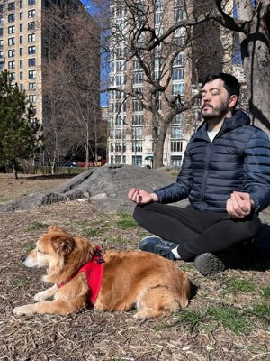
I'm Fer. Argentinian, living in New York for the last five years, walking around Central Park with my dog Pericles most mornings. I've been an instructional designer for 15+ years. I've built things that worked and things that absolutely did not.
See you in the park.
AI in the Park · ai-in-the-park.vercel.app

