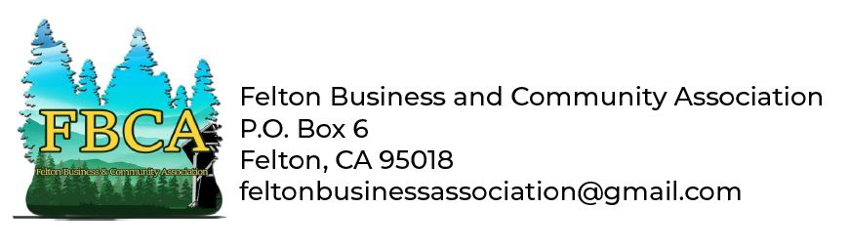
FBCA Membership Form

Dear Felton Business, or Community Member:

The Felton Business and Community Association (FBCA) has been an important part of Felton since 1963, and we're committed to continuing that legacy in 2022, and beyond. You knew us previously as just the Felton Business Assn (FBA), but we've changed our name to include the Community aspect of our membership and projects.

The FBCA is involved every year in putting on several community events, such as the Felton Remembers Memorial Day Parade and Covered Bridge Festival, the 10K Race Thru The Redwoods, our annual Heritage Tree lighting and Visit With Santa at the Felton Firehouse just after Thanksgiving. These are done for the enjoyment and benefit of the people of Felton and the SLV. Through the fundraising for these events, we also support several community groups with our excess funds such as the Mountain Community Resources, the SLV High School Track and XC team, Felton Fire, Zayante Fire, Mountain Parks Foundation, and other programs as we have funds available.

Please consider joining the FBCA as a financial supporter, volunteer, or both. Without our community support, none of these projects would be possible, and we thank you for your support. Membership options are:

- annual membership of $50
- part time volunteering, with floating membership dues of $25-50
- full time volunteering; dues optional

Business Name (personal name)
Mailing Address
Contact Name
Contact Phone (cell/land)
Email Address

The FBCA meets on the 2nd Thursday of every month, with our regular location TBD (you'll receive an email before meetings). We welcome your involvement with the FBCA, either with your time, and/or your financial support. Please print and fill out this form with your information, and return with a check payable to the FBCA, to:

Felton Business and Community Association
P.O. Box 6
Felton CA, 95018

Thank You!

