**Program Description:**

A program that recognizes strings based on given deterministic finite automata. Program takes in .dfa and .in files and determines if each line in a .in file is a valid output of the provided dfa table.

**Program Modules:**

**DFATableGenerator.py**

Creates the table for the DFA

1. generateTable() - function that prints out the DFA table given a canvas and the path to the DFA file.

**main-ui.py**

Source code file for the UI design of the program. Includes the location as to where the information is to be displayed to their respective frames

1. loadFile() - function for loading in the in. and .dfa files.
2. processInputFile() - function for calling functions from DFAProcessing module and errorChecking module to process the loaded files.
3. deleteCanvas() - function for deleting the canvases.

**DFAProcessing.py**

Source code file for analyzing the string validity given the dfa table.

1. processfile(string, string) - takes in string and dfa paths and creates and analyzes whether each string inputs are viable using the dfa table
2. readinput(string) - takes .in or .dfa paths and converts their files to a string array separated by line
3. dfa(string) - takes in .dfa path and creates a graph data structure based on the adjacency presented by the dfa file
4. ffstate(string) - takes in .dfa path and returns a tupple of starting node and ending node arrays

**errorChecking.py**

Source code file for catching errors from both input files which includes the .in and .dfa

1. checkInput(string, string, label) - takes in string and dfa paths to check user .in file loaded by the user using flags and and for loops to check whitespaces. Also, calls compareString function. Returns true or false back to main-ui.py
2. checkDFA(string) - takes in dfa path to check user .dfa file loaded by the user also using loops and checks if duplicates exist in the first line of the file. Returns true or false back to main-ui.py
3. takes in the first line from .dfa file and strips the comma and stores the result as a string. Returns the string to checkDFA function
4. compareString(string, string, label) - compares the characters from the string of the first line of .dfa file with the elements of the strings from the .in file. The .in file strings should only contain the same characters from the first line from .dfa file. Returns the true or false to checkInput function.

**Control Flow:**

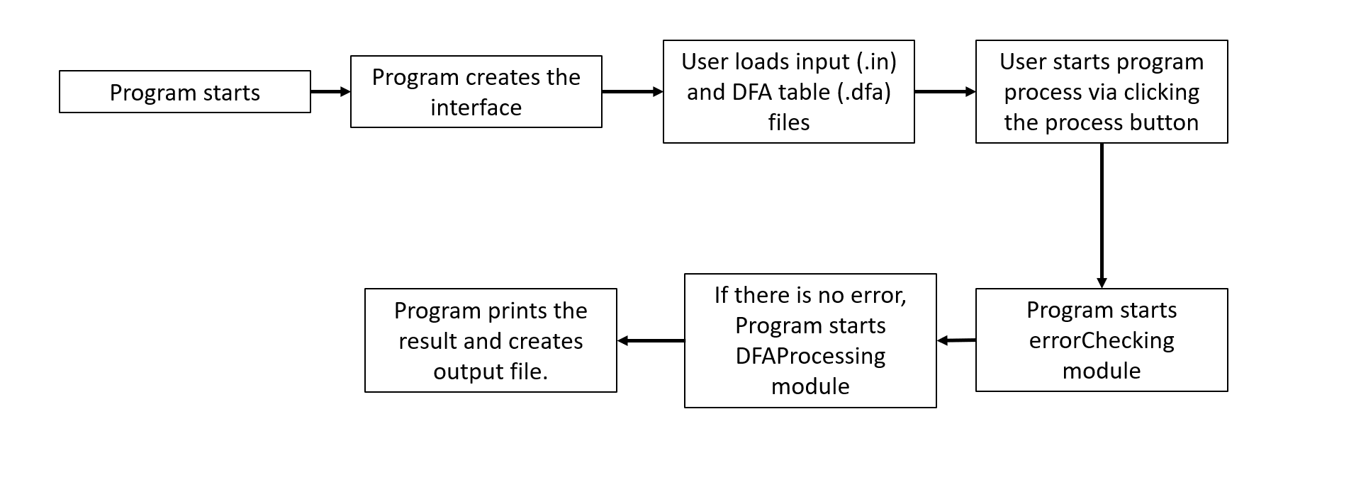

**Module Distribution:**

Program UI and output file creation by Ferdinand Gador

Error checking by Mark Valderama and Jasper Villarosa

DFA and String recognition and analysis by Van Joseph P. Cabuga