# Configuring iOS build options

When using Syncfusion.XlsIO.Portable class library in iOS application, please follow the below instructions and update the iOS build options as mentioned.

1. **Link behavior**: Link SDK assemblies only (otherwise classes you need in Syncfusion.XlsIO.Portable.dll are linked away).

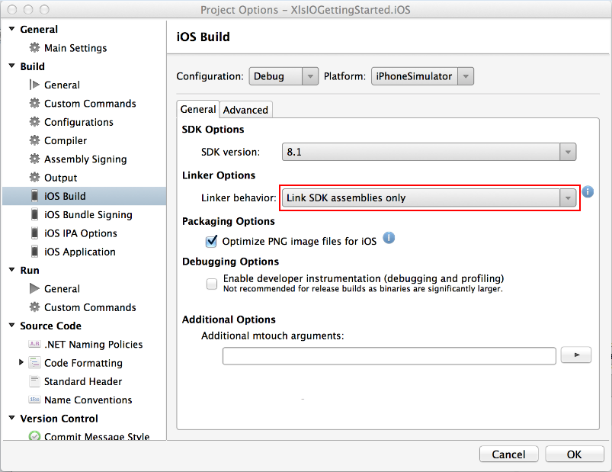

1. **Enable developer instrumentation**: Unchecked (this is to create a smaller binary, since adding debug information makes it somewhat bigger).

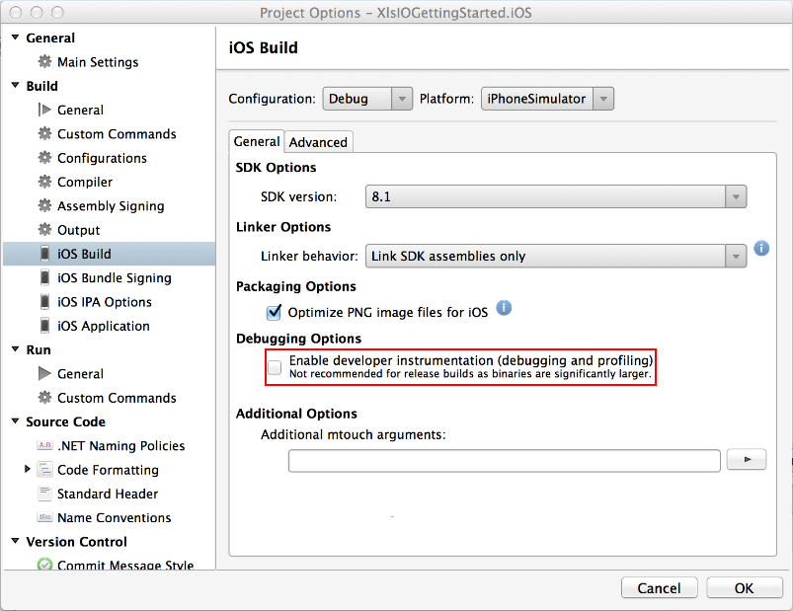

1. **Enable generic value type sharing**: Checked (this is also to create a smaller binary).

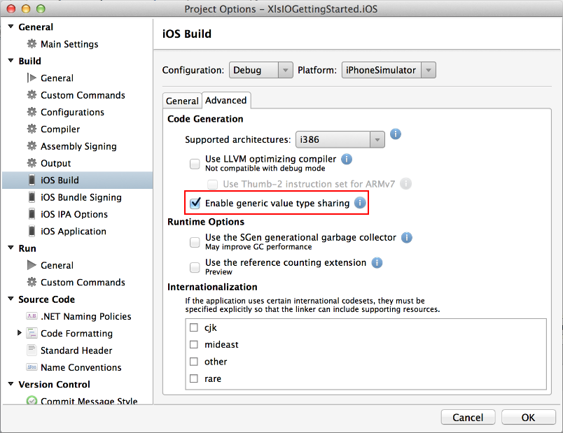

Applying these settings will execute the application properly in iOS device or Simulator.

You might face the following behaviors, if above mentioned build options are missed out.

1. You might get "Native linking error" while compiling.
2. You might face runtime Exception ("System.TypeInitializationException").