**Laporan Tugas Pemrograman Web Lanjut**

Dosen Pengampu : **AJIB SUSANTO, M.Kom**

Tanggal Pertemuan : 5 Maret 2025

Nama : Ferdian Nur Fariza  
NIM : A11.2023.15074  
Kelas : A11.4409  
Mata Kuliah : Pemrograman Web Lanjut

Topik :

**OOP – Object Oriented Programming Using PHP Language**

Tabel Deskripsi :

|  |  |
| --- | --- |
| **Pertemuan** | **Isi Laporan** |
| 2 | Dokumentasi hasil |
| Source Code |

**Dokumentasi Hasil**

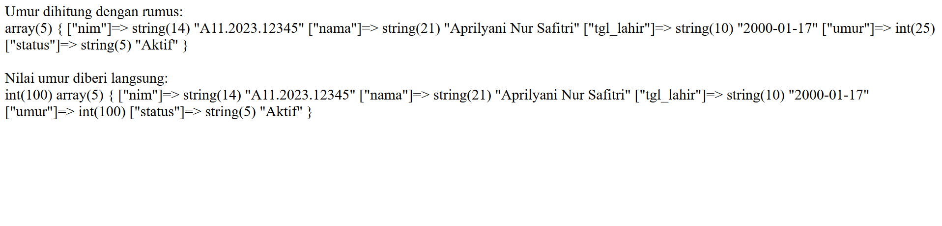

**index.php**

<?php

include "Mahasiswa.php";

include "Matakuliah.php";

$mahasiswa_1 = new Mahasiswa();

$makul_1 = new MataKuliah();

$mahasiswa_1->setData("A11.2023.12345", "Aprilyani Nur Safitri", "2000-01-17");

echo "Umur dihitung dengan rumus: <br> ";

var_dump($mahasiswa_1->getData());

echo "<br>";

echo "<br> Nilai umur diberi langsung: <br>";

$mahasiswa_1->umur = 100;

var_dump($mahasiswa_1->umur);

var_dump($mahasiswa_1->getData());

**index2.php**

<?php

include "Mahasiswa.php";

include "MahasiswaTransfer.php";

$daftar_nilai = [

    "A22.123" => ['sks' => 2, 'nilai' => 'A'],

    "A22.456" => ['sks' => 3,  'nilai' => 'B'],

    "A22.789" => ['sks' => 2, 'nilai' => 'C'],

];

$mahasiswa_1 = new MahasiswaTransfer($daftar_nilai);

$mahasiswa_1->setData("A11.2023.12345", "Aprilyani Nur Safitri", "2000-01-17");

echo "<pre>";

print_r($mahasiswa_1->getData());

echo "</pre>";

**mahasiswa.php (class mahasiswa)**

<?php

class Mahasiswa

{

    private $nim;

    private $nama;

    private $tgl_lahir;

    public $status;

    public $umur;

    public function __construct()

    {

        $this->status = 'Aktif';

    }

    public function setData($nim, $nama, $tgl_lahir)

    {

        $this->nim = $nim;

        $this->nama = $nama;

        $this->tgl_lahir = $tgl_lahir;

        $this->setUmur();

    }

    public function setUmur()

    {

        $this->umur =  date("Y") -  substr($this->tgl_lahir, 0, 4);

    }

    public function getData()

    {

        return [

            "nim" => $this->nim,

            "nama" => $this->nama,

            "tgl_lahir" => $this->tgl_lahir,

            "umur" => $this->umur,

            "status" => $this->status

        ];

    }

}

**mahasiswaTransfer.php (child dari class mahasiswa)**

<?php

class MahasiswaTransfer extends Mahasiswa

{

    private $daftar_nilai;

    private $ipk = 0, $tot_sks = 0, $jml_bobot = 0;

    private $bobot = ['A' => 4, 'B' =>3, 'C' => 2];

    public function __construct($daftar_nilai)

    {

        $this->daftar_nilai = $daftar_nilai;

        $this->getIPK();

        $this->status = 'Aktif';

    }

    public function getIPK()

    {

        if (!empty($this->daftar_nilai)) {

            foreach ($this->daftar_nilai as $data) {

                $this->tot_sks += $data['sks'];

                $this->jml_bobot += $data['sks'] * $this->bobot[$data['nilai']];

            }

        }

        $this->ipk = $this->jml_bobot / $this->tot_sks;

        return $this->ipk;

    }

    public function getData() {

        return array_merge(parent::getData(), ["daftar_nilai" => $this->daftar_nilai, "ipk" => round($this->ipk, 2)]);

    }

}

**MataKuliah.php (class MataKuliah)**

<?php

class MataKuliah{

    private $kode;

    public $nama;

    public function setData($kode, $nama){

        $this -> kode = $kode;

        $this -> nama = $nama;

    }

    public function getData(){

        return [$this->kode, $this->nama];

    }

}

?>