**Laporan Tugas Pemrograman Web Lanjut**

Dosen Pengampu : **AJIB SUSANTO, M.Kom**

Tanggal Pertemuan : 9 April 2025

Nama : Ferdian Nur Fariza  
NIM : A11.2023.15074  
Kelas : A11.4409  
Mata Kuliah : Pemrograman Web Lanjut

Topik :

**Session**

Tabel Deskripsi :

|  |  |
| --- | --- |
| **Pertemuan** | **Isi Laporan** |
| 6 | Langkah menyusun Login Session dan verifikasi |

**Session Login dan Logout**

# # Mengganti Route Sign Out

Mengganti hypertext reference dengan “logout”.

# # Mengubah Username Dashboard

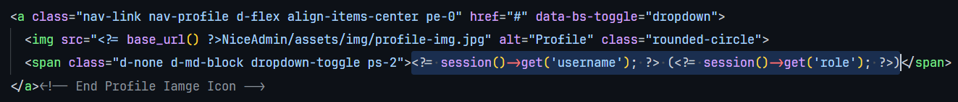

Mengganti K. Anderson dengan :

<?= session()->get('username'); ?> (<?= session()->get('role'); ?>)

# # Membuat File layout_clear.php

Membuat layout dengan tanpa merender header, footer dan sidebar. Dan menghapus id dan class dari main di file layout_clear.php.

# # Mengubah title layout.php dan layout_error.php



Mengubah static menjadi:

<title>- Toko - <?php echo $hlm ?></title>

# # Membuat File v_login.php

Dengan isi :

<?= $this->extend('layout_clear') ?>

<?= $this->section('content') ?>

<section>…</section>

<?= $this->endSection() ?>

# # Mengubah Nama Toko

Mengubah dan dapat merubah logo yang digunakan dari asset.

# # Menambahkan Variabel untuk setiap komponen

# Menambah Kondisi Session

# Mengganti Section <Form>

# Membuat Controller baru AuthController.php

# Menambah Fungsi pada AuthController

# Fungsi Logout

# Menambah route baru di app/config/Routes.php

# Buka pada localhost:8080/login

Berikut adalah tampilan ketika username dan password salah

Tampilan ketika password dan username cocok dengan codebase

Jika Sign Out maka akan di direct ke halaman login kembali.