BrandDocs Brand Operations Review
Annual Brand Operations Review - BrandDocs Corp (synthetic)
Document ID: DSK-BR-2026-014
June 5, 2026

Table of Contents

1 Overview 3
1.1 Scope 3
1.2 Audience 4
2 Methodology 5
2.1 Data sources 5
3 Results 6

Table of Tables

Table 1. BrandDocs FY2026 quarterly revenue 5
Table 2. BrandDocs program rollout matrix 7

Table of Figures

Figure 1. BrandDocs Corp logo mark 2
Figure 2. BrandDocs growth curve 6

Brand operating principles
- Consistency before customization
  - One palette: navy, teal, amber
  - Type scale fixed across all templates
- Templates are contracts, not suggestions
  - Cover, contents, and indices are preserved
  - Body content is regenerated per request

Rollout sequence
- Extract the template surface and brand profile
- Review the captured slots and index front matter
- Generate the branded document

BrandDocs quarterly revenue
Quarter | Revenue | Growth | Region
Q1 2026 | $3.20M | +8.4% | North
Q2 2026 | $3.48M | +8.8% | South
Q3 2026 | $3.91M | +12.4% | EMEA
Q4 2026 | $4.25M | +8.7% | APAC
Table 1. BrandDocs FY2026 quarterly revenue by region (synthetic data).

BrandDocs brand mark

Figure 1. BrandDocs Corp logo mark (synthetic).
BrandDocs Corp is a synthetic, fictional company used to demonstrate an on-brand internal brief. All figures, names, and regions in this template are illustrative.

BrandDocs footnote demo
BrandDocs Corp is a registered placeholder brand used throughout this template.

Overview
This brief summarizes how the BrandDocs Corp brand system is applied across internal documents. It exists to show a complete, on-brand template; a generation run replaces this body with the requested content.

Methodology
Figures are drawn from a synthetic operations dataset maintained by the BrandDocs brand office. Revenue, growth, and regional splits are illustrative and should not be read as real performance data.

BrandDocs landscape appendix
This appendix sits in a landscape section. It carries a wide program rollout matrix and a second brand figure that the portrait body cannot fit. Demo content the generator may clear.

Program rollout matrix
Workstream | Owner | Q1 | Q2 | Q3 | Q4 | Status
Template surface | Brand Office | Scope | Build | QA | Ship | On track
Profile extraction | Platform | Spec | Build | Verify | Tune | On track
Generation engine | Platform | Design | Build | Build | Verify | At risk
Rollout & training | Enablement | Plan | Draft | Pilot | Launch | Planned
Table 1. BrandDocs FY2026 program rollout matrix (synthetic).

BrandDocs growth curve
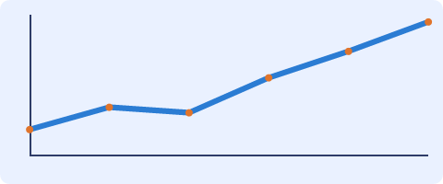
Figure 1. BrandDocs Corp growth curve (synthetic illustration).

BrandDocs Corp is a fictional company used only for testing.

